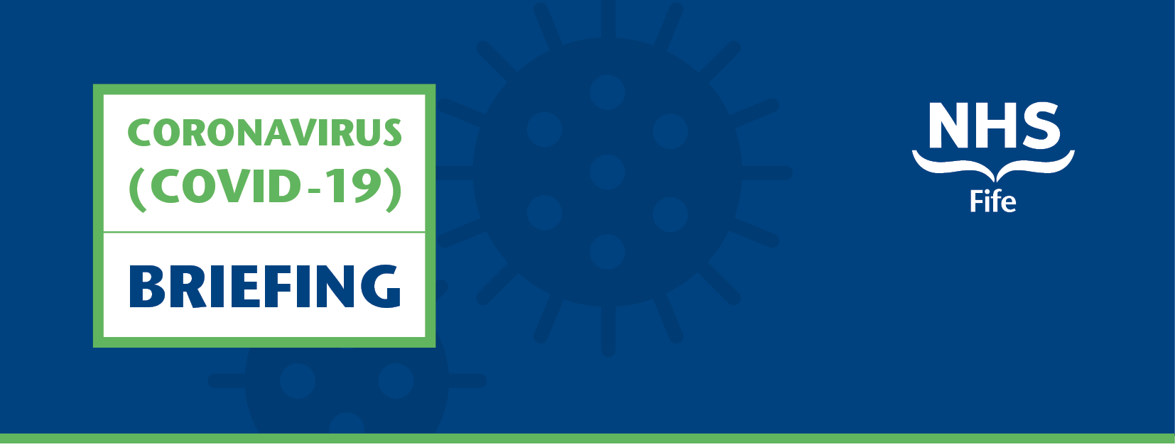
Issue 1 | 9 April 2020

Introduction
As part of our efforts to keep you informed, NHS Fife will be issuing weekly updates to Fife’s Elected Members, MSP’s and MP’s dedicated to NHS Fife’s response to the Coronavirus pandemic.
This digital update will include information on matters including planning and resilience, operational updates, along with signposting to the latest media updates issued by NHS Fife to ensure clear, consistent and timely sharing of information.
Updates will also be issued on NHS Fife’s new public facing Coronavirus micro site providing a hub of information and advice as well as our established, Facebook, Twitter and Instagram pages.

Hot Topics
Personal Protective Equipment (PPE)
NHS Fife is working round the clock with our partners across the public sector to ensure staff in both our acute and community hospitals remain protected and supported throughout this pandemic, and that our patients continue to get timely access to the care they need. We are also working with Health Protection Scotland to ensure the most current recommendations around appropriate application of PPE is communicated to staff.
Staff Testing
New staff testing arrangements, launched last week, will help make NHS Fife more resilient in the face of unprecedented levels of pressure on our services.
NHS Fife has introduced a new drive-through testing programme for a select group of health and social care workers to support the resilience of services during the coronavirus pandemic. The new drive-through testing programme is prioritising frontline workers and their immediate household contacts to enable those assessed as not carrying the virus to return to caring for patients.

Media
New coronavirus micro site launched
NHS Fife has launched a new website to keep patients informed about local health and social care services during the coronavirus pandemic. The new site provides a one-stop-shop for local updates and signposts to helpful guidance from NHS Inform and the Scottish Government to help limit the spread of the virus here in Fife. It also includes materials in a range of languages, as well as British Sign Language for those with a hearing impairment. coronavirus.nhsfife.org
DNA CPR forms
NHS Fife performs resuscitation in line with guidance provided by the Resuscitation Council UK. Our policy on resuscitation has remained unchanged despite the spread of coronavirus and there are no protocols in place preventing staff from performing resuscitation on patients with COVID-19. The care we provide to all patients is person-centred, with any clinical decisions made based entirely on the individual and their particular circumstances. As with any aspect of patient care, we have an obligation to prevent our staff from being exposed to harm and have asked that the necessary personal protective equipment is worn when performing CPR to prevent possible exposure to the virus.

Clinical updates
Red and Green Zones
Hospitals across Fife are being divided into red and green zones to enable appropriate safe care to be delivered for all of our patients. Red zones are for patients who have symptoms that put them in the suspect category or have been confirmed positive. Green zones are for patients who are requiring care but do not have respiratory symptoms suggestive of COVID-19. There is no routine movement between areas and any movement is strictly managed and minimised.
Near Me hospital appointments
All GP practices and hospitals in Scotland have been asked to increase their use of remote consultations by phone or video. This will mean most people can receive the NHS care and advice they need from their own home to reduce the spread of COVID-19. NHS Fife introduced Near Me last week and more information can be found at: coronavirus.nhsfife.org
Covid-19 community hub and assessment centre set up
A new community hub and assessment centre has been established to help provide a dedicated route to clinical advice and support. Patients who show symptoms of coronavirus and who do not improve within seven days are advised to call 111 day or night. They will be assessed and, if necessary, transferred to a community hub staffed by clinicians who will provide the best advice at the right time. They will then be given further advice on self-isolating at home or attending the local Covid-19 assessment centre at the Victoria Hospital for further treatment.

Suspension of routine dental care services
Routine dental care services in high street practices in Fife were suspended at the end of March. Those with an urgent dental need, in normal working hours, should contact the practice, who will provide advice or reassurance through telephone assessment.
Patient screening introduced at Victoria and Queen Margaret sites
In order to increase safety across our sites screening is now taking place at both the VHK and QMH sites for patients attending for urgent outpatient appointments. Our nurses will take patients through a few questions prior to allowing them to attend their appointments.
Suspension of screening programmes
The following screening programmes have been temporarily suspended until further notice - Breast Screening, Cervical Screening, Bowel Screening, Abdominal Aortic Aneurysm Screening, Diabetic Retinothapy Screening.
Sexual health drop in centre’s suspended
Sexual Health Fife is no longer providing a drop-in service. For patients requiring urgent advice they are being advised to call 01592 647979 and may be offered a telephone consultation.
Cancellation of all antenatal and postnatal physiotherapy services
NHS Fife has had to cancel all inpatient and outpatient antenatal and postnatal physiotherapy services in response to Covid-19. Those who are affected by pregnancy related pain or are unsure what to do to help recovery after birth are being encouraged to use the resources available on the Maternity App.
Suspension of newborn hearing screening service
NHS Fife has suspended the newborn hearing screening service. For those affected, their baby may receive an appointment for a hearing assessment when we are able to offer this again. We know that about 1 in every 1000 babies born will have a hearing problem that benefits from early treatment or help. We also know that a very small number of babies are at a slightly higher risk of having a hearing problem - therefore we will identify these children and arrange a hearing test for them at a later date.
Hearing aid battery service
NHS Fife is providing a postal NHS hearing aid battery service from our Audiology Hub. To access the hub you can make contact via the following routes:
- 01592 643355 EXT: 28355
- Audiologyfife@nhs.net
- Via Deaf Communication Service:
SMS text message 07984356580
Fife Council Deaf Communication Service
swinfo.deafcommunications@fife.gov.uk
- https://contactscotland-bsl.org/ (01592 643355 EXT 28355)

Workforce updates
New Staff Support Hubs
New support hubs for staff have opened at Victoria Hospital and Queen Margaret Hospital. The hubs provide a calm and welcoming space for staff to take time out from work during a demanding time. Staff are encouraged to use it as a quiet space with no need for interaction, however, psychology staff will be on hand to provide support, with a variety of easily accessible staff resources also available for use. It is also hoped to extend the hub model to other NHS Fife sites over the coming week.
Staff Listening Service
A new Staff Listening Service is available to staff and provides a space for staff to confidentially reflect on their experience and consider how the current situation affects them personally and professionally voice their concerns, worries and hopes without criticism.
Recruitment Area on Coronavirus micro site
As part of ongoing Covid-19 resilience, NHS Fife is recruiting additional staff to complement its existing workforce. Details on how we are recruiting to these additional roles can be found on our dedicated Coronavirus microsite at https://coronavirus.nhsfife.org/opportunities/
GMC Medical Staff Recruitment
NHS Fife is looking to recruit doctors who live in Fife and work elsewhere that could provide support at the frontline of care. Hospitals, GP Practices and GP out of Hours services have shifts across Fife and those with experience in all specialties are being sought.
Community workforce hub
A Workforce Hub has been launched to co-ordinate the deployment of staff with all levels of skills including: Nursing, AHPs, Health Care Support Roles and Administrative Staff and even staff that would be willing to undertake ‘General Duties’. Services are being asked to consider releasing a staff member for mobilisation for part of their contractual working hours.
Friends and family staff bank referral scheme paused
Due to a fantastic response to this recruitment campaign, which has resulted in a high volume of candidates, the Friends & Family Staff Bank Referral Scheme has been paused to enable recruitment processes to be completed for applicants. NHS Fife looks forward to welcoming successful candidates as a supplementary workforce in the coming days and weeks.

National Guidance
Health Protection Scotland Guidance
Available at: www.hps.scot.nhs.uk/a-to-z-of-topics/covid-19
Information and Guidance for Non-Healthcare Settings
https://hpspubsrepo.blob.core.windows.net/hps-website/nss/2973/documents/1_COVID-19-Guidance-for-non-healthcare-settings.pdf
Information and guidance for social or community care residential settings
www.hps.scot.nhs.uk/web-resources-container/covid-19-information-and-guidance-for-social-or-community-care-residential-settings/
Ready Scotland Information
https://www.readyscotland.org/coronavirus/
NHS Inform
www.nhsinform.scot/illnesses-and-conditions/infections-and-poisoning/coronavirus-covid-19
NHS Inform Covid-19 translated materials
NHS Inform has created a toolkit of accessible versions and translated Coronavirus information.
Download the Coronavirus (COVID-19) communication toolkit (ZIP, 20 MB)
Download translated versions of our COVID-19 posters (ZIP, 22MB)
Free Helpline for those who do not have symptoms
A free helpline has been set up for those who do not have symptoms but are looking for general health advice Tel: 0800 028 2816.
Helpline for small businesses
A helpline providing businesses across Scotland with advice and guidance on COVID-19 is open Monday to Friday, between 8.30am to 5.30pm.
Tel: 0300 303 0660.

Issued by NHS Fife Communications, information correct at: 09/04/2020

