NHS Fife provides accessible communication in a variety of formats including for people who are speakers of community languages, who require Easy Read versions, who speak BSL, read Braille or use Audio formats.

NHS Fife SMS text service number 07805800005 is available for people who have a hearing or speech impairment.

To find out more about accessible formats contact:

Fife.equalityandhumanrights.nhs.scot or phone 01592 729130

Further patient information leaflets are available online on our website [www.nhsfife.org/](http://www.nhsfife.org/)

Fife Council and NHS Fife

are supporting the people

of Fife together through

Fife’s Health and Social

Care Partnership.

**www.fifehealthandsocialcare.org**



|  |  |
| --- | --- |
| Issued | Mar 2016 |
| Revised | Sept 2020 |
| Next Review | Sept 2022 |
| Images | NHS Podiatry |



PODIATRY

DEPARTMENT

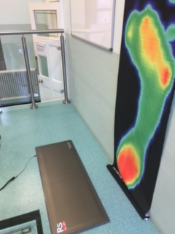

GAIT CLINIC

**WHAT IS A GAIT CLINIC?**

**Gait** is another word for **walking**. Our gait clinic has specialised equipment on the floor which allows us to assess walking and the pressures applied to the foot when walking.

The equipment helps to design or adjust devices/orthotics that are worn in your shoes to help with your foot condition, when prescribed orthotics have failed to provide the results your Podiatrist expected.

**WHAT WILL HAPPEN DURING MY ASSESSMENT?**

**Your appointment will last between 45mins-1 hour.**

* Please wear loose trousers or bring shorts.
* Please bring 2 or 3 pairs of day to day footwear.
* Please bring with you any foot orthotics/devices which you have been issued.
* An examination of your foot/leg will take place, then you will be asked to walk up and down a ‘walkway’ several times with and without shoes.

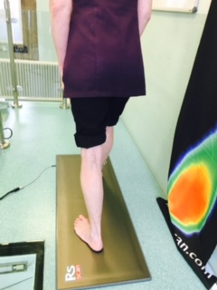

The Podiatrist will look at the results with you and explain what they see.

**All information gathered will be reported back to the person that referred you to the gait lab in order to help with any ongoing care plan.**

HOW MANY APPOINTMENTS WILL I NEED?

This will be determined by your individual needs; however most people only need to come to the walking clinic once or twice.