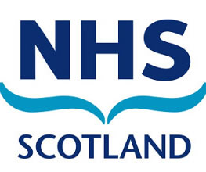
NHS Scotland Public Statement

NHS Scotland participation in the scheme created by The Redress for Survivors (Historical Child Abuse in Care) (Scotland) Act 2021

On 6 December 2021, Scotland’s NHS Boards were formally invited to participate in the Redress Scheme for survivors of historical child abuse in residential care settings in Scotland.

We acknowledge the wrongfulness of historical child abuse, and the harm this caused to survivors. We offer our full and sincere apologies to anyone who suffered harm and abuse while in the care of NHS Scotland.

We, as Scotland’s NHS Boards, recognise that this Scheme seeks to acknowledge and provide tangible recognition of past harm, and its impact on survivors. Participation in the Redress Scheme is a practical part of our national apology to children who suffered harm while in NHS care.

Further, we recognise that financial redress is only one aspect of acknowledging past harm within care settings for vulnerable children in Scotland.

All 22 of Scotland’s NHS Boards are fully committed to supporting the Redress Scheme. By contributing to the Scheme, we are setting out the commitment from NHS Scotland to support survivors and take steps to provide some redress for past trauma.

We therefore commit to living our values of care and compassion by pledging to be open, transparent and caring in how we engage with anyone who was in the care of NHS Scotland and who makes an application for a redress payment.

Information on the Scheme and support for people affected by this issue can be found through the following links:

- Applying to the scheme - Applying for redress – Redress Scotland
- Support for survivors of abuse -
  - https://future-pathways.co.uk
  - https://www.mygov.scot/childhood-abuse
  - https://www.thesurvivorstrust.org/scotland
- Information about the scheme and contributors - Scotland's Redress Scheme - gov.scot (www.gov.scot)

