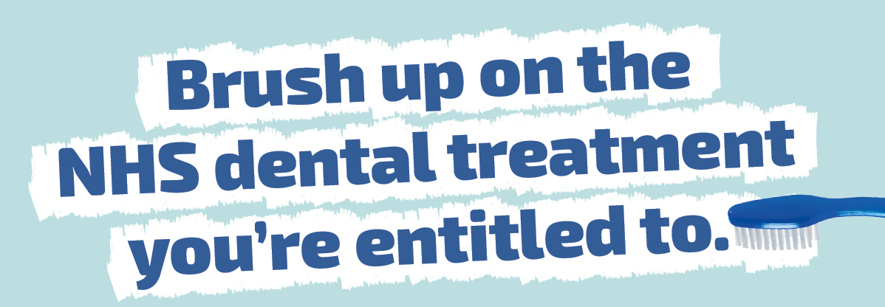

You may have heard about changes to NHS dental care and treatment in Scotland. What isn’t changing is that you can still get a comprehensive range of dental care and treatments through the NHS. And for some people, treatment could be completely free.

Find out more at NHSInform.scot/dentist

Treatment and examination costs
From 1 November 2023, if you pay for your NHS dental treatment you may notice an increase in treatment charges. These increases are necessary to ensure that we are able to continue to provide NHS dental services and reflect the increase in cost of delivering the care required for patients.
NHS dental check ups
Everyone in Scotland is entitled to a free NHS dental check up. However the frequency of these is now based on your individual need. Your dentist will discuss this with you at each examination.

Patient Charge
As before, NHS patients who pay for their treatment pay 80% of the treatment costs. This continues to be capped at a maximum of £384 per course of treatment. Any costs over this maximum continues to be fully subsidised by the NHS. You will never pay more than £384 per course of treatment. The vast majority of patients will pay much less than this.

Free or reduced priced NHS dental treatment
The following people can receive free NHS dental treatment;

- Everyone aged 25 and under
- People who are pregnant or have given birth in the last 12 months
- Those with certificated exemption from patient charge because of income or receipt of certain benefits

Others may be entitled to dental treatment at a reduced cost through the NHS Low Income Scheme (LIS). The LIS helps towards some or all of the cost of NHS patient charges for those who are not automatically entitled to free treatment, who may have difficulty in paying. Help under the scheme is income-related and based on an assessment of each person’s ability to pay. Information on Help with Health Care Costs can be found here: Help with health costs | NHS inform

NHS Pricelist
Dental care | Patient charge
Check-up (examination) | £0.00
Check-up and preventive advice (which can include a scale and polish if deemed necessary) | £15.68
Two small X-rays | £11.04
One large X-ray of teeth and jaws | £13.56
Course of oral hygiene and deep gum cleaning (over 1 – 4 separate appointments) | £32.24 to £93.32
Small white filling (front tooth) | £21.20
Small metal filling (back tooth) | £12.72
Large metal filling (back tooth) | £27.12
Root canal treatment | £94.96 to £153.48
Additional fee for a re-root canal treatment | £44.08
Single Crown (for those 17 years or over only) | £149.24 to £185.72
Simple extraction (per tooth) | £28.84
Surgical / complex extraction (per tooth) | £55.12 to £75.48
Complete upper and lower set of dentures | £344.32

