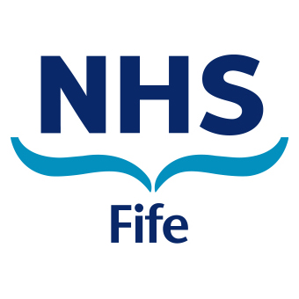
Participation Request Form
under the Community Empowerment Act 2015
To make a Participation Request to NHS Fife please complete this form and return, with a copy of your written constitution or governance documentation, to one of the contact addresses below.

- Contact details for the Community Participation Body
(Name, address, email address, telephone number, website etc.)

- Details of the Lead Public Authority to whom the request is being made

- Details of any other Public Authorities who you wish should participate in the outcome improvement process
(e.g. request can be made to one or more designated public service authorities, i.e. also Fife Council, Scottish Enterprise etc.)

- Describe the outcome your organisation / group want to improve
(e.g. improving the health of a community or the delivery of a service)

- Please give reasons why your organisation / group should participate in an outcome improvement process
(e.g. have you gathered evidence or views that would impact on and influence the current anticipated outcome?)

- Describe the knowledge, expertise and / or other experience your organisation / group has in relation to the outcome
(e.g. please provide full details of any knowledge, expertise and experience your organisation / group has in relation to the outcome specified in section 4)

- Describe how the outcome will be improved because of the involvement of your organisation / group
(e.g. please provide an explanation of how you anticipate your participation will improve the proposed outcome)

- Is your organisation / group a community participation body, as defined in Section 20 of the Act? (if so, please specify what type of body you are)
(e.g. a community controlled body; a community council; a body designated by Scottish Ministers; a community body without a written constitution – only certain groups are eligible to make a participation request under the relevant legislation)

- Please provide any additional information in support of your request

Please return this completed form, along with a copy of your written constitution or governance documentation, to one of the addresses below:

Where to contact us

In writing to:
NHS Fife
Patient Relations Department
1st Floor, Hayfield House
Hayfield Road
Kirkcaldy
Fife
KY2 5AH

By email at: fife-UHB.ParticipationandEngagements@nhs.net

Need Communication Support?

NHS Fife provides accessible communication in a variety of formats including for speakers of community languages or for those who require easy read versions.
Formats are also provided for those who speak British Sign Language (BSL) or read Braille.
A text messaging service is available for those who are Deaf or who have hearing loss.
To find out more about accessible formats and the text messaging service contact us by email
Fife-UHB.EqualityandHumanRights@nhs.net
Or phone us on 01592 729130

