- Avoid placing hands in hot water as this will increase any swelling.

- Pace yourself with hand actions or positions that makes your symptoms worse (e.g. ironing, driving) and limit repetitive activities for long periods (e.g. typing or writing).

- Speak to your pharmacist about medication that may help the pain but is safe to take during pregnancy.

- Consider wearing a wrist splint to wear overnight or during the day for activities that make your symptoms worse but try not to wear it all day.
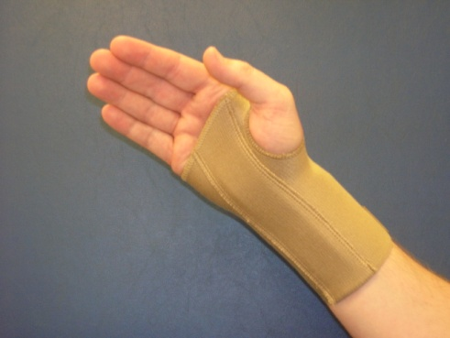
- The splint comes with an angled metal bar in it. This angle is not recommended for carpal tunnel syndrome. Before use, straighten the bar by pushing it down on a flat surface. This gives your nerve more space to move. The bar runs along the palm side of your wrist and should not limit thumb or finger movement.

- The Velcro straps should hold the splint in position but not so tight that they cause discomfort or swelling in your fingers. If your symptoms get worse when you first use the splint, retry after a few days. If they are still worse, stop using the splint.

Can I drive?

- Yes, you can continue to drive as long as you have full grip power and feeling.

Carpal Tunnel Syndrome during Pregnancy

Service User Information Leaflet

Pelvic Health Physiotherapy Service: 01592 648106

Date of issue: Sep 2020 Review Date: Sep 2022

NHS Fife provides accessible communication in a variety of formats including for people who are speakers of community languages, who require Easy Read versions, who speak BSL, read Braille or use Audio formats.

NHS Fife SMS text service number 07805800005 is available for people who have a hearing or speech impairment.

To find out more about accessible formats phone 01592 729130 or contact: fife.equalityandhumanrights@nhs.scot.

What is Carpal Tunnel Syndrome?

- The carpal tunnel is a canal that lies between the small bones of the wrist and a ligament at the front of the wrist.

- The tendons that control the movement of the thumb and fingers pass through this tunnel on their way to the hand.

- The median nerve that gives you feeling in the hand and makes the tendons work also runs through the carpal tunnel (as shown below).

- Any swelling increases the pressure on the nerve inside the tunnel and causes symptoms known as Carpal Tunnel Syndrome.
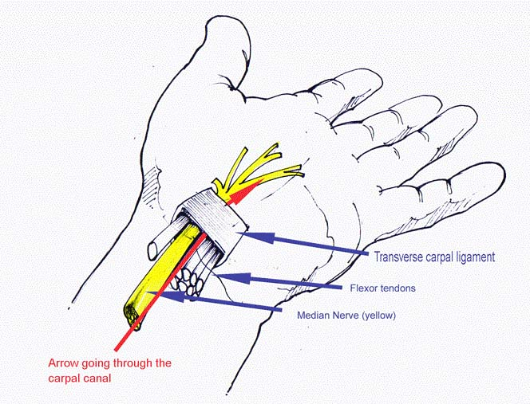

What causes Carpal Tunnel Syndrome in pregnancy?

- Hormone changes during pregnancy can cause swelling of different body parts including the wrist.

- It usually resolves within three months of giving birth.
What are the symptoms of Carpal Tunnel Syndrome?

- Pain, pins and needles, numbness or burning in the hand affecting the thumb, index, middle or ring fingers.

- Pain that shoots up from your hand as far as your shoulder.

- Often worse at night or first thing in the morning.

- Weakness in your hand and forearm.

- You may drop objects or have trouble performing tasks such as writing because of reduced grip.

- Hands may be hot, swollen and sweaty.

What can I do to help reduce my symptoms?

- Elevate your arms with pillows when resting to help reduce any swelling.
- Use ice packs on the wrist to reduce swelling. Wrap ice in a damp cloth and place on the wrist for 10-15 minutes, 3-4 times each day. Do not use ice if you cannot tell the difference between hot and cold.
- Try to avoid bending your wrist far forward or back as the pressure in the carpal tunnel is lowest when your wrist is straight.
- Avoid any heavy lifting as this will make the swelling worse.

