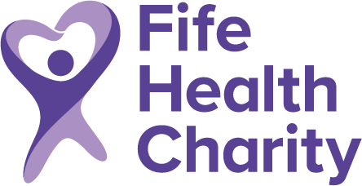

You can make your donation go even further. Gift Aid means that for every pound you give, we get an extra 25 pence from HM Revenue & Customs. This can enable your gift to make an even greater difference.

If you are a UK taxpayer and want to take advantage of Gift Aid, please complete the declaration below and return it in the prepaid envelope.

Gift Aid Declaration

I would like Fife Health Charity to treat this donation and any further donations as Gift Aid donations unless I inform you otherwise.

Amount of Donation
Ward / Department donation made to
Name
Address
Post Code
Signed
Date

I understand that I must pay an amount of Income or Capital Gains tax at least equal to the tax the charity reclaims on my donations in the tax year.

Please remember to notify us if:

- You no longer pay enough Income or Capital Gains tax to cover the money we claim back from HM Revenue & Customs
- You change your name or address
- You wish to cancel your declaration

Donations Form Serial Number (for office use)

