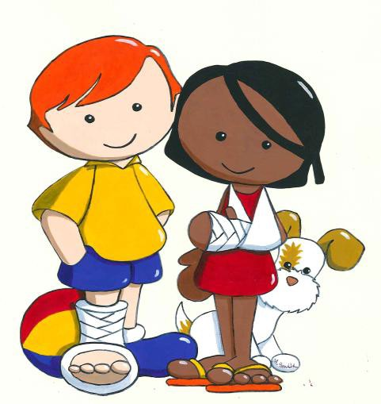

Have you ever been in hospital before?

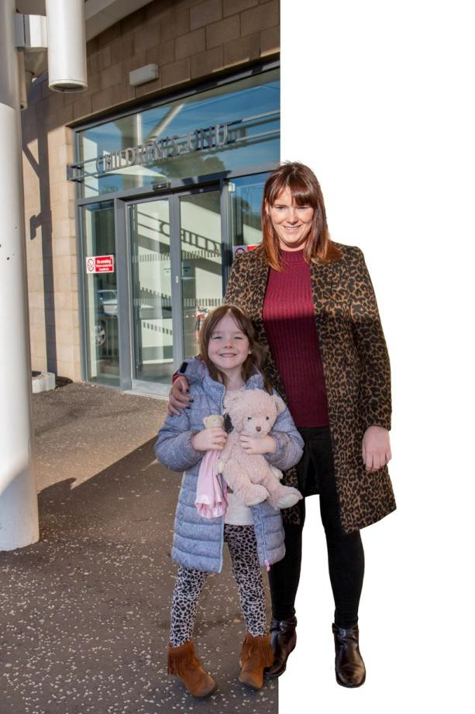

The Children’s unit is a place just for children. Everyone who works here will help you to get Well and make your body strong again.
You might feel a bit nervous about coming for an operation, so we like to explain things. Whenever you don’t understand something, it is OK to ask questions.

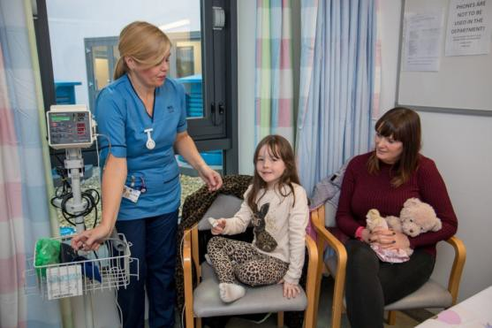

When you arrive at the hospital a nurse will show you to your bed and will ask your family lots of questions about you.
The nurse will put a soft peg on your finger and a cuff on your arm and number will appear on a machine.
Everyone who is a patient gets a name band. The band may go on your wrist or your ankle.
The nurse will put some special numbing cream on the back of both your hands and will put a plaster over it to make sure it does not come off.

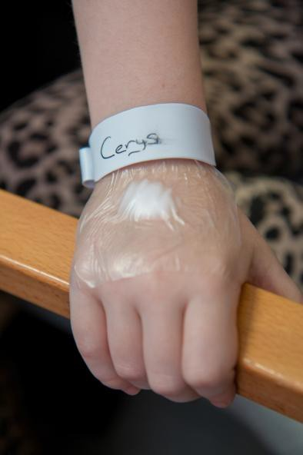

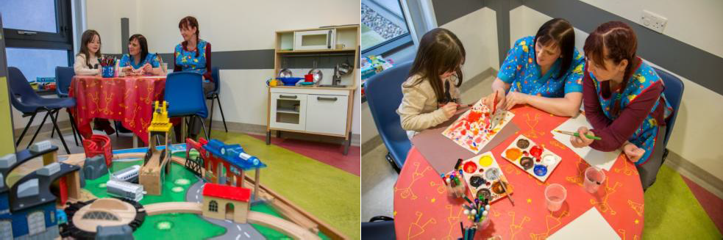

A member of play staff will show you the play area and let you choose an activity to do such as painting, gluing or playing a game.

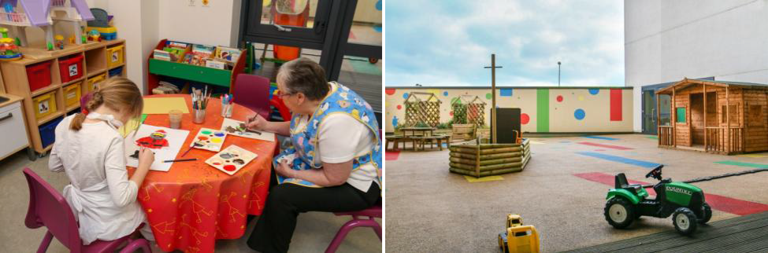

What is your favourite game or toy?

When you have an operation, it is important that your stomach is empty so you don’t get an upset tummy.
Your family will tell you when you should stop having anything to eat or drink.

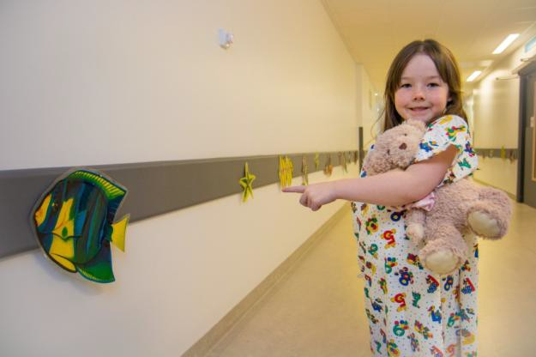

On your way to theatre you may see some sea animals. How many will you be able to count?

In the anaesthetic room where you will fall asleep for your operation you will meet the doctors and nurses who will look after you.

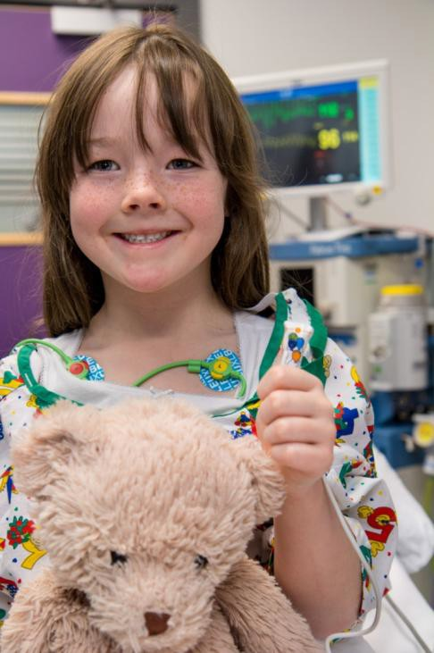

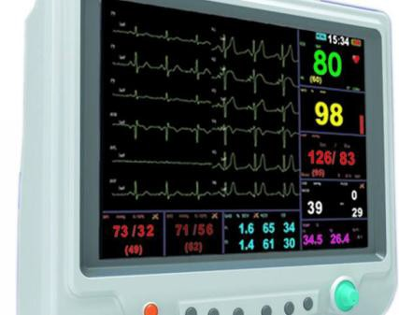We will attach you to the monitor so we can see your heart tracing on
the computer

We will give you some medicine either through a little straw in the back of your hand or you might get some special air to breathe through a mask, this will make you fall asleep so you don’t feel anything during your operation.

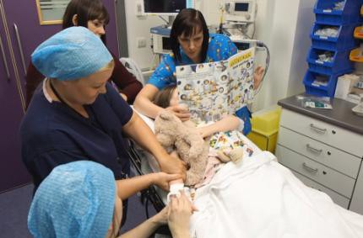

Cerys is looking at a book while the doctor is having a look at her hand where the cream has been.
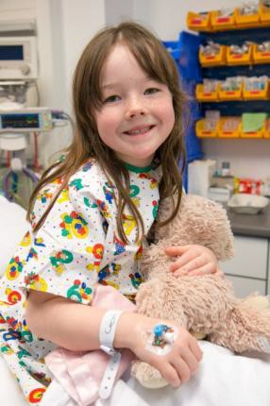

The doctor has given Cerys a little straw in her hand so she can be given the special sleepy medicine this means she can have her operation.
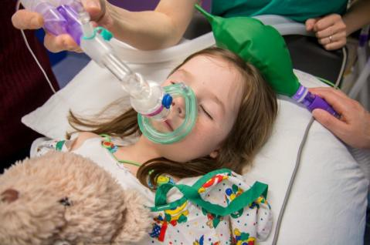

Sometimes the mask is used to give the patient sleepy air.

While you are having your operation, your family will wait for you in the waiting room. After your operation, you will start to wake up in the recovery room. Someone will always be with you.
As soon as possible your nurse and family will be called to come to collect you.

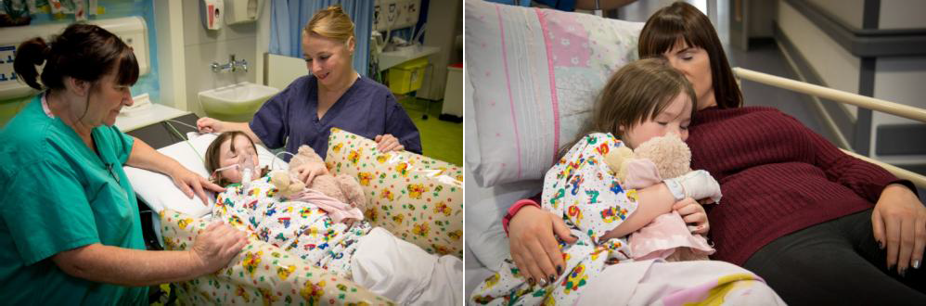

After Cerys has her operationshe was taken to the recovery room.
She was still asleep and the nurses looked after her until her mum arrived.

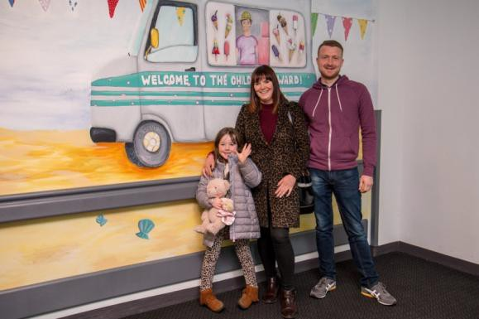

When the doctor said it was okay for Cerys to go, she went home with her family.

What can I to bring into hospital?

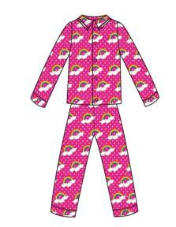

Your pyjamas

Your Favourite DVD

Your toothbrush

iPad/Tablet
Your favourite toy

Your favourite book

Your slippers

Comfort blanket

Hospital Word Search

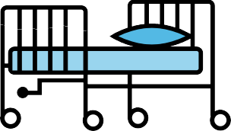

C | T | T | O | P | L | A | Y | R | O | O | M | N | A | Y | P
O | R | H | D | E | I | Q | U | I | B | E | D | D | H | W | L
P | G | E | L | S | P | A | I | N | T | I | N | G | E | S | A
D | S | A | A | G | S | Y | L | A | E | J | E | A | L | L | Y
O | I | T | F | M | W | E | P | R | D | O | L | M | P | E | S
C | L | R | G | A | M | B | U | L | A | N | C | E | T | E | P
T | E | E | O | S | Y | P | G | S | J | E | I | T | D | N | E
O | V | F | A | K | E | L | A | T | U | R | L | R | S | C | C
R | M | E | B | E | P | T | M | E | D | I | C | I | N | E | I
Z | P | T | L | A | O | W | E | V | Y | C | I | N | M | A | A
H | L | S | C | N | U | R | S | E | B | I | N | G | A | M | L
B | N | R | I | P | L | O | T | W | E | N | E | S | S | H | I
J | O | H | P | W | E | T | A | L | A | E | Q | E | C | S | S
A | K | O | L | D | A | R | I | N | R | A | U | N | L | R | T
B | U | A | K | E | S | N | A | C | K | B | O | X | E | L | F
W | D | I | H | S | T | O | N | A | M | E | B | A | N | D | E

Nurse Games Mask
Doctor Books Painting
Name band Medicine Sleep
Cream Judy Bear Ambulance
Bed Theatre Playroom Play Specialist Snack box

Colouring In

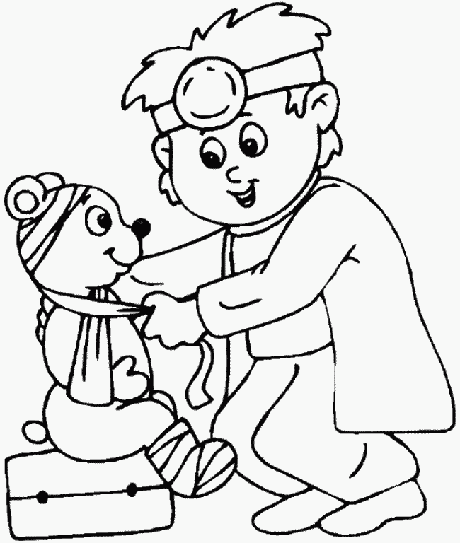

Do you have any questions ???

To help you remember them you can write them down

(For instance. “How long will I have to stay in hospital?” “When can I go back to school?” – Or… “How long can I stay off school?”)

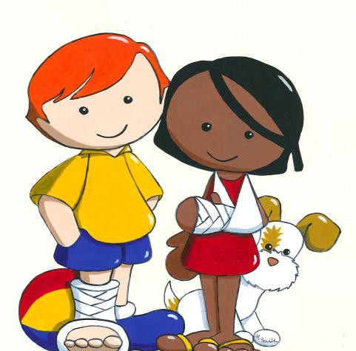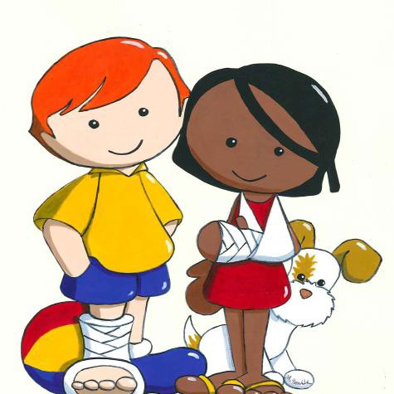If you want to find out more – have a look at our website!! https://sites.google.com/site/fifechildrensanaestheticinfo/

