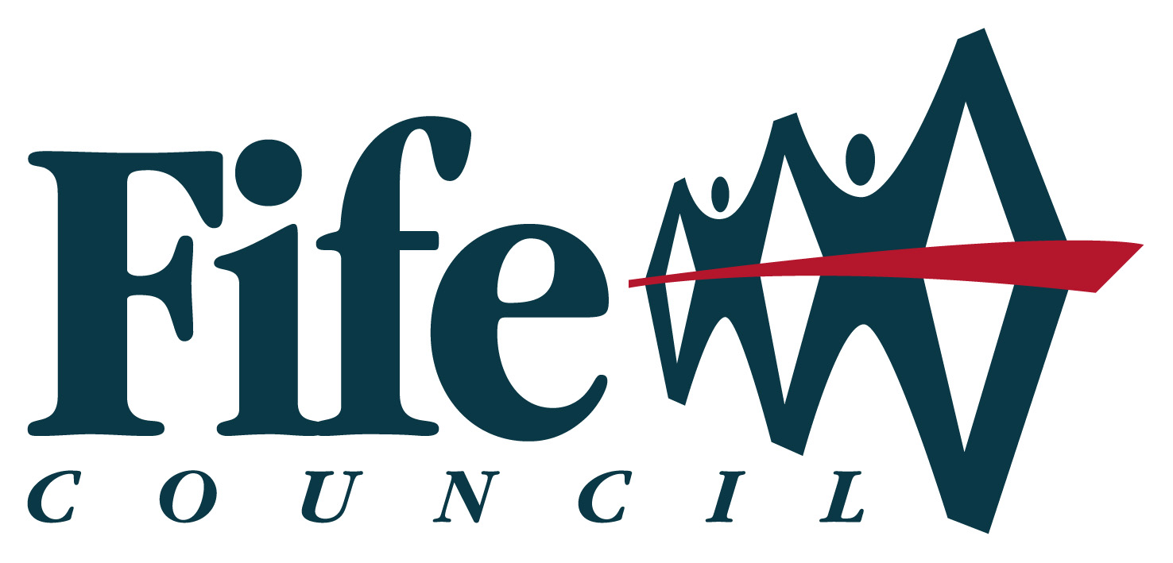

NHS Fife Equality Impact Assessment

Equality Impact Assessment Guidance is available to support this process

Contact the Angela Heyes, Equality and Human Rights Lead if support is required to completed the EQIA: fife-UHB.EqualityandDiversity@nhs.net

Title of proposal, policy or service redesign | NHS Fife Job Share Policy
Description  of proposal including intended outcomes and purpose | This policy describes NHS Fife’s approach to job sharing within NHS Fife
Directorate, service area or partnership | HR
EQIA lead reviewer | Head of HR
Staff involved in carrying out this EQIA | Head of HR/HR Policy Group
Start date of EQIA | 16 December 2013
Policy Number | HR9

Part 1: Checklist - Identifying Relevance to Equality
How relevant do you think the proposal will be to the following protected characteristics (See Appendix 1 for an explanation of relevance and evidence)

Protected characteristics | Employees | Equality group
 | Relevance of proposal to each group H-High, M-Medium, L-Low
Age (children and young people, older people) | L | L
Disability (including people with mental health difficulties) | L | L
Race (black and ethnic people incl. gypsy travellers, refugees and migrant workers) | L | L
Sex (women and men) | M | M
Sexual orientation (lesbian, gay and bisexual) | L | L
Religion and Belief | L | L
Gender reassignment | L | L
Pregnancy and maternity | M | M
Marriage and civil partnership | L | L
Are there any other groups this proposal may affect e.g. people living in rural areas, areas of disadvantage, homeless people, people on low incomes or people involved in the criminal justice system. Expand box as appropriate. | N/A | N/A

Relevance to General Duty – Equality Act 2010

Having considered the range of evidence available, what kind of impact will the proposal have on the General Duty? This will help to identify whether the proposal has any potential to discriminate against any of the 9 Protected Characteristics.

 | Positive  Impact | No impact | Negative | Evidence for choice of impact  provide a brief explanation of evidence used and where there is insufficient evidence to determine impact
Foster good relations | √ |  |  | Describes NHS Fife’s to job sharing and offers advice for employees and managers.
Advance equality of opportunity | √ |  |  | Describes NHS Fife’s commitment to job sharing.
Accessibility of services including information and physical access |  | √
Involvement, engagement and inclusion |  | √
Range of facilities and services | √ |  |  | Describes NHS Fife’s job sharing and offers advice for employees and managers.

Having considered the relevance and nature of the impact above in relation to the Protected Characteristics please indicate in the matrix below whether a full equality impact assessment is required.

Positive impact No impact Negative impact

High relevance  Medium relevance  Low relevance | EQIA not required | EQIA not required | Full EQIA required
High relevance  Medium relevance  Low relevance | EQIA not required | EQIA not required | Full EQIA required
High relevance  Medium relevance  Low relevance | EQIA not required | No EQIA required | EQIA may be required – contact the Equality and diversity Team for advice
- All proposals which have been marked high or medium relevance above and have a negative impact must be equality impact assessed see the Equality Impact Assessment form at Part 2 and then complete the EQIA summary.
- If a proposal has low relevance to the 9 Protected Characteristics and the impact is positive, please complete the EQIA summary.

Part 2 – Full Equality Impact Assessment

This form must be completed if a high or medium relevance and negative impact has been identified in relation to any of the protected characteristics.

- Staff and stakeholder involved in development of EQIA.

2. Name of policy, procedure or service redesign and brief description of proposed changes

3. Part 1 checklist which identifies relevance to equality, provide a brief explanation of the reasons for identifying high or medium relevance to one or more of the protected characteristics.

- Describe the negative impact for any of the 9 Protected Characteristics

5. What data, research or other evidence has been used to inform this EQIA?

6. Details of involvement, engagement and inclusion.

7. What does the involvement indicate about the negative impact of the proposal on any of the 9 Protected Characteristics?

8. Recommendations and implementation

9. Monitoring and review arrangements

10. If you believe your service is doing something that ‘stands out’ as an example of good practice use the box below to describe the activity and the benefits this has brought to the service. This information will help others to consider opportunities for developments in their services.

Date completed: _________________________

Review date: _____________________________

Name: __________________________________

Signature: __________________________________

Designation: ___________________________________________________

Date sent to Equality and Diversity Team: ______________________________

fife-UHB.EqualityandDiversity@nhs.net

Equality Impact Assessment (EQIA) Summary Form

Identified Impacts and Recommendations
Key positive impacts | Recommendations to enhance impacts
Key negative impacts | Recommendations to minimise impacts
Key no impacts | Recommendations to address no impact
Any other issues arising from EQIA
What is the outcome of the EQIA? (please tick)
Outcome 1
Outcome 2
Outcome 3
If Outcome 3 has been selected an EQIA should have been carried out using the Part 2 form.

EQIA Sign Off
Lead reviewer:  Designation:  Date: |  | To be completed by Equality and Diversity Team  EQIA checked by:  Date any comments  passed to Lead contact:  Date EQIA published:

- If outcomes 1 or 2 have been selected above, please send the completed Part 1 Checklist and the EQIA summary form to the Equality and Diversity Team for recording and publication
- If outcome 3 has been selected above, please send the completed Part 1 Checklist, EQIA Full Impact assessment and the EQIA summary to the Equality and Diversity Team for publication fife-UHB.EqualityandDiversity@nhs.net

