Fife Food Champion Network
Going Forward after Covid-19 August 19th 2020
#Feeding Fifers

Contents

Background Information 3
Introduction 5
Going Forward after Covid-19 6
In summary: 10
Evaluation 10
Next Steps 11
Appendix One 12

Background Information

Around one in five children live in low income families in Fife and too many children are not ready to learn when they start school. Many people in Fife are unable to manage financially; more than a third of residents live in fuel poverty and around 24,000 residents are unsure about how they can pay for food.
The costs of living - how much a family pays for housing, food, fuel, transport and childcare costs, and other household costs - is a key driver of poverty. Many families struggle to afford essentials and often must make the difficult decision of choosing to heat their home or buying food. The latest Scottish House Condition Survey showed that 44,000 households (26% of all households) in Fife are in fuel poverty with 11% in extreme fuel poverty. In terms of families, 19% of families are living in fuel poverty (7,000 households) and 5% are in extreme fuel poverty in Fife (Scottish Government, Feb 2020).
Research by Iconic Consulting on Food Poverty and Food Insecurity in Fife published in 2017 found that at least 24,300 adults in Fife could be living in food insecure households (Iconic Consulting, Aug 2017). Since this report was published, food insecurity has been made a top priority for Fife’s WRAP groups. Increases in food bank usage, as well as increase use of community pantries and fridges, over recent years have been compounded by the pandemic with many officers in the public and third sector reporting more families accessing emergency food provision as a direct result from the pandemic.

With food poverty/food insecurity on the rise it is now even more crucial that we work with vulnerable/low income families to help them maximise their budgets and encourage them to eat better to help improve their health and wellbeing. The Fife Food Champion Network works tirelessly with vulnerable families by providing support, advice and guidance to encourage healthier eating.

There are a number of key strategic drivers that support the work of the Food Champions:

- Plan for Fife 2017-27 - “Opportunities for all outcome”. The Food champion work helps towards maximising household income and children are ready to learn by improving their diet.

- A Healthier Future: Scotland's diet and healthy weight delivery plan - The impacts of poor diet and overweight are profound. They affect not only our health, but also our ability to lead happy, fulfilling lives. They have also led to increased, unsustainable demand on the NHS and other public services. The Scottish
diet remains unhealthy, and we are far from meeting our dietary goals . This has a direct impact on levels of overweight and obesity - and therefore health harm – in the population. Food champions contribute to this agenda by ensuring parents and carers are supported to make informed decisions, whether it's about breastfeeding and weaning, nutrition, portion size or mealtime behaviours.
- Public Health Priority 6: A Scotland where we eat well, have a healthy weight and are physically active - partners support healthier eating

Introduction

Covid-19 has caused disruption throughout the UK’s food system, introducing some families to food insecurity for the first time and putting new strains on those families already struggling with it. Local Food banks and Community Food initiatives have seen an increase in the number of families accessing their services as result of a reduction in income, being furloughed or made redundant.
Prior to the lock-down, a wide range of cooking groups were run across Fife, with the main aim to provide skills, knowledge and confidence and to encourage participants to “cook from scratch” These classes were designed to support low income and vulnerable families and help them maximise the money they spend on food. Unfortunately, as a result of Covid-19 these groups had to stop, but the issues for the families still remained.
In Fife there is a network of Food Champions that have been trained to deliver cooking skills classes aimed particularly at vulnerable and low income families. These groups tend to be run in community venues, churches and educational establishments.
This report outlines a joint piece of work between the Food and Health Team, Health Promotion Service and the Fife Community Food Development Workers, Fife Council and the Fife Food Champion Network.

Going Forward after Covid-19

Since lockdown was introduced in March 2020, life for most of us has changed dramatically and we now have had to adapt to a different way of life and a different way of working.
One of the key aspects of being a Fife Food Champion is working with individuals, families and groups to promote healthier eating habits. Most of this work happens face to face and obviously due to lockdown this was no longer an option. Things had to change and different ways of working had to be found.
To establish what was happening across Fife it was decided to hold a virtual workshop for Food Champions to find out how they had adapted to Covid-19, what the challenges are for going forward and how could we as a network overcome these challenges and barriers.
An invitation was sent out to the Fife Food Champion Network and 19 Food Champions signed up. The workshop was held on Teams on 19th August 2020.
In order to find out what has been happening across Fife, all the participants were asked what changes they had introduced as a result of lockdown. Some of the main changes were:
- An increase in the use of social media
  - Introduction of #FeedingFifers
- The use of Zoom and Teams to connect with people
- Reduction in Face-to-Face meetings
- Introduction of “Take-a-away” meals for vulnerable families and individuals
- Investigating on-line training – REHIS Cooking Skills/REHIS Food Hygiene
- Ensuring that recipe cards were available at all the community hubs
The workshop was facilitated by Lyndsay Clark, Senior Health Promotion Officer Health, Vicki Bennett, Community Dietitian, Food and Health Team, Health Promotion, Health & Social Care Partnership and Catherine Nugent and Iain Anderson, Community Food Development workers, Fife Council
All the participants were split into workshops with a facilitator and asked to discuss a specific question. Each session was recorded.
From the data, key themes were identified.
Question One:
“What are the challenges for Food Champions going forward?”
- Practical Elements
This is probably one of the most challenging thing moving forward for Food Champions, all venues were closed, meaning that it became problematical to hold cooking groups, and most groups were put on hold or cancelled. Government restrictions meant it was not possible to meet in groups. As a result of lockdown it has become more challenging to engage with groups/families/individuals so as a result this lack of physical engagement has made it difficult to build relationships, trust and confidence. It is also more challenging to keep people’s interest in what you are trying to achieve.
Not being able to have families (members of public) in buildings has made it difficult to engage particularly in school/nursery settings when new parents are involved and relationships not established.
- Social Media
Although social media could be seen as a positive way of engaging with people during lockdown there were still some challenges, whereas the majority of people are comfortable using social media there is a percentage of people who lack confidence using technology, have limited access to the internet. It was also identified that some people have no access at all, so organisations had to work hard to ensure that everyone they were working with had the means to access services via the internet, and understood how to use the technology. New meeting Apps were introduced and people had to become familiar with Microsoft Teams and Zoom, and new policies and procedures had to be quickly developed to safeguard participants. One of the key challenges is that Zoom was thought not to be secure and not the preferred option for the Council and NHS. This is problematical when learners are using and familiar with Zoom and Council staff can’t use it. This is not so much of an issue for third sector organisations as they can use multiple platforms for engagement.
Participants also had to get used to the different ways of engaging and some didn’t like being “seen” on the screen and “allowing” people into their homes. Also hearing yourself speak puts people off and makes them uncomfortable and unwilling to engage
Monitoring engagement through social media is difficult, are people really engaging? How do we get meaningful information that could support future work?
- Community Food Resilience
At the start of lockdown saw the introduction of a number of community initiatives aimed at supporting people through this crisis by offering free food. This was over and above the food provision by the Government for those that were shielding and food provision from Fife Council. Whereas this provision was required the concern is that people have now become dependent on free food with some families accessing multiple sources. This provision is not sustainable and the worry is what will people do once the service/s are no longer available. A more coordinated approach would have been beneficial.
- Time
Gingerbread have been running virtual classes over Facebook during lockdown, but the logistics of doing this is time consuming, ensuring the families have the food they need to participate, delivering the food the various houses etc. The planning of the sessions takes more time, thinking about suitable dishes, do families have the necessary equipment to make the dish etc.

Question Two

“How can we overcome these challenges to support those who we work with?”

- Creating Shared Resources

The discussions from all the groups felt it was important that going forward we should be looking at becoming better at sharing resources/good practice and have a better coordinated approach to delivering cooking skill groups. Ideas as to how we could do this suggested the creation of a toolbox that was easily accessible for all food champions, sharing recipes, creating short videos. Having a range of resources for different people/groups including How to guides for completing a risk assessment and how to run a group under social distancing.

Venues that can now be used and comply with the rules surrounding social distancing may not have sufficient equipment, could cooking kits be made available for hire through the Community Food Team or could funding be sourced to see if kits could be purchased and hired out as required?

Policies and procedures could be developed and shared, but these would need to be practical so that they were easy to comply with to encourage engagement. They could include FAQ’s for example; do we need to wear masks?

- Improve communication

Covid-19 has highlighted and brought to the front some key flaws in the current food system, in order to move forward we need to improve communication between, communities/organisations and individuals. We need to become better at working together with shared goals and supporting each other. We need to be connecting with local communities, see what’s been established during lockdown and supporting these local initiatives to make them more sustainable. Sharing good practice with them and ensuring they are aware of all that is available to them to make them sustainable. It is also important to ensure that everyone is aware of exactly what is available and when within their area.

- Food Resilience Group

This group was established at the start of Covid-19 and it coordinated the emergency food provision on behalf of the Council. The group reacted quickly, however not all key players were involved. Now that the situation is more under control and returning to the new “norm” it was suggested that there still was a role for this group, but the remit could be re-visited and could look at appropriate referral processes, to ensure that the right people get the support that they need, rather than it be a universal approach, or “free” access for everyone.

- Engagement

Participants may not feel confident to attend classes for the foreseeable future, reluctance to come out of the house, mix with other people outside their “bubble”, travel on public transport, is it safe? An idea of delivering a “pretend” cooking skills group was presented as an idea; this way procedures could be tried and tested to see that they work and that facilitators and participants feel safe.

We may need to look at different venues, Churches may be a good option, and some organisations have already been using Churches to support some of the more vulnerable families. Looking at outdoor possibilities may be an option, but the Scottish weather may be a big barrier!

However whatever we do we need to make things accessible, easy and build people’s confidence to such a level that cooking from scratch becomes the norm for them.

Case Study:
Kerry Jones from Fife Gingerbread – Making it work for Lone Parents gave an overview of work she was doing and how she had adapted the way she worked because of the pandemic. Details of her work can be found in Appendix One.

In summary:
There have been a few benefits as a result of Covid-19, Food champions have been engaging with new people that in the past have not engaged with services. More people have been cooking in their homes for their families and have tried new foods
“Never cooked food like this before – but learning what to do with it”
Food has never been so topical as it is at the moment, it’s high on the agenda and we need to capitalise on this, making sure key people and organisations are aware of the importance of delivering cooking skills groups –not just a wee cooking group, that there is benefits to doing this work.
A lot of these challenges and barriers are not new; they have just been brought to the front as a result of Covid-19 and the restrictions that have been placed on us. Things are not going to change for the foreseeable future and we need to adapt accordingly.
It was suggested that we use Microsoft Teams as a way of keeping connected, and keeping communication channels open. Procedures could be posted and used by the Team, recipes downloaded and other useful information added.

Evaluation

A short evaluation form was sent out to all the participants after the event. Nine participants responded. All respondents felt that the workshop was very useful and would like to attend future similar events. Going forward most felt that it would be beneficial to keep in touch and keep sharing ideas, resources and being informed as to what is happening across Fife, venues that could be used etc. Knowing where to source equipment from to support people at home would be useful for one respondent. It was suggested that a sub group could be established to come together to share ideas which could then be shared across the network
Considering this was the first time that we had held an event like this, it was felt that it was well run; taking into consideration we are still all learning about Teams and how it works!
“In times of uncertainty I think having the Food Development Team at the end of the phone for guidance has been very beneficial”

Next Steps

It looks highly likely that the situation around the restrictions due to Covid-19 are here to stay for the foreseeable future and as a network of food champions we are going to have to work in different ways. Support for one and other is key, sharing ideas and learning from each other will be vital going forward.
With the introduction of Microsoft Teams, and its associated technology this could provide the means of communicating with Food Champions and providing guidance and support from the #Feeding Fifers team. A Food Champion Team will be created and information, guidance, recipes, generic risk assessments, suitable venues and a “what’s on guide” for example will be posted for all to access.
Report compiled by:
Lyndsay Clark, Senior Health Promotion Officer, Health Promotion Service, Fife Health and Social Care Partnership with input by Vicki Bennett, Community Dietitian, Health Promotion Service, FHSCP, Catherine Nugent and Iain Anderson, Fife Community Food Development Workers, Fife Council.

Appendix One

Fife Gingerbread – Making it work for Lone Parents
Delivering Community Food projects During Lockdown.
Case Study 1 - Fife Gingerbread Provisions
Prior to lockdown Fife Gingerbread ran many cooking groups within the community and also cooking skills certificates. As lockdown happened, we knew that food insecurity was a hot topic and often the lack of items available or affordability of foods was quickly becoming an issue. We Decided to continue running cooking groups but taking this virtually.
We have a private group page for the Making it Work project and we got the views of the families on participating on virtual groups, it was fairly unanimous at the beginning that parents did not want to do video groups. I then decided to make videos each week based mainly on store cupboard, easily accessible ingredients and also foods that were easily made with basic utensils and equipment or how to do things alternatively. To gain families momentum and keep up motivation we incorporated this into a ‘points mean Prizes’ Challenge and if the families made the recipes and sent in pictures they received bonus points towards 3 overall prizes that were available which ranged from a family day out (once lockdown restrictions decreased) Afternoon tea for the family and a cinema trip.
This quickly become popular and each week a core group of approx. 10 parents got involved. The group would decide on things they would like to be shown how to make or would decide on the 5 ingredients to be used etc. I also broke down costs and had a challenge with our projects Citizens advice worker on who could get the ingredients the cheapest, we would post this online so that families knew the best places to shop to make their budget stretch.
We incorporated the Community food themes each week and gave links to follow the pages these were posted on the local areas.
When I do face to face groups there is normally an element of low confidence in the kitchen, and parents will ask if things look right or taste right etc. In doing the groups virtually they could not ask the questions during cooking. This increased the parent’s confidence in making and trying new foods and recipes.
The learning and experience of doing this has progressed into delivering a REHIS Cooking Skills programme to 4 of the parents who were actively involved each week and really wanted this to continue as lockdown eased.

Case Study 2 - Parents Progress
S was receiving buddy support through Fife Gingerbread prior to lockdown, she has 7 children and was struggling financially and with her mental health. She was feeling very unmotivated in various aspects of her life. Being affected by the benefit cap and then having the children at home full time she began struggling with food insecurities. She joined the private group for Fife gingerbread and at the beginning she did not interact with the posts. A few weeks into lockdown I received a private message of one pictures of one of the meals I had posted a video online of. S was extremely proud of what she had made. She said “I never knew I could make this as easy and for as cheap, thankyou” This began S sending me weekly pictures of things she had made and as time went on she began changing ingredients to suit her families likes and dislikes.
She also began interacting with other online activities that were being ran and her worker commented that was more motivated. She had also asked for a referral into the Making it Work project to begin progressing further and doing online confidence building groups and more. As lockdown was beginning to ease and we were able to see families face to face more S feedback that she has really enjoyed the cooking and would like to continue more groups with this. She is now completing her REHIS Cooking Skills with myself virtually and would like to do her food hygiene certificate and look at jobs in the future to do with cooking.
Comments from S -
“..I have loved the cooking, and going to miss it, would love to do more of this type of thing with you…”
Below are just some of the recipes S made.

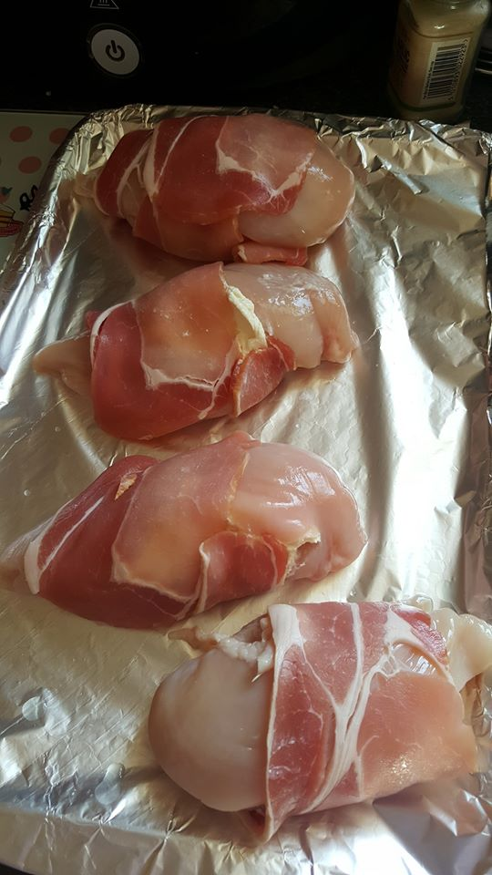
“I knew I would love the apple pie recipe,
I even changed it a little to make strawberry pies..”
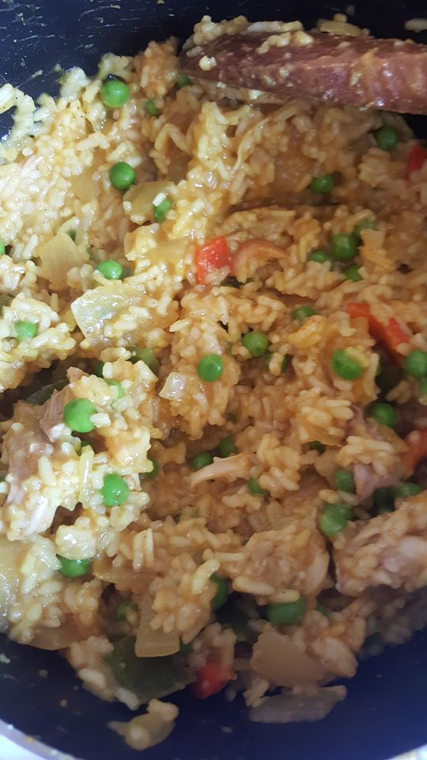

Fife Child Poverty Action plan 2020

