Treatments can improve mobility, and in the early stages muscle strength, which may prevent or slow the progression of foot deformity.

Your podiatrist will devise a care plan with you. It is important to follow any advice fully and keep all appointments.

NHS Fife provides accessible communication in a variety of formats including for people who are speakers of community languages, who require Easy Read versions, who speak BSL, read Braille or use Audio formats.

NHS Fife SMS text service number 07805800005 is available for people who have a hearing or speech impairment.

To find out more about accessible formats contact:

Fife.equalityandhumanrights.nhs.scot or phone 01592 729130

Further patient information leaflets are available online on our website [www.nhsfife.org/](http://www.nhsfife.org/)

Fife Council and NHS Fife

are supporting the people

of Fife together through

Fife’s Health and Social

Care Partnership.

**www.fifehealthandsocialcare.org**



|  |  |
| --- | --- |
| Issued | June 2015 |
| Reviewed | Sept 2020 |
| Next Review | Sept 2022 |
| Images | NHS Fife |



PODIATRY

DEPARTMENT

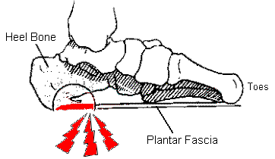

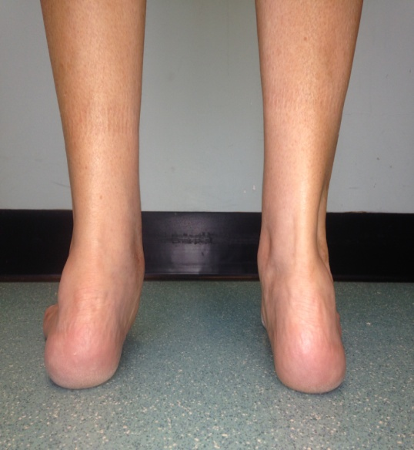

**Posterior Tibial Tendon Dysfunction**

**POSTERIOR TIBIAL TENDON DYSFUNCTION (PTTD).**

**Where is the tendon?**

The posterior tibial tendon runs behind the ankle bone on the inside of your ankle.

**What does the tendon do?**

It helps to support the ankle and the arch of the foot when walking.

**What is PTTD?**

Posterior tibial tendon dysfunction occurs when the tendon becomes stretched, inflamed or torn.

There are different stages of PTTD from mild to severe symptoms and deformity.

Early detection and treatment of posterior tibial tendon dysfunction is best.

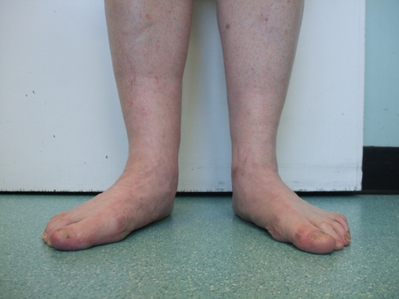

**SYMPTOMS**

Symptoms are dependant on the stage but include;

Occasional tenderness and swelling

along the tendon.

Painful or unable to stand on tip toe on the affected foot.

Difficulty walking on uneven ground.

Pain is worse at the end of the day.

Occasionally patients may experience a burning, tingling or shooting pain behind the inside ankle area.

**LONG TERM EFFECTS**

The shape of the foot can change if it is not treated early.

Patients can develop a flat foot due to weakness or stretching of the posterior tibial tendon as this helps to support the arch of the foot.

Some go on to develop arthritis in the ankle.

**WHAT CAN CAUSE PTTD?**

* Flat feet
* Trauma/ injury
* Age – over 40
* Gender – 3 x more common in

females

* Being overweight can

make symptoms worse.

**WHAT CAN I DO TO HELP MYSELF?**

* Rest
* Ice
* Anti- inflammatory medication
* Support bandage
* Supportive footwear
* Calf stretching
* Weight loss

**If your symptoms do not improve within a few weeks you may wish to consider seeing a Podiatrist. Treatments may include;**

* MSK Assessment
* Strapping
* Strengthening exercises
* Stretching programme
* Functional foot orthotics
* Acupuncture
* Low level light Therapy
* Onward referral to orthopaedics

(In severe cases) for consideration of surgery.