



**Pelvic Floor Exercises**

**For Men**

**Service User Information Leaflet**

Produced by: Pelvic Health Physiotherapy Service

Date of issue: Sep 2020 Review Date: Sep 2022

NHS Fife provides accessible communication in a variety of formats including for people who are speakers of community languages, who require Easy Read versions, who speak BSL, read Braille or use Audio formats.

NHS Fife SMS text service number 07805800005 is available for people who have a hearing or speech impairment.

To find out more about accessible formats phone 01592 729130 or contact: fife.equalityandhumanrights@nhs.scot.

**What is the pelvic floor?**

The pelvic floor muscles are like a hammock between the bottom of your spine and the pubic bone.

**Side view of a man’s pelvic floor**

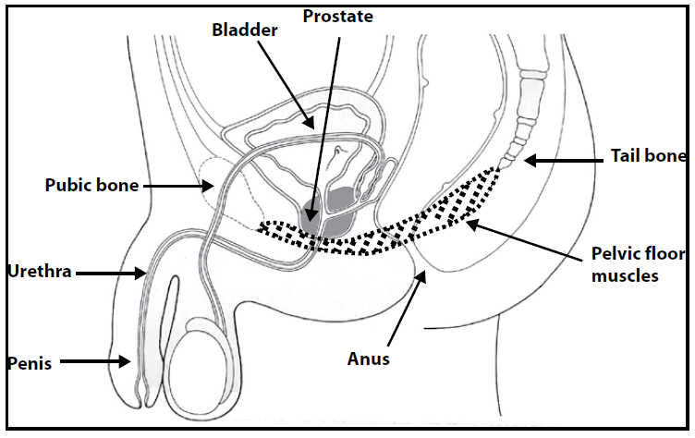

**What does the pelvic floor do?**

* It supports the bladder and bowel.
* It controls the release of urine, stool and wind.
* It is important for erectile function and ejaculation.
* It helps to stabilise and support the spine.

**Weakness in the pelvic floor**

The muscles may become weakened by:

* Repeated straining to empty the bowels.
* Repeated heavy lifting.
* Prostate surgery.
* Being overweight.
* A chronic cough.
* Smoking.
* Lack of general fitness.

**How to strengthen your pelvic floor**

To work these muscles, pull your scrotum up towards your abdomen or try to shorten your penis. Once you can do that, pull up around your back passage as well as if you are trying to stop passing wind. You can feel the muscles working by placing your finger tips on the skin behind the scrotum. You should feel the muscles tighten up and lift away from your fingers. The base of your penis may move towards your abdomen.

# Your exercise programme

This should include slow exercises for endurance and fast exercises for power. They should be practiced at least 4 times each day. Try them in a variety of different positions.

* Lie on your back with your knees bent and feet comfortably apart.

* Sit up tall on a firm chair with your feet flat on the floor.
* Stand

**Slow Exercises**

Pull up gently with your pelvic floor. Hold for as long as you can up to 10 seconds. Make sure that you continue to breathe normally. Your buttocks and abdomen should stay relaxed. Now repeat this and write down below how long and how many repetitions you can do.

How long can you hold? Seconds

How many times can you repeat? Times

**Fast Exercises**

Pull up quickly and strongly with your pelvic floor muscles. Relax and repeat up to 10 times.

How many fast contractions?....................Times

**The Knack**

Tighten your pelvic floor quickly just before and during activities such as lifting, coughing, sneezing or shouting.

**Post void dribble**

After you have emptied your bladder, try pulling up your pelvic floor muscles strongly while still over the toilet. This can help prevent that embarrassing dribble.

**Warning**

Although stopping the flow of urine midstream does work your pelvic floor, this should not be done on a regular basis. It may interfere with normal bladder function.