Pelvic Floor Exercises

Service User Information Leaflet

Produced by: Pelvic Health Physiotherapy Service

Date of issue: Sep 2020 Review Date: Sep 2022

NHS Fife provides accessible communication in a variety of formats including for people who are speakers of community languages, who require Easy Read versions, who speak BSL, read Braille or use Audio formats.

NHS Fife SMS text service number 07805800005 is available for people who have a hearing or speech impairment.

To find out more about accessible formats phone 01592 729130 or contact: fife.equalityandhumanrights@nhs.scot.

Pelvic Floor Muscles

The pelvic floor muscles are just inside your body, between your legs. They are attached between the bottom of your spine (coccyx) and the bone at the front (pubic bone).

They help to support the pelvic organs such as the bladder, the womb and the bowel. These muscles work to help to keep the bladder and bowel openings closed to stop leakage and they relax when you pass urine and empty your bowels.

Pelvic floor muscles should be worked to keep them healthy and strong like other muscles in your body. They can become damaged and weak like any other muscles in your body.

Side view of a woman’s pelvic floor muscles

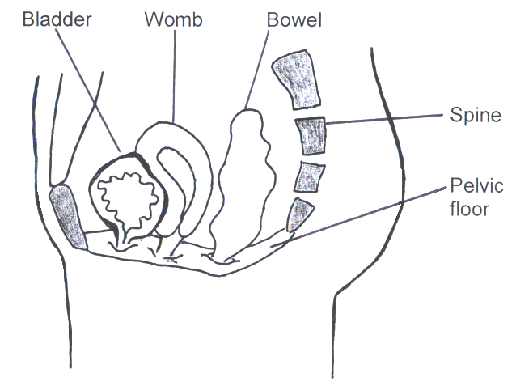

Risk factors for your pelvic floor

Childbirth. This weakens the muscles especially if you had an assisted delivery such as a forceps delivery, a large tear or big baby.

Constipation or straining to empty bowels. This can lead to stretching and weakness of the muscles over time. Weak muscles can affect how effectively your bowel can empty.

Heavy or repeated lifting. Causes strain on the muscles and ligaments.

Chronic cough, Due to smoking or illness weakens the muscles over time.

Being overweight. Increases the pressure on the muscles and can cause weakness.

Menopause. Changes in the vaginal tissues following menopause can make your problems worse.

Finding your pelvic floor muscles

Using a mirror, the area between your vagina and back passage (perineum) should move up and inwards away from the mirror when you contract your pelvic floor muscles. If you see any bulging - STOP, you may make your pelvic floor muscle problem worse. You should try to get help from a specialist physiotherapist.

Feel inside your vagina with your thumb or index finger. Tighten your pelvic floor muscles. You should feel the muscles tightening around your thumb or finger.

If you are sexually active, you could try to squeeze your muscles during sex. Ask if your partner can feel the squeeze.

Pelvic floor exercises

To work these muscles you should pull up around your anus (back passage) as if you are trying to stop passing wind. At the same time, try to pull up as if you were trying to stop passing urine mid-flow. You should be pulling upwards and forwards from your back passage towards your bladder.

You might find it easier to do them lying on your back or sitting. It is easy to use the wrong muscles instead of the pelvic floor, try not to squeeze your buttocks or tummy. Remember to keep breathing throughout.

If you get any pain, or your symptoms worsen after doing these exercises, stop and seek help from your specialist physiotherapist.

Long Squeezes

Tighten your muscles as described and hold this squeeze for as long as you can (up to a maximum of 10 seconds) Rest for the same amount of time.

How long can you hold for? ……….. Seconds

Repeat this as many times as you can (a maximum of 10 repetitions)

How many times can you repeat? ……… times

Now gradually increase your hold time and number of repetitions until you can do 10 seconds x 10 repetitions.

Fast Squeezes

Tighten your muscles as hard and as quickly as you can. Do not hold this time, just let it go. Repeat up to 10 times.

You should practise both long and fast exercises at least 3 times a day, e.g. morning, lunchtime and evening. You may find it easier to do them ‘little and often’ to start with.

Keep going! It can sometime take about 3-6 months of daily exercise to increase your muscle strength. After this, keep doing them regularly, at least once per day, to maintain the strength.

“The Knack”

It is important that you can tighten these muscles quickly when they are needed, e.g. every time you cough, sneeze, laugh or lift. This is called “The Knack” and with practice can help to reduce some of the leaks you may be having.

Remembering to do your exercises

It can be easy to forget to do your exercises at first. Try to use daily activities such as brushing your teeth or having a shower to remind you to do your exercises. You could practice them on a daily journey such as train, car, or bus. Or use a pelvic floor app such as Squeezy below.

Pelvic Floor Exercise App

“Squeezy” is the NHS App for pelvic floor muscle exercises and is available from the App Store and Google Play. This app has been designed by physiotherapists working in the NHS. It is discreet, informative and has helpful visual and audio prompts to support your exercise programme. It can give you reminders to exercise and records the number of exercises you have completed. There are also other pelvic floor exercise apps available.

What else can be done?

Your physiotherapist might refer you to another healthcare professional for other treatment options.

Vaginal oestrogen. Hormones may be inserted into the vagina via a pessary used at home. This is suitable for post-menopausal women but may not be suitable in women who have had breast cancer.

Urodynamic investigation. Tests which measure how much fluid the bladder holds, how it squeezes to empty and what causes your leakage.

Electrical Muscle Stimulation. A stimulator may be inserted into the body to help strengthen the pelvic floor muscles.

Pessaries. These are intra-vaginal devices designed to reduce your leakage. Most can be inserted and removed by yourself when needed.

Further information

www.nhs.uk/conditions/urinary-incontinence
www.bladderandbowel.org
www.bladdermatters.co.uk
https://pogp.csp.org.uk/publications/pelvic-floor-muscle-exercises-women

References

POGP Pelvic Floor Exercises for Women
BAUS Incontinence of Urine webpage
NICE Guideline: Urinary incontinence in women: Management

