OBC
Fife Elective Orthopaedic Centre
NHS Fife


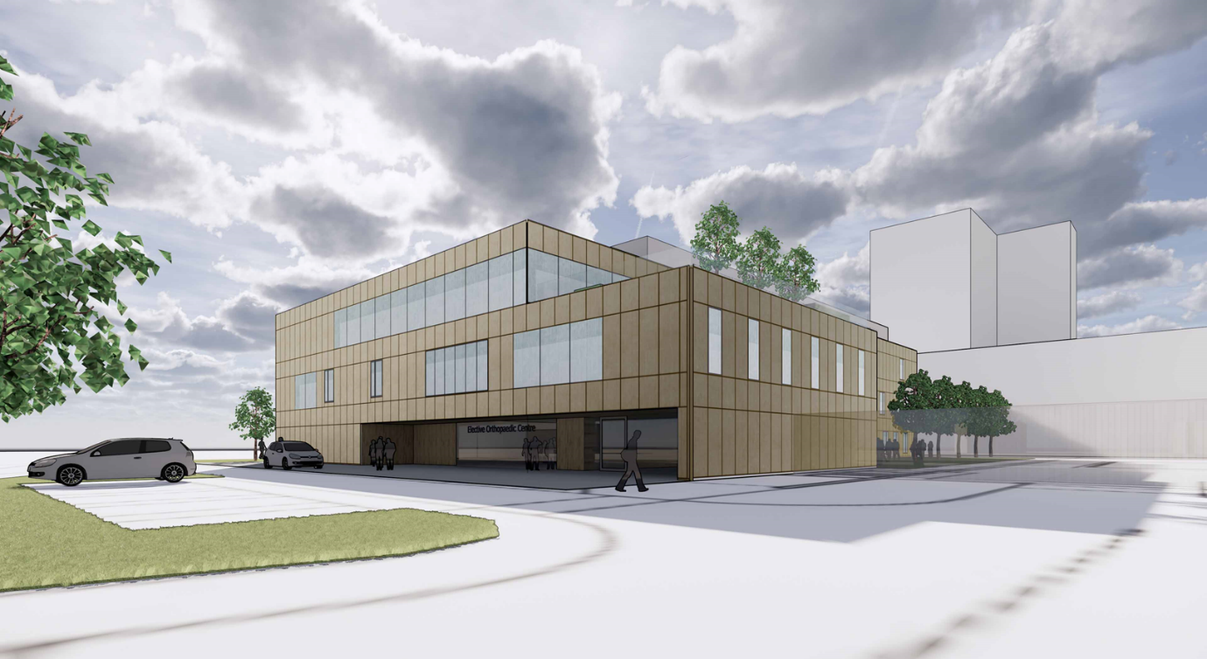
Proposed Fife Elective Orthopaedic Centre (Image provided by Norr Achitects)

Contents
Glossary of Terms 5
1 Executive Summary 6
1.1 Introduction 6
1.2 Strategic Case 6
1.3 Economic Case 9
1.4 Commercial Case 9
1.5 Financial Case 10
1.6 Management Case 11
1.7 Conclusion and Recommendations 11
2 Strategic Case 12
2.1 Introduction 12
2.2 Revisiting the Strategic Case 12
2.3 Description of Existing Service 13
2.4 Existing Service Arrangements 14
2.5 Future Arrangements 22
2.6 Service Provider 24
2.7 Condition and Performance 24
2.8 Supporting Statement 28
3 Strategic Context 29
3.1 The Need for Change 29
3.2 Organisation’s Goals 31
4 Economic Case 34
4.1 Introduction 34
4.2 Revisiting the Economic Case 34
4.3 Stakeholder Engagement 34
4.4 Long List of Options 36
4.5 Short List of Options 36
4.6 Indicative Costs 39
4.7 Option Appraisal 40
4.8 Sensitivity Analysis 43
4.9 Conclusion 44
5 Commercial Case 45
5.1 Introduction 45
5.2 Revisiting the Commercial Case 45
5.3 Procurement Strategy 45
5.4 Scope of Works 46
5.5 Risk Allocation 53
5.6 Payment Structure 55
5.7 Contractual Arrangements 57
6 Financial Case 59
6.1 Introduction 59
6.2 Revisiting the Financial Case 59
6.3 Financial Model: Costs and Associated Funding for the Project 59
6.4 Statement of Affordability 64
6.5 Stakeholder Support 64
6.6 Financial situation 64
6.7 Resources 65
6.8 Capital and revenue constraints 65
6.9 Financial contributions 65
7 Management Case 66
7.1 Introduction 66
7.2 Revisiting the Management Case 66
7.3 Reporting Structure and Governance Arrangements 66
7.4 Change Management Arrangements 75
7.5 Benefits Realisation 77
7.6 Risk Management 79
7.7 Commissioning 80
7.8 Post Project Evaluation 81
Appendix A – Strategic Assessment 82
Appendix B – Existing Plans 83
Appendix C – Projected Future Demand 84
Appendix D – Long and Short List of Options 85
Appendix E – Option Cost Breakdown and Assumptions 86
Appendix F – Proposed Floor Layouts 87
Appendix G – AEDET 88
Appendix H – HAI SCRIBE – Stage 1 89
Appendix I – Design Statement 90
Appendix J – Derogation Schedule 91
Appendix K – Cost Plan Extract 92
Appendix L – Benefits Register 93
Appendix M – Benefits Realisation Plan 94
Appendix N – Risk Register 95
Appendix O – Communication Plan 96

Rev | Originator | Approved | Date
0 – DRAFT / Comment | Ben Johnston | Draft for comment | 4 October 2019
1 – DRAFT / Comment | Ben Johnston | Draft for comment | 10 October 2019
2 – DRAFT / Comment | Ben Johnston | Draft for comment | 14 October 2019
/tmp/lo/0000.doc

Glossary of Terms
AEDET Achieving Excellence Design Evaluation Toolkit
HAI Healthcare Associated Infection
IA Initial Agreement
DC Day Case
IP In patient
FBC Full Business Case
GIFA Gross Internal Floor Area
GIRFT Getting it Right First Time
GP General Practitioner
HFS Health Facilities Scotland
KPI Key Performance Indicator
MSK Musculoskeletal
NDAP NHSScotland Design Assessment Process
NEC New Engineering Contract
OBC Outline Business Case
PSC Professional Services Consultant
PSCP Principal Supply Chain partner
QMH Queen Margaret Hospital, Dunfermline
SA Strategic Assessment
SCIM Scottish Capital Investment Manual
TTG Treatment Time Guarantee
VHK Victoria Hospital, Kirkcaldy
WTE Whole Time Equivalent

Executive Summary

Introduction
This proposal sets out the strategy for re-provision of the elective orthopaedic service at Victoria Hospital, Kirkcaldy (VHK). The existing orthopaedic service provides a dedicated environment in which patients within the catchment of Fife can be treated. The service currently performs extremely well, demonstrating a high level of attainment against relevant benchmarks and KPI’s but is held back by condition and functionality of the existing environment in which the service is provided from. The investment proposal therefore seeks to maintain current performance levels whilst safeguarding the service over the longer term via the provision of a sustainable healthcare environment. This will be delivered by providing a standalone Fife Elective Orthopaedic Centre at Victoria Hospital in Kirkcaldy incorporating theatres, inpatient and outpatient accommodation.
The accommodation has been developed from the IA (IA) stage in collaboration with stakeholder representatives. Notwithstanding the introduction of two new radiography rooms (previously unscheduled) to support the service, net usable area has been controlled within the original allocation. Gross area has increased marginally however to accommodate a covered rooftop plantroom accommodating critical equipment. Given the recent climate in respect to mechanical and electrical systems, this measure is considered a sensible investment.
In respect to cost, whilst there has been an inflationary rise since IA, taking account of this, the costs are reported to be on budget at this stage with reasonable contingencies allocated to control development of the design through FBC.

Strategic Case
The Strategic Case remains valid and has not changed since the IA.

Existing Arrangements
The existing service consists of 2 laminar flow theatres and a dedicated 24 bed ward provided from the “phase 2” tower bock within VHK. Over and beyond, orthopaedic outpatient services are provided from Queen Margaret Hospital in Dunfermline and VHK.
Currently, surgery time runs from 09:00 to 17:00 Monday to Friday with additional provision on Saturdays where demand dictates. Two 3.5 hour sessions are scheduled each day. To provide a general perspective, 4 major joint operations can be performed in a day. Through working on Saturdays up to 22 sessions can be performed in a week.
From a utilisation and performance perspective the service performs extremely well against all benchmarks and KPI’s – further details in this respect can be found at Section 2.2.
The condition and functionality of the existing assets is below the standard expected and is non-compliant in respect to current healthcare guidance (SHTMs and HBNs). The tower block at VHK was constructed in 1967 and the existing main services infrastructure is showing signs of age, increasingly risking service provision and continuity. The service is regularly disrupted because of infrastructure failures. There is no quick fix available (i.e. localised refurbishment) that would allow the service to remain in its current location over the longer term. This investment proposal has therefore been initiated to maintain the current service via the provision of the most effective long-term sustainable solution available within the constraints imposed.

Strategic Context
Through dealing with the need for change, this investment proposal will realise a number of important benefits and these are summarised in the table below:
Need for change |  | Anticipated benefits
- Current ward provision does not support infection control, safety and the overarching strategy to move towards single room accommodation. |  | - Positive patient experience and dignity respected
- Current accommodation does not support effective patient pathways / flow with bottle-necks arising. Situation affects efficiency of service provision. |  | - Maintain support to allow people to live independently together with life quality. Overarching benefit
- Current provision compromises patient dignity and quality of experience overall. |  | - Improves the healthcare state (condition, quality, perception, statutory, back-log and lifecycle)
- Condition of existing facilities are below the required standard to support the service over the longer term. |  | - Minimises readmissions (post operation complications) and optimises timely discharge
 |  | - Optimises resource usage (theatre and bed utilisation)
 |  | - Improves HAI and patient safety
 |  | - Community benefits realised from implementation of the investment proposal.
Table 1 - Need for change and benefits

Opportunities
In reviewing the current arrangements and considering the need for change surrounding this investment proposal potential opportunities were highlighted.

Capacity to meet future demand
In dealing with the underlying need for change, this investment proposal also seeks to take advantage of an opportunity to increase service capacity to cater for future local demand projections and in doing so reducing any Regional strain particularly in respect to separate elective provision that is being considered. In high-level terms the following accommodation is anticipated to cope with future demand over the next 20 years.
Theatres Current | Theatres Proposed
2 laminar flow theatres | 3 laminar flow theatres
Wards Current | Wards proposed
24 beds | 33 beds
Outpatient Department Current | Outpatient Department Proposed
11 consulting rooms (variable use) | 12 consulting rooms (fully utilised)
Table 2 - Proposed accommodation

Colocation of outpatients
Currently Orthopaedic services are delivered across multiple sites within NHS Fife. Working in this manner means there are expected inefficiencies and inconsistency in how some parts of the service is delivered. Clinical time is also lost in asking clinical staff to travel between facilities during the working day. The opportunity to centralise MSK OPD activity within a purpose build facility is appealing and has a potential number of benefits in ensuring the service is delivered in the most efficient way. These benefits are set out at Section 2.2.1.
This investment proposal seeks to pursue this opportunity by making allowance for an outpatient department within the Fife Elective Orthopaedic Centre.

Estate rationalisation
In addition to the opportunities noted above another key aspect relates to the long-term benefit of being able to progressively re-provide all clinical services currently within the tower block at VHK. The condition and clinical functionality of the tower block is unsustainable over the longer term. The estimated capital cost to deal with significant clinical backlog within the tower block is £25m, of which £20m relates to repairing the external fabric which has reached the end of its life. Through re-providing clinical services, the Board will be better positioned to implement an option appraisal for the tower block within the context of a VHK masterplan.

Economic Case
The Economic Case builds upon the initial work presented within the IA where a long-list of options were rationalised into a shortlist of five. The OBC appraises these options in more detail - the non-financial benefits for the options are measured against cost estimates to identify which option represents best value for money. A summary of the results following this exercise is set out in the table below:
 | Option 1 | Option 2 | Option 3 | Option 4 | Option 5
 | As Existing | Refurb Existing | Refurb other | Modular | New build
Net Present Cost (NPC) - £m | 226.7 | 237 | 300.1 | 337.1 | 303
Weighted Benefit Points (WBP) | 545 | 660 | 1,250 | 1,785 | 2,000
NPC per WBP - £000 | 416 | 359 | 240 | 189 | 151
Rank | 5th | 4th | 3rd | 2nd | 1st
Table 3 - Cost per benefit point for each option
The net present value/cost has been calculated using discounted cash flow techniques on the capital and revenue costs associated with the options as entered into the generic economic model (GEM).
The recommended preferred option as identified at IA stage remains the same for this OBC.
Option 5 – preferred way forward (new-build facility at VHK to meet the current requirements together with added capacity for future demand projections)

Commercial Case
The Commercial Case has been developed significantly since the IA demonstrating that the proposal is commercially viable. The commercial case covers the following areas:
- The procurement strategy and appropriate procurement route for the Project;
- The scope and content of the proposed commercial arrangement;
- Risk allocation and apportionment between public and private sector;
- The payment structure and how this will be made over the lifetime of the Project; and
- The contractual arrangements for the Project
The project is being delivered using HFS Frameworks Scotland 2 (FS2) which operates using the NEC3/ECC3 form of contract.

Financial Case
The Financial Case considers the affordability of the scheme, sets out all associated capital and revenue costs, assesses the affordability of the preferred option and considers the impact on NHS Fife’s finances. The affordability model assessment has been developed to cover all aspects of projected costs including estimates for:
- Capital costs for the option considered (including construction and equipment);
- Non-recurring revenue costs associated with the project;
- Recurring revenue costs (pay and non-pay) for current model i.e. baseline; and
- Recurring revenue costs (pay and non pay) for the preferred option.
The assumptions within the Financial Case will continue to be challenged and refined through development of the FBC to ensure capital and revenue affordability.

Capital Costs
A capital cost summary is provided in the table below. More detailed information can be found within the Financial Case (Section 6).
IA Initial | Updated IA* (B) | OBC Cost Plan (C) | Difference (B-C)**
£28,258,368 | £30,000,000 | £32,155,999 | -£2,155,999
Table 4 - Summary of capital costs
* There was agreement between NHS Fife and SCIG to increase the IA budget to take account of car parking re-provision and NHS Fife direct labour costs (previously not accounted for).
** The £2,155,999 difference between the updated IA budget and OBC cost plan is attributed to an inflationary increase (construction costs only) from IA to construction. The Cost Advisor’s calculation in respect to inflation can be provided upon request.
Given the notes above, the project is reported as being on budget.

Revenue Costs
A summary of the revenue costs is provided in the table below. Further detail can be found within the Commercial Case at Section 6.
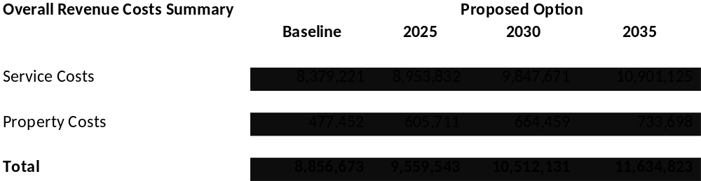
Table 5 - Summary of revenue costs

Management Case
The Management Case identifies the actions that will be required to ensure the successful delivery of the scheme; it covers:
- Project management arrangements, reporting structure, key roles and responsibilities and project recruitment needs;
- Project Plan;
- Change management arrangements;
- Stakeholder engagement and communication;
- Benefits realisation;
- Risk management;
- Commissioning arrangements; and
- Post project evaluation
The management case confirms that the project is achievable and can be delivered. Key milestones for the project are identified in the table below:
Description / Activity | Date
- OBC Approval | Nov. 2019
- FBC Approval | Sept. 2020
- Construction start | Oct. 2020
- Construction completion | March 2022
- Completion | March 2022
Table 6 - Milestone dates

Conclusion and Recommendations
This investment proposal is a key priority for NHS Fife, to safeguard the provision of a high performing, essential clinical service over the longer term. The preferred option will provide the Board with an opportunity to plan for the future, ensuring that the service is robust enough to offer the necessary supply to meet the projected local future demand and to provide a safe, effective and person-centred orthopaedic service. In addition, the preferred option will contribute towards decanting clinical services from within the tower block at VHK unlocking future options within the context of the site masterplan.
A robust stakeholder focussed outline design has been developed that encompasses all of NHS Fife’s requirements. The accommodation requirements have broadly been controlled within the constraints set out at IA and notwithstanding some inflationary impact in respect to cost, the project remains affordable and within budget.
The OBC has been delivered within a challenging programme but on time and within budget providing confidence in respect to delivery of subsequent stages. Approval of this OBC will ensure that progress can be made at pace towards the development of this critical project.

Strategic Case

Introduction
The main purpose of the Strategic Case at OBC stage is to confirm that the background for selecting the preferred strategic / service solution(s) at IA stage has not changed. It will do this by revisiting the Strategic Case set out in the IA whilst responding, as appropriate, to the following questions:
- Have the current arrangements changed?
- Is the case for change still valid?
- Is the choice of preferred strategic / service solution(s) still valid?
Section 2.2 responds to each of these questions providing an overview in respect to any key changes since IA.

Revisiting the Strategic Case

Outpatients
Generally, the Strategic Case has not changed since IA. The key change relates to the inclusion of the outpatient department within the narrative. Previously the strategic case focussed on theatres and wards as the main emphasis of the investment proposal was concerned with re-providing this accommodation due to problems with the building’s infrastructure and condition. Orthopaedic outpatient services are provided across Fife at Queen Margaret Hospital in Dunfermline and at Victoria Hospital in Kirkcaldy and are not subject to the same risks.
The schedule of accommodation included within the IA, did however reference outpatient accommodation and through implementing this project there is a great opportunity to combine and collocate the planned orthopaedic service into one facility.
Currently Orthopaedic services are delivered across multiple sites within NHS Fife. Working in this manner means there are expected inefficiencies and inconsistency in how some parts of the service is delivered. Clinical time is also lost in asking clinical staff to travel between facilities during the working day. The opportunity to centralise all MSK OPD activity within a purpose build facility is appealing and has a potential number of benefits in ensuring service is delivered in the most efficient way.
- Maximising potential efficiencies in new patient flow management;
- Fulfil aims of the Scottish Access Collaborative and Modern Outpatient Programme
- Rationalise how some services are delivered (currently trauma fracture clinics are delivered in 10 individual consultant’s clinics and capacity is impacted by consultant leave etc). There is potential to rationalise fracture clinic care by the provision of generic clinics five times a week. This is enabled by running clinics from a centralised facility. This will improve the sustainability and planning for of fracture clinic service, allowing greater flexibility in managing variable trauma demand;
- MDT development. All clinical staff contributing to MSK service delivery will benefit from working within a single facility.
- Clinical pathway consistency – working form a single clinical hub will ensure pathways are consistently applied to the benefit of the patient;
- Working from a single unit will promote staff development within the MSK service. By working is a single speciality area staff can be encouraged to upskill and perform enhanced roles (e.g. nurse led fracture clinics); and
- Staff may be able to be trained to contribute to a number of roles (OPD staff contributing to the pre assessment of patients).
This centralised working is likely to lead to efficiencies in how orthopaedic new patient assessment is undertaken.

Have the current arrangements changed?
The current arrangements have not changed. The strategic case has however been updated to include outpatients as referenced at Section 2.2.1.
The backlog maintenance figures have been updated to reflect the movement in costs since IA.

Is the case for change still valid?
Yes – the case for change remains the same as set out within the IA. The need for change and investment objectives remain unaltered.

Is the choice of preferred strategic / service solution(s) still valid?
The strategic case has not changed therefore the preferred service solution remains valid. In fact, with the decision taken to incorporate outpatients strengthens the case for the preferred service solution as many of the other options could not have accommodated this proportion of accommodation. A standalone new elective orthopaedic centre is therefore the obvious solution.

Description of Existing Service
The service affected by this proposal is the Fife Elective Orthopaedic Centre which caters locally for the community of Fife providing elective orthopaedic treatment.
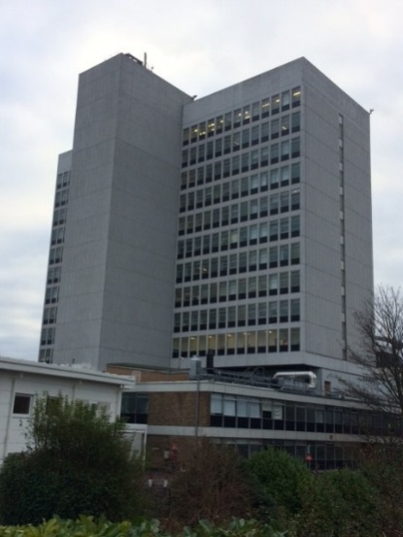
The service is located within “Phase 2” of the Victoria Hospital Tower Block in Kirkcaldy and includes 2 orthopaedic laminar flow theatres on the 3rd floor with supporting ward accommodation (24 bed) on the 4th floor. The two floors are connected by a dedicated lift and an adjacent staircase.
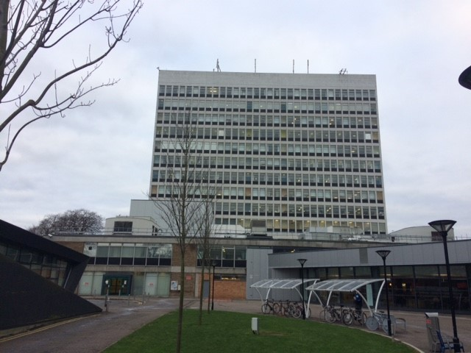

Figure 1 – VHK Tower Block
Figure 2 – VHK Tower Block
Plan drawings capturing the existing theatre and ward layouts are referenced in Appendix B for information.
Orthopaedic Outpatient and Pre-assessment services support the overall care provision. These services are currently spread across two sites at Queen Margaret Hospital (QMH) in Dunfermline and Victoria Hospital in Kirkcaldy (VHK). Resources are diluted and duplicated across sites. Staff travelling time compromises clinical time efficiencies. Opportunities exist to improve the efficiency of OPD service by centralising the majority of service within a single purpose-built facility.
Queen Margaret Hospital Outpatient Facilities
- OPD 1 (Ortho)
- OPD 2 (GPwSI)
- OPD 5 (Hands)
- Physio department (ad hoc)
- Treatment room
- Venepuncture room
Victoria Hospital Outpatient Facilities
- OPD 5 (ortho)
- OPD 3 and 4
- Preassessment clinic (Level 8) – 3 rooms/venepuncture facilities/communal education area
- VFC Triage room
- Physio department (ad hoc)
- Two treatment rooms

Existing Service Arrangements
The service currently performs extremely well, demonstrating a high level of attainment against relevant benchmarks and KPI’s as demonstrated below.

Care Pathways
The patient journey is normally initiated through a GP referral. Thereafter specialist clinics triage the patients prior to listing for surgery. The twelve-week Treatment Time Guarantee (TTG) sets out the requirement for patients to receive treatment within twelve weeks from the point of being diagnosed and agreeing to treatment.
The beds allocated for the service are protected which facilitates an improved patient flow and as a result ensures fewer cancellations. NHS Fife have recently introduced advanced nursing practitioners to support the ward, therefore the ward is not reliant on either rotating junior doctors or locum medical staff. This ensures standardised and consistent care. The clinical and financial benefits of protected beds are well documented (GIRFT Report, March 2016), these include; reduced infection, shorter length of stay and better patient flow with fewer cancellations. As testament to this, NHS Fife is one of the 40% high performing hospitals which manage four daily knee or hip replacements through its elective theatre lists.
From the point of receiving elective orthopaedic treatment in Fife the patient can stay on the ward for circa four days for major joint replacements (hips/knees). This is however amongst the shortest lengths of stay in Scotland (refer to figures 3 and 4 below) demonstrating the excellent service efficiencies.
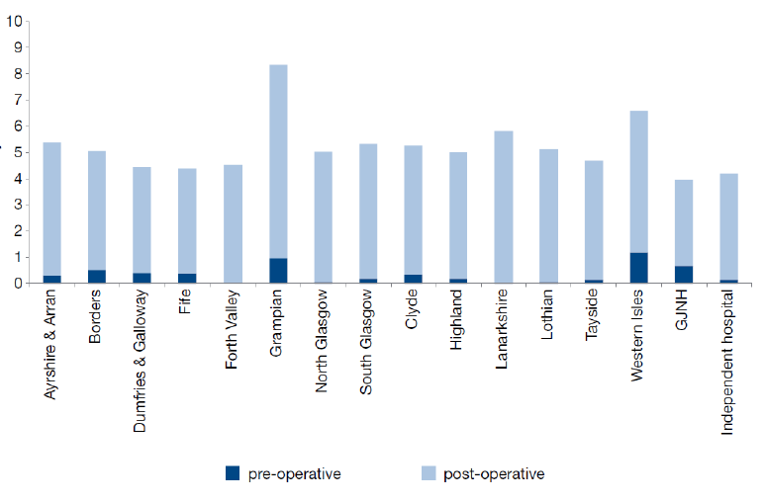
Figure 3 – Average (days) Pre/Post Operative Length Stay – Hip Replacements (2015)
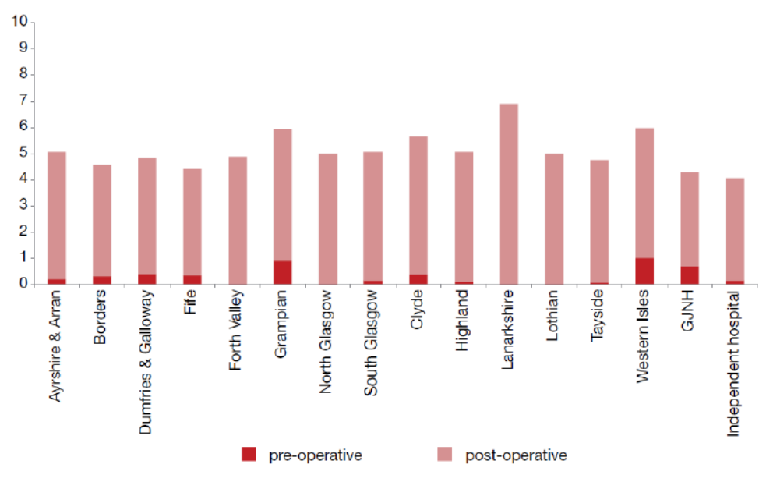
Figure 4 – Average (days) Pre/Post Operative Length Stay – Knee Replacements (2015)

Patterns of Working

Theatres
Currently, surgery time runs from 09:00 to 17:00 Monday to Friday with additional provision on Saturday’s where demand dictates. Two 3.5 hour sessions are scheduled each day. To provide a general perspective, 4 no. major joint operations can be performed in a day. There are 22 sessions running from Monday to Saturday and the Whole Time Equivalent (WTE) is 16.6 (currently short of 1.0 WTE based on number of sessions covered).

Outpatient Department
Total clinic room usage is summarised in the graph below. There are 91 sessions per week. The current job plans have a disproportionate number of sessions at the beginning of the week.
Pre assessment clinics currently accounts for 28 sessions of clinic room utilisation. These clinics run 5 days a week and require approximately 3-4 clinic rooms all day Monday to Friday.
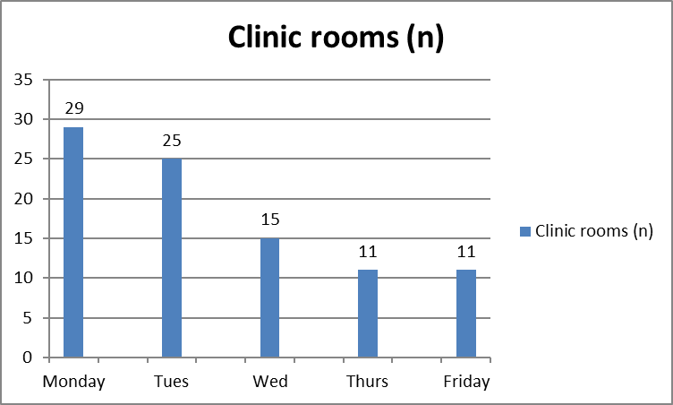
Figure 5 - Clinic room utilisation by day of the week. Each clinic room corresponds to a session (hrs) of clinical activity. Two sessions equates to a clinic room being utilised all day.

Wards
The wards facilitate orthopaedic theatre activity and function 24 hours per day, 7 days a week. The available bed numbers reduce from 24 to 16 at weekends. Currently the wards cater for inpatient activity predominantly (90%) as there is no dedicated support for day case activity.

Staffing

Theatre Staff
There are currently 22.04 whole time equivalent theatre staff, comprising:
- Band 7 – 1.00
- Band 6 – 1.00
- Band 5 – 11.88
- Band 3 – 2.76
- ODP theatres (band 5) – 2.9
- Anaesthetist – 2.5

Ward staff
There are currently 32.46 whole time equivalent ward staff, comprising:
- Band 7 – 1.00
- Band 6 – 1.00
- Band 5 – 17.96
- Band 3 – 1.00
- Band 2 – 6.22
- Physio / OT – 5.28

Consultants
There are currently 13.7 whole time equivalent orthopaedic consultants.

Existing Service Capacity

Theatres
Based on patterns of working and staffing noted under Section 2.2.2, the theatres are capable of accommodating 22 sessions per week. Two theatres run Monday to Friday (20 sessions) whilst one theatre operates on a Saturday (2 sessions).
No of theatres | Days per week | Sessions per day | Sessions available per week
2 | 5.5 | 2 | 22
Table 7 – Existing service capacity

Outpatient Department
Current OPD capacity for NP attendances based on clinic templates for 2018-2019 equate to 12,987 appointments. This includes NP appointments offered by all clinical staff (Cons, ESP, Podiatry, GPwSI). It also includes Virtual Fracture Clinic (VFC) NP referrals.

Wards
There is currently access to 24 beds within ward 10 made up of six 4-bedded bays. Capacity can be affected by male/female ratios. Furthermore, day cases are restricted due to a lack of dedicated support.

Existing Service Utilisation

Service Utilisation
The theatres and supporting ward accommodation currently run at capacity utilising the proportion of available hours. Table 1 demonstrates the utilisation rate for all specialities, the figures are an accumulation of both VHK and QMH activity.
 | June 2019 |  | July 2019 |  | August 2019
Session Holder | Unutilised Hours - % | Utilised Hours - % | Unutilised Hours - % | Utilised Hours - % | Unutilised Hours - % | Utilised Hours - %
Cardiology | 16.9% | 83.1% | 7.9% | 92.1% | 7.6% | 92.4%
Ear, Nose & Throat | 14.3% | 85.7% | 15.3% | 84.7% | 11.7% | 88.3%
General Surgery | -1.9% | 101.9% | -0.3% | 100.3% | -0.2% | 100.2%
Gynaecology | 3.3% | 96.7% | 13.2% | 86.8% | 5.3% | 94.7%
Obstetrics | 54.7% | 45.3% | 53.4% | 46.6% | 55.5% | 44.5%
Ophthalmology | 10.1% | 89.9% | 10.4% | 89.6% | 16.1% | 83.9%
Oral-Maxillofacial Sugery | -2.9% | 102.9% | -28.7% | 128.7% | 11.1% | 88.9%
Paediatric Surgery | -5.0% | 105.0% | -22.0% | 122.0% | -1.1% | 101.1%
Plastic Surgery | 16.0% | 84.0% | 30.5% | 69.5% | 22.8% | 77.2%
Respiratory Medicine | 27.5% | 72.5% | 21.1% | 78.9% | 41.8% | 58.2%
Trauma and Orthopaedics | -2.0% | 102.0% | -0.1% | 100.1% | 1.0% | 99.0%
Urology | 6.0% | 94.0% | 0.9% | 99.1% | 11.6% | 88.4%
Vascular Surgery | 39.0% | 61.0% | 24.9% | 75.1% | 29.2% | 70.8%
Total | 17.2% | 82.8% | 17.5% | 82.5% | 20.4% | 79.6%
Table 8 – Existing service utilisation

Future Projections

Theatre demand
Projected future sessional demand for elective surgical in-patient (IP) and day case (DC) activity within NHS Fife is set out below. It should be noted that IP care is currently provided from Victoria Hospital Kirkcaldy whilst DC procedures are delivered from Queen Margaret Hospital in Dunfermline. A more detailed table providing context and assumptions used to project future demand is contained at Appendix C.
 | Current | 2025 | 2030 | 2035
Session demand | 1,459 | 1,722 | 1,868 | 1,940
Percentage change | 0% | 18% | 28% | 33%
Table 9 - Projected future sessional demand for elective surgical activity
From table 5 it can be seen that by 2035 it is projected that there will be a requirement for an additional 481 sessions representing an increase of 33% against current demand.

Outpatient demand
Future demand for OPD NP capacity formed part of the Regional Orthopaedics workgroups 2017-2018, where DCAQ activity for the South East Scotland (NHS Fife, NHS Borders and NHS Lothian) was calculated.
Population demographics described population expansion in all areas. Population expansion was expected to be greatest for the cohort of the population with age of greater than 65. This is important as it is this cohort who form the majority of referrals to MSK services for degenerative musculoskeletal problems. The population changes are described in fig. 6.
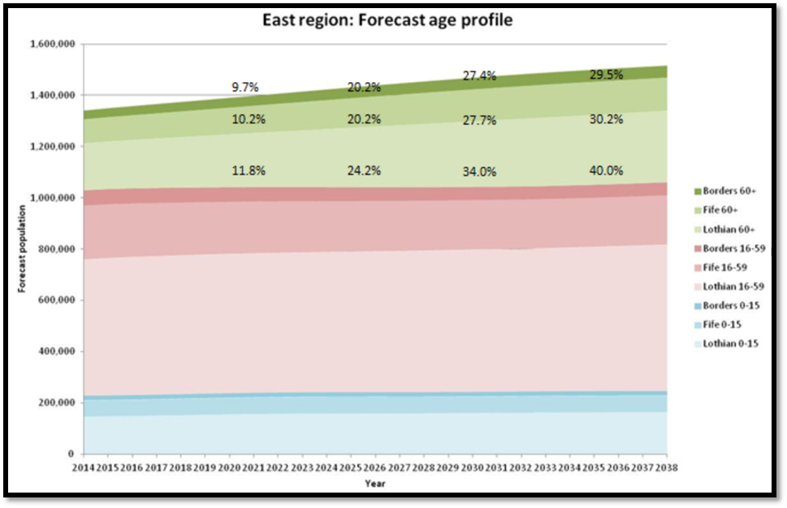
Figure 6 - East Region: Forecast Age profile (presented C Meyers, Acute Workstream Sub Group: Orthopaedic Project Group Workshop 6th Feb 2018)
This is expected to result in an increase in OPD New patient activity (Fig 7). An increase of approximately 6.5% to 10% can be anticipated over the next 20 years. This would equate to an additional 1-2 sessions of NP clinical activity per day across the MSK service if service was to continue to be delivered as it is currently.
Based on growth of arthroplasty in >60 and growth in other demand for <60 years, we feel this is likely to underestimate the increase in new patient attendances for NHS Fife. The true value is likely to be between the 6.5% increase and the 17% indicated for NHS Lothian. For the purpose of projections an increase of 10% is suggested.

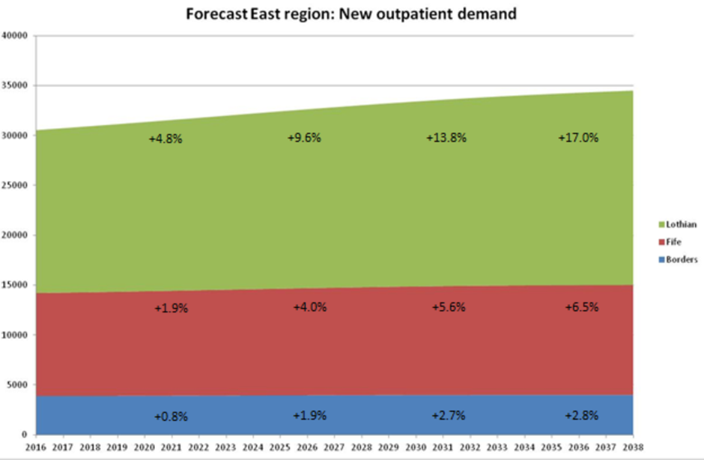
Figure 7 - Forecast East Region: new outpatient demand (presented C Meyers, Acute Workstream Sub-Group: Orthopaedic Project Group Workshop 6th Feb 2018).

Wards
In 2022, the Fife Elective Orthopaedic Centre will have a third theatre. This will accommodate hands which is largely a day case activity. Normally they require up to 10 day beds for a full day list. Therefore, the FEOC needs sufficient beds to accommodate:
- Current and projected elective activity inpatient beds; and
- A significant increase in day case activity through a dedicated area (hands, day case arthroplasty and other day case procedures).
Inpatient beds need to accommodate increased activity over the next 20 years, but with a decreased length of stay. In respect to total patient bed days it is assumed that these forecast changes can be accommodated within the current footprint (24 beds). It is projected that an additional 9 beds will be adequate to accommodate increased day case activity over the next 20 years. A spilt of single beds and 4-bedded bays will enable inpatient capacity whilst offering flexibility for an increase in day case demand.

Service Performance
The service is able to demonstrate excellent performance data via a variety of local and national key performance indicators. A high-level overview of relevant performance data is set out below.

Getting it Right First Time (GIRFT)
A highly respected peer review (GIRFT NHS Fife Feedback Repot, 26 November 2015) acknowledged and commended the efficient use of orthopaedic theatres in Fife – “the Health Board should be commended for their orthopaedic advanced recovery programme”.

Bed Optimisation
NHS Fife has lower than average orthopaedic (mixed emergency and elective) beds per consultant and lower beds per 100,000 population. Despite this the Board and Service are able to maintain excellent theatre efficiency.
Indicator | NHS Fife | Scotland
Available beds per consultant | 4.6 | 5.4
Available beds per 100,000 population | 16.4 | 23.2
Table 10 – Table 2: beds optimisation, T&O Dashboard Report

Treatment Time Guarantee (TTG)
As a result of current theatre efficiency, NHS Fife is able to demonstrate a significantly better performance than its peers in respect to meeting the Scottish Government’s TTG for patients listed for surgery.
Indicator | NHS Fife | Scotland
% of patients not meeting 12 week TTG | 0.8 | 21.7
% of patients not meeting 18 week TTG | 9.2 | 21.5
Table 11 - Inpatient and day case capacity optimisation, T&O Dashboard Report
In respect to the outpatient department, NHS Fife currently performs well against Scottish outpatient waiting times standards. There is a 0.8% failure to meet the 12-week target. The national mean is 30.8%. In addition, NHS Fife has the lowest time to clear its outpatient queue in Scotland.

Theatre Capacity Optimisation
The Service is able to demonstrate superior efficiencies in theatre capacity optimisation when compared against its peers.
Indicator | NHS Fife | Scotland
Late starts (>15 min) as % of used theatre hours (scheduled planned sessions) | 1.7 | 4.5
Theatre cancelled session time - % of planned session hours cancelled (scheduled planned sessions) | 0 | 11.8
Table 12 – Table 4: Theatre capacity optimisation, T&O Dashboard Report

Workforce
For trauma and orthopaedic services, NHS Fife are able to demonstrate an efficient use of their workforce.
Indicator | NHS Fife | Scotland
Consultants per 100,000 population | 3.5 | 4.5
Table 13 – Table 5: Trauma and orthopaedics WTE headcount, T&O Dashboard Report

Future Arrangements

Theatres
Referring back to Section 2.4.6.1, it was noted that by 2035 an additional 481 sessions will be required representing an increase of 33% against current demand.
In terms of total orthopaedic care within NHS Fife (IP and DC) there are currently 1,664 sessions available at 100% utilisation. A realistic percentage for session availability is considered to be 85%, therefore if one assumes that 1,414 sessions are available currently and the demand by 2035 is calling for 1,940 sessions then the deficit is 526 sessions. A theatre running 5 days a week for 52 weeks a year would provide 520 sessions. As a result there is considered to be a solid case supporting the requirement for a third theatre.
The above noted projections combine orthopaedic activity at VHK (IP) and QMH (DC). Further detail supporting this analysis can be found at Appendix C.

Wards
The clinical team are projecting a requirement for a further 9 beds which takes the ward accommodation from 24 beds to 33.

Outpatient Department
It is anticipated that twelve consulting and four treatment rooms will provide the required capacity to deliver a centralised orthopaedic OPD services over the next 20 years.
Twelve consulting rooms will allow current activity to be accommodated, however in order to ensure sustainability of the OPD service over the next 20 years other strategies will be developed as part of the transition of services. It is recognised there will be an increase in OPD activity of approximately 10% over the next 20 years (see Section 2.4.6.2). These strategies will link into initiatives being proposed by the MSK Quality improvement Project in relation to how outpatient services in MSK are delivered. The aim of these strategies is to limit the number of patients who are required to attend for face to face consultant appointments. Strategies include:
- Active Clinical Referral Triage (ACRT): Patients are triaged by trained clinical staff, and where appropriate before patients are offered a face to face new patient appointment, the patient is provided with information which describes treatment options.
- Patient Initiated Follow up (PIFU): This allows patients to be discharged with guidance on how they can access secondary care again if there is a problem, rather than arranging a routine review.
- Remote Consultation via NHSNearMe: This is a video conferencing platform that can allow patient to access clinical appointment remotely by their phone or home PC.

Projected Staffing
Following on from the proposed increase in accommodation, initial staffing projections have also been contemplated and these are set out in the tables below. Staff increases will not be realised straight away, but are likely to be phased to meet demand from 2022 to 2035.

Theatres
 | Current Staff (WTE) | Projected Staff (WTE) | Difference (WTE)
Band 7 | 1.00 | 1.00 | 0
Band 6 | 1.00 | 2.46 | 1.46
Band 5 | 11.88 | 16.88 | 5.00
Band 3 | 2.76 | 4.76 | 2.00
ODP Theatres – Band 5 | 2.90 | 4.36 | 1.46
Anaesthetist | 2.5 | 3.75 | 1.25
Total | 22.04 | 33.21 | 11.17
Table 14 - Theatre Staffing

Ward Staffing
 | Current Staff (WTE) | Projected Staff (WTE) | Difference (WTE)
Band 7 | 1.00 | 1.00 | 0
Band 6 | 1.00 | 1.00 | 0
Band 5 | 17.96 | 24.13 | 6.17
Band 3 | 1.00 | 1.00 | 0
Band 2 | 6.22 | 15.61 | 9.39
Physio / OT | 5.28 | 8.5 | 3.22
Total | 32.46 | 51.24 | 18.78
Table 15 - Ward staffing

Consultants
Current Staff (WTE) | Projected Staff (WTE) | Difference (WTE)
13.7 | 15.7 | 2
Table 16 - Consultant staffing

Service Provider
The service is currently provided exclusively by NHS Fife.

Condition and Performance

Condition
The condition of the existing facilities from where the service is provided is commensurate with the age of the building and supporting infrastructure. The building was erected in 1967 and the last major refurbishment took place circa 20 years ago. The internal fabric of the facilities are showing signs of age which requires to be replenished. The external fabric is in extremely poor condition having reached the end of its useful life. The replacement of the curtain walling would be a significant and costly undertaking due to the location of the tower block within the site.
- Internal fabric condition rating: B (acceptable) / C (requires capital)
- External fabric condition rating: D (not acceptable)
The primary supporting infrastructure (electrical and mechanical) within the tower block is reaching the end of its useful life and requires to be replaced. There are now a number of recurring environmental problems arising from the tower block infrastructure – flooding/leaks and electrical issues. These will continue to occur regardless of any localised upgrade undertaken. Intermittently the service has lost activity within theatres due to drainage problems. In respect to the existing arrangements, it is considered that there is no sustainable solution for this service to be provided from the tower block in the medium to longer term. Meanwhile the current conditions represent a significant threat to service continuity.
- Engineering condition rating: D (not acceptable)

Safety
The facilities are generally considered to be safe when taking recent HAI reports into consideration. Safety performance is considered to be achieved through good management and staff commitment in respect to following mandated processes and procedures. The building fabric and layout does not currently maximise opportunities to support the provision of a safe environment in which to treat patients effectively. This is evidenced via the following statements and photograph.
- The bed accommodation within the wards is provided via open plan bays off the main corridors which is not conducive to best practice infection control;
- The scrub area within the theatres is open plan and can be viewed from the theatre main reception area (Figure 5); and
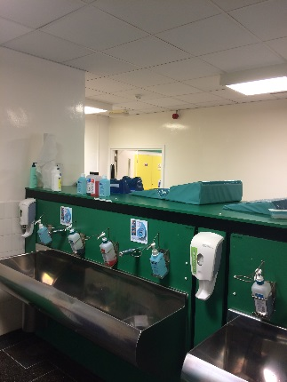
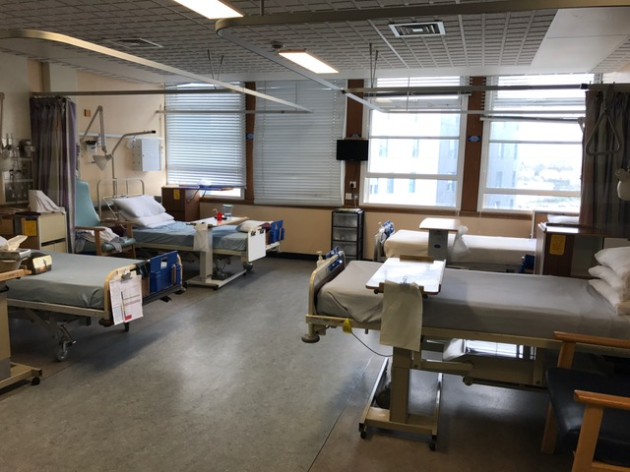
- The laminar flow within theatres it currently too small to enable all of the trays to be accommodated within the clean air flow.
Figure 8 - Scrub area
Figure 9 - Existing bed accommodation

Backlog Maintenance
The summary in respect to the current back-log for the theatres and the ward accommodation is outlined below.
Theatres | £1.185m
Ward 10 | £0.954m
Total | £2.139m
Table 17 - Backlog maintenance
The estimated capital cost to deal with significant clinical backlog within the tower block is £36.5m, of which £21.4m relates to repairing the external fabric which has reached the end of its life.

Functional Suitability
The ward and theatres may have been functionally suitable at a point in time, however the facilities are now inhibited on a number of fronts.
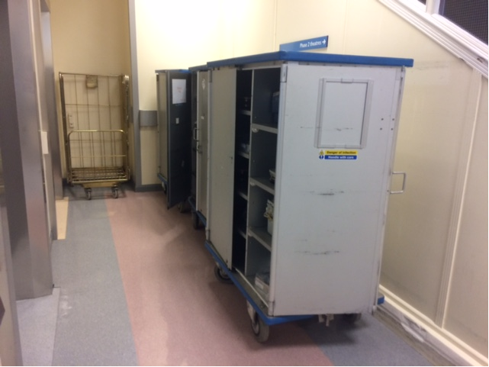
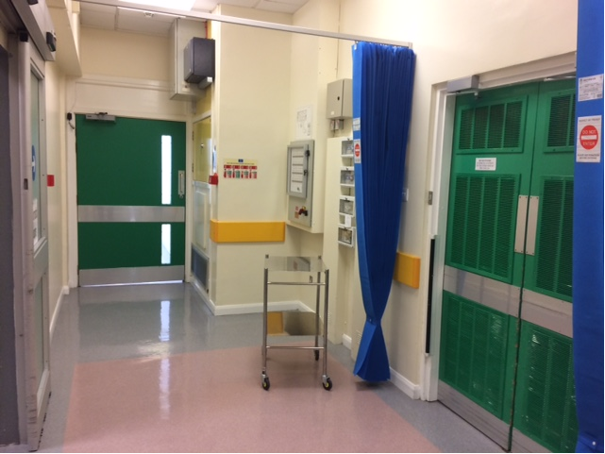
The patient journey from the ward to the theatre and vice-versa is functionally unsuitable as there is a bottle-neck when patients arrive at the theatre reception. Patients arriving have to be parked to the side whilst outgoing patients pass-by. There is a privacy curtain, however the current situation does little to contribute towards patient assurance and dignity. Furthermore this staggered approach to patient arrival and departure is inefficient where time is lost transferring patients affecting theatre productivity.
Figure 10 - Lifts to theatre (congested)
With advances in surgery and complexities in revision surgery, the theatres area is no longer suitable or compliant in terms of current technical guidance in respect to size. This means that currently the area of the laminar flow is too small to allow all of the trays to be accommodated inside the clean air flow. To mitigate this stacking arrangements are used which is inefficient. In addition, circulating areas are also less than recommended. There is a general lack of storage within the theatre accommodation. The effect is that storage has to be found in rooms/spaces that were not designed for this purpose. The knock on effect is that rooms and corridors are cluttered contributing towards inefficiencies in these spaces.
Figure 11 - Theatre reception lobby
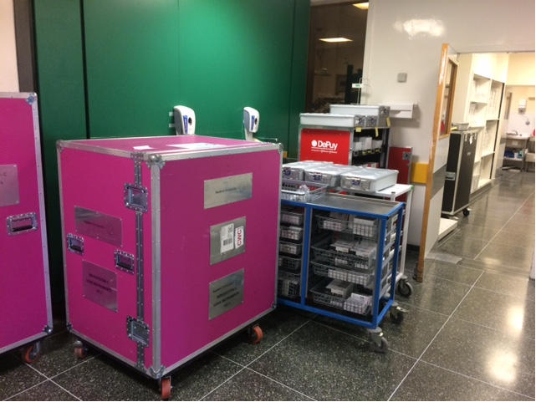
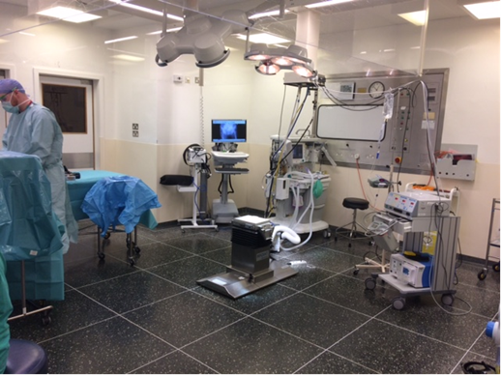
Figure 12 - Existing theatre
Figure 13 - Circulation storage

Space Utilisation
Both the ward and theatre accommodation is currently running at capacity and the space is fully utilised to meet this demand.

AEDET Review of Existing Facilities
An AEDET review of the existing facilities was undertaken where the Stakeholders considered the facilities against the predefined scoring criteria. A summary of the scoring is set out in fig. 14 below.
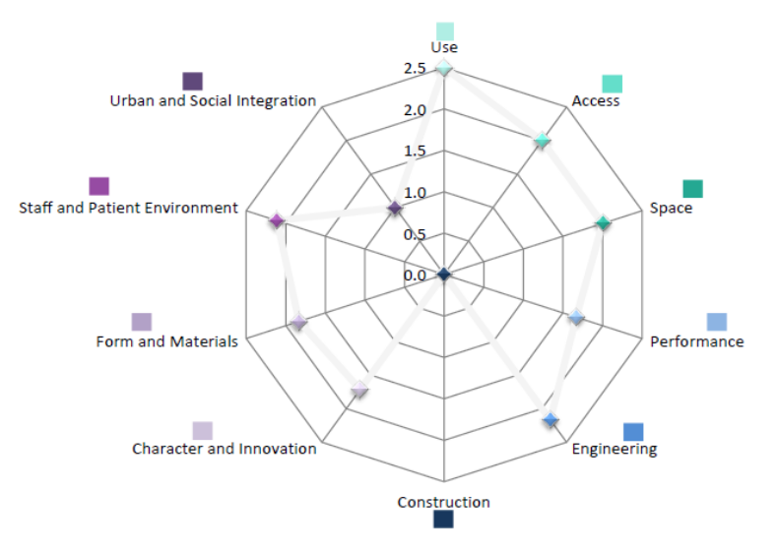
Note: scoring ranges from “1 – virtually no agreement” to “6 – virtually total agreement”.
Figure 14 - Existing facility AEDET score

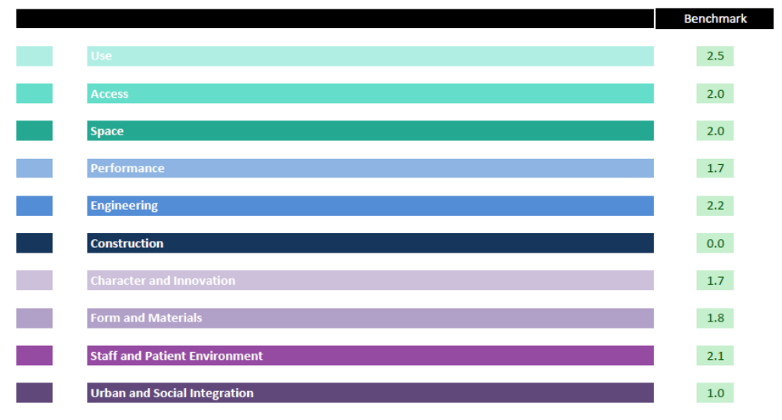
A score of 3 is “little agreement”. It can be seen that all of the scores are 2.5 or less which demonstrates that in the Stakeholder’s collective view, the existing facilities are below expectations across all categories.
Figure 15 - Existing facility AEDET score

Supporting Statement
The current services are still needed and they need to be provided in a similar manner to build upon what is an excellent and efficient service, serving the community of Fife. Wide ranging options were considered as part of the option appraisal exercise and this process helped to reinforce this view.
If the current arrangement is maintained with little or no investment, then there will be significant risks in respect to safety and service continuity due to the condition of the existing accommodation and supporting infrastructure. The VHK tower block is unsustainable as a clinical environment over the longer term, therefore a strategy is required to decant clinical activity to environments that are more suitable. In addition to service risk, the current arrangements fail to contribute sufficiently towards patient dignity and theatre access flows are inefficient counteracting against what is otherwise a very efficient high performing service.
This business case was initially conceived in response to dealing with the condition of the current environment. The problems flowing from the existing situation are not currently performance, demand/supply or patient pathway related. It is more concerned with improving the current condition, functionality and safety of the environment whilst considering other opportunities arising from this principle requirement. In taking forward this investment proposal the following opportunities are being incorporated:
- To increase capacity to cope with future demand on the service.
- To create a standalone Fife Elective Orthopaedic Centre incorporating theatres, inpatients and outpatients.

Strategic Context

The Need for Change

Problems Associated with the Current Arrangements
The problems associated with the current arrangements all primarily flow from the condition and performance of the current facilities as set-out and described in Section 2.7. In addition the key needs for change are summarised within the Strategic Assessment which is contained as Appendix A. A summary of the need for change is outlined below.
What is the cause of the need for change? | What effect is it having, or likely to have, on the organisation? | Why action now:
Current ward provision does not support infection control, safety and the overarching strategy to move towards single room accommodation. | Existing arrangements are contributing towards increased levels of infection risk. | To mitigate the existing risk and in doing so seek to contribute towards NHS Scotland’s policy of providing single room accommodation across the NHS Estate.
Current accommodation does not support effective patient pathways / flow with bottle-necks arising. Situation affects efficiency of service provision. | Whilst the service is very efficient making the best of the existing situation, the current arrangements are affecting the service’s ability to maximise its potential. | With demand for elective orthopaedic procedures set to increase in the future, any additional efficiencies that can be created maximising supply will be of benefit in protecting the sustainability of the service over the longer term.
Current provision compromises patient dignity and quality of experience overall. | The existing situation contributes towards a negative perception from patients diminishing the quality of work/care administered by staff. | Person Centred care is one of NHS Scotland’s strategic investment priorities with “positive experiences” and “dignity” at the core.
Condition of existing facilities are below the required standard to support the service over the longer term. | Space constraints are affecting the services potential to work more efficiently and the existing fabric/infrastructure has and will continue to cause disruptions to service continuity. | Building condition and performance risks will continue to deteriorate if action isn’t taken now.
Table 18 – Summarising the Need for Change

Opportunities for Improvement
Opportunities for improvement relate to aspects of the current arrangements that are not necessarily causing a problem but may still present an opportunity to improve as a consequence of instigating the investment proposal. Potential opportunities are noted below.
- Increased supply through additional beds and/or theatres protecting supply v demand over the longer term;
- An increase in beds and/or theatres, may permit additional capacity and flexibility for trauma and/or general day surgery;
- Through increasing supply to meet local future projected demand it may be possible to reduce strain on services from a Regional perspective.
- A significant increase in capacity may be able to do all of the above plus offer Regional utilisation (i.e. use by other Boards).
- There may be an opportunity to improve the Board’s quality of estate generally by removing clinical care from the VHK tower block. This is turn would assist with the strategy of removing clinical services from the tower block to enable a tower block option appraisal to be conducted.
- There is an opportunity to “spend to save”. A refurbishment or new-build option could omit the requirement for back-log costs in the order of £2m overall.
- There is an opportunity to create a dedicated Fife Elective Orthopaedic Centre incorporating theatres, wards, outpatients and pre-assessment.
The above noted opportunities were considered as part of the option appraisal exercise and have been reflected within the 5 no. shortlisted options where appropriate.

Other Drivers for Change
National, local and service strategies are also contributing towards the need for change. Key strategies are outlined below:

National Strategies
- The Healthcare Quality Strategy for NHSScotland, May 2010: Quality Ambitions include “safe” and “effective” care.
- 2020 Vision for Health and Social Care: the 2020 vision describes a healthcare system where “care will be provided to the highest standards of quality and safety” and where “there will be a focus on ensuring that people get back into their home or community environment as soon as appropriate, with minimal risk to readmission”.

Local Strategies
- NHS Fife Clinical Strategy, 2016: the strategy discusses the intention to continue the ongoing review into theatre efficiency across all sites (i.e. increase efficiencies within the current capacity). For elective orthopaedics this many involve investigating options for seven day working and longer days whilst continuing to protect beds. The strategy also mentions the requirement for “efficient, fit-for-purpose facilities” and the intention to “reconfigure the estate to provide safe, high quality, person centred care from the most suitable locations”.

Service Strategies & Reports
- GIRFT, Trauma and Orthopaedic ACCESS Review, March 2016 (for NHSScotland): the report focuses on sustainably embedding quality patient pathways of care, optimising the use of existing capacity (theatres and beds), determining if there is sufficient capacity and addressing gaps to deliver safe and timely care for patients now and in the future – having the services in the right place with the patient at the centre.
- MSK and Orthopaedic Quality Drive: five priority work-strands, each with a clinical evidence/best practice base, have been identified to have the greatest impact. The work-strands relevant to theatre redesign are:
    - Enhanced Recovery - Optimising patient recovery after joint replacement
    - Demand and Capacity Planning and Management - Supporting strategic and operational decisions
    - GIRFT, Trauma and Orthopaedic ACCESS Review, November 2015 (for NHS Fife): The report commends the Board’s orthopaedic enhanced recovery programme, acknowledging the efficient use of the theatres. However the report also notes the risks to theatre efficiency over the longer term due to the age of the existing facilities.

Organisation’s Goals

Investment Objectives
The existing arrangements and the associated need for change have been set in previous Sections. The table below summarises the key problems flowing from the current arrangements together with what needs to be achieved to overcome these problems – i.e. investment objectives.
Effect of the need for change on the organisation: | What has to be achieved to deliver the necessary change? (Investment Objectives)
Existing arrangements are contributing towards increased levels of infection risk. | Improve infection control and safety risk.
Whilst the service is very efficient making the best of the existing accommodation, the current arrangements are affecting the service’s ability to maximise its potential. | Improve patient pathways / flows.
The existing environment contributes towards a negative perception from patients which potentially may lead to reputational damage for the Board. | Improve patient perception.
Space constraints are affecting the services potential to work more efficiently and the existing fabric/infrastructure has and will continue to cause disruptions to service continuity. | Improve accommodation in respect to space standards and physical condition.
Table 19 - Investment Objectives
Each of the identified investment objectives is described in further detail below outlining how they may be achieved.

Improve Infection Control and Safety Risk
This investment objective could be achieved by improving the condition of the facilities, utilising best practice finishes, fixtures and fittings to achieve a modern environment that can be cleaned and maintained efficiently. In addition functionality of rooms and spaces can be improved to reduce infection risk – as discussed previously single room accommodation and segregated scrub areas are key examples of where improvement can be sought.

Improve Patient Pathways / Flows
This can be achieved by reviewing the accommodation requirements and planning spatial adjacencies in such a way that maximises efficiencies in respect to the patient throughput. The patient journey from the ward to theatre and vice-versa will be important considerations.

Improve Patient Perception
This objective can be realised by improving the condition of the facilities generally and by planning the accommodation, flows and adjacencies in such a way that patient dignity can be respected in a passive manner.

Improve Accommodation in Respect to Space Standards and Physical Condition
This can be achieved ensuring that any new facilities are designed and constructed in accordance with current healthcare guidance in respect to space planning and technical requirements.

Benefits
If the investment objectives can successfully be realised then it is anticipated that the associated benefits will also be generated.
A summary of the key benefits flowing from the investment objective is outlined below:
- Positive patient experience and dignity respected;
- Maintain support to allow people to live independently, together with life quality;
- Improves the healthcare state (condition, sustainability, quality, perception, statutory, back-log and lifecycle);
- Minimises readmissions (post operation complications) and optimises timely discharge;
- Optimises resource usage (theatre and bed utilisation);
- Improves HAI and patient safety; and
- Community benefits flowing from the need for a project necessary to implement the changes.
The Benefits Register is located at Appendix M and the Benefits Realisation Plan can be found at Appendix N.

Risks
Risk is now covered within the Commercial Case (Section 5) and Management Case (Section 7). The project’s Risk Register can be found at Appendix O.

Constraints and Dependencies

Constraints
Constraints are limitations on the investment proposal. Key constraints relating to this particular investment proposal are noted below:
- Financial – given the current climate it is recognised that the project is likely to be constrained financially. Once the project budget it is set, the project will require to be delivered within this.
- Programme – given the risks associated with the current arrangements, there is a need to deliver the project as quickly as possible.
- Quality – the project will require to comply with all applicable healthcare guidance and achieve the AEDET pre-defined target criteria across all categories.
- Sustainability – as the preferred option is a new-build there will be a requirement to achieve BREEAM “Excellent”.
- Site – as the preferred option is within a live environment, delivery of the project may be restricted and constrained depending on the preferred location. Careful planning will be required to plan how the project can be delivered efficiently and safely with minimal disturbance to adjacent areas of the hospital.

Dependencies

Dependencies are where action from others is required to ensure success of the investment proposal.

The preferred option is a new-build facility at Victoria Hospital Kirkcaldy. The new facility will be constructed on existing car parking spaces in order to provide a physical connection to the existing building for an ICU adjacency. The car parking spaces will be re-provided at Whyteman’s Brae and must be in place in advance of the main building works to ensure there is no deficit in parking provision.

This car park enabling project is considered to be the only dependency project, however it is controlled by the Project Team helping to mitigate any associated programme risk.

Economic Case

Introduction
The purpose of the Economic Case is to undertake a detailed analysis of the costs and benefits of a short list of options, including a do nothing and/or do minimum option, for implementing the preferred strategic / service solution(s) identified within the IA.
The objective is to demonstrate the relative value for money of the chosen option in delivering the required outcomes and services.

Revisiting the Economic Case
Within the IA, the Economic Case established a long list of possible options from which a short list of five options were established. The IA contemplated the advantages and disadvantages associated with each option and established budget costs for comparison purposes. Based on this information the IA selected the best option and this was:
Option 5 – preferred way forward (new-build facility at VHK to meet the current requirements together with added capacity for future demand projections)

The OBC seeks to analyse the options in greater detail to evidence if the preferred option is in fact the correct decision. It does this by using benefits and costs to evaluate each option. Sensitivity analysis is then carried out to validate the result.

Stakeholder Engagement
An important aspect of considering options and developing them in subsequent business case stages is Stakeholder engagement. The following table summarises the current status in respect to Stakeholder engagement for the project.
Stakeholder Group | Engagement | Support
Patients / service users | As outlined in Section 4.9 the proposed option relates to providing the same service at the same hospital. As such patients and service users will not materially be affected by the proposal.  Patient surveys are underway to understand views, opinions and experiences so that key themes can be addressed particularly in respect to briefing and design development. Patient surveys will also be used as part of the benefit measurement criteria.  To date patient representatives have been actively involved in developing the Design Statement. They have also recently participated in the OBC AEDET workshop. | To date patient participation has been gained through the Design Assessment process where patient representatives provided views on the important characteristics of the proposed facility from their perspective.  They have also recently participated in the OBC AEDET workshop where they were able to critique the design proposals.  Overall, there has been enthusiastic support for the project and praise in connection with the design proposals.
General public | Given the proposed option, the general public are unlikely to be negatively affected by this proposal from a clinical perspective.  General public may become involved in any statutory planning activity. The Project Team may hold an open day as this has been a tried and tested successful means of engaging with the public on other new-build projects implemented by the Project Board in the recent past. | Not applicable  Advanced planning consultation with Fife Council has been applied for at OBC. Discussions and actions will become clear within the FBC period.
Staff / resources | Staff are well represented at Project Board and Project Team level.  In order to develop this OBC, several collaborative workshops have taken place to develop the design proposals. Workshops have included 1:500 (site/departmental adjacency) and 1:200 (room adjacency). | The staff consultation process has been robust with staff attending all key workshops to date. This has culminated in an agreed set of plans for OBC.
Other key stakeholders and partners | Elective services at Phase 3 – based on the preferred option, no impact envisaged.  Anaesthetic services – no impact envisaged.  Hospital at night – require to be consulted as a change of location may have an impact on their service.  Ambulance/transport service – require to be consulted as drop-off arrangements are likely to change. Note: drop-off arrangements likely to improve under preferred option. | Consultation established. No significant impact envisaged.  Consultation established. Proposals offer a betterment compared to the status quo.
Table 20 – Stakeholder engagement

Long List of Options
A Stakeholder workshop was arranged to review a long list of possible options. Options were generated against 3 no. headings:
- Scope of Services
- Service Solution
- Potential Delivery Options
The feasibility of the options were considered and either noted as “preferred”, “possible” or “discounted”. For detail in respect to the long list of options considered, please refer to Appendix D.
In contemplating the long list of options against the needs for change and investment objectives, the Stakeholders also considered the opportunities arising through contemplating change. Whilst the fundamental initial need for change could be tackled by providing like for like facilities it was considered to be remiss not to take cognisance of future orthopaedic care requirements and what this might mean in terms of demand and supply. A decision was taken to present this business case on the basis of re-provision whilst taking advantage of the opportunity to plan for future demand. Whilst this will result in an increase in accommodation, staffing and overall affordability, the key benefits are as follows:
- Additional accommodation would provide NHS Fife with additional surgical capacity to manage NHS Fife patients locally now and well into the future;
- The theatres would be used flexibly offering in-patient and day case capacity;
- It is important to maintain a robust core orthopaedic service (i.e. provision of care for low volume complex work such as ankle replacements, shoulder replacements, elbow replacements). This will support the increasing trauma demand for fragility fractures over the next 20 years; and
- A robust orthopaedic service within Fife will reduce strain on any interconnected Regional offer.
In addition to building in capacity to meet future demand, the opportunity to develop a standalone Fife Elective Orthopaedic Centre was pursued. This involves providing theatres, inpatients and outpatient services via one standalone facility.

Short List of Options
From the long list of options, the Stakeholders subsequently consolidated a blend of feasible options to arrive at a shortlist of five main options.
The shortlist of options were considered in detail, together with their advantages and disadvantages and to what extent they met the investment objectives. High level affordability was also considered before determining whether the shot listed option was “preferred”, “possible” or “rejected”. All of the detail in respect to the option appraisal is clearly set out in Appendix D, however a high-level summary is provided below for ease of reference.

Option | Description | Meets Investment Objectives? | Preferred / Possible / Rejected
Option 1 - Do minimum (as existing) | Elective orthopaedic centre as per current arrangements | No | Rejected
Option 2 – Refurbishment of existing | Elective orthopaedic centre as per current arrangements provided from its current location | Partially but not sufficiently | Rejected
Option 3 – Refurbish other estate at VHK | Services to be provided at VHK within a refurbished area of the existing Estate  Elective orthopaedic centre as per current arrangements but with added capacity to meet future local service demand projections | Partially | Possible
Option 4 – VHK modular new-build | Service would be provided within a dedicated new modular building on the VHK site.  Elective orthopaedic centre as per current arrangements but with added capacity to meet future service demand projections | Yes, but not to the same extent as option 5 | Rejected
Option 5 – VHK new-build | Service would be provided within a dedicated traditional new building on the VHK site.  Elective orthopaedic centre as per current arrangements but with added capacity to meet future service demand projections | Fully | Preferred
Table 21 - Shortlist of options

Option 1 – do minimum (as existing)
This option is the base option where the existing service would be provided in the same way from the same facilities. It is considered that some work (minimal) would be required to improve the existing condition of the facilities, however this would not be sufficient to overcome the wider systemic issues present within the VHK tower block which is no longer fit for clinical use as a consequence of risks within the existing supporting infrastructure which cannot be resolved locally. In addition, this option fails to realise the opportunity to remove clinical services from the tower block, restricting the Board’s ability to consider longer term options for the tower block within the context of the site masterplan. Option 1 does not sufficiently deal with the needs for change or meet the investment objectives and thus has been discounted.

Option 2 – refurbishment of existing
This option is similar to option 1, in that the existing services would continue to be provided in the same way from the same facilities. The existing accommodation would undergo a more significant refurbishment under this option which would go some way to improving conditions at least in the short term. Ongoing risks with the VHK tower block would continue to threaten service provision under this option and it is considered that the existing footprint would do little to improve accommodation adjacencies or space standards. In addition, this option fails to realise the opportunity to remove clinical services from the tower block, restricting the Board’s ability to consider longer term options for the tower block within the context of the site masterplan. Option 2 does not sufficiently deal with the needs for change or meet the investment objectives and thus has been discounted.

Option 3 – refurbish other estate at VHK
This option is based on the same service but anticipates additional accommodation to meet local future demand projections. Additional capacity will also help the orthopaedic service to work more flexibly servicing in-patient and day case to meet spikes in demand. The accommodation would be offered through refurbishment of the Board’s existing assets elsewhere within the VHK estate. Space has been identified at Phase 1 of the hospital that would be suitable for refurbishment, however the space is inadequate to accommodate a third theatre, additional ward space and supporting accommodation. This option is the best in terms of utilising the Board’s existing estate and reducing back-log, however decant and space re-provision costs would need to be offset against this benefit. This option would assist with enabling clinical services to be removed from the tower block and this is of value to the Board in the context of the long-term site masterplan at VHK. This option overall is worthy of consideration for a like for like service solution. However, in contemplating additional accommodation to meet future demand, this option is inadequate as sufficient and suitable space is not available.

Option 4 – VHK modular new-build
This option is based on the same service but anticipates additional accommodation to meet local future demand projections. Additional capacity will also help the orthopaedic service to work more flexibly servicing in-patient and day case to meet spikes in demand. This option would assist with enabling clinical services to be removed from the tower block and this is of value to the Board in the context of the long-term site masterplan at VHK. The accommodation would be offered through a modular new building at VHK. This option is quite attractive in that it meets most of the investment objectives and being modular could be delivered more quickly than a conventional building. Although the quality of modular buildings have improved in recent years there is a concern that a modular facility would not offer the required quality over the longer term (FM and lifecycle) when compared to a conventional building and being modular compromises might require to be accepted in terms of the design, layout, future flexibility and adjacencies. Initial cost projects also suggest that a modular building might be more expensive than a traditional building due to the scale. This option is a possibility but due to compromises on quality and initial cost projections it has been discounted.

Option 5 – VHK new-build
This option is based on the same services but anticipates additional accommodation to meet local future demand projections. Additional capacity will also help the orthopaedic service to work more flexibly servicing in-patient and day case to meet spikes in demand. This option would assist with enabling clinical services to be removed from the tower block and this is of value to the Board in the context of the long-term site masterplan at VHK. The accommodation would be offered through a conventional new building at VHK. The option would meet all of the investment objectives and stands the best chance of realising all of the briefing criteria set out within the Design Statement. It is the second most expensive option, but money spent on this option will not be compromised to the same extent that it might be if another option was to be pursued – as such it is the preferred option.

Indicative Costs
Indicative costs for each of the proposed solutions is demonstrated in the table below.
Description | Option 1 | Option 2 | Option 3 | Option 4 | Option 5
 | As existing  (GIFA – 1,992m/2 | Refurb. of existing asset  GIFA – 1,992m/2 | Refurb of other asset  GIFA – 5,920m/2 | New-build modular  (GIFA – 5,920m/2 | New-build traditional  (GIFA – 5,920m/2
Capital cost | £63,386 | £12,154,400 | £25,611,943 | £44,166,612 | £33,637,272
Life cycle costs  (60 years) | £7,627,913 | £8,627,913 | £23,669,300 | £89,358,224 | £7,967,369
Operating costs (FM)  (60 years) | £539,081,109 | £550,156,954 | £715,999,520 | £797,150,669 | £706,985,364
Estimated net present value of costs  (60 years) | £226,669,632 | £236,964,794 | £300,090,439 | £337,129,911 | £302,982,384
Table 22 - Indicative costs
The net present value/cost has been calculated using discounted cash flow techniques on the capital and revenue costs associated with the options as entered into the generic economic model (GEM).

Option Appraisal
The non-financial benefits for the options are measured against cost estimates to identify which option represents best value for money.

Benefits Criteria and Weightings
The benefits criteria and associated weightings were established at a workshop in August 2019. Service Leads, the Clinical Lead and Service Manager were in attendance. The table provided below summarises the benefits and agreed weightings.
Benefit | Weighting (%)
Positive patient experience and dignity respected | 20
Maintain support to allow people to live independently together with life quality | 10
Improves the healthcare estate (condition, quality, perception, statutory, back-log and lifecycle) | 20
Minimises readmissions (post operation complications) and optimises timely discharge | 15
Optimises resource usage (theatre and bed utilisation) | 15
Improves HAI and patient safety | 15
Community benefits | 5
 | 100
Table 23 - Benefits and weightings

Option Scoring
Following the exercise to weight the benefits, the group systematically scored the options using a scale of 0 to 20. A score of 0 indicates that the option offers no benefits at all in terms of the relevant criterion, while a score of +20 indicates that it represents some "maximum" or "ideal" level of performance. Scores between 0 and +20 indicate intermediate levels of performance. Net scoring of the options prior to applying the benefit weighting criteria is presented in the table below.
Benefit | Option 1 | Option 2 | Option 3 | Option 4 | Option 5
 | As Existing | Refurb. Existing | Refurb other | Modular | New build
Positive patient experience and dignity respected | 5 | 7 | 10 | 13 | 20
Maintain support to allow people to live independently together with life quality | 15 | 15 | 16 | 19 | 20
Improves the healthcare estate (condition, quality, perception, statutory, back-log and lifecycle) | 0 | 2 | 12 | 18 | 20
Minimises readmissions (post operation complications) and optimises timely discharge | 12 | 12 | 18 | 20 | 20
Optimises resource usage (theatre and bed utilisation) | 5 | 5 | 12 | 20 | 20
Improves HAI and patient safety | 2 | 4 | 10 | 20 | 20
Community benefits | 2 | 3 | 10 | 15 | 20
Total | 41 | 48 | 88 | 125 | 140
Rank | 5th | 4th | 3rd | 2nd | 1st
Table 24 - Non financial benefits scoring (net scores)

The net scores were then multiplied by the agreed benefit weighting criteria to arrive at a total weighted score. The results are summarised in the table below:
Benefit | Option 1 | Option 2 | Option 3 | Option 4 | Option 5
 | As Existing | Refurb. Existing | Refurb other | Modular | New build
Positive patient experience and dignity respected | 100 | 140 | 200 | 260 | 400
Maintain support to allow people to live independently together with life quality | 150 | 150 | 160 | 190 | 200
Improves the healthcare estate (condition, quality, perception, statutory, back-log and lifecycle) | 0 | 40 | 240 | 360 | 400
Minimises readmissions (post operation complications) and optimises timely discharge | 180 | 180 | 270 | 300 | 300
Optimises resource usage (theatre and bed utilisation) | 75 | 75 | 180 | 300 | 300
Improves HAI and patient safety | 30 | 60 | 150 | 300 | 300
Community benefits | 10 | 15 | 50 | 75 | 100
Total | 545 | 660 | 1,250 | 1,785 | 2,000
Rank | 5th | 4th | 3rd | 2nd | 1st
Table 25 - Non financial benefits scoring (weighted scores)

The Preferred Option
This section presents the case for the selection of the preferred option. The first step merges the results of the NPV/NPC calculations and non-financial benefits. In line with HM Treasury guidance, the NPC is divided by the weighted benefits (WBP) score to determine the cost per benefit point for each option.
 | Option 1 | Option 2 | Option 3 | Option 4 | Option 5
 | As Existing | Refurb. Existing | Refurb other | Modular | New build
Net Present Cost (NPC) - £m | 226.7 | 237 | 300.1 | 337.1 | 303
Weighted Benefit Points (WBP) | 545 | 660 | 1,250 | 1,785 | 2,000
NPC per WBP - £000 | 416 | 359 | 240 | 189 | 151
Rank | 5th | 4th | 3rd | 2nd | 1st
Table 26 - Cost per benefit point for each option
These results demonstrate that although option 5 has second highest NPC, it has the highest WBP and also the lowest cost of providing each weighted benefit point. Option 5 is therefore confirmed as the preferred option.

Sensitivity Analysis
Sensitivity analysis is a technique used to assess the impact of uncertainty over the assumptions being made within the evaluation. The basic procedure is to alter an assumption and recalculate the NPC for each option, to test how these uncertainties may affect the choice between options. This tests the rigour of the appraisal conclusions to consider how options are affected relative to each other by reasonable variations in each assumption.
Sensitivity analysis of both costs and non-financial benefits has been carried out to understand how reactive the results are to change in the underlying assumptions. This tests whether changes to any of the capital or revenue costs have a significant impact on the option rankings. The following scenarios/tests were undertaken for each option:
- Capital costs increased/reduced by 20%; and
- Service costs increased/reduced by 20%.
Sensitivity Scenario | Option 1 |  | Option 2 |  | Option 3 |  | Option 4 |  | Option 5
 | NPC per WBP £000 | Rank | NPC per WBP £000 | Rank | NPC per WBP £000 | Rank | NPC per WBP £000 | Rank | NPC per WBP £000 | Rank
No changes | 416 | 5 | 359 | 4 | 240 | 3 | 189 | 2 | 151 | 1
Capital costs increased by 20% | 416 | 5 | 362 | 4 | 243 | 3 | 193 | 2 | 154 | 1
Capital costs decreased by 20% | 416 | 5 | 356 | 4 | 237 | 3 | 185 | 2 | 149 | 1
Service costs increased by 20% | 498 | 5 | 427 | 4 | 284 | 3 | 219 | 2 | 179 | 1
Service costs decreased by 20% | 333 | 5 | 291 | 4 | 196 | 3 | 158 | 2 | 124 | 1
Table 27 - Sensitivity Analysis (costs)
The ranking is unchanged in all cases and Option 5 remains ranked above all other options.
Sensitivity analysis has also been undertaken in relation to the changes in the weights and scores used to evaluate non-financial benefits. The following scenarios have been evaluated:
- Equal weighting applied to all criteria; and
- Scores with the highest weighted criterion excluded.
Sensitivity Scenario | Option 1 |  | Option 2 |  | Option 3 |  | Option 4 |  | Option 5
 | NPC per WBP £000 | Rank | NPC per WBP £000 | Rank | NPC per WBP £000 | Rank | NPC per WBP £000 | Rank | NPC per WBP £000 | Rank
No changes | 416 | 5 | 359 | 4 | 240 | 3 | 189 | 2 | 151 | 1
Equal weight | 395 | 5 | 353 | 4 | 244 | 3 | 193 | 2 | 155 | 1
Exclude top rank score | 509 | 5 | 494 | 4 | 370 | 3 | 289 | 2 | 252 | 1
Table 28 - Sensitivity analysis non-financial benefits
The ranking is unchanged in all cases and Option 5 remains ranked above all other options.

Conclusion
The recommended preferred option as identified at IA stage remains the same for this OBC.
Option 5 – preferred way forward (new-build facility at VHK to meet the current requirements together with added capacity for future demand projections)

Commercial Case

Introduction
This section outlines the commercial arrangements and implications for the Project. This is done by responding to the following points:
- The procurement strategy and appropriate procurement route for the Project
- The scope and content of the proposed commercial arrangement
- Risk allocation and apportionment between public and private sector
- The payment structure and how this will be made over the lifetime of the Project
- The contractual arrangements for the Project

Revisiting the Commercial Case
The commercial case has generally been updated and expanded since IA in accordance with SCIM OBC guidance. In particular, the design of the preferred option has been progressed allowing for a detailed overview on the status of the design to be provided.

Procurement Strategy
To enable the project to be delivered in accordance with NHS Scotland construction procurement policy, NHSScotland Frameworks Scotland 2 (FS2) has been selected as the most appropriate option. This procurement route operates via capital funding where a single contractor (including design team) is appointed to deliver the project within agreed time, cost and briefing parameters. FS2 has been used successfully by NHS Fife for many years and there is a clear organisational understanding of the process.
The following are the key features of the proposed procurement route for the delivery of this Project:
- The Framework Agreement is managed by Health Facilities Scotland (HFS) (a division of NHS National Services Scotland) on behalf of the Scottish Government Health Directorate (SGHSCD).
- The Framework embraces the principles of collaborative working, public and private sectors working together effectively, and it is designed to deliver on-going tangible performance improvements due to repeat work being undertaken by the supply chains.
- The form of contract is likely to be the Engineering and Construction Contract (NEC3), Option A or C.
- The general principle of the Framework is that risks are passed to ‘the party best able to manage them’, subject to value for money.
This capital procurement route is consistent with the other elective care developments currently being progressed across Scotland as part of the national elective care programme.
Under FS2, there is no need to advertise in the Official Journal of the European Union (OJEU). The five PSCPs on the Framework have been selected via a compliant OJEU tender process in 2012 / 2013 for capital investment construction schemes across Scotland up to 2019. Appointment of a PSCP is made following a mini-competition process.
The same form of process applies to the NHSScotland Consultants Frameworks (PSCs) for Project Manager and Joint Cost Advisor.
The summary table below provides an overview in respect to procurements to date:
Framework | Appointment | Status
Contractor, designers and Principal Designer (PSCP) | Graham Construction | Appointed to OBC
Project Manager | Thomson Gray | Appointed to OBC
Joint Cost Advisor | Gardiner and Theobald | Appointed to OBC
NEC3 Supervisor | TBC | To be appointed at FBC
Table 29 - Consultant procurement status
Upon approval of the OBC, NHS Fife would look to extend the above appointments to cover the FBC stage of the project.

Scope of Works

Overview
The project involves designing and constructing a new Fife Elective Orthopaedic Centre at Victoria Hospital in Kirkcaldy. The new building is currently scheduled to be 6,142m2 in size and will be physically connected to the existing buildings to enable a direct route to the Intensive Care Unit. The facility will include 3 no. operating theatres, a 33-bed ward, an outpatient department, radiology rooms and supporting staff areas. The overall complement of accommodation will serve to provide a dedicated Fife Elective Orthopaedic Centre.
In order to facilitate the connection to ICU, the new building will be located on an existing car park. The displaced car parking space will be re-provided as part of the project and costs relating to this aspect have been included and set out within the Financial Case. A conceptual image is provided below to aid context and understanding of the proposed development.
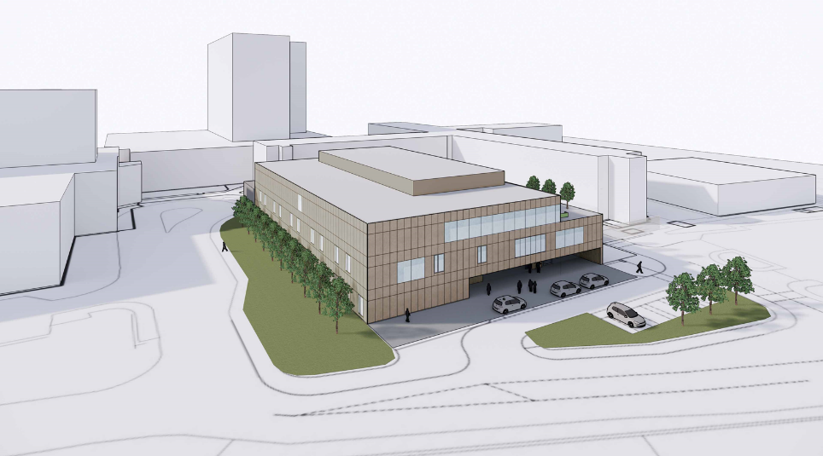
Figure 16 - Proposed development (Norr Architects)
The scope of the project entails designing and constructing the Fife Elective Orthopaedic Centre. The operation of the new facilities following completion and handover of the construction phase will be undertaken directly by NHS Fife and fall out with the scope of the project.

Current Design Status
The design has been completed to RIBA Stage 2 which aligns with OBC and NDAP requirements. The table referenced below provides an overview of how the project is performing against predefined OBC requirements.
OBC Design Requirements | Project Status
Concept Design incl. Arch, M&E, C&S, Fire, Landscape | Complete
Outline drawings (≥1:200, key ≥1: 50) & specifications | Complete
Outline sustainability strategy | BREEAM Pre-assessment completed
Outline construction strategy incl. HAI, CDM H&S Plan | Complete
3D sketches of key Design Statement spaces | Complete
Completed Design Statement OBC self-assessment | Complete – assessed through AEDET workshop
Completed AEDET OBC self-assessment | Complete
Photographs of site showing broader context | Complete
Evidence of Local Authority Planning consultation and/or alignment with Local Development Plan. | Pre-planning engagement has been sought from Fife Council via a formal application and fee. Consultation and feedback will be received early within the FBC period.
Extract of draft OBC detailing benefits & risks analysis | Provided within this OBC.
Evidence of HAI & CDM consultation | HAI SCRIBE Stage 1 has been completed on draft – awaiting ground investigation results to conclude.  A Principal Designer is in place.
Evidence Sustainability commitments will be met. e.g. accurate & NCM models (DSM). BREEAM, .CAB files and BRUKL; show how design will be optimised | This has been achieved through regular consultation with HFS where the approach to modelling was agreed.
Evidence Equality & access commitments will be met | Complete.
Evidence of VfM e.g. WLC on key design options | Value against the brief has been monitored throughout the OBC programme.
Evidence Activity Data Base (ADB) use optimised | Room data sheets and 1:50 layouts have been produced for repeatable rooms (bedrooms and consulting rooms etc).  Remaining room data sheets and 1:50 layouts will be developed and finalised within the FBC programme.
Evidence NHS guidance & technical standards will be met; list any derogations, with their technical reasons | Complete – refer to Section 5.4.5 below.
OBC design report evidencing all above & IA brief met ≥1:500, ≥1:200, key ≥1: 50; diagrams, sections plans, 3Ds, specs, comfort & energy DSMs, to RIBA Stage 2 Concept plus key elements developed to Stage 3 | Complete – NDAP submission made on 26 September 2019.
Table 30 - OBC design status

Schedule of Accommodation (SoA) Development
A SoA was developed at the IA stage of the project. Whilst the schedule was tested with stakeholders at this stage to inform budgetary costings it was very much a working draft. The schedule was developed further within the OBC stage in parallel with the concept design.
The table below compares the IA SoA to the OBC “as drawn” outturn. As it can be seen there is an increase of 222m2 overall. The net area (usable rooms) has actually decreased against the original schedule despite adding two radiology rooms. The gross area has increased due to a requirement for a link corridor and a rooftop plantroom.
Description | IA SoA (m2) | OBC “as drawn” (m2) | Difference (m2)
 | 5,920 | 6,142 | 222
Table 31 - SoA Development

Inpatient beds
The initial schedule of accommodation (presented as part of the IA) set out the requirement for 34 beds made up of 16 single rooms, 7 double rooms and 1 4-bedded rooms (47% single beds).
At commencement of the OBC Stage the schedule of accommodation was reviewed and refined. A decision was taken to omit the double rooms and provide 14 single rooms and 5 4-bedded rooms (41% single rooms).
Through engagement with HFS and NHS Fife’s internal infection control department, notwithstanding clinical preference, the Project Team was requested to increase the proportion of single rooms. As things stand the schedule of accommodation now allows for 33 beds comprising 17 single rooms and 4 4-bedded rooms (52% single beds). Two of the 4-bedded rooms are likely to be used for day cases initially so shall be furnished with chairs as opposed to beds. As time moves on it is likely that the third and eventually fourth 4-bedded bays will be used in this manner also.
Current guidance for new healthcare facilities in Scotland suggests that 100% single rooms should be provided unless there is a justifiable clinical reason for not doing so. To this end, our Clinical Lead has prepared a report setting out the key reasons why a mix of room accommodation is most appropriate for planned Orthopaedic care. Key reasons are summarised below for ease of reference:
- The facility is being designed exclusively for planned orthopaedic care where patients are medically well – there are admission requirements for MRSA screened patients and high-risk patients are not admitted;
- The existing ward configuration is made up of 6 4-bedded bays with 4 side rooms and the ward has very low surgical site infection rates for major joint surgery;
- A mix of accommodation will provide flexibility aligned with changing requirements for elective orthopaedics where patients are increasingly being treated as day cases;
- Through engaging with patients, there is a preference for a mix of accommodation – some patients prefer single rooms offering privacy where others favour 4-beded bays which tend to be more sociable;
- Ward staff have advised that a mix of beds will be more efficient to manage offering patients more face-to-face time; and
- 4-bedded bays will support patients to rehabilitate more quickly through peer support and encouragement.
It is important to note that the Project Board have carefully reviewed the Clinical Lead’s paper and are supportive of it together with the current room configuration. We have discussed the matter with HFS and are hopeful that they will positively support the planned strategy also.

Standards
The brief for the design process is that the proposal must conform to all statutory requirements. In addition, the design proposals must meet all relevant Healthcare Guidance as published by HFS on their website.
The PSCP is required to schedule all relevant healthcare guidance and identify any associated derogations against that guidance. The OBC draft derogation schedule is located at Appendix J.
In respect to governance, the Project Team will be charged with reviewing and agreeing proposed derogations. Thereafter the Project Board have assumed responsibility for sanctioning any proposed derogations. This will be an iterative process culminating in formal acceptance of derogations in advance of Stage 4 (construction). The Project Team will liaise with Health Facilities Scotland for support and guidance where necessary when contemplating derogations.
Please note that the derogations schedule contained in the Appendix to this document is a draft working version and no derogations have been formally accepted to date in line with the process outlined in the paragraph above. This will be undertaken during FBC up to FBC submission where derogations will be formalised.

NHSScotland Design Assessment Process (NDAP)
The purpose of NDAP is to promote design quality and service. It does this by mapping design standards to the key investment deliverables, including Scottish Government objectives and expectations for public investment, then demonstrating their delivery via self, and independent assessments. NDAP is made up of personnel from Health Facilities Scotland (HFS) and Architecture Design Scotland (A&DS).
During the IA Stage, A&DS helped to facilitate a Design Statement workshop. This document forms part of the Project Brief, setting out design objectives for the Project Team. The project’s design statement is located at Appendix I.
At commencement of OBC shortly after PSCP appointment, the Project Team met with HFS and A&DS to discuss the project, principles and expectations. This helped to provide a framework for development of the design during the OBC Stage.
The OBC NDAP submission was issued on 26 September 2019. The Project Team met with HFS and A&DS on 9 October 2019 to present the proposals. This forum helped to inform HFS and A&DS aiding their independent assessment of the design.
HFS and NDAP’s report is currently awaited at the time of concluding this OBC.

Achieving Excellence Design Evaluation Toolkit (AEDET)
In accordance with SCIM guidance and the investment objectives, AEDET will be used throughout the development of the Project to help NHS Fife manage the design from initial proposals through to detailed design and will continue to do so through to Project Evaluation.
The AEDET toolkit has three key dimensions (functionality, build quality and impact) and outlines 10 assessment criteria. Each of the 10 areas is assessed using a series of questions which are scored on a scale of 1 - 6.
AEDET assessments are to be undertaken at predefined stages throughout the project’s lifecycle. The stages are outlined in the table below together project progress against these to date.

Stage | Project Progress
Benchmark – assessment of current asset(s) | Completed at IA
Target – aspiration for project | Completed at IA
OBC – assessment of design proposals | Complete
FBC – assessment of design proposals | To be completed at FBC
Table 32 - AEDET status
On 26 September 2019, an AEDET workshop was held to review the OBC stage design against the agreed target scores. This workshop involved a wide range of participants including staff, service users and the PSCP. During each AEDET assessment, an effort was made to achieve a consistent approach in terms of who was involved in the workshops. A core of people has been involved in all three AEDET workshops to date. The OBC AEDET scores are included in the table below together with the benchmark and target scores.
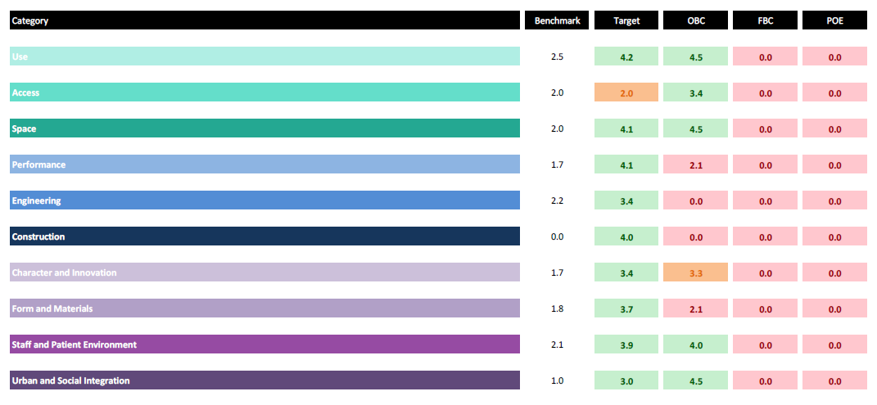
The “performance”, “engineering”, “construction” and “innovation and character” sections could not be fully completed at this stage of the design process and will be reviewed again at the FBC stage when the design is fully detailed. The design scored well across all other categories at this stage with opportunities to improve the scoring further at FBC.

BREEAM
Projects requiring capital investment through the Scottish Government are required to demonstrate sustainable credentials in order to contribute towards the development of a sustainable NHS estate.
The project has been assessed using BREEAM UK New Construction 2018. The assessment took place at a workshop on 15 August 2019 with representation from the Project Team and HFS. The collaborative workshop allowed all the criteria to be discussed and debated. A bespoke approach was adopted where criteria offering value to NHS Fife was targeted. Following the exercise an initial target score of 34.44% was identified which equates to a PASS rating. A number of additional credits have been identified as possibilities, so the target score has opportunities to increase further at the FBC stage.
BREEAM UK New Construction 2018 is in its infancy – initial benchmarks for other recent healthcare projects in Scotland are generating target scores between 30-40%. As a comparison the Fife Elective Orthopaedic Project currently sits within this range with opportunities to increase the target further at FBC.

Healthcare Associated Infection System for Controlling Risk in the Built Environment (HAI SCRIBE)
HAI SCRIBE is a risk management process aiding the identification and mitigation of design and construction related infection risks within the built environment. There are four stages within the process – these are identified in the table below together with project progress against these stages to date.
Stage | Project Progress
Stage 1 – Site Selection | Draft complete within OBC stage. Ground investigation required to complete in final format.
Stage 2 – Design | To be completed at FBC stage.
Stage 3 – Construction | To be completed at FBC stage.
Stage 4 – Occupation | To be completed post completion.
Table 33 - HAI SCRIBE status

Building Information Modelling (BIM)
Building Information Modelling (BIM) describes the process of designing and constructing a building collaboratively using one coherent system of digital models and linked non graphical data, as opposed to separate sets of drawings and documents. These models and data also incorporate information which will be carried over and used in the operational phase.
NHSScotland is supporting the adoption of Level 2 BIM maturity following the SG mandate in support of the recommendations of the “Review of Scottish Public Sector Procurement in Construction” which endorsed that “BIM will be introduced in central government with a view to encouraging adoption across the public sector. The objective states that, where appropriate, projects across the public sector adopt BIM level 2 by April 2017.”
The NHSScotland BIM strategy is intended to ensure the creation of a digitised information management process which all Boards and teams working on NHSScotland programmes should follow to maintain consistency and facilitate collaborative working, which will in turn reduce waste and non-conformances.
The Project will use BIM as a key design tool during the design and construction phases of the project helping to facilitate coordination and mitigate risks. Another benefit of BIM is that NHS Fife will have true “as built” records along with the project specific asset tagging that will assist with the operation, maintenance and replacement of components.
An NHS Fife Employers Information Requirements (EIR) has been developed and offered to the PSCP as part of the Project Brief. The EIR in turn has helped to inform the BIM Execution Plan (BEP) which has been developed by the PSCP. These two documents control how BIM will be utilised on the project.

eHealth
Consultation has been ongoing with eHealth during the OBC phase of the project. Initial efforts have largely focussed on ensuring the IT infrastructure will be sufficiently robust and flexile to accommodate a number of wider initiatives that will help to support the service over the longer term during the operational phase. Such initiatives (subject to separate funding sources) include:
- Pre appointment system via internet / mobile phones
- Self check-in facilities
- Virtual clinics
- Waiting management solutions for OPD
- Theatre cameras for education
- Theatre sound system
- General information screens
- Trak care
- Flexible/efficient patient entertainment system
- Pharmacy fridges security controlled like “hotel fridges” (to identify user)
- Theatre robot

Risk Allocation
Framework Scotland 2 stipulates the use of the NEC, Engineering and Construction Contract (ECC). The ECC is a collaborative form of contract that encourages good management, flexibility and ease of understanding. The contract endeavours to allocate risk fairly via its Compensation Event procedure where the Contractor is compensated if a predefined event occurs. The risk table below provides a high-level overview in respect to the likely risk profile through utilising this form of contract.
 | Potential allocation of risk
Risk Category | Public | Private | Shared
Client / Business risks (title, ground conditions, where not disclosed) | 100% | 0%
Design | 0% | 100%
Development and Construction (note dark ground and contamination remain with the public) | 50% | 50%
Transition and Implementation (commissioning and migration Board responsibility) | 100% | 0%
Availability and Performance (during operation) | 100% | 0%
Operating | 100% | 0%
Revenue | 100% | 0%
Termination | 40% | 60%
Technology and Obsolescence | 80% | 20%
Control | 100% | 0%
Financing | 100% | 0%
Legislative | 100% | 0%
Other Project risks | 50% | 50%
Table 34 - Risk allocation
The risk register established at IA has been developed in greater detail during the OBC stage. A copy of the updated project risk register is contained at Appendix O.

Key Risks
Key risks have been extracted from the risk register and set out in the table below for ease of reference.
Risk | Mitigation
Building Size/Configuration (Clinical Pathways) New clinical pathways may impact on schedule of accommodation —pre-assessment, radiology and outpatient require further clarification. | Patient flows, demand and future operational design to be better understood and planned.
The project becomes unaffordable. | Complete and agree stage 2 cost plan.
Project Plan. The Project Plan does not adequately reflect required tasks and timescales. | A Project Plan is in place and accepted. The pace is fairly aggressive however the Project Team is assembled and motivated to meet the objectives. Progress currently in line with programme.
Risks associated with ground conditions. | Undertake ground investigation. OBC design based on reasonable volume of existing information meantime.
Table 35 - key risks

Payment Structure
Under Frameworks Scotland 2 Consultants and the PSCP are appointed under the NEC form of contract – Options A or C. Under option A, a fixed price is submitted and payment is made on completion of each activity in an activity schedule. Option C is a target price paid monthly up to a target cap.
For the OBC stage of the project, consultants have been appointed under Option A whilst the PSCP has been appointed under Option C. If the OBC is approved, it is envisaged that this arrangement would be extended to cover the FBC stage of the project.
In respect to construction phase it is envisaged that the consultants will remain on Option A contracts. Further consideration on the most appropriate option for the PSCP will be undertaken during the FBC stage of the project. This decision would depend on the maturity of the design and cost information at a point in time. Where the design is practically complete and robust market testing has been undertaken, then an Option A might be more appropriate for the PSCP. Where the design and costs are more fluid then an Option C could be more beneficial helping to encourage collaboration and the joint pursuit of value for money resulting in “share gain” for both parties.
Payments are generally made on a monthly basis in line with the NEC contract provisions.

Project Bank Account
The Project will operate a Project Bank Account (PBA), consistent with Scottish Government Guidance for public sector construction projects. A Project Bank Account is a ring-fenced bank account from which prompt payments are made directly and simultaneously to a lead contractor and members of the supply chain. PBA’s improve subcontractors’ cashflow and ring-fence it from upstream insolvency.
It is the intention that the PBA will become operational during Stage 4 (construction) of the project. The documentation and contractual arrangements associated with setting up the are currently being developed in collaboration between NHS Fife and the PSCP.

Risk Contingency Management
A project risk register was developed at IA and this has since been developed further during OBC. It is used as an active management tool to identify and mitigate risks progressively as the design is developed. The risk register has been priced at the OBC stage to inform contingency allowances. It will be developed further during the FBC stage and priced again at the end of that stage to reflect the residual balance of risk contingency required to complete the project. The balance or risk contingency will generally be apportioned to the party best able to manage each risk as set out and agreed in the risk register.
During the construction stage of the project risks and issues are communicated using the NEC3 Early Warning process. This process encourages the PSCP and Project Manager to alert each other to emerging issues and risks so that they can be discussed and managed collaboratively for the overall benefit of the project.
It is important to note that the risk register is primarily a tool for identifying and managing risks. It is then conveniently used as a method for assessing reasonable allocations of risk contingency in advance of construction. Once in construction however, Employer risks are defined within the NEC3 contract and administered in line with the contract provisions – i.e. the risk register has no commercial relevance.

Contract Variations
As noted, the project is procured under the FS2 NEC3 form of contract which manages contract variations by means of Compensation Events. The major benefit of this process is that Compensation Events are dealt with quickly within pre-defined timescales, this helps to maintain an up to date cost forecast.
The Compensation Event process enables Employer’s risk items which transpire to be reflected in an adjustment to the Target/Price and/or an adjustment to the programme.

Disputed Payments
The FS2 NEC3 form of contract has processes to manage disputed payments. PSCP applications for payment may have disallowed costs which are monitored by the Joint Cost Advisor (JCA) at each monthly assessment to ensure that only payments due and fully accounted for are passed.

Payment Indexation
Payment indexation is managed centrally on FS2 and hourly staff rates for both PSCs and PSCPs are adjusted and notified annually across the Frameworks by HFS.
Construction inflation is managed by reference to Building Cost Information Services (BCIS) published cost indices. The construction inflation risk is held by the PSCP for the first two years of the programme. The risk is then passed to the NHS Client for the balance of the programme beyond two years.

Utilities and Service Connection Charges
As the Project is publicly funded, utilities and service connection charges are paid by NHS Fife as part of the contract.

Performance Incentives
The main NEC3 PSCP contract option for construction has yet to be selected. There is an opportunity to use an Option C Target Price arrangement which is an incentivised arrangement.
Once the Target Price has been agreed, the PSCP is paid their defined costs plus fee on a monthly basis. If the PSCP’s defined cost at the end of the project falls below the Target Price, then they are entitled to a share of the difference. If, however the PSCP’s defined cost exceeds the Target Price then they are wholly liable for the difference. The share/pain arrangements are summarised on the table below.
Share range of Target Price | Contractor Share at Stage 4 (construction)
Less than 95% | Nil %
From 95% to 100% | 50%
Greater than 100% | 100%
Table 36 - NEC contract data share ranges

Contractual Arrangements

Contractual Overview
As previously noted under FS2 the NEC3 (ECC3) form of contract will be used to administer the contract. The NEC3 is a flexible contract allowing Client or Contractor design. It also allows for sharing of design responsibility. In addition, the contract supports six main pricing options. Under FS2, two options are offered these being:
- Option A: Price contract with activity schedule
- Option C: Target Contract with Activity schedule
In respect to design responsibility, the contract will be drafted so that 100% design responsibility is allocated to the contractor (PSCP). The contract will therefore be 100% contractor led design and build.
In terms of the main options for the PSCP, it is anticipated that Option C will be utilised for the pre-construction phases of the project (OBC and FBC). A decision on the preferred option for the construction stage together with rationale will be set out within the FBC.
The project will be procured via stages in line with Framework Scotland 2 methodology. At the end of each stage the contract documentation for consultants and the contractor will be updated and executed to allow entry into the subsequent stage. The key stages and outline dates are set out below:
Stage | Dates | In contract?
Stage 2 – OBC | May 19 to Oct. 19 | Yes
Stage 3 – FBC | Nov. 19 to Sept. 20 | No
Stage 4 – Construction | October 20 to Mar 22 | No
Table 37 - Milestone dates

Roles and Responsibilities
Contractual roles and responsibilities are set out within the ECC. These roles are summarised below:
- Employer: NHS Fife
- Contractor: Graham Construction
- Project Manager: Thomson Gray
- Supervisor: To be confirmed

Dispute Resolution and Termination
Procedures for contract administration, dispute resolution and termination are clearly set out within the NEC3 form of contract.

Asset Ownership
In respect to asset ownership, the project is being procured using traditional capital funding. In this relationship the PSCP is responsible for designing and constructing the facilities. At Completion, NHS Fife will take possession of the building and will be responsible for the ongoing operation and maintenance of the facilities.

Personnel Implications
There are no employees who are wholly or substantially employed on services that will be transferred to the private sector under the proposals for this Project, and therefore the Transfer of Undertakings (Protection of Employment) Regulations 1981 (TUPE) will not apply.

Financial Case

Introduction
The Financial Case considers the affordability of the scheme. This section sets out all associated capital and revenue costs, assesses the affordability of the preferred option and considers the impact on NHS Fife’s finances. The affordability model assessment has been developed to cover all aspects of projected costs including estimates for:
- Capital costs for the option considered (including construction and equipment);
- Non-recurring revenue costs associated with the project;
- Recurring revenue costs (pay and non-pay) for current model i.e. baseline; and
- Recurring revenue costs (pay and non pay) for the preferred option.

Revisiting the Financial Case
The IA was approved by Scottish Government Health and Social Care Department (SGHSCD) in January 2018 and no specific conditions were outlined in the approval letter in relation to the Financial Case.
NHS Fife have considered the affordability of this proposal by undertaking a review of the financial implications of investment, both capital and revenue.

Financial Model: Costs and Associated Funding for the Project

Capital Costs
Capital costs have been estimated by independent cost Advisors Gardiner & Theobald and have been summarised in Table 38 below. The Capital Cost Report Summary is included in appendix K and the full detailed Cost Report is available if required.
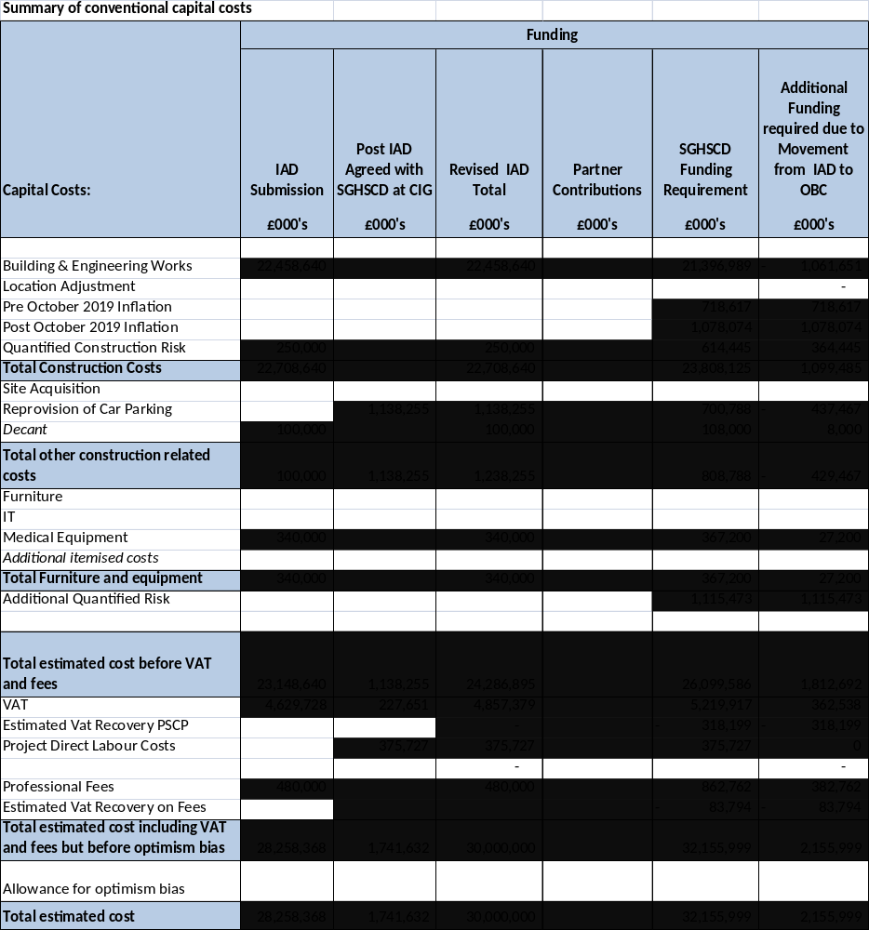
Table 38 - Summary of conventional capital costs

The total cost of the preferred option, which is to develop an Elective Orthopaedic Centre for NHS Fife is £32,155,999.
Table 39 below provides a summary of key project cost adjustments. The adjustments are described further beneath the table from a budgetary perspective.
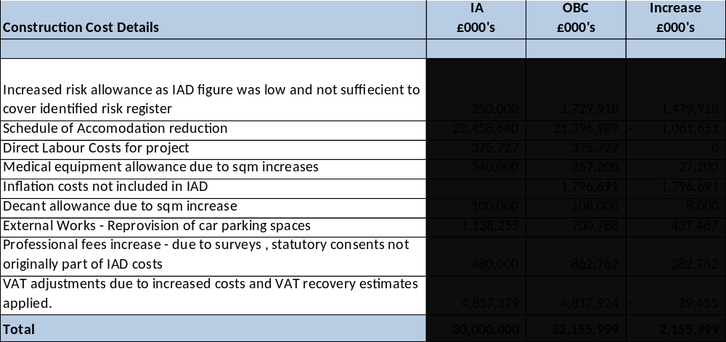
Table 39 - Project cost adjustments
Following submission of the IA to SGHSCD it was agreed at CIG that car parking re-provision and direct labour costs associated with the project should be allowed for within the budget – the IA figure rose from £28,258,368 to an agreed £30,000,000 to take account of this. The car parking re-provision amounted to £1,365,906 whilst the direct labour costs for the project were established at £375,727.
In respect to the OBC cost plan, there is a difference amounting to £2,155,999 when compared to the agreed IA allocation (£30,000,000). This difference is attributed to inflation from a budgetary perspective and has been calculated against the construction costs from IA to construction. Costs have been allocated within the adjusted budget taking account of inflation.
In the OBC cost plan the inflation assumptions have been rebased to ensure they are as current as possible, and inflation relating to the period between IA and OBC is now historical, and therefore now included in the current construction costs. There is a forecast inflation allowance built in from the period October 2019 to construction. This highlights the need when developing business cases to avoid unnecessary delay in order to alleviate inflationary pressures.

The estimates above include the following key assumptions:
Cost | Assumption
Professional Fees | Professional fees are based on tenders awarded except the supervisor fees, survey and statutory consents which are currently an estimate and yet to be awarded.
Equipment | Estimated % cost based on cost advisor allowance. Transferable equipment will be moved to the new unit.
Contingency | A priced risk register has replaced Optimism bias at OBC stage.
Inflation | Based on October 2019 Indices to construction.
VAT | VAT has been applied where applicable. Cost advisor VAT recovery estimates have been built in to the cost plan – this will to be confirmed with VAT advisors and HMRC after contract is awarded.
Table 40 – Capital key assumptions

Revenue costs
In order to confirm the revenue implications of the project the baseline costs (do nothing/minimum option) have been thoroughly reviewed and then compared to the projected costs of the preferred option to assess the financial implications.
A number of assumptions have been made at the OBC stage which will be further evaluated and revised throughout the process to FBC development. These assumptions are as detailed in the table below.
Cost | Assumption
Costs | Costs are calculated using 2018/19 prices and using 2018/19 budgetary information.
Workforce | Calculations include allowances for on-costs, enhancements, sick leave, public holidays and annual leave. Workforce increases are based on forecast demand growth.
Non-Pay | Non-pay costs assumed to increase in line with phased forecast demand.
Depreciation | Building – 60 years and equipment 10yrs.
Table 41 - Revenue key assumptions

The clinical and support costs for the existing Elective Orthopaedic service have been calculated as the baseline and then used as a benchmark against which any changes are considered. Estimated costs for the preferred option reflect forecast demand from 2025 (initial forecast activity increase), 2030 the second phased activity increase and then 2035 onwards showing the full impact of the increased anticipated activity.

Service model costs
The tables below summarise the total increase in costs arising from these estimates.
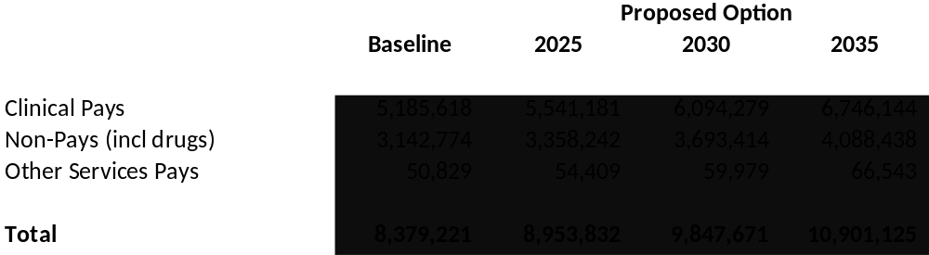
Table 42 - Revenue cost increases

Property costs
An outline of the changes in both running costs and depreciation is summarised below:
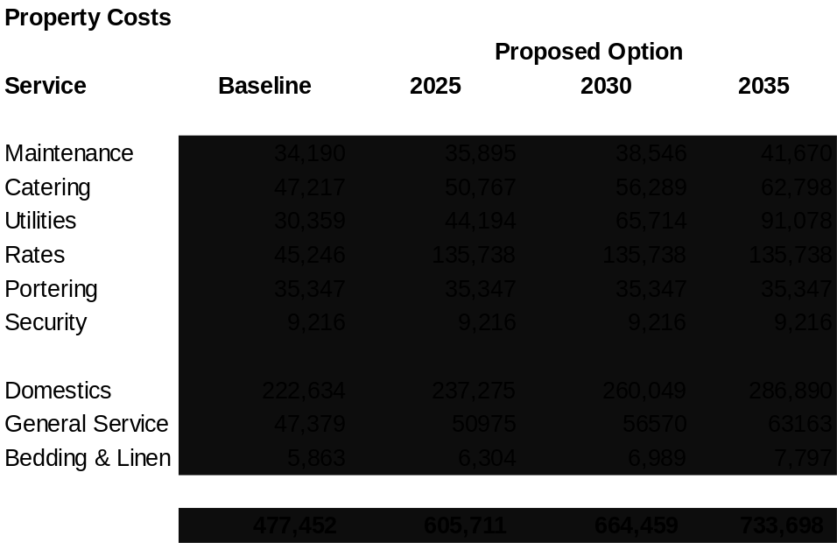
Table 43 - Property costs

Depreciation
The depreciation for the preferred option is £572,653 based on an asset building life of 60yrs and 10yrs for equipment on an overall capital cost of £32,156,000. The overall increase in depreciation is £572,653 - which will be met from the current ring-fenced NHS Fife non-core depreciation budget. The buildings depreciation charge is pre any Valuation Office valuation being done after completion – there is an expectation that any non-value works will reduce the value held in the balance sheet once the valuation is carried out and therefore reduce the depreciation charge going forward.

Revenue cost summary
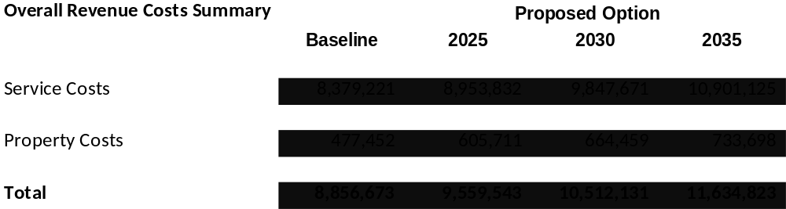
Table 44 - Revenue cost summary
The OBC identifies a phased overall recurring revenue impact by 2035 onward of £2,778,150 (excluding depreciation) for the preferred option against the baseline costs.
There are considerable staff costs associated with this development - staffing, non-pay and consumable costs will continue to be reviewed as the FBC develops.

Accounting Treatment
The traditional funding route for the project will impact on NHS Fife’s Balance Sheet - both the capital cost of the development and the associated capital equipment will be added as non-current assets to the balance sheet and depreciated over the life of the assets in line with accounting policies.

Statement of Affordability
NHS Fife confirm that this project remains affordable in both revenue and capital terms. The capital costs of the investment will be met through a capital contribution from the Scottish Government Health and Social Care Division capital budget.
Additional recurring revenue costs for the Elective Orthopaedic Centre will be incorporated into NHS Fife’s Annual Operational Plan for future years.

Stakeholder Support
As the project will be delivered by NHS Fife for Fife, written agreement of Stakeholder support from other NHSScotland / public sector organisations is not required in this instance.

Financial situation
Based on the current costs and assumptions identified, NHS Fife recognises the project will exceed what was estimated within the Local Delivery Plan 2017/18, due to various different models that were considered. The original submission has since evolved into a standalone elective orthopaedic centre, providing future sustainability for the people of Fife.
The revenue costs are considered to be affordable within the revenue resources available.
All costs will continue to be reviewed and refined throughout the FBC process.

Resources
Both Project Board and Project Team have been established with governance arrangements in place. The Project Board will ensure appropriate governance throughout the project. The Board has insured that the following dedicated internal resources have been made available to date:
- Project Director (full time);
- Finance Accountant (part-time);
- Clinical Advisor (part-time);
- Project Administrator (full time);
Other internal stakeholders outlined at Section 7.3.1 are involved and committed to the project as noted – their project roles are over and above their core day to day roles.

Capital and revenue constraints
NHS Fife’s capital funding commitments mean that the project cannot exceed the available budget. Any additional revenue costs will be met within NHS Fife’s overall revenue resource envelope.

Financial contributions
Other than capital funding from the Scottish Government, there will be no financial contributions from external partners in respect to this project.

Management Case

Introduction
The main purpose of the Management Case is to demonstrate that NHS Fife is ready and capable of delivering the project successfully.

Revisiting the Management Case
Since IA, the management case has generally been developed in greater depth. This has been done using SCIM OBC guidance as a framework.

Reporting Structure and Governance Arrangements

Project Organisation
In order to deliver the project successfully, good governance is required to monitor and direct it. An understanding of the structure and mechanisms for escalation and reporting is set out on the organogram overleaf.
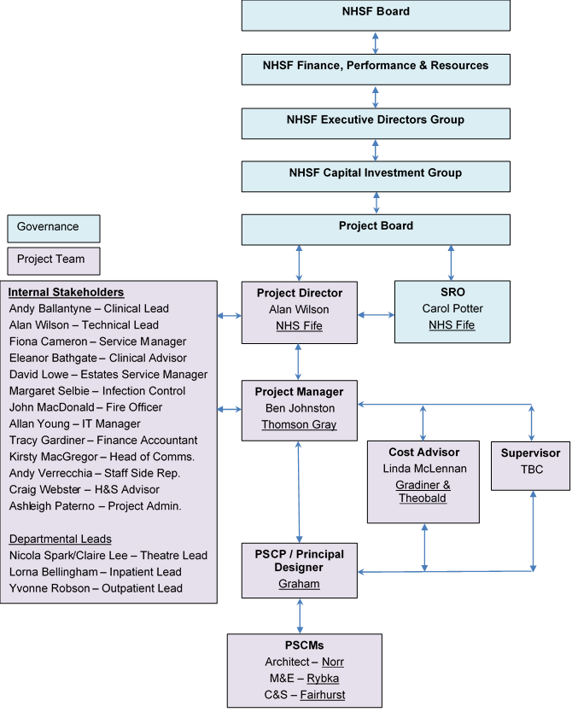
Figure 17 - Project structure

Project Board
A Project Board has been established to oversee the project. The Project Board was set up at commencement of the OBC and Terms of Reference have been agreed. The Project Board meets monthly where they receive a regular project update report from the Project Director. Necessary matters are escalated by the Project Director as required whilst the Project Board offers direction to the Project Team.
Project Board membership and experience is outlined in the table below:
Named Person | Project Role and Responsibilities | Experience
Carol Potter (Director of Finance) | Senior Responsible Officer – SRO with overall responsibility and accountability for the project. | Carol is a strategic finance leader with over 25 years experience across the public sector and a Chartered Public Finance Accountant. Carol has provided strong financial management support and governance to major capital investment projects within the NHS. Carol is an Executive Board Director with NHS Fife and provides a direct governance link to the NHS Board and associated Committees.
Alan Wilson (Capital Projects Director) | Project Director – Responsible for the delivery of the project from inception to completion. | Alan has worked within NHS Fife for 23 years within Estates Operations. He has over 10 years experience in the delivery of a wide range of Capital Projects within Healthcare environment. Alan is a Chartered Engineer and also an accredited NEC Project Manager.
Andy Ballantyne (Lead Consultant Orthopaedics) | Clinical Lead - Responsible for clinical governance. | Andy Ballantyne is a Consultant Orthopaedic Surgeon with NHS Fife since 2005.Andy has been the Clinical lead for Orthopaedics in NHS Fife since 2015. Andy was also a member of the core team involved in the development and submission of the IA for the Fife Elective Orthopaedic Centre delivered to CIG in Nov 2018. Andy has extensive experience in local DCAQ planning and delivery. Andy is an active member of the national Scottish Committee for Orthopaedic s and Trauma for 10 years, in roles of treasurer and more recently secretary and is also Co-Chair on the East Region Acute service review – orthopaedics work stream with specific involvement in DCAQ evaluation 2016-2018.
Andrew Fairgrieve (Director of Estates, Facilities & Capital Services) | Project Board Member – Responsible for contributing towards general governance. | Andrew has vast Property and Asset management experience in the private sector and within the NHS. Andrew has a degree in IT/Electronics and a Masters Degree in building services design (mechanical and electrical). Andrew has also managed large new build and refurbishment projects.
Ellen Ryabov (Chief Operating Officer) | Project Board Member – Responsible for contributing towards general governance. | Ellen has worked in the NHS for 30 years and is both a qualified accountant ACMA and an MBA Graduate of Strathclyde Graduate Business School. Ellen has extensive Board level experience, having worked in three of the largest Acute Trusts in England. Ellen was appointed to the post of Chief Operating Officer (Acute Services) on 28 January 2019, prior to this she held the post of Chief Operating Officer with Hull and East Yorkshire Hospital before deciding to return to the NHS in Scotland.
Fiona Cameron (Service Manager Planned Care) | Service Lead – Responsible for service governance. | Fiona is Service manager Orthopaedic, theatres & anaesthetics. Fiona has 15 years experiences of Orthopaedics as an extended scope physiotherapist, Orthopaedic service improvement lead and service manager. Fiona was a member of the core team involved in the development and submission of the IA for the Fife Elective Orthopaedic Centre. Fiona is also a Member of the Scottish Orthopaedic Service managers group and a member of East Region Orthopaedic service review group. Fiona has extensive experience of Orthopaedic and theatre redesign projects.
Kirsty MacGregor (Communications Manager) | Project Board Member – Responsible for communications governance. | Kirsty MacGregor brings more than 25 years of experience in public relations and marketing communications. Kirsty has a proven track record of providing expert and informed advice to senior management teams on all aspects of internal and external communications across a range of sectors including Higher Education, Local Government and the NHS.  A CIPR Accredited Practitioner, Kirsty also holds two Postgraduate Diplomas from the Chartered Institute of Public Relations, and the Chartered Institute of Marketing.
Murray Cross (General Manager Planned Care) | Project Board Member - Responsible for contributing towards general governance. | Murray has worked in NHS Fife for over 30 years, having started in Finance before moving into management in 1999. Murray has held a wide range of management positions across the Acute Division and has been in his current post of General Manager for Planned Care for the last 4 years.
Rona Laing (Non Executive Board Member) | Project Board Member – Responsible for contributing towards general governance. | Rona has been a Non-Executive Board member for 5 years she chaired the Audit and Risk Committee for several years and now chairs the Finance Performance and Resources Committee. Rona has contributed to the review and enhancement of the Board governance processes
Tracy Gardiner (Capital Accountant) | Capital Finance Lead – Responsible for financial governance. | Tracy has worked within NHS Fife for 25 years within the capital branch of the finance department. Tracy has a wide range of knowledge and experience in the delivery of capital projects within NHS Fife.
Wilma Brown (Employee Director) | Project Board Member – Responsible for staff governance. | Wilma has been the Employee Director for 10 years and will ensure we meet the required Staff Governance Standards through our Partnership processes. Wilma has been involved in a number of projects such as this and will ensure any aspects of the SG Standards are correctly identified and communicated between staff, staff side reps and the Project Board.
Table 45 - Project Board experience

Project Team
The project team sits below the Project Board and are responsible for delivering the project on a day to day basis. This includes, developing the design, managing risks, developing the costs, developing the business case, constructing the facility, commissioning the facility and successfully handing the facility over to NHS Fife at completion.
Within the Project Team, there are a range of roles with different responsibilities. The key roles and responsibilities are listed below:
Project Director – the Project Director is responsible for overseeing the delivery of the project on a day-to-day basis and for generally acting as the link between the Project Team and the Project Board. The Project Director will report to the Senior Responsible Officer and Project Board.
Clinical Lead and Service Manager – the Clinical Lead and Service Manager is responsible for clinical governance ensuring that sufficient engagement and participation is evidenced to allow the briefing and related design proposals to be robustly developed. They will also be responsible for accepting design proposals from a clinical perspective at key stages as part of the governance process and for resolving any conflict amongst Clinical Stakeholders.
Clinical Advisor – the Clinical Advisor role will involve providing support to the Clinical Lead and Service Manager. The role will also include leading on commissioning from a clinical perspective ensuring that the transfer to the new asset is managed smoothly.
Technical Lead – the Technical Lead will be responsible for ensuring that the briefing and related technical proposals align with the Board’s expectations and requirements. The Technical Lead will also be responsible for accepting design proposals from a technical perspective at key stages as part of the governance process.
Technical Stakeholders – the Technical Stakeholder group consists of representation form the following areas: estates, FM, fire, ICT and infection control. They will be responsible for providing local knowledge and advice in order to refine the briefing. They will also be required to review the PSCP’s proposals and attend agreed meetings so that the proposals can progressively be accepted in advance of the construction stage.
Clinical Stakeholders – the Clinical Stakeholder group are responsible for providing local knowledge and advice in order to refine the briefing. They will also be required to review the PSCP’s proposals and attend agreed meetings so that the proposals can progressively be accepted in advance of the construction stage.
Project Manager – the Project Manager will be the central hub within the project responsible for delivering the project within pre-agreed time, cost and quality parameters. All project communication should flow through the Project Manager as outlined within the organogram at Section 7.3.1. The Project Manager will report to the Project Director. The Project Manager will also be responsible for managing the project in accordance with the contract option selected.
Joint Cost Advisor – the Joint Cost Advisor will primarily work alongside the Project Manager assisting with setting the budget, creating cost plans, agreeing the target/price whilst contributing towards value management, value engineering and risk management. They will also assist the Project Manager with payment assessments and compensation events. The Joint Cost Advisor will act in a “joint” capacity assisting the PSCP with preparing pricing schedules / bills of quantities and other documentation required for tender purposes.
Supervisor – the Supervisor’s main duties relate to ensuring quality is provided during the construction stage. They do this through acting in accordance with the contract. The Supervisor may be appointed during the pre-construction phase to assist with developing the Works Information (testing requirements) and reviewing the PSCP’s proposals.
PSCP – the PSCP is responsible for designing and constructing the project within the agreed time, cost and quality constraints. They are also responsible for working in a safe manner whilst mitigating the risk of any operational disruption caused by the works. The PSCP’s full scope of duties are contained within the contract Works Information.
Principal Designer – the PSCP will be appointed as Principal Designer, in line with the CDM Regulations 2015. The role involves planning, management and coordination of health and safety in the pre-construction period, help and advice in bringing together the pre-construction information pack, working with the other designers to eliminate foreseeable health and safety risks, and ensuring the PSCP team are informed of risks requiring management in construction.
The Principal Designer is also responsible for coordinating and developing the Health and Safety File and for providing copies at the end of the project.
PSCMs – Principal Supply Chain members are designers and sub-contractors appointed directly by the PSCP to deliver and design the works.

External Advisors
Independent consultants who have been appointed by the Board are set out in the table below:
Project role | Organisation | Lead person(s)
Project Manager | Thomson Gray | Ben Johnston
Cost Advisor | Gardiner & Theobald | Neil Cowan  Linda McLennan
Business Case Author | Thomson Gray | Ben Johnston
NEC Supervisor | TBC | TBC
Clerk of Works | TBC | TBC
Table 46 - External Advisors

Project Recruitment Needs
The Project Team has been developed robustly during the OBC Stage. The only remaining roles to be filled are NEC Supervisor and Clerk of Works. At this point in time, it is considered that these roles will be external appointments and will be procured towards the end of the FBC Stage. The roles may be combined into one procurement to be fulfilled by one organisation.

Project Plan and Key Milestones
The project plan and key milestones are set out in the table below:
Description / Activity | Date
OBC
- Submit to Capital Investment Group (CIG), Scottish Government (SG) | 15 Oct. 2019
- Finance Performance and Resources Committee (FP&R), NHS Fife | 5 Nov. 2019
- Capital Investment Group (CIG), Scottish Government (SG) Meeting | 12 Nov. 2019
- NHS Fife Board Meeting | 27 Nov. 2019
FBC
- Complete car park enabling works (to enable site to be cleared for construction) | Aug. 2020
- Statutory consents | Aug. 2020
- Submit to Capital Investment Group (CIG), Scottish Government (SG) | 11 Aug. 2020
- Finance Performance and Resources Committee (FP&R), NHS Fife | Aug. 2020
- Capital Investment Group (CIG), Scottish Government (SG) Meeting | 9 Sept. 2020
- NHS Fife Board Meeting | Sept. 2020
Construction and handover
- Start | Sept. 2020
- Completion | March 2022
- Post Project Evaluation | March 2023
Table 47 - Project plan and key milestones

Car Park
As noted within the project plan, the current strategy is to complete a replacement car park as enabling works during FBC. This will allow displaced car parking to be re-provided in advance of main project works commencing.
The car park will be formed at Whyteman’s Brae on land currently owned by NHS Fife. This will allow additional staff car parking at Whyteman’s Brae freeing up patient/visitor car parking adjacent to the hospital.
Costs associated with the car park have been budgeted and included within the Financial Case capital cost allocation.

Change Management Arrangements

Operational and Service Change Plan
The Fife Elective Orthopaedic Centre will result in the following changes:
- Increased surgical capacity by the provision of a third elective orthopaedic theatre with capacity to manage elective orthopaedic requirements for inpatient activity for the next 20 years based on ISD projections;
- Increased ward capacity to provide a mixture of single room and day case facility to reflect the changing requirements for inpatient elective orthopaedic surgery;
- Centralisation of NHS Fife MSK services to a single site, with resultant improved efficiency in OPD activity through developments consistent with the objectives of the Scottish Access Collaborative (SAC) in demand management within outpatients;
- Utilisation (where appropriate) of IT strategies building consistency with local and national strategy in the delivery of the aims of the SAC in demand management.

Theatres
Theatres plan to provide increased capacity by the provision of a third elective orthopaedic theatre. This will accommodate future demand for major joint surgery within NHS Fife over the next 20 years. These calculations are based on ISD projections for hip and knee arthroplasty (2017).
Short term theatre utilisation will be attained by relocating the Hand Service to the Fife Elective Orthopaedic Centre. Future demand will be accommodated by increasing theatre time utilisation and job plan redesign (weekend working and 3 session days).
The relocation of hand service will coincide with the opening of the Fife Elective Orthopaedic Centre. Subsequent adjustment to job plans will be recognised in future consultant appointments and a review of current job plans will be undertaken with a view to increasing flexibility. This will be a progressive process over the next 20 years reflecting the demands on service.
This will be led by Clinical Leads and Service Managers working in partnership with consultants to achieve theatre efficiency and delivery of the TTG.

Wards
In respect to the increased ward capacity, the workforce planning tool will be utilised to determine future nursing needs.
It is recognised that providing a mixture of day case beds and single room inpatient beds offers patient capacity consistent to the changing requirements for inpatient bed space. An increasing number of patients, including lower limb arthroplasty, can be managed through a day case facility. This has the benefit of maximising the efficient use of staff as it is recognised that a 100% single room wards have increased nursing requirements.

Centralisation of MSK services
Currently MSK service is delivered form a number of sites across NHS Fife. Often MSK practitioners are working in isolation with limited clinical or peer support. The centralisation of MSK services to a single purpose-built facility in Fife offers a number of benefits:
- MDT MSK delivery from single site;
- Opportunity to develop MDT support – clinical staff not working in isolation;
- Development of consistently applied pathways for MSK conditions;
- Efficiency opportunities in how aspects of service delivered (fracture clinics);
- Opportunities to develop AHP staff into more advance roles (fracture clinic nurses/ANP roles); and
- Opportunities to incorporate national and local IT strategies consistent with the Scottish Access Collaborative aims in demand management within outpatient services:
- Opt-In care
- Patient initiated review appointments
- Development of virtual clinics (NP and review)
This will be achieved by the service undertaking a review of current OPD activity and through a series of workshops looking at redesigning part of the service. Staff and patient engagement will be implemented within this transition. Service redesign will occur over the next three years to enable changes to be embedded prior to the transfer of services to the Fife Elective Orthopaedic Centre.

Facilities Change Plan
The new facility will be serviced by NHS Fife’s in-house facilities team. The facility is a replacement for the current orthopaedic theatres and the associated ward currently located in Phase 2 tower block. The facility will be serviced under the existing facilities strategy through the link corridor provided in the new design that connects to the hospitals main FM corridor. Recognition has taken place that there will be a need for extra revenue costs for providing facilities services to the new building due to the increase in patient numbers projected over the next 25 years. These costs have been provided within the Financial Case (see Section 6).

Stakeholder Engagement and Communications Plan
A Stakeholder Engagement and Communication Plan has been developed and endorsed by the Project Board. A copy of the plan can be located at Appendix P.
Stakeholder engagement has occurred at different levels to date. From a design perspective staff and service users have been actively involved in helping to develop the design of the facility. This has occurred through the following workshops:
- Development of the project’s Design Statement;
- 1:500 / 1:200 site and departmental adjacency workshops; and
- Achieving Excellence Design Evaluation Toolkit (AEDET) workshop.
At a higher level several tools have been used to communicate the project to wider staff, service users and the general public. These tools have included:
- Dedicated intranet page for staff;
- Dedicated page on NHS Fife’s website for the public; and
- Project displays / notice boards within the main hospital reception at VHK.

Benefits Realisation

Benefits Register
The rationale for an investment needs to be reflected in the realisation of demonstrable benefits, as this will provide the evidence base that the proposal is worthwhile and that a successful outcome is achievable. The benefits to be achieved are discussed in the Strategic Case and have resulted in the creation of a Benefits Register and Benefit Realisation Plan for the Project. The Benefits Register is located at Appendix M.
The benefits register includes a range of benefits to be realised by the development. Each benefit includes a target that will be used to indicate the measure of success during the Post Project Evaluation (PPE).
Benefits are either assessed in a quantitative or qualitative manner.
For the quantitative benefits, the register indicates the baseline (current position) at the start of the project including the source. This will be compared with the same data source in 2023 when the PPE is completed.
For benefits that are qualitative in nature, questionnaires will be developed, and a mix of patient and staff surveys/interviews will be undertaken to outline the baseline for these benefits. The same survey tools will be used during the PPE to examine to what degree the improvements sought were achieved.

Additionally, a Red, Amber, Green (RAG) score highlighting the relative importance of each benefit is indicated using the scale outlined below in the table below.
Scale / RAG | Relative importance
1 | Fairly insignificant
2
3 | Moderately important
4
5 | Vital
Table 48 - Benefits and relative importance
Whilst the benefits “measurement methods” have been identified within the OBC period, further work is required to identify the baseline and target values for each benefit – this will be undertaken within the FBC period.
Community Benefits
The Benefits Register also sets out wider sustainability opportunities associated with this Project. Notably there is potential to deliver community benefits through education, training and recruitment, whilst targeting work packages offered to Small or Medium Size Enterprises (SMEs).
Within the procurement process the requirement for community benefits was set out in the tender documentation. These requirements are referenced within the Benefits Register which the PSCP will be expected to meet and surpass.

Benefits Realisation Plan
A Benefits Realisation Plan has been produced to support the achievement of the benefits outlined in the Benefits Register, and it is included as Appendix N.
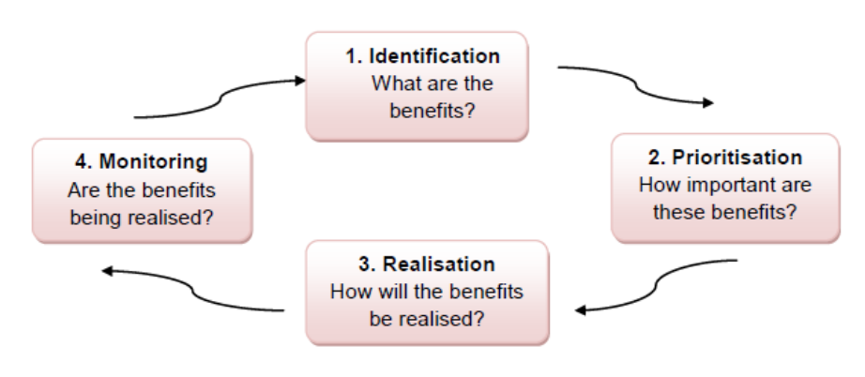
The benefits realisation process is a planned and systematic process consisting of four defined stages outlined below. The implementation of this plan will be reviewed regularly by the Project Board.
Figure 18 - Benefits realisation process
The Benefits Realisation Plan outlines:
- Which Investment Objective the benefit addresses;
- Who will receive the benefit;
- Who is responsible for delivering the benefit;
- Any dependencies that could affect delivery of the benefit; and
- Any support needed from other agencies etc. to realise the benefit.
Benefits monitoring will be ongoing over the life of the Project through the planning, procurement and implementation phases. Progress will be reported to the Project Board at regular intervals and will culminate in the Project Evaluation Report to be produced in 2023.

Risk Management
Risk management is a structured approach to identifying, assessing and controlling risks that emerge during the project lifecycle. It is a critical and continuous process throughout the planning, procurement and implementation journey of a project.
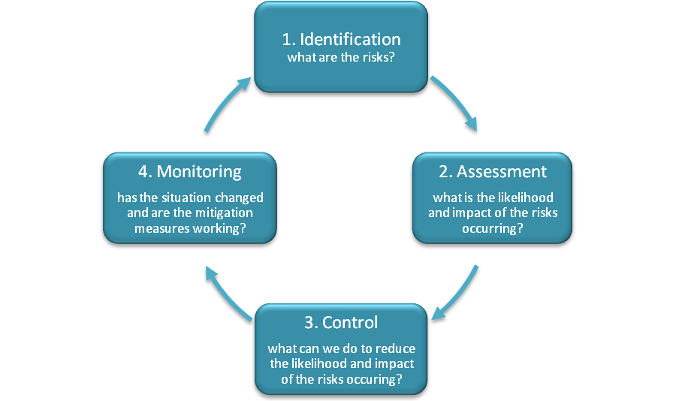
Figure 19 - Risk management process

Updated Risk Register
The Project Team have developed the initial Risk Register created at IA. The current risk register can be located at Appendix O. The risks are generally now more project focussed on balance and reflective of the current stage in the process. The headline items noted below, demonstrate how the risk register has been developed since IA.
- New risks have been identified and added to the register, whilst other risk have been closed;
- Probability, impact and risk ratings have been updated progressively at risk workshops;
- Mitigation measures have been agreed and updated;
- Each risk has been identified as quantifiable or unquantifiable – where the risk is identified as quantifiable it has been carried forward to allow pricing of contingency;
- Risk owners and managers have been allocated. A risk owner has overall responsibility for the risk, whilst a manager is responsible for helping to mitigate the risk.

Governance
The Project Director has overall responsibility for the project risk register. The Project Manager is however responsible for maintaining the risk register on a day to day basis and for organising regular risk workshops to review and manage the risks.
The risk register is updated and provided to the Project Board on a monthly basis as an Appendix to the Project Manager’s monthly progress report. Key risks are extracted from the risk register and highlighted within the Project Manager’s monthly report for ease of reference. The Project Board provide direction to the Project Director and Project Manager on risk matters as necessary.

Commissioning
The importance of the commissioning process cannot be underestimated, as failure to adequately consider this process is likely to cause increases to project costs and failure to deliver agreed service benefits and project outcomes. The Project Board and Director are fully committed to implementing a robust commissioning process, ensuring that the facilities are safe to use and operate from the outset. With this in mind; the Project Director is actively keen to embrace and trial new commissioning and testing procedures. These will be collaboratively agreed with the PSCP, NEC Supervisor and Clerk of Works and incorporated into the contractual Woks Information as agreed obligations.
The commissioning process will be treated as a distinct workstreams, but fully integrated into the overall project to enable a smooth transition to the new working arrangements and realisation of the anticipated benefits. Workstreams will include Technical Commissioning and Operational Commissioning and these will be supported by BIM and Soft Landing processes.
Technical Commissioning concentrates on the readiness of the facility to support operational activity. As such the mechanical and electrical systems all need to be operating satisfactorily at handover of the facility and beyond. Operational Commissioning on the other hand is involved with getting the clinical services transferred into the facility with minimal disruption to business continuity. Given these separate requirements an Operational Commissioning Manager will be appointed directly by NHS Fife (this appointment is already in place). The Technical Commissioning Manager role will be undertaken by the PSCP; however, the Project Director, Project Manager, NEC Supervisor and Clerk of Works will maintain active roles helping to facilitate a robust technical commissioning process.
The Commissioning Managers will report to the Project Manager on a day to day basis but will maintain lines of communication with the wider team to deliver against the plans.
The Commissioning Managers will be charged with developing the Commissioning Requirement Brief and Masterplan within the FBC stage of the programme. These documents will be offered as part of the FBC submission.

Post Project Evaluation
The arrangements for post implementation review and project evaluation reviews have been established in accordance with best practice. These reviews will determine whether the anticipated benefits identified at the outset have been delivered. The project will be evaluated in stages:
Stage 1 – Procurement Process Evaluation
An evaluation of the procurement process will be undertaken following the signing of the contract to assess the effectiveness of the procurement process in meeting the project objectives. This will identify any issues and lessons to be learned that will benefit future projects.
Stage 2 – Monitoring Construction
During the construction period progress will be monitored to ensure delivery of the project to time, cost, and quality to identify issues and actions arising. On completion of the construction phase the actual project outputs achieved will be reviewed and assessed against requirements, to ensure these match the project’s intended outputs and deliver its objectives.
Stage 3 – Initial Project Evaluation of the Service Outcomes
This will be undertaken 6 to 12 months after the new facility has been commissioned. The objective is to determine the success of the commissioning phase and the transfer of services into the new facilities and what lessons may be learned from the process.
Stage 4 – Follow-up Project Evaluation
This will be undertaken 2 years into the operational phase by the Evaluation Team to assess the longer-term service outcomes and ensure that the project’s objectives continue to be delivered.
The following questions will be asked at each stage:
- Have relevant project objectives been achieved?
- Has the project progressed as planned?
- If the plan was not followed, why did this occur?
- If appropriate, how should plans for future projects be amended?
The process will be led by evaluators, independent of the delivery team, who will meet with representatives of the user groups and other key stakeholders. The Project Sponsor, on behalf of the Project Board, will receive reports at each stage of the evaluation process.

Appendix A – Strategic Assessment
Appendix B – Existing Plans
Appendix C – Projected Future Demand
Appendix D – Long and Short List of Options
Appendix E – Option Cost Breakdown and Assumptions

Appendix F – Proposed Floor Layouts
Appendix G – AEDET

Appendix H – HAI SCRIBE – Stage 1

Appendix I – Design Statement

Appendix J – Derogation Schedule
Appendix K – Cost Plan Extract
Appendix L – Benefits Register
Appendix M – Benefits Realisation Plan
Appendix N – Risk Register

Appendix O – Communication Plan

