

Medical Education Services Welcomes You to NHS Fife



This welcome booklet covers all of the key information you will need before starting and throughout your placement. If you do not find the information you need, please contact us using the contact details on the final page.

Contents

Guidance 3

First Day and Induction 4

Accommodation 5

Queen Margaret Hospital Accommodation 5

Fire Safety 6

Security 6

Parking 6

Wi-Fi 6

Placement Information 7

Timetables and Absence 7

Assessments 7

Confidentiality 7

Tutorials 7

TuBs 7

Teams 7

The Education Centre 8

The Skills Hub QMH 8

Student ID Badges 9

Student IT Access 9

Password Requirements 9

Shuttle Bus Service 10

End of Placement Information 11

Contact Us 11

Feedback 12

# Guidance

Please note before reading further, we have tried our best to cover all placement types and make this document as generic/relevant to all Year Groups and Specialties as possible.

However, we have a large number of students coming to us from various universities and degree programmes, so there may be parts of this document that don’t apply to your placement specifically.

**If there is conflicting information on this document to the details sent by the Undergraduate/ScotGEM Coordinators, please follow the information sent to you directly in the first instance.**

In particular, if you are on the ScotGEM degree programme, some parts will not apply to you, such as the induction arrangements, reporting procedure and in some cases, the accommodation details. Also, if your placement is based at Queen Margaret, Stratheden etc, you may also feel that there are parts of this document that are irrelevant to you.

# First Day and Induction

On arrival, you will be greeted by a Medical Education Service member of staff who will summarise the basics of your placement during a short induction.

Please let us know if you are unable to attend induction.

For placements based at The Victoria Hospital (VHK), inductions will take place in the Education Centre located on Level 2 of Phase 2 unless otherwise advised in your welcome email. For placements based elsewhere, you will find your first day instructions in the Welcome Email.

At inductions there will be some paperwork to complete, and you will collect your Medical Student ID badge and accommodation keys if applicable.

Information on what you will do following induction will be in your welcome email, be given to you at induction or sent to you by your module lead prior to arrival.

# Accommodation

**Victoria Hospital Accommodation**

A room has already been allocated to you. If you do not need accommodation, please let us know as rooms are in high demand. For those based at VHK we have three sites for accommodation - 19 Rooms at **Rowan House**, 20 rooms at **Matthew Street** and 40 rooms at the **College of Nursing Campus**. Please note if you are placed at the College of Nursing Campus, the gates are closed in the late evening and weekends for security reasons. This information is on the notice boards on the ground floors of every block together with the key code for entry. You will also find this information on your key envelope.

Please note that your accommodation may not be accessible until 1pm even if you have received your key that morning at induction. If you do need to go to the accommodation to drop off your luggage, you are welcome to do so but please be prepared that our domestic colleagues may still be working on getting the rooms ready if you go before 1pm.

Please note if you are staying on for a consecutive block, please tell us so we know to advise the Estates team that you will not be moving out on your end date.

We unfortunately cannot accommodate requests to share rooms with friends etc. as our accommodation is already very limited in relation to our student numbers.

We would also ask that you do not swap with colleagues, as we need to know who to contact for key return and for your own safety/welfare, we need to know where you will be staying for the duration of your placement.

## Queen Margaret Hospital Accommodation

If you are attending a placement based at QMH your accommodation will be at Queen Margaret. To collect your keys, first you will need to pay a £30 deposit at the cashier's office located in Phase 2, then collect your keys from the Domestic Supervisor's Office on Level 3.

Please note Regional Residents will be housed at this accommodation.

**Stratheden Hospital Accommodation**

If you are on placement in Stratheden for Psychiatry, accommodation requests are sent to our colleagues there who will meet you and advise you of the arrangements when you arrive. You will need to pay a £30 deposit.

## Fire Safety

There is strictly no smoking or vaping allowed in the accommodations. The breaking of this rule, or interfering with any smoke/fire detection equipment may result in being asked to leave your accommodation.

## Security

You can request for a member of the Security team to walk you back to your accommodation block if you are on a late shift by calling 8888 from an internal phone.

## Parking

There is free parking at our sites of accommodation. There is also free parking at the hospital. Our advice is to park at Whytemans Brae overspill car park. This is located at the very top of Whytemans Brae, opposite the ambulance depot and is about a 7 minute walk to the hospital.

## Wi-Fi

Wi-Fi is available in your accommodation. There is ‘patient Wi-Fi’ available to access throughout the rest of the hospital. Both Eduroam and UoD Wi-Fi connections are available in the Education Centre and library. Eduroam users: omit the sms part of your e-mail address when entering as user name. You can access your University email from the library PCs as well as the NHS Fife intranet where you will also find information about teaching and clinical services.

# Placement Information

## Timetables and Absence

Please ensure you follow your timetable or instructions from your Local Module Lead. If you are going to be absent for any reason, you must contact your university, your module lead and Medical Education.

## Assessments

Please remember it is your responsibility to ensure you get your assessment/skills passport completed and submitted to your Local Module Lead before leaving your placement.

## Confidentiality

Please always be aware of where you are and who you are talking to. Even in the Education Centre please note it is not uncommon to have members of the public, patients or families present for various reasons.

## Tutorials

Tutorials will be facilitated through TuBs, MS Teams or face to face.

## TuBs

Please ensure you sign up for TuBs (tutorial booking system) - [https://tutorialbooking.com/.](https://tutorialbooking.com/) Once you have signed up, please check that NHS Fife is included in your preferred groups so you can see the teaching offered here whilst on placement.

## Teams

Some of your module leads will add you to Teams groups for general communication and tutorials, or they may send you Teams links via email for you to attend meetings and tutorials. If you need any guidance on downloading and logging into MS Teams, or on using Teams, please email your request to <fife.mesbookingrequests@nhs.scot>, and we will send you some instructional documents.

# The Education Centre

The majority of placements will attend induction in the education centre on your first day. The centre has a locker area, main hub area with seating, a lecture theatre, various rooms for teaching and tutorials and through the door to the left of the locker area, a library.

The library and hub areas are available for you to use as study areas whilst on placement.

You can use the centres hub and library areas any time, however, if you would like to book rooms please contact [fife.mesbookingrequests@nhs.scot](mailto:fife.mesbookingrequests@nhs.scot)

Please treat the education centre, as you would your workplace -

* If a room appears empty and you wish to use it, please check with a member of staff first
* Please keep the area you use clean and tidy, use the litter and recycling bins provided
* Please wear a face covering when not eating and drinking
* The rooms surrounding the hub area are used for teaching and meetings, please be quiet in this area to minimise disruption

## The Skills Hub QMH

Please pay a visit to the Skills Hub in the QMH Education Centre. It is booked out most days for students should they need a place to study or practice some skills..

We have organised a timetable with our various models rotating on a weekly basis, this is available to view in the skills hub or if you’d like a copy sent to you, please ask us and we will send it to you.

All kit will be set up on a Monday and tidied away on a Friday, and you are welcome to drop in to practice your skills during that time. There will be no staff to teach you; this is purely for self-directed study, though there will generally be a member of staff around during office hours, should you have any issues with the kit.

Please ensure you sign in and out, and leave the room ready to receive further visitors.

# Student ID Badges

All of the badges given to you will give you swipe access wherever you need to go in the hospital. If for whatever reason your swipe access does not work, please report this to security who are based on the ground floor of Victoria Hospital beside A&E.

# Student IT Access

The username and password provided will provide limited IT access to NHS Fife systems while you are on placement. If you return for multiple placements throughout the academic year, you will keep the same login information, so please keep this safe.

You may need to reactivate the account if it has been a while between placements, this can be done by contacting IT.

When you first log into an NHS Fife computer it will ask you to change the password, please refer to the NHS Fife password requirements below before attempting to do so.

### Password Requirements

Passwords need to be **at least 14 characters** in length. To make this simpler we suggest using 3 random words, for example: sloth-table-cloud is a secure password that follows the updated policy. Numbers and symbols can be added, however, this is not necessary.

Common words and passwords previously discovered by hackers or used by other members of staff will not be accepted along with easy-to-guess words. Such as including first and second names, hospital names, computer names and seasons.

Below are a few examples passwords that **do not** meet the policy -   
nhsfifehospital – contains hospital names  
johnsmithdoctor – contains usernames  
treelegspring – too short

The username you have been given identifies you, and you accept responsibility for all access tracked to this. You must not share your login information with anyone else.

# Shuttle Bus Service

If during your placement you need to travel between The Victoria Hospital, Kirkcaldy and The Queen Margaret Hospital, Dunfermline, NHS Fife offers a shuttle bus service.

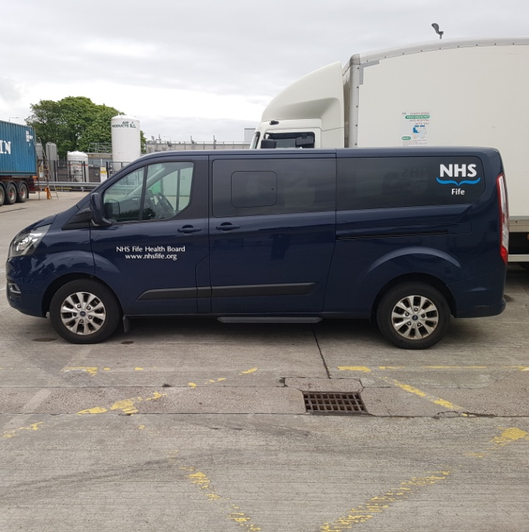

The service currently runs on the below timetable (subject to change) –

**VHK to QMH QMH to VHK**

**07:55am 09:00am**

**09:40am 11:00am**

**11:45am 12:30pm**

**01:40pm 02:30pm**

**03:45pm 04:30pm**

**05:15pm 06:00pm**

If you are interested in using this service please contact us using the details below –

Email – [fife.mesbookingrequests@nhs.scot](mailto:fife.mesbookingrequests@nhs.scot)

Tel - 01592 643355 ext 28831

Please note this is a popular service and capacity remains restricted, we cannot guarantee availability.

# End of Placement Information

A few reminders before you leave -

* Please vacate your accommodation by 10am on your last day. If you need to leave your luggage somewhere feel free to use the lockers in the Education Centre or for bigger items just pop them under a table in the Education Centre
* Please return your accommodation keys when you arrive at the hospital on you last day. You should drop these into the green drop box on the wall in the locker/foyer area of the Education Centre. Please do not wait until the end of the day to return keys.
* Please return your ID badge and pink card holder, please drop it in the green drop box before you leave on your last day.

# Contact Us

**Danielle Scott**

Undergraduate Medical Education Coordinator

<danielle.scott17@nhs.scot>  
Tel: 01592 643355 ext. 22051

**Gemma Morris**

Undergraduate Medical Education Coordinator

[gemma.morris@nhs.scot](mailto:gemma.morris@nhs.scot)  
Tel: 01592 643355 ext. 21748

**Amanda Duff**

ScotGEM Lead Coordinator

<amanda.duff@nhs.scot>  
Tel: 01592 643355 ext. 21598

**Room and Shuttle Bus Bookings**

[fife.mesbookingrequests@nhs.scot](mailto:fife.mesbookingrequests@nhs.scot)

Tel: 01592 643355 ext 28831

# Feedback

Please note along with the annual feedback the university will ask you to complete, we may also contact you for feedback on certain teaching sessions, placement changes etc.

This may be in the form of an online survey or we may email you direct to ask your thoughts on something you experienced during your placement.

We would ask however that at the end of your placement, you leave some comments using the QR code below, this helps us improve our placement offering for future groups.

