|  |
| --- |
| Full Business Case |
|  |
| Fife Elective Orthopaedic Centre |
| NHS Fife |
|  |



*Proposed Fife Elective Orthopaedic Centre* (*Image provided by Norr Achitects)*

Contents

Glossary of Terms 5

1 Executive Summary 6

1.1 Introduction 6

1.2 Strategic Case 6

1.3 Economic Case 9

1.4 Commercial Case 9

1.5 Financial Case 11

1.6 Management Case 12

1.7 Conclusion and Recommendations 13

2 Strategic Case 14

2.1 Introduction 14

2.2 Revisiting the Strategic Case 14

2.3 Description of Existing Service 14

2.4 Existing Service Arrangements 15

2.5 Future Arrangements 23

2.6 Service Provider 25

2.7 Condition and Performance 25

2.8 Supporting Statement 29

3 Strategic Context 30

3.1 The Need for Change 30

3.2 Organisation’s Goals 32

4 Economic Case 35

4.1 Introduction 35

4.2 Revisiting the Economic Case 35

4.3 Stakeholder Engagement 35

4.4 Long List of Options 37

4.5 Short List of Options 37

4.6 Indicative Costs 40

4.7 Option Appraisal 41

4.8 Sensitivity Analysis 44

4.9 Conclusion 46

5 Commercial Case 47

5.1 Introduction 47

5.2 Revisiting the Commercial Case 47

5.3 Procurement Strategy 47

5.4 Scope of Works 48

5.5 Risk Allocation 56

5.6 Payment Structure 59

5.7 Contractual Arrangements 60

6 Financial Case 62

6.1 Introduction 62

6.2 Revisiting the Financial Case 62

6.3 Financial Model: Costs and Associated Funding for the Project 62

6.4 Statement of Affordability 67

6.5 Stakeholder Support 68

6.6 Financial situation 68

6.7 Resources 68

6.8 Capital and revenue constraints 68

6.9 Signed Statement from Project Board Members 68

7 Management Case 70

7.1 Introduction 70

7.2 Revisiting the Management Case 70

7.3 Reporting Structure and Governance Arrangements 71

7.4 Change Management Arrangements 80

7.5 Benefits Realisation 82

7.6 Risk Management 84

7.7 Commissioning 85

7.8 Post Project Evaluation 86

Appendix A – Strategic Assessment 88

Appendix B – Existing Plans 89

Appendix C – Projected Future Demand 90

Appendix D – Long and Short List of Options 91

Appendix E – Proposed Floor Layouts 92

Appendix F – AEDET 93

Appendix G – HAI SCRIBE 94

Appendix H – Design Statement 95

Appendix I – Derogation Schedule 96

Appendix J – Target Price and Project Budget Summary 97

Appendix K – Benefits Register 98

Appendix L – Benefits Realisation Plan 99

Appendix M – Risk Register 100

Appendix N – Communication Plan 101

Appendix O – Project Board Member’s Statement of Support 102

Appendix P – Commissioning Strategy 103

|  |  |  |  |
| --- | --- | --- | --- |
| Rev | Originator | Approved | Date |
| 0 – DRAFT / Comment | Ben Johnston | Draft for comment | 18 Sept. 2020 |
| 1 – DRAFT / Comment | Ben Johnston | Draft for FCIG | 25 Sept. 2020 |
| 2 – DRAFT / Comment | Ben Johnston | Draft for EDG | 02 Oct. 2020 |
|  | | | |
|  | | | |

Glossary of Terms

AEDET Achieving Excellence Design Evaluation Toolkit

HAI Healthcare Associated Infection

IA Initial Agreement

DC Day Case

IP In patient

FBC Full Business Case

GIFA Gross Internal Floor Area

GIRFT Getting it Right First Time

GP General Practitioner

HFS Health Facilities Scotland

KPI Key Performance Indicator

MSK Musculoskeletal

NDAP NHSScotland Design Assessment Process

NEC New Engineering Contract

OBC Outline Business Case

PSC Professional Services Consultant

PSCP Principal Supply Chain partner

QMH Queen Margaret Hospital, Dunfermline

SA Strategic Assessment

SCIM Scottish Capital Investment Manual

TTG Treatment Time Guarantee

VHK Victoria Hospital, Kirkcaldy

WTE Whole Time Equivalent

# Executive Summary

## Introduction

This proposal sets out the strategy for re-provision of the elective orthopaedic service at Victoria Hospital, Kirkcaldy (VHK). The existing orthopaedic service provides a dedicated environment in which patients within the catchment of Fife can be treated. The service currently performs extremely well, demonstrating a high level of attainment against relevant benchmarks and KPI’s but is held back by condition and functionality of the existing environment in which the service is provided from. The investment proposal therefore seeks to maintain current performance levels whilst safeguarding the service over the longer term via the provision of a sustainable healthcare environment. This will be delivered by providing a standalone Fife Elective Orthopaedic Centre at Victoria Hospital in Kirkcaldy incorporating theatres, inpatient and outpatient accommodation.

A summary of the key changes since OBC are outlined below:

* Some minor changes have been made to the proposed staffing within the Strategic Case – refer to Section 2.5.4
* Stakeholder consultation and the option costs have been updated within the Economic Case – the preferred option continues to score most highly
* The Commercial, Financial and Management Cases have been updated and finalised

## Strategic Case

### Existing Arrangements

The existing service consists of 2 laminar flow theatres and a dedicated 24 bed ward provided from the “phase 2” tower bock within VHK. Over and beyond, orthopaedic outpatient services are provided from Queen Margaret Hospital in Dunfermline and VHK.

Currently, surgery time runs from 09:00 to 17:00 Monday to Friday with additional provision on Saturdays where demand dictates. Two 3.5 hour sessions are scheduled each day. To provide a general perspective, 4 major joint operations can be performed in a day. Through working on Saturdays up to 22 sessions can be performed in a week.

From a utilisation and performance perspective the service performs extremely well against all benchmarks and KPI’s – further details in this respect can be found at Section 2.2.

The condition and functionality of the existing assets is below the standard expected and is non-compliant in respect to current healthcare guidance (SHTMs and HBNs). The tower block at VHK was constructed in 1967 and the existing main services infrastructure is showing signs of age, increasingly risking service provision and continuity. The service is regularly disrupted because of infrastructure failures. There is no quick fix available (i.e. localised refurbishment) that would allow the service to remain in its current location over the longer term. This investment proposal has therefore been initiated to maintain the current service via the provision of the most effective long-term sustainable solution available within the constraints imposed.

### Strategic Context

Through dealing with the need for change, this investment proposal will realise a number of important benefits and these are summarised in the table below:

| **Need for change** |  | **Anticipated benefits** |
| --- | --- | --- |
| * Current ward provision does not support infection control, safety and the overarching strategy to move towards single room accommodation for inpatients. |  | * Positive patient experience and dignity respected |
| * Current ward provision does not reflect the increasing requirement for short stay facilities in the delivery of orthopaedic services. Current ward provision lacks flexibility to meet future demand |  | * Optimises resource usage (theatre and bed utilisation) |
| * Current accommodation does not support effective patient pathways / flow with bottle-necks arising. Situation affects efficiency of service provision. |  | * Maintain support to allow people to live independently together with life quality. Overarching benefit |
| * Current provision compromises patient dignity and quality of experience overall. |  | * Improves the healthcare estate (condition, quality, perception, statutory, back-log and lifecycle) |
| * Condition of existing facilities are below the required standard to support the service over the longer term. |  | * Minimises readmissions (post operation complications) and optimises timely discharge |
|  |  | * Optimises resource usage (theatre and bed utilisation) |
|  |  | * Improves HAI and patient safety |
|  |  | * Community benefits realised from implementation of the investment proposal. |

Table 1 - Need for change and benefits

### Opportunities

In reviewing the current arrangements and considering the need for change surrounding this investment proposal potential opportunities were highlighted.

#### Capacity to meet future demand

In dealing with the underlying need for change, this investment proposal also seeks to take advantage of an opportunity to increase service capacity to cater for future local demand projections and in doing so reducing any Regional strain particularly in respect to separate elective provision that is being considered. In high-level terms the following accommodation is anticipated to cope with future demand over the next 20 years.

|  |  |
| --- | --- |
| **Theatres Current** | **Theatres Proposed** |
| 2 laminar flow theatres | 3 laminar flow theatres |
| **Wards Current** | **Wards Proposed** |
| 24 beds | 33 beds |
| **Outpatient Department Current** | **Outpatient Department Proposed** |
| 11 consulting rooms (variable use) | 12 consulting rooms (fully utilised) |

Table 2 - Proposed accommodation

#### Colocation of outpatients

Currently Orthopaedic services are delivered across multiple sites within NHS Fife. Working in this manner means there are expected inefficiencies and inconsistency in how some parts of the service is delivered. Clinical time is also lost in asking clinical staff to travel between facilities during the working day. The opportunity to centralise MSK OPD activity within a purpose build facility is appealing and has a potential number of benefits in ensuring the service is delivered in the most efficient way.

This investment proposal seeks to pursue this opportunity by making allowance for an outpatient department within the Fife Elective Orthopaedic Centre.

#### Estate rationalisation

In addition to the opportunities noted above another key aspect relates to the long-term benefit of being able to progressively re-provide all clinical services currently within the tower block at VHK. The condition and clinical functionality of the tower block is unsustainable over the longer term. The estimated capital cost to deal with significant clinical backlog within the tower block is £36.5m, of which £21.4m relates to repairing the external fabric which has reached the end of its life. Through re-providing clinical services, the Board will be better positioned to implement an option appraisal for the tower block within the context of a VHK master plan.

## Economic Case

The Economic Case builds upon the initial work presented within the IA where a long-list of options were rationalised into a shortlist of five. The OBC appraised these options in more detail - the non-financial benefits for the options are measured against cost estimates to identify which option represents best value for money. At FBC, the option costs were updated to reflect the current position. A summary of the results following this exercise is set out in the table below:

|  |  |  |  |  |  |
| --- | --- | --- | --- | --- | --- |
|  | **Option 1** | **Option 2** | **Option 3** | **Option 4** | **Option 5** |
|  | As Existing | Refurb. Existing | Refurb other | Modular | New build |
| Net Present Cost (NPC) - £m | 240.9 | 254.8 | 323.1 | 354.5 | 325.3 |
| Weighted Benefit Points (WBP) | 545 | 660 | 1,250 | 1,785 | 2,000 |
| NPC per WBP - £000 | 442 | 386 | 258 | 199 | 163 |
| **Rank** | **5th** | **4th** | **3rd** | **2nd** | **1st** |

*Table 3 - Cost per benefit point for each option*

*The net present value/cost has been calculated using discounted cash flow techniques on the capital and revenue costs associated with the options as entered into the generic economic model (GEM).*

Option 5 – preferred way forward (new-build facility at VHK to meet the current requirements together with added capacity for future demand projections)

The recommended preferred option continues to be Option 5:

## Commercial Case

The Commercial Case was developed significantly at OBC and has been finalised within this FBC. Key aspects contained within the commercial case are summarised below.

* The project is being delivered using HFS Frameworks Scotland 2 (FS2) which operates using the NEC3/ECC3 form of contract. Contract option A has been selected which operates under a lump sum price arrangement. Given the maturity of the design it is considered that is the most suitable option for the project.
* The target price has been developed through a robust market testing process where a wide range of contractors have been invited to participate in providing prices for the various work packages.
* The design has been fully developed in conjunction with the Project Team and Stakeholders. With exception to the NSS Design Quality Assurance process which is ongoing, the design has been well received through HAI, NDAP, AEDET and focussed design workshops.
* The has been some upward movement in the area of the building from OBC to FBC. This has been caused by the rooftop plantroom which has increase in size through design development.
* Statutory applications have been made and approvals are anticipated in advance of the planned construction start date.
* The current key risks facing the project are summarised in the table below:

| **Risk** | **Mitigation** |
| --- | --- |
| COVID-19 impacts progress affecting cost and the completion date. | The works will be external until the middle of 2021. The impact up until that date should be minimal as social distancing should be able to be maintained. If COVID-19 is likely to affect the project thereafter, mitigation plans will require to be developed. The risk has been identified within the project risk register and a provisional risk allowance has been made – this may however prove to be inadequate depending on events may unfold. An application for additional funding may be required to cover any deficit that may arise. |
| BREXIT impact on material availability and impact on programme. | Given the current market, supply chains and procurement of materials extend beyond the UK borders. It is difficult to mitigate and control this risk which will be affected by political policy and decisions regarding trade between borders. The risk has been identified within the project risk register and a provisional risk allowance has been made – this may however prove to be inadequate depending on the severity of any associated restrictions and constraints flowing from BREXIT. |
| NSS Design Quality Assurance | Towards the end of FBC, the project was informed that the design needed to be reviewed by the NSS Design Quality Assurance team. This process is underway and all parties are cooperating collaboratively. There is a risk that any matters arising through this process may lead to changes to the design and potentially additional cost. |
| Ground conditions | A lot of due diligence has been undertaken to understand the ground conditions and obstructions through detailed surveys and investigations. This has helped to create a robust Site Information pack. In construction there is however always a residual risk. This has been identified within the risk register together with an appropriate contingency budget to deal with any unforeseen events arising. |

Table 4 - Key risks

## Financial Case

The Financial Case considers the affordability of the scheme, sets out all associated capital and revenue costs, assesses the affordability of the preferred option and considers the impact on NHS Fife’s finances. The affordability model assessment has been developed to cover all aspects of projected costs including estimates for:

* Capital costs for the option considered (including construction and equipment);
* Non-recurring revenue costs associated with the project;
* Recurring revenue costs (pay and non-pay) for current model i.e. baseline; and
* Recurring revenue costs (pay and non pay) for the preferred option.

### Capital Costs

A capital cost summary is provided in the table below demonstrating the total FBC cost for the project, together with the movement in cost since OBC.

|  |  |  |
| --- | --- | --- |
| **OBC** | **FBC** | **Movement** |
| £32,155,999 | £33,199,596 | £1,043,596 |

Table 5 - Summary of capital costs

The key reasons for the movement in cost since OBC, are set out below:

* Additional car park enabling costs due to planning and flood constraints;
* Design development concerning the roof top plant room increased the building size;
* Design development led to an increase in the building height to accommodate services;
* Am increase in general equipment costs through detailed development of the project requirements; and
* The addition of specialist radiology equipment to equip the radiology rooms (NB: radiology accommodation was not included within the original schedule of accommodation).

Net departmental area has been controlled tightly since IA and is actual marginally less at FBC – this has of course been offset an increase in gross area as noted above. Despite the cost increase from OBC to FBC, the development cost equates to £5,267m/2 which is reasonable when compared to other comparable benchmark projects.

### Revenue Costs

A summary of the revenue costs is provided in the table below. Further detail can be found within the Financial Case at Section 6.



Figure 1 - Revenue Cost Summary

## Management Case

The Management Case identifies the actions that will be required to ensure the successful delivery of the scheme. The management case has been updated for this FBC and demonstrates that the Board are well prepared to deliver the project successfully during the construction phase and beyond. Key milestones for the project are identified in the table below:

| **Description / Activity** | **Date** |
| --- | --- |
| FBC |  |
| * Complete car park enabling works (to enable site to be cleared for construction) | Dec. 2020 |
| * Statutory consents | Dec. 2020 |
| * Fife Capital Investment Group (FCIG) | 1 Oct. 2020 |
| * Executive Director’s Group (EDG) | 8 Oct. 2020 |
| * Submit to Capital Investment Group (CIG), Scottish Government (SG) | 13 Oct. 2020 |
| * Clinical Governance | 4 Nov. 2020 |
| * Finance Performance and Resources Committee (FP&R), NHS Fife | 10 Nov. 2020 |
| * Capital Investment Group (CIG), Scottish Government (SG) Meeting | 11 Nov. 2020 |
| * Area Partnership Forum (APF) | 18 Nov. 2020 |
| * NHS Fife Board Meeting | 25 Nov. 2020 |
| Construction and handover (main works) |  |
| * Ground consolidation works | Jan. 2021 |
| * Start (main works) | Feb. 2021 |
| * Completion | Jul. 2022 |
| * NHSF commissioning / service migration | Aug. 2022 |
| * Operation / use | Sept. 2022 |

Table 6 - Milestone dates

## Conclusion and Recommendations

This investment proposal is a key priority for NHS Fife, to safeguard the provision of a high performing, essential clinical service over the longer term. The preferred option will provide the Board with an opportunity to plan for the future, ensuring that the service is robust enough to offer the necessary supply to meet the projected local future demand and to provide a safe, effective and person-centred orthopaedic service. In addition, the preferred option will contribute towards decanting clinical services from within the tower block at VHK unlocking future options within the context of the site masterplan.

A robust stakeholder focussed detailed design has been developed that encompasses all of NHS Fife’s requirements. The accommodation requirements have broadly been controlled within the constraints set out at IA and notwithstanding some marginal movement in cost from OBC to FBC, the project remains affordable when compared to other comparable benchmark projects. Approval of this FBC will ensure that construction works can commence allowing this critical project to be delivered in line with the projected programme.

# Strategic Case

## Introduction

The main purpose of the Strategic Case is to confirm the background and drivers for change for the proposition. It also sets out the key investment objectives and associated benefits.

## Revisiting the Strategic Case

Since OBC, there has been minor changes to the staff projections located at Section 2.5.4. Other than that the Strategic Case remains the same and is still valid.

## Description of Existing Service

The service affected by this proposal is the Fife Elective Orthopaedic Centre which caters locally for the community of Fife providing elective orthopaedic treatment.

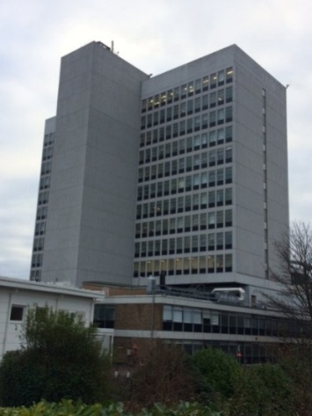The service is located within “Phase 2” of the Victoria Hospital Tower Block in Kirkcaldy and includes 2 orthopaedic laminar flow theatres on the 3rd floor with supporting ward accommodation (24 bed) on the 4th floor. The two floors are connected by a dedicated lift and an adjacent staircase.

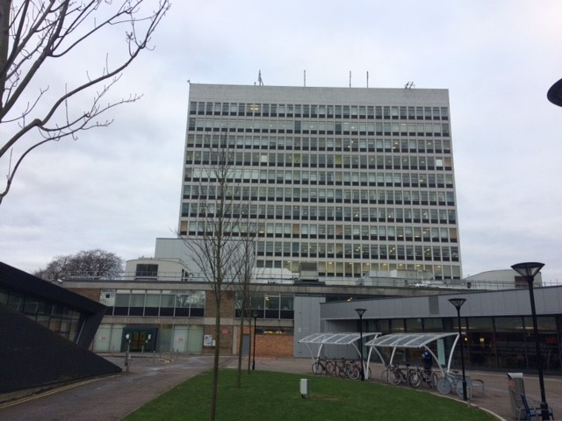

Figure 2 – VHK Tower Block

Figure 3 – VHK Tower Block

Plan drawings capturing the existing theatre and ward layouts are referenced in Appendix B for information.

Orthopaedic Outpatient and Pre-assessment services support the overall care provision. These services are currently spread across two sites at Queen Margaret Hospital (QMH) in Dunfermline and Victoria Hospital in Kirkcaldy (VHK). Resources are diluted and duplicated across sites. Staff travelling time compromises clinical time efficiencies. Opportunities exist to improve the efficiency of OPD service by centralising the majority of service within a single purpose-built facility.

**Queen Margaret Hospital Outpatient Facilities**

* OPD 1 (Ortho)
* OPD 2 (GPwSI)
* OPD 5 (Hands)
* Physio department (ad hoc)
* Treatment room
* Venepuncture room

**Victoria Hospital Outpatient Facilities**

* OPD 5 (ortho)
* OPD 3 and 4
* Preassessment clinic (Level 6) – 3 rooms/venepuncture facilities/communal education area
* VFC Triage room
* Physio department (ad hoc)
* Two treatment rooms

## Existing Service Arrangements

The service currently performs extremely well, demonstrating a high level of attainment against relevant benchmarks and KPI’s as demonstrated below.

### Care Pathways

The patient journey is normally initiated through a GP referral. Thereafter specialist clinics triage the patients prior to listing for surgery. The twelve-week Treatment Time Guarantee (TTG) sets out the requirement for patients to receive treatment within twelve weeks from the point of being diagnosed and agreeing to treatment.

The beds allocated for the service are protected which facilitates an improved patient flow and as a result ensures fewer cancellations. NHS Fife have recently introduced advanced nursing practitioners to support the ward, therefore the ward is not reliant on either rotating junior doctors or locum medical staff. This ensures standardised and consistent care. The clinical and financial benefits of protected beds are well documented (GIRFT Report, March 2016), these include; reduced infection, shorter length of stay and better patient flow with fewer cancellations. As testament to this, NHS Fife is one of the 40% high performing hospitals which manage four daily knee or hip replacements through its elective theatre lists.

From the point of receiving elective orthopaedic treatment in Fife the patient can stay on the ward for circa four days for major joint replacements (hips/knees 2015). This is however amongst the shortest lengths of stay in Scotland (refer to figures 3 and 4 below) demonstrating the excellent service efficiencies. This figure has continued to fall and currently length of stay is around 2.5 days (2019). In the last 2 years the department has developed day surgery hip and knee replacement pathways contributing to this further significant reduction in length of hospital stay.

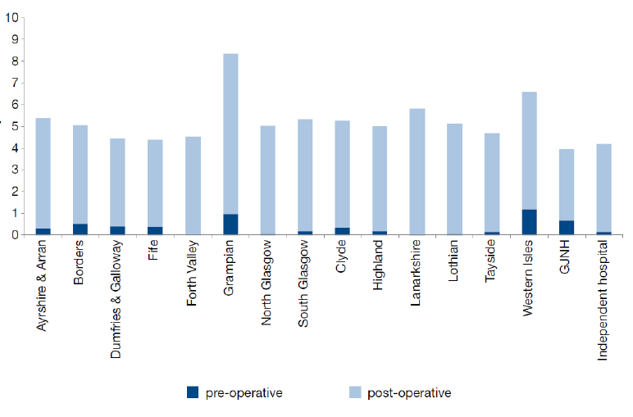

Figure 4 – Average (days) Pre/Post Operative Length Stay – Hip Replacements (2015)



Figure 5 – Average (days) Pre/Post Operative Length Stay – Knee Replacements (2015)

### Patterns of Working

#### Theatres

Currently, surgery time runs from 09:00 to 17:00 Monday to Friday with additional provision on Saturday’s where demand dictates. Two 3.5 hour sessions are scheduled each day. To provide a general perspective, 4 no. major joint operations can be performed in a day. There are 22 sessions running from Monday to Saturday and the Whole Time Equivalent (WTE) is 16.6 (currently short of 1.0 WTE based on number of sessions covered). There is little flexibility to provide additional theatre sessions to support new consultant appointments required to balance DCAQ and projected increased demand over next 20 years.

#### Outpatient Department

Total clinic room usage is summarised in the graph below. There are 91 sessions per week. The current job plans have a disproportionate number of sessions at the beginning of the week.

Pre assessment clinics currently accounts for 28 sessions of clinic room utilisation. These clinics run 5 days a week and require approximately 3-4 clinic rooms all day Monday to Friday.

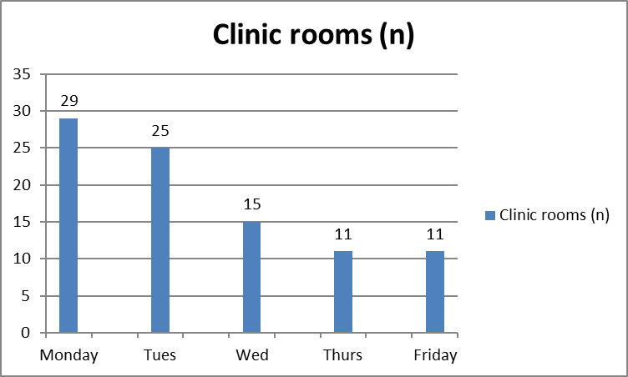

Figure 6 - Clinic room utilisation by day of the week. Each clinic room corresponds to a session (hrs) of clinical activity. Two sessions equates to a clinic room being utilised all day.

#### Wards

The wards facilitate orthopaedic theatre activity and function 24 hours per day, 7 days a week. The available bed numbers reduce from 24 to 16 at weekends. Currently the wards cater for inpatient activity predominantly (90%) as there is no dedicated support for day case activity.

### Staffing

#### Theatre Staff

There are currently 22.04 whole time equivalent theatre staff, comprising:

* Band 7 – 1.00
* Band 6 – 1.00
* Band 5 – 11.88
* Band 4 – 0.00
* Band 3 – 2.76
* Band 2 – 0.00
* ODP theatres (band 5) – 2.90
* Anaesthetist – 2.5

#### Ward staff

There are currently 32.46 whole time equivalent ward staff, comprising:

* Band 7 – 1.00
* Band 6 – 1.00
* Band 5 – 17.96
* Band 4 – 0.00
* Band 3 – 1.00
* Band 2 – 6.22
* Physio / OT – 5.28

#### Consultants

There are currently 14.48 whole time equivalent orthopaedic consultants.

### Existing Service Capacity

#### Theatres

Based on patterns of working and staffing noted under Section 2.4.2, the theatres are capable of accommodating 22 sessions per week. Two theatres run Monday to Friday (20 sessions) whilst one theatre operates on a Saturday (2 sessions).

|  |  |  |  |
| --- | --- | --- | --- |
| **No of theatres** | **Days per week** | **Sessions per day** | **Sessions available per week** |
| 2 | 5.5 | 2 | 22 |

Table 7 – Existing service capacity

#### Outpatient Department

Current OPD capacity for NP attendances based on clinic templates for 2018-2019 equate to 12,987 appointments. This includes NP appointments offered by all clinical staff (Cons, ESP, Podiatry, GPwSI). It also includes Virtual Fracture Clinic (VFC) NP referrals.

#### Wards

There is currently access to 24 beds within ward 10 made up of six 4-bedded bays. Capacity can be affected by male/female ratios. Furthermore, day cases are restricted and often fail to attain BADS targets (see Benefits Register) due to a lack of dedicated support suitable for day case facilities.

### Existing Service Utilisation

#### Service Utilisation

The theatres and supporting ward accommodation currently run at capacity utilising the proportion of available hours. The table below demonstrates the utilisation rate for all specialities, the figures are an accumulation of both VHK and QMH activity.

|  | June 2019 | | July 2019 | | August 2019 | |
| --- | --- | --- | --- | --- | --- | --- |
| **Session Holder** | **Unutilised Hours - %** | **Utilised Hours - %** | **Unutilised Hours - %** | **Utilised Hours - %** | **Unutilised Hours - %** | **Utilised Hours - %** |
| Cardiology | 16.9% | 83.1% | 7.9% | 92.1% | 7.6% | 92.4% |
| Ear, Nose & Throat | 14.3% | 85.7% | 15.3% | 84.7% | 11.7% | 88.3% |
| General Surgery | -1.9% | 101.9% | -0.3% | 100.3% | -0.2% | 100.2% |
| Gynaecology | 3.3% | 96.7% | 13.2% | 86.8% | 5.3% | 94.7% |
| Obstetrics | 54.7% | 45.3% | 53.4% | 46.6% | 55.5% | 44.5% |
| Ophthalmology | 10.1% | 89.9% | 10.4% | 89.6% | 16.1% | 83.9% |
| Oral-Maxillofacial Sugery | -2.9% | 102.9% | -28.7% | 128.7% | 11.1% | 88.9% |
| Paediatric Surgery | -5.0% | 105.0% | -22.0% | 122.0% | -1.1% | 101.1% |
| Plastic Surgery | 16.0% | 84.0% | 30.5% | 69.5% | 22.8% | 77.2% |
| Respiratory Medicine | 27.5% | 72.5% | 21.1% | 78.9% | 41.8% | 58.2% |
| Trauma and Orthopaedics | -2.0% | 102.0% | -0.1% | 100.1% | 1.0% | 99.0% |
| Urology | 6.0% | 94.0% | 0.9% | 99.1% | 11.6% | 88.4% |
| Vascular Surgery | 39.0% | 61.0% | 24.9% | 75.1% | 29.2% | 70.8% |
| **Total** | **17.2%** | **82.8%** | **17.5%** | **82.5%** | **20.4%** | **79.6%** |

Table 8 – Existing service utilisation

### Future Projections

#### Theatre demand

Projected future sessional demand for elective surgical in-patient (IP) and day case (DC) activity within NHS Fife is set out below. It should be noted that IP care is currently provided from Victoria Hospital Kirkcaldy whilst DC procedures are delivered from Queen Margaret Hospital in Dunfermline. A more detailed table providing context and assumptions used to project future demand is contained at Appendix C.

|  |  |  |  |  |
| --- | --- | --- | --- | --- |
|  | **Current** | **2025** | **2030** | **2035** |
| Session demand | 1,459 | 1,722 | 1,868 | 1,940 |
| Percentage change | 0% | 18% | 28% | 33% |

Table 9 - Projected future sessional demand for elective surgical activity

It can be seen that by 2035 it is projected that there will be a requirement for an additional 481 sessions representing an increase of 33% against current demand.

#### Outpatient demand

Future demand for OPD NP capacity formed part of the Regional Orthopaedics workgroups 2017-2018, where DCAQ activity for the South East Scotland (NHS Fife, NHS Borders and NHS Lothian) was calculated.

Population demographics described population expansion in all areas. Population expansion was expected to be greatest for the cohort of the population with age of greater than 65. This is important as it is this cohort who form the majority of referrals to MSK services for degenerative musculoskeletal problems. The population changes are described in fig. 6.

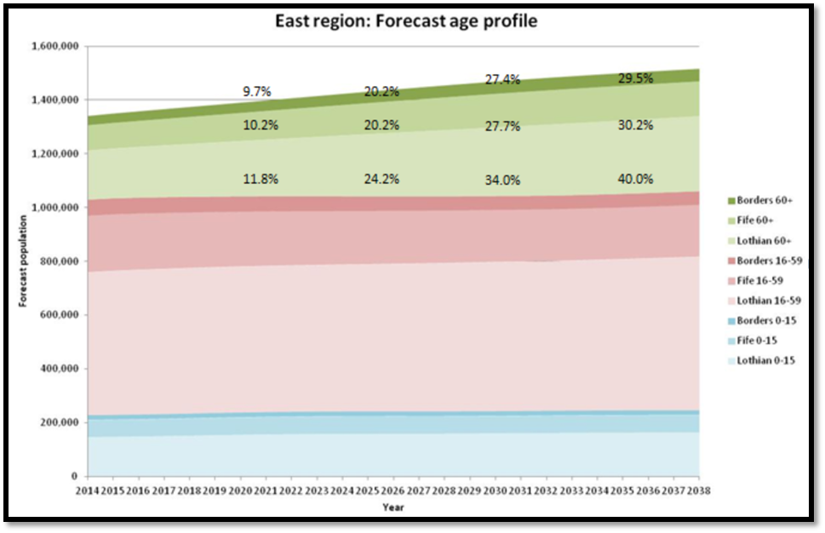

Figure 7 - East Region: Forecast Age profile (presented C Meyers, Acute Workstream Sub Group: Orthopaedic Project Group Workshop 6th Feb 2018)

This is expected to result in an increase in OPD New patient activity (Fig 7). An increase of approximately 6.5% to 10% can be anticipated over the next 20 years. This would equate to an additional 1-2 sessions of NP clinical activity per day across the MSK service if service was to continue to be delivered as it is currently.

Based on predicted growth of arthroplasty in the population >60 and growth in other demand including younger age groups, we feel this is likely to underestimate the increase in new patient attendances for NHS Fife. The true value is likely to be between the 6.5% increase and the 17% indicated for NHS Lothian. For the purpose of projections an increase of 10% is suggested.

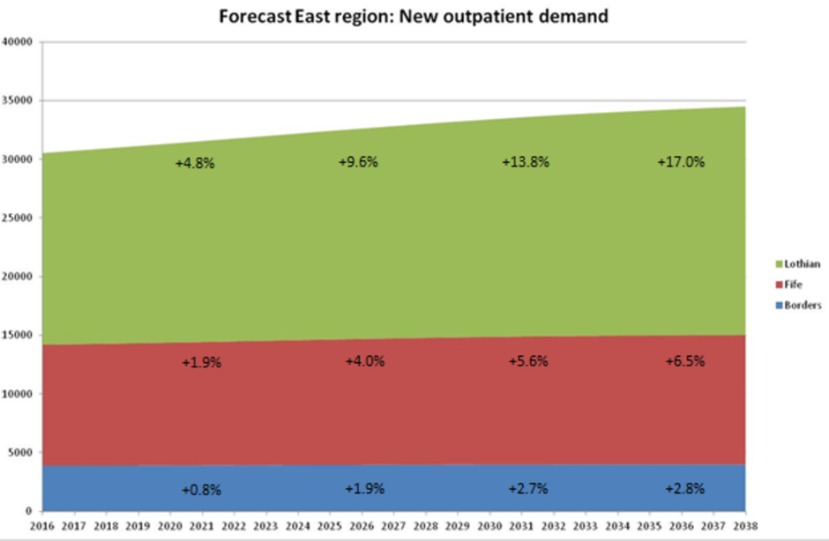

Figure 8 - Forecast East Region: new outpatient demand (presented C Meyers, Acute Workstream Sub-Group: Orthopaedic Project Group Workshop 6th Feb 2018).

#### Wards

Theatres plan to provide increased capacity by the provision of a third elective orthopaedic theatre. This will accommodate future demand for major joint surgery within NHS Fife over the next 20 years. These calculations are based on ISD projections for hip and knee arthroplasty (2017). Short term theatre utilisation will be attained by relocating day case Foot & ankle and arthroscopy lists to the Fife Elective Orthopaedic Centre.

In 2022, the Fife Elective Orthopaedic Centre will have a third theatre. This will accommodate hands which is largely a day case activity. Normally they require up to 10 day beds for a full day list. Therefore, the FEOC needs sufficient beds to accommodate:

1. Current and projected elective activity inpatient beds; and
2. A significant increase in day case activity through a dedicated area (arthroscopic procedures, F&A day case arthroplasty and other day case procedures).

Inpatient beds need to accommodate increased activity over the next 20 years, but with a decreased length of stay. In respect to total patient bed days it is assumed that these forecast changes can be accommodated within the current footprint (24 beds). It is projected that an additional 9 beds will be adequate to accommodate increased day case activity over the next 20 years. A spilt of single beds and 4-bedded bays will enable inpatient capacity whilst offering flexibility for an increase in day case demand. This will provide a split area of 17 single rooms and a 4-bed. A further 3 4-bed bays will support a short stay facility. This will deliver a clinical space that has flexibility to deliver future service needs.

### Service Performance

The service is able to demonstrate excellent performance data via a variety of local and national key performance indicators. A high-level overview of relevant performance data is set out below.

#### Getting it Right First Time (GIRFT)

A highly respected peer review (GIRFT NHS Fife Feedback Repot, 26 November 2015) acknowledged and commended the efficient use of orthopaedic theatres in Fife – “the Health Board should be commended for their orthopaedic advanced recovery programme”.

#### Bed Optimisation

NHS Fife has lower than average orthopaedic (mixed emergency and elective) beds per consultant and lower beds per 100,000 population. Despite this the Board and Service are able to maintain excellent theatre efficiency.

|  |  |  |
| --- | --- | --- |
| **Indicator** | **NHS Fife** | **Scotland** |
| Available beds per consultant | 4.6 | 5.4 |
| Available beds per 100,000 population | 16.4 | 23.2 |

Table 10 – Table 2: beds optimisation, T&O Dashboard Report

#### Treatment Time Guarantee (TTG)

As a result of current theatre efficiency, NHS Fife is able to demonstrate a significantly better performance than its peers in respect to meeting the Scottish Government’s TTG for patients listed for surgery.

|  |  |  |
| --- | --- | --- |
| **Indicator** | **NHS Fife** | **Scotland** |
| % of patients not meeting 12 week TTG | 0.8 | 21.7 |
| % of patients not meeting 18 week TTG | 9.2 | 21.5 |

Table 11 - Inpatient and day case capacity optimisation, T&O Dashboard Report

In respect to the outpatient department, NHS Fife currently performs well against Scottish outpatient waiting times standards. There is a 0.8% failure to meet the 12-week target. The national mean is 30.8%. In addition, NHS Fife has the lowest time to clear its outpatient queue in Scotland.

#### Theatre Capacity Optimisation

The Service is able to demonstrate superior efficiencies in theatre capacity optimisation when compared against its peers.

|  |  |  |
| --- | --- | --- |
| **Indicator** | **NHS Fife** | **Scotland** |
| Late starts (>15 min) as % of used theatre hours (scheduled planned sessions) | 1.7 | 4.5 |
| Theatre cancelled session time - % of planned session hours cancelled (scheduled planned sessions) | 0 | 11.8 |

Table 12 – Table 4: Theatre capacity optimisation, T&O Dashboard Report

#### Workforce

For trauma and orthopaedic services, NHS Fife are able to demonstrate an efficient use of their workforce.

|  |  |  |
| --- | --- | --- |
| **Indicator** | **NHS Fife** | **Scotland** |
| Consultants per 100,000 population | 3.5 | 4.5 |

Table 13 – Table 5: Trauma and orthopaedics WTE headcount, T&O Dashboard Report

## Future Arrangements

### Theatres

Referring back to Section 2.4.6.1, it was noted that by 2035 an additional 481 sessions will be required representing an increase of 33% against current demand.

In terms of total orthopaedic care within NHS Fife (IP and DC) there are currently 1,664 sessions available at 100% utilisation. A realistic percentage for session availability is considered to be 85%, therefore if one assumes that 1,414 sessions are available currently and the demand by 2035 is calling for 1,940 sessions then the deficit is 526 sessions. A theatre running 5 days a week for 52 weeks a year would provide 520 sessions. As a result there is considered to be a solid case supporting the requirement for a third theatre.

The above noted projections combine orthopaedic activity at VHK (IP) and QMH (DC). Further detail supporting this analysis can be found at Appendix C.

### Wards

The clinical team are projecting a requirement for a further 9 beds which takes the ward accommodation from 24 beds to 33. This will support inpatient short stay surgical activity using a mixture of single rooms and 4-bed bays. The bays will form a short stay area.

### Outpatient Department

It is anticipated that twelve consulting and four treatment rooms will provide the required capacity to deliver a centralised orthopaedic OPD services over the next 20 years.

Twelve consulting rooms will allow the majority of current activity to be accommodated, however in order to ensure sustainability of the OPD service over the next 20 years other strategies will be developed as part of the transition of services. It is recognised there will be an increase in OPD activity of approximately 10% over the next 20 years (see Section 2.4.6.2). These strategies will link into initiatives being proposed by the MSK Quality improvement Project in relation to how outpatient services in MSK are delivered. The aim of these strategies is to limit the number of patients who are required to attend for face to face consultant appointments. Strategies include:

* Active Clinical Referral Triage (ACRT): Patients are triaged by trained clinical staff, and where appropriate before patients are offered a face to face new patient appointment, the patient is provided with information which describes treatment options.
* Patient Initiated Follow up (PIFU): This allows patients to be discharged with guidance on how they can access secondary care again if there is a problem, rather than arranging a routine review.
* Remote Consultation via NHSNearMe: This is a video conferencing platform that can allow patient to access clinical appointment remotely by their phone or home PC.

### Projected Staffing

Following on from the proposed increase in accommodation, initial staffing projections have also been contemplated and these are set out in the tables below. Staff increases will not be realised straight away, but are likely to be phased to meet demand from 2022 to 2035.

#### Theatres

|  |  |  |  |
| --- | --- | --- | --- |
|  | **Current Staff (WTE)** | **Projected Staff (WTE)** | **Difference (WTE)** |
| Band 7 | 1.00 | 1.00 | 0.00 |
| Band 6 | 1.00 | 3.00 | 2.00 |
| Band 5 | 11.88 | 16.35 | 4.47 |
| Band 4 | 0.00 | 1.00 | 1.00 |
| Band 3 | 2.76 | 3.56 | 0.80 |
| Band 2 | 0.00 | 3.27 | 3.27 |
| ODP Theatres – Band 5 | 2.90 | 4.37 | 1.47 |
| Anaesthetist | 2.5 | 3.75 | 1.25 |
| **Total** | **22.04** | **33.83** | **14.26** |

Table 14 - Theatre Staffing

#### Ward Staffing

|  |  |  |  |
| --- | --- | --- | --- |
|  | **Current Staff (WTE)** | **Projected Staff (WTE)** | **Difference (WTE)** |
| Band 7 | 1.00 | 1.00 | 0.00 |
| Band 6 | 1.00 | 1.00 | 0.00 |
| Band 5 | 17.96 | 24.13 | 6.17 |
| Band 4 | 0.00 | 0.00 | 0.00 |
| Band 3 | 1.00 | 1.00 | 0.00 |
| Band 2 | 6.22 | 15.81 | 9.59 |
| Physio / OT | 5.28 | 8.50 | 3.22 |
| **Total** | **32.46** | **51.44** | **18.98** |

Table 15 - Ward staffing

#### Consultants

|  |  |  |
| --- | --- | --- |
| **Current Staff (WTE)** | **Projected Staff (WTE)** | **Difference (WTE)** |
| 14.48 | 16.48 | 2 |

Table 16 - Consultant staffing

#### Outpatients

Outpatient staff currently work on a rotational basis across the services. Moving forward there will be an element of staff relocation from Queen Margret Hospital together with an anticipated marginal uplift to meet demand. This uplift has been factored into the revenue costs within the financial case.

## Service Provider

The service is currently provided exclusively by NHS Fife.

## Condition and Performance

### Condition

The condition of the existing facilities from where the service is provided is commensurate with the age of the building and supporting infrastructure. The building was erected in 1967 and the last major refurbishment took place circa 20 years ago. The internal fabric of the facilities are showing signs of age which requires to be replenished. The external fabric is in extremely poor condition having reached the end of its useful life. The replacement of the curtain walling would be a significant and costly undertaking due to the location of the tower block within the site.

* Internal fabric condition rating: B (acceptable) / C (requires capital)
* External fabric condition rating: D (not acceptable)

The primary supporting infrastructure (electrical and mechanical) within the tower block is reaching the end of its useful life and requires to be replaced. There are now a number of recurring environmental problems arising from the tower block infrastructure – flooding/leaks and electrical issues. These will continue to occur regardless of any localised upgrade undertaken. Intermittently the service has lost activity within theatres due to drainage problems. In respect to the existing arrangements, it is considered that there is no sustainable solution for this service to be provided from the tower block in the medium to longer term. Meanwhile the current conditions represent a significant threat to service continuity.

* Engineering condition rating: D (not acceptable)

### Safety

The facilities are generally considered to be safe when taking recent HAI reports into consideration. Safety performance is considered to be achieved through good management and staff commitment in respect to following mandated processes and procedures. The building fabric and layout does not currently maximise opportunities to support the provision of a safe environment in which to treat patients effectively. This is evidenced via the following statements and photograph.

* The bed accommodation within the wards is provided via open plan bays off the main corridors which is not conducive to best practice infection control;
* The scrub area within the theatres is open plan and can be viewed from the theatre main reception area (Figure 9); and
* 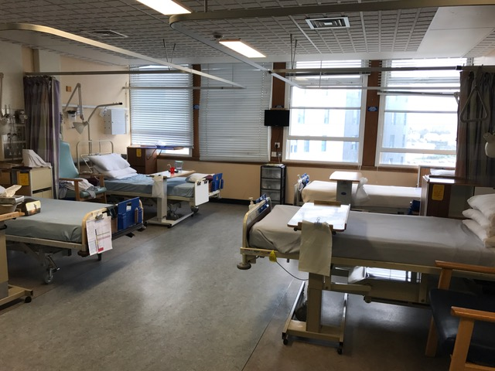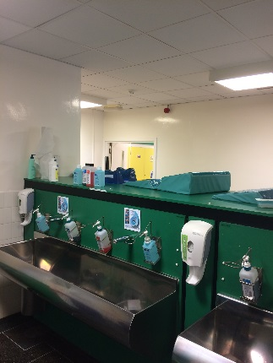The laminar flow within theatres it currently too small to enable all of the trays to be accommodated within the clean air flow.

Figure 9 - Existing bed accommodation

Figure 10 - Scrub area

### Backlog Maintenance

The summary in respect to the current back-log for the theatres and the ward accommodation is outlined below.

|  |  |
| --- | --- |
| Theatres | £1.185m |
| Ward 10 | £0.954m |
| **Total** | **£2.139m** |

Table 17 - Backlog maintenance

The estimated capital cost to deal with significant clinical backlog within the tower block is £36.5m, of which £21.4m relates to repairing the external fabric which has reached the end of its life.

### Functional Suitability

The ward and theatres may have been functionally suitable at a point in time, however the facilities are now inhibited on a number of fronts.

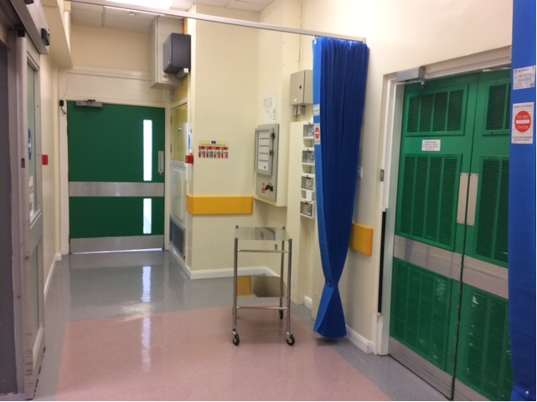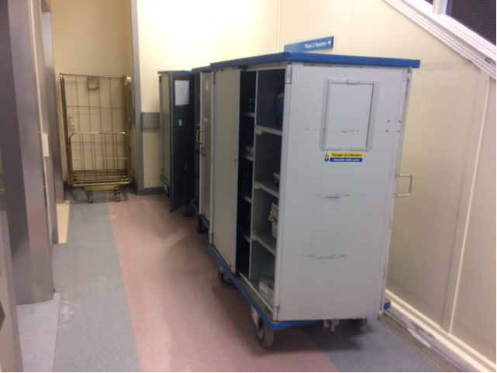The patient journey from the ward to the theatre and vice-versa is functionally unsuitable as there is a bottle-neck when patients arrive at the theatre reception. Patients arriving have to be parked to the side whilst outgoing patients pass-by. There is a privacy curtain, however the current situation does little to contribute towards patient assurance and dignity. Furthermore this staggered approach to patient arrival and departure is inefficient where time is lost transferring patients affecting theatre productivity.

Figure 11 - Lifts to theatre (congested)

With advances in surgery and complexities in revision surgery, the theatres area is no longer suitable or compliant in terms of current technical guidance in respect to size. This means that currently the area of the laminar flow is too small to allow all of the trays to be accommodated inside the clean air flow. To mitigate this stacking arrangements are used which is inefficient. In addition, circulating areas are also less than recommended. There is a general lack of storage within the theatre accommodation. The effect is that storage has to be found in rooms/spaces that were not designed for this purpose. The knock on effect is that rooms and corridors are cluttered contributing towards inefficiencies in these spaces.

Figure 12 - Theatre reception lobby

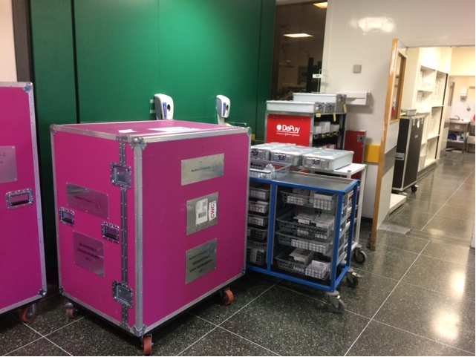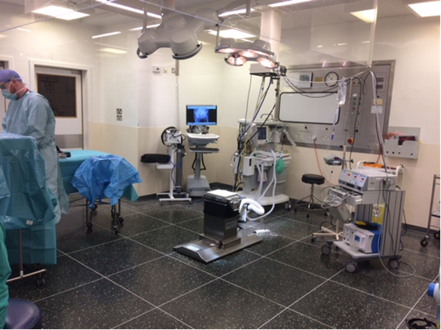

Figure 13 - Circulation storage

Figure 14 - Existing theatre

### Space Utilisation

Both the ward and theatre accommodation is currently running at capacity and the space is fully utilised to meet this demand.

### AEDET Review of Existing Facilities

An AEDET review of the existing facilities was undertaken where the Stakeholders considered the facilities against the predefined scoring criteria. A summary of the scoring is set out in fig. 14 below.

Note: scoring ranges from “1 – virtually no agreement” to “6 – virtually total agreement”.

|  |  |
| --- | --- |
| **Category** | **Benchmark** |
| Use | 2.5 |
| Access | 2.0 |
| Space | 2.0 |
| Performance | 1.7 |
| Engineering | 2.2 |
| Construction | 0.0 |
| Character & Innovation | 1.7 |
| Form & Materials | 1.8 |
| Staff & Patient Environment | 2.1 |
| Urban & Social Integration | 1.0 |

Table 18 - AEDET Benchmark

A score of 3 is “little agreement”. It can be seen that all of the scores are 2.5 or less which demonstrates that in the Stakeholder’s collective view, the existing facilities are below expectations across all categories.

## Supporting Statement

The current services are still needed and they need to be provided in a similar manner to build upon what is an excellent and efficient service, serving the community of Fife. Wide ranging options were considered as part of the option appraisal exercise and this process helped to reinforce this view.

If the current arrangement is maintained with little or no investment, then there will be significant risks in respect to safety and service continuity due to the condition of the existing accommodation and supporting infrastructure. The VHK tower block is unsustainable as a clinical environment over the longer term, therefore a strategy is required to decant clinical activity to environments that are more suitable. In addition to service risk, the current arrangements fail to contribute sufficiently towards patient dignity and theatre access flows are inefficient counteracting against what is otherwise a very efficient high performing service.

This business case was initially conceived in response to dealing with the condition of the current environment. The problems flowing from the existing situation are not currently performance, demand/supply or patient pathway related. It is more concerned with improving the current condition, functionality and safety of the environment whilst considering other opportunities arising from this principle requirement. In taking forward this investment proposal the following opportunities are being incorporated:

* To increase capacity to cope with future demand on the service.
* To create a standalone Fife Elective Orthopaedic Centre incorporating theatres, inpatients and outpatients.

# Strategic Context

## The Need for Change

### Problems Associated with the Current Arrangements

The problems associated with the current arrangements all primarily flow from the condition and performance of the current facilities as set-out and described in Section 2.7. In addition the key needs for change are summarised within the Strategic Assessment which is contained as Appendix A. A summary of the need for change is outlined below.

|  |  |  |
| --- | --- | --- |
| **What is the cause of the need for change?** | **What effect is it having, or likely to have, on the organisation?** | **Why action now:** |
| Current ward provision does not support infection control, safety and the overarching strategy to move towards single room accommodation for inpatients. | Existing arrangements are contributing towards increased levels of infection risk. | To mitigate the existing risk and in doing so seek to contribute towards NHS Scotland’s policy of providing single room accommodation across the NHS Estate. |
| Current ward provision does not reflect the increasing requirement for short-stay facilities in the delivery of orthopaedic services. | Current ward provision lacks flexibility to meet future demand. | To provide a sustainable flexible service to meet future demand. |
| Current accommodation does not support effective patient pathways / flow with bottle-necks arising. Situation affects efficiency of service provision. | Whilst the service is very efficient making the best of the existing situation, the current arrangements are affecting the service’s ability to maximise its potential. | With demand for elective orthopaedic procedures set to increase in the future, any additional efficiencies that can be created maximising supply will be of benefit in protecting the sustainability of the service over the longer term. |
| Current provision compromises patient dignity and quality of experience overall. | The existing situation contributes towards a negative perception from patients diminishing the quality of work/care administered by staff. | Person Centred care is one of NHS Scotland’s strategic investment priorities with “positive experiences” and “dignity” at the core. |
| Condition of existing facilities are below the required standard to support the service over the longer term. | Space constraints are affecting the services potential to work more efficiently and the existing fabric/infrastructure has and will continue to cause disruptions to service continuity. | Building condition and performance risks will continue to deteriorate if action isn’t taken now. |

Table 19 – Summarising the Need for Change

### Opportunities for Improvement

Opportunities for improvement relate to aspects of the current arrangements that are not necessarily causing a problem but may still present an opportunity to improve as a consequence of instigating the investment proposal. Potential opportunities are noted below.

1. Increased supply through additional beds and/or theatres protecting supply v demand over the longer term;
2. An increase in beds and/or theatres, may permit additional capacity and flexibility for trauma and/ or day case orthopaedic procedures
3. Through increasing supply to meet local future projected demand it may be possible to reduce strain on services from a Regional perspective.
4. A significant increase in capacity may be able to do all of the above plus offer Regional utilisation (i.e. use by other Boards).
5. There may be an opportunity to improve the Board’s quality of estate generally by removing clinical care from the VHK tower block. This is turn would assist with the strategy of removing clinical services from the tower block to enable a tower block option appraisal to be conducted.
6. There is an opportunity to “spend to save”. A refurbishment or new-build option could omit the requirement for back-log costs in the order of £2m overall.
7. There is an opportunity to create a dedicated Fife Elective Orthopaedic Centre incorporating theatres, wards, outpatients and pre-assessment.

The above noted opportunities were considered as part of the option appraisal exercise and have been reflected within the 5 no. shortlisted options where appropriate.

### Other Drivers for Change

National, local and service strategies are also contributing towards the need for change. Key strategies are outlined below:

#### National Strategies

* The Healthcare Quality Strategy for NHSScotland, May 2010: Quality Ambitions include “safe” and “effective” care.
* 2020 Vision for Health and Social Care: the 2020 vision describes a healthcare system where “care will be provided to the highest standards of quality and safety” and where “there will be a focus on ensuring that people get back into their home or community environment as soon as appropriate, with minimal risk to readmission”.

#### Local Strategies

* NHS Fife Clinical Strategy, 2016: the strategy discusses the intention to continue the ongoing review into theatre efficiency across all sites (i.e. increase efficiencies within the current capacity). For elective orthopaedics this many involve investigating options for seven day working and longer days whilst continuing to protect beds. The strategy also mentions the requirement for “efficient, fit-for-purpose facilities” and the intention to “reconfigure the estate to provide safe, high quality, person centred care from the most suitable locations”.

#### Service Strategies & Reports

* GIRFT, Trauma and Orthopaedic ACCESS Review, March 2016 (for NHSScotland): the report focuses on sustainably embedding quality patient pathways of care, optimising the use of existing capacity (theatres and beds), determining if there is sufficient capacity and addressing gaps to deliver safe and timely care for patients now and in the future – having the services in the right place with the patient at the centre.
* MSK and Orthopaedic Quality Drive: five priority work-strands, each with a clinical evidence/best practice base, have been identified to have the greatest impact. The work-strands relevant to theatre redesign are:
  + - *Enhanced Recovery - Optimising patient recovery after joint replacement*
    - *Demand and Capacity Planning and Management - Supporting strategic and operational decisions*
* GIRFT, Trauma and Orthopaedic ACCESS Review, November 2015 (for NHS Fife): The report commends the Board’s orthopaedic enhanced recovery programme, acknowledging the efficient use of the theatres. However the report also notes the risks to theatre efficiency over the longer term due to the age of the existing facilities.

## Organisation’s Goals

### Investment Objectives

The existing arrangements and the associated need for change have been set in previous Sections. The table below summarises the key problems flowing from the current arrangements together with what needs to be achieved to overcome these problems – i.e. investment objectives.

|  |  |
| --- | --- |
| **Effect of the need for change on the organisation:** | **What has to be achieved to deliver the necessary change? (Investment Objectives)** |
| Existing arrangements are contributing towards increased levels of infection risk. | Maintain infection control and improve safety risk. |
| Whilst the service is very efficient making the best of the existing accommodation, the current arrangements are affecting the service’s ability to maximise its potential. | Improve patient pathways / flows. |
| The existing environment contributes towards a negative perception from patients which potentially may lead to reputational damage for the Board. | Improve patient perception. |
| Space constraints are affecting the services potential to work more efficiently and the existing fabric/infrastructure has and will continue to cause disruptions to service continuity. | Improve accommodation in respect to space standards and physical condition. |

Table 20 - Investment Objectives

Each of the identified investment objectives is described in further detail below outlining how they may be achieved.

#### Improve Infection Control and Safety Risk

This investment objective could be achieved by improving the condition of the facilities, utilising best practice finishes, fixtures and fittings to achieve a modern environment that can be cleaned and maintained efficiently. In addition functionality of rooms and spaces can be improved to reduce infection risk – as discussed previously single room accommodation and segregated scrub areas are key examples of where improvement can be sought.

#### Improve Patient Pathways / Flows

This can be achieved by reviewing the accommodation requirements and planning spatial adjacencies in such a way that maximises efficiencies in respect to the patient throughput. The patient journey from the ward to theatre and vice-versa will be important considerations.

#### Improve Patient Perception

This objective can be realised by improving the condition of the facilities generally and by planning the accommodation, flows and adjacencies in such a way that patient dignity can be respected in a passive manner.

#### Improve Accommodation in Respect to Space Standards and Physical Condition

This can be achieved ensuring that any new facilities are designed and constructed in accordance with current healthcare guidance in respect to space planning and technical requirements.

### Benefits

If the investment objectives can successfully be realised then it is anticipated that the associated benefits will also be generated.

A summary of the key benefits flowing from the investment objective is outlined below:

* Positive patient experience and dignity respected;
* Maintain support to allow people to live independently, together with life quality;
* Improves the healthcare state (condition, sustainability, quality, perception, statutory, back-log and lifecycle);
* Minimises readmissions (post operation complications) and optimises timely discharge;
* Optimises resource usage (theatre and bed utilisation);
* Maintains excellent HAI standards and improves patient safety; and
* Community benefits flowing from the need for a project necessary to implement the changes.

The Benefits Register is located at Appendix K and the Benefits Realisation Plan can be found at Appendix L.

### Risks

Risk is now covered within the Commercial Case (Section 5) and Management Case (Section 7). The project’s Risk Register can be found at Appendix O.

### Constraints and Dependencies

#### Constraints

Constraints are limitations on the investment proposal. Key constraints relating to this particular investment proposal are noted below:

* Financial – given the current climate it is recognised that the project is likely to be constrained financially. Once the project budget it is set, the project will require to be delivered within this.
* Programme – given the risks associated with the current arrangements, there is a need to deliver the project as quickly as possible.
* Quality – the project will require to comply with all applicable healthcare guidance and achieve the AEDET pre-defined target criteria across all categories.
* Sustainability – as the preferred option is a new-build there will be a requirement to achieve BREEAM “Excellent”.
* Site – as the preferred option is within a live environment, delivery of the project may be restricted and constrained depending on the preferred location. Careful planning will be required to plan how the project can be delivered efficiently and safely with minimal disturbance to adjacent areas of the hospital.

#### Dependencies

#### Dependencies are where action from others is required to ensure success of the investment proposal.

#### The preferred option is a new-build facility at Victoria Hospital Kirkcaldy. The new facility will be constructed on existing car parking spaces in order to provide a physical connection to the existing building for an ICU adjacency. The car parking spaces will be re-provided at Whyteman’s Brae and must be in place in advance of the main building works to ensure there is no deficit in parking provision.

#### This car park enabling project is considered to be the only dependency project, however it is controlled by the Project Team helping to mitigate any associated programme risk.

# Economic Case

## Introduction

The purpose of the Economic Case is to undertake a detailed analysis of the costs and benefits of a short list of options, including a do nothing and/or do minimum option, for implementing the preferred strategic / service solution(s) identified within the IA.

The objective is to demonstrate the relative value for money of the chosen option in delivering the required outcomes and services.

## Revisiting the Economic Case

Since OBC, the Economic Case has been updated as follows:

* Section 4.3 – has been updated to reflect the status of Stakeholder Engagement at FBC.
* The option costs, scoring and sensitivity analysis has been updated to reflect the final position at FBC. Option 5 continues to be the preferred option.

## Stakeholder Engagement

An important aspect of considering options and developing them in subsequent business case stages is Stakeholder engagement. The following table summarises the current status in respect to Stakeholder engagement for the project.

| **Stakeholder Group** | **Engagement** | **Support** |
| --- | --- | --- |
| Patients / service users | Patient and service user engagement has been obtained through the initial design briefing process where participants were invited to provide views on the important characteristics of the proposed facility from their perspective. This helped to inform the Design Statement from a patient / service user perspective.  More recently patients / service users have been involved in the subsequent AEDET workshops at OBC and FBC. These workshops allowed for the design proposals to be reviewed and assessed against the Design Statement. AEDET then allows the design proposals to be assessed and scored. | The AEDET scores at OBC and FBC, demonstrate that the design has successfully responded to the Design Statement receiving wide stakeholder support from patients / service users and staff. Refer to the Commercial Case for a summary of the AEDET scores. |
| General public | Public consultation was required as part of the statutory planning process. This involved publicly consultation event in multiple local newspapers. Two public consultation events were held on 28 January 2020 and 11 February 2020. | Despite robust advertising across Fife, the two events were not well attended. For those who did attend, no adverse comments were received on the proposals.  The lack of attendance/interest is possibly be due to the service remaining at Victoria Hospital. In addition, the proposed development is within the vicinity of the existing hospital site with no / limited impact on adjacent developments. |
| Staff / resources | Staff are well represented at Project Board and Project Team level.  Staff representatives have been heavily involved in the project from inception all the way through to completion of the FBC. To date they have been involved in:   * Creation of the design statement * 1:500 (site/departmental adjacency) workshops * 1:200 (room adjacency) workshops * 1:50 room layout workshops * AEDET (design review) workshops * HAI SCRIBE workshops * Monthly Project Team meetings * Technical workshops (multiple) | Due to the engaging and iterative design process, staff have been involved all the way through the design process. Their comments have been reviewed and incorporated into the design proposals where appropriate. Meeting notes and comment trackers have been generated to record this process. |
| Other key stakeholders and partners | HFS and A+DS have been involved all the way through the process. They were initially involved in assisting with the development of the design statement. They were then involved in reviewing the design information at OBC and FBC in line with the NDAP process map.  More recently, the project has been asked to participate in the new “design quality assurance” review process. The initial meeting in respect to this initiative was on 31 August 2020. | Subject to a number of recommendations, NDAP were supportive of the project at OBC and praised how the Project Team went about integrating them into the process to develop BREEAM targets etc.  NDAP were also supportive of the project at FBC subject to six key observations being purified (refer to the Commercial Case for further information). |

Table 21 – Stakeholder engagement

## Long List of Options

A Stakeholder workshop was arranged to review a long list of possible options. Options were generated against 3 no. headings:

* Scope of Services
* Service Solution
* Potential Delivery Options

The feasibility of the options were considered and either noted as “preferred”, “possible” or “discounted”. For detail in respect to the long list of options considered, please refer to Appendix D.

In contemplating the long list of options against the needs for change and investment objectives, the Stakeholders also considered the opportunities arising through contemplating change. Whilst the fundamental initial need for change could be tackled by providing like for like facilities it was considered to be remiss not to take cognisance of future orthopaedic care requirements and what this might mean in terms of demand and supply. A decision was taken to present this business case on the basis of re-provision whilst taking advantage of the opportunity to plan for future demand. Whilst this will result in an increase in accommodation, staffing and overall affordability, the key benefits are as follows:

* Additional accommodation would provide NHS Fife with additional surgical capacity to manage NHS Fife patients locally now and well into the future;
* The theatres would be used flexibly offering in-patient and day case capacity;
* It is important to maintain a robust core orthopaedic service (i.e. provision of care for low volume complex work such as ankle replacements, shoulder replacements, elbow replacements). This will support the increasing trauma demand for fragility fractures over the next 20 years; and
* A robust orthopaedic service within Fife will reduce strain on any interconnected Regional offer.

In addition to building in capacity to meet future demand, the opportunity to develop a standalone Fife Elective Orthopaedic Centre was pursued. This involves providing theatres, inpatients and outpatient services via one standalone facility.

## Short List of Options

From the long list of options, the Stakeholders subsequently consolidated a blend of feasible options to arrive at a shortlist of five main options. The shortlist of options were considered in detail, together with their advantages and disadvantages and to what extent they met the investment objectives. High level affordability was also considered before determining whether the shot listed option was “preferred”, “possible” or “rejected”. All of the detail in respect to the option appraisal is clearly set out in Appendix D, however a high-level summary is provided below for ease of reference.

|  |  |  |  |
| --- | --- | --- | --- |
| **Option** | **Description** | **Meets Investment Objectives?** | **Preferred / Possible / Rejected** |
| Option 1 - Do minimum (as existing) | Elective orthopaedic centre as per current arrangements | No | Rejected |
| Option 2 – Refurbishment of existing | Elective orthopaedic centre as per current arrangements provided from its current location | Partially but not sufficiently | Rejected |
| Option 3 – Refurbish other estate at VHK | Services to be provided at VHK within a refurbished area of the existing Estate  Elective orthopaedic centre as per current arrangements but with added capacity to meet future local service demand projections | Partially | Possible |
| Option 4 – VHK modular new-build | Service would be provided within a dedicated new modular building on the VHK site.  Elective orthopaedic centre as per current arrangements but with added capacity to meet future service demand projections | Yes, but not to the same extent as option 5 | Rejected |
| Option 5 – VHK new-build | Service would be provided within a dedicated traditional new building on the VHK site.  Elective orthopaedic centre as per current arrangements but with added capacity to meet future service demand projections | Fully | Preferred |

Table 22 - Shortlist of options

### Option 1 – do minimum (as existing)

This option is the base option where the existing service would be provided in the same way from the same facilities. It is considered that some work (minimal) would be required to improve the existing condition of the facilities, however this would not be sufficient to overcome the wider systemic issues present within the VHK tower block which is no longer fit for clinical use as a consequence of risks within the existing supporting infrastructure which cannot be resolved locally. In addition, this option fails to realise the opportunity to remove clinical services from the tower block, restricting the Board’s ability to consider longer term options for the tower block within the context of the site masterplan. Option 1 does not sufficiently deal with the needs for change or meet the investment objectives and thus has been discounted.

### Option 2 – refurbishment of existing

This option is similar to option 1, in that the existing services would continue to be provided in the same way from the same facilities. The existing accommodation would undergo a more significant refurbishment under this option which would go some way to improving conditions at least in the short term. Ongoing risks with the VHK tower block would continue to threaten service provision under this option and it is considered that the existing footprint would do little to improve accommodation adjacencies or space standards. In addition, this option fails to realise the opportunity to remove clinical services from the tower block, restricting the Board’s ability to consider longer term options for the tower block within the context of the site masterplan. Option 2 does not sufficiently deal with the needs for change or meet the investment objectives and thus has been discounted.

### Option 3 – refurbish other estate at VHK

This option is based on the same service but anticipates additional accommodation to meet local future demand projections. Additional capacity will also help the orthopaedic service to work more flexibly servicing in-patient and day case to meet spikes in demand. The accommodation would be offered through refurbishment of the Board’s existing assets elsewhere within the VHK estate. Space has been identified at Phase 1 of the hospital that would be suitable for refurbishment, however the space is inadequate to accommodate a third theatre, additional ward space and supporting accommodation. This option is the best in terms of utilising the Board’s existing estate and reducing back-log, however decant and space re-provision costs would need to be offset against this benefit. This option would assist with enabling clinical services to be removed from the tower block and this is of value to the Board in the context of the long-term site masterplan at VHK. This option overall is worthy of consideration for a like for like service solution. However, in contemplating additional accommodation to meet future demand, this option is inadequate as sufficient and suitable space is not available.

### Option 4 – VHK modular new-build

This option is based on the same service but anticipates additional accommodation to meet local future demand projections. Additional capacity will also help the orthopaedic service to work more flexibly servicing in-patient and day case to meet spikes in demand. This option would assist with enabling clinical services to be removed from the tower block and this is of value to the Board in the context of the long-term site masterplan at VHK. The accommodation would be offered through a modular new building at VHK. This option is quite attractive in that it meets most of the investment objectives and being modular could be delivered more quickly than a conventional building. Although the quality of modular buildings have improved in recent years there is a concern that a modular facility would not offer the required quality over the longer term (FM and lifecycle) when compared to a conventional building and being modular compromises might require to be accepted in terms of the design, layout, future flexibility and adjacencies. Initial cost projects also suggest that a modular building might be more expensive than a traditional building due to the scale. This option is a possibility but due to compromises on quality and initial cost projections it has been discounted.

### Option 5 – VHK new-build

This option is based on the same services but anticipates additional accommodation to meet local future demand projections. Additional capacity will also help the orthopaedic service to work more flexibly servicing in-patient and day case to meet spikes in demand. This option would assist with enabling clinical services to be removed from the tower block and this is of value to the Board in the context of the long-term site masterplan at VHK. The accommodation would be offered through a conventional new building at VHK. The option would meet all of the investment objectives and stands the best chance of realising all of the briefing criteria set out within the Design Statement. It is the second most expensive option, but money spent on this option will not be compromised to the same extent that it might be if another option was to be pursued – as such it is the preferred option.

## Indicative Costs

Indicative costs for each of the proposed solutions is demonstrated in the table below. The costs noted within the table have been updated for FBC purposes. The area (GIFA) noted for options 3-5 has also been updated at FBC and equalised for comparative purposes.

| **Description** | **Option 1** | **Option 2** | **Option 3** | **Option 4** | **Option 5** |
| --- | --- | --- | --- | --- | --- |
|  | As existing  (GIFA – 1,992m/2 | Refurb. of existing asset  GIFA – 1,992m/2 | Refurb of other asset  GIFA – 6,303m/2 | New-build modular  (GIFA – 6,303/2 | New-build traditional  (GIFA – 6,303m/2 |
| Capital cost | £63,386 | £12,154,400 | £27,133,495 | £46,995,526 | £33,199,596 |
| Life cycle costs  (60 years) | £78,036 | £15,298,713 | £33,001,095 | £78,740,876 | £14,958,500 |
| Operating costs (FM)  (60 years) | £569,737,148 | £595,033,670 | £774,442,873 | £833,466,335 | £762,758,403 |
| Estimated net present value of costs  (60 years) | £240,969,592 | £254,764,650 | £323,103,580 | £354,534,630 | £325,335,195 |

Table 23 - Indicative costs

*The net present value/cost has been calculated using discounted cash flow techniques on the capital and revenue costs associated with the options as entered into the generic economic model (GEM).*

## Option Appraisal

The non-financial benefits for the options are measured against cost estimates to identify which option represents best value for money.

### Benefits Criteria and Weightings

The benefits criteria and associated weightings were established at a workshop in August 2019. Service Leads, the Clinical Lead and Service Manager were in attendance. The table provided below summarises the benefits and agreed weightings.

|  |  |
| --- | --- |
| **Benefit** | **Weighting (%)** |
| Positive patient experience and dignity respected | 20 |
| Maintain support to allow people to live independently together with life quality | 10 |
| Improves the healthcare estate (condition, quality, perception, statutory, back-log and lifecycle) | 20 |
| Minimises readmissions (post operation complications) and optimises timely discharge | 15 |
| Optimises resource usage (theatre and bed utilisation) | 15 |
| Improves HAI and patient safety | 15 |
| Community benefits | 5 |
|  | **100** |

Table 24 - Benefits and weightings

### Option Scoring

Following the exercise to weight the benefits, the group systematically scored the options using a scale of 0 to 20. A score of 0 indicates that the option offers no benefits at all in terms of the relevant criterion, while a score of +20 indicates that it represents some "maximum" or "ideal" level of performance. Scores between 0 and +20 indicate intermediate levels of performance. Net scoring of the options prior to applying the benefit weighting criteria is presented in the table below.

|  |  |  |  |  |  |
| --- | --- | --- | --- | --- | --- |
| **Benefit** | **Option 1** | **Option 2** | **Option 3** | **Option 4** | **Option 5** |
|  | As Existing | Refurb. Existing | Refurb other | Modular | New build |
| Positive patient experience and dignity respected | 5 | 7 | 10 | 13 | 20 |
| Maintain support to allow people to live independently together with life quality | 15 | 15 | 16 | 19 | 20 |
| Improves the healthcare estate (condition, quality, perception, statutory, back-log and lifecycle) | 0 | 2 | 12 | 18 | 20 |
| Minimises readmissions (post operation complications) and optimises timely discharge | 12 | 12 | 18 | 20 | 20 |
| Optimises resource usage (theatre and bed utilisation) | 5 | 5 | 12 | 20 | 20 |
| Improves HAI and patient safety | 2 | 4 | 10 | 20 | 20 |
| Community benefits | 2 | 3 | 10 | 15 | 20 |
| **Total** | **41** | **48** | **88** | **125** | **140** |
| **Rank** | **5th** | **4th** | **3rd** | **2nd** | **1st** |

Table 25 - Non financial benefits scoring (net scores)

The net scores were then multiplied by the agreed benefit weighting criteria to arrive at a total weighted score. The results are summarised in the table below:

|  |  |  |  |  |  |
| --- | --- | --- | --- | --- | --- |
| **Benefit** | **Option 1** | **Option 2** | **Option 3** | **Option 4** | **Option 5** |
|  | As Existing | Refurb. Existing | Refurb other | Modular | New build |
| Positive patient experience and dignity respected | 100 | 140 | 200 | 260 | 400 |
| Maintain support to allow people to live independently together with life quality | 150 | 150 | 160 | 190 | 200 |
| Improves the healthcare estate (condition, quality, perception, statutory, back-log and lifecycle) | 0 | 40 | 240 | 360 | 400 |
| Minimises readmissions (post operation complications) and optimises timely discharge | 180 | 180 | 270 | 300 | 300 |
| Optimises resource usage (theatre and bed utilisation) | 75 | 75 | 180 | 300 | 300 |
| Improves HAI and patient safety | 30 | 60 | 150 | 300 | 300 |
| Community benefits | 10 | 15 | 50 | 75 | 100 |
| **Total** | **545** | **660** | **1,250** | **1,785** | **2,000** |
| **Rank** | **5th** | **4th** | **3rd** | **2nd** | **1st** |

Table 26 - Non financial benefits scoring (weighted scores)

### The Preferred Option

This section presents the case for the selection of the preferred option. The first step merges the results of the NPV/NPC calculations and non-financial benefits. In line with HM Treasury guidance, the NPC is divided by the weighted benefits (WBP) score to determine the cost per benefit point for each option.

|  |  |  |  |  |  |
| --- | --- | --- | --- | --- | --- |
|  | **Option 1** | **Option 2** | **Option 3** | **Option 4** | **Option 5** |
|  | As Existing | Refurb. Existing | Refurb other | Modular | New build |
| Net Present Cost (NPC) - £m | 240.9 | 254.8 | 323.1 | 354.5 | 325.3 |
| Weighted Benefit Points (WBP) | 545 | 660 | 1,250 | 1,785 | 2,000 |
| NPC per WBP - £000 | 442 | 386 | 258 | 199 | 163 |
| **Rank** | **5th** | **4th** | **3rd** | **2nd** | **1st** |

Table 27 - Cost per benefit point for each option

These results demonstrate that although option 5 has second highest NPC, it has the highest WBP and also the lowest cost of providing each weighted benefit point. Option 5 is therefore confirmed as the preferred option.

## Sensitivity Analysis

Sensitivity analysis is a technique used to assess the impact of uncertainty over the assumptions being made within the evaluation. The basic procedure is to alter an assumption and recalculate the NPC for each option, to test how these uncertainties may affect the choice between options. This tests the rigour of the appraisal conclusions to consider how options are affected relative to each other by reasonable variations in each assumption.

Sensitivity analysis of both costs and non-financial benefits has been carried out to understand how reactive the results are to change in the underlying assumptions. This tests whether changes to any of the capital or revenue costs have a significant impact on the option rankings. The following scenarios/tests were undertaken for each option:

* Capital costs increased/reduced by 20%; and
* Service costs increased/reduced by 20%.

| **Sensitivity Scenario** | **Option 1** | | **Option 2** | | **Option 3** | | **Option 4** | | **Option 5** | |
| --- | --- | --- | --- | --- | --- | --- | --- | --- | --- | --- |
|  | NPC per WBP £000 | Rank | NPC per WBP £000 | Rank | NPC per WBP £000 | Rank | NPC per WBP £000 | Rank | NPC per WBP £000 | Rank |
| No changes | 442 | 5 | 386 | 4 | 258 | 3 | 199 | 2 | 163 | 1 |
| Capital costs increased by 20% | 442 | 5 | 390 | 4 | 263 | 3 | 206 | 2 | 166 | 1 |
| Capital costs decreased by 20% | 442 | 5 | 382 | 4 | 254 | 3 | 192 | 2 | 160 | 1 |
| Service costs increased by 20% | 531 | 5 | 459 | 4 | 305 | 3 | 231 | 2 | 192 | 1 |
| Service costs decreased by 20% | 442 | 5 | 382 | 4 | 254 | 3 | 192 | 2 | 160 | 1 |

Table 28 - Sensitivity Analysis (costs)

The ranking is unchanged in all cases and Option 5 remains ranked above all other options.

Sensitivity analysis has also been undertaken in relation to the changes in the weights and scores used to evaluate non-financial benefits. The following scenarios have been evaluated:

* Equal weighting applied to all criteria; and
* Scores with the highest weighted criterion excluded.

|  |  |  |  |  |  |  |  |  |  |  |
| --- | --- | --- | --- | --- | --- | --- | --- | --- | --- | --- |
| **Sensitivity Scenario** | **Option 1** | | **Option 2** | | **Option 3** | | **Option 4** | | **Option 5** | |
|  | NPC per WBP £000 | Rank | NPC per WBP £000 | Rank | NPC per WBP £000 | Rank | NPC per WBP £000 | Rank | NPC per WBP £000 | Rank |
| No changes | 416 | 5 | 359 | 4 | 240 | 3 | 189 | 2 | 151 | 1 |
| Equal weight | 421 | 5 | 377 | 4 | 259 | 3 | 204 | 2 | 164 | 1 |
| Exclude top rank score | 544 | 5 | 527 | 4 | 394 | 3 | 307 | 2 | 268 | 1 |

Table 29 - Sensitivity analysis non-financial benefits

The ranking is unchanged in all cases and Option 5 remains ranked above all other options.

## Conclusion

The recommended preferred option is:

Option 5 – preferred way forward (new-build facility at VHK to meet the current requirements together with added capacity for future demand projections)

# Commercial Case

## Introduction

This section outlines the commercial arrangements and implications for the Project. This is done by responding to the following points:

* The procurement strategy and appropriate procurement route for the Project
* The scope and content of the proposed commercial arrangement
* Risk allocation and apportionment between public and private sector
* The payment structure and how this will be made over the lifetime of the Project
* The contractual arrangements for the Project

## Revisiting the Commercial Case

The commercial case has generally been updated and expanded since OBC in accordance with SCIM FBC guidance. The main sections remain the same and text has been updated where appropriate to reflect the current status of the project.

## Procurement Strategy

To enable the project to be delivered in accordance with NHS Scotland construction procurement policy, NHSScotland Frameworks Scotland 2 (FS2) has been selected as the most appropriate option. This procurement route operates via capital funding where a single contractor (including design team) is appointed to deliver the project within agreed time, cost and briefing parameters. FS2 has been used successfully by NHS Fife for many years and there is a clear organisational understanding of the process.

The following are the key features of the proposed procurement route for the delivery of this Project:

* The Framework Agreement is managed by Health Facilities Scotland (HFS) (a division of NHS National Services Scotland) on behalf of the Scottish Government Health Directorate (SGHSCD).
* The Framework embraces the principles of collaborative working, public and private sectors working together effectively, and it is designed to deliver on-going tangible performance improvements due to repeat work being undertaken by the supply chains.
* The form of contract is proposed to be the Engineering and Construction Contract (NEC3), Option A.
* The general principle of the Framework is that risks are passed to ‘the party best able to manage them’, subject to value for money.

This capital procurement route is consistent with the other elective care developments currently being progressed across Scotland as part of the national elective care programme.

Under FS2, there is no need to advertise in the Official Journal of the European Union (OJEU). The five PSCPs on the Framework have been selected via a compliant OJEU tender process for capital investment construction schemes across Scotland. Appointment of the PSCP is made following a mini-competition process.

The same form of process applies to the NHSScotland Consultants Frameworks (PSCs) for Project Manager, Joint Cost Advisor and Supervisor.

The summary table below provides an overview in respect to procurements to date:

| **Framework** | **Appointment** | **Status** |
| --- | --- | --- |
| Contractor, designers and Principal Designer (PSCP) | Graham Construction | Appointed to FBC |
| Project Manager | Thomson Gray | Appointed to FBC |
| Joint Cost Advisor | Gardiner and Theobald | Appointed to FBC |
| NEC3 Supervisor | AECOM | Appointed to FBC |

Table 30 - Consultant procurement status

Upon approval of the FBC, NHS Fife would look to extend the above appointments to cover the construction stage of the project. This is all in accordance with the FS contract procedures which is geared towards contracting stage by stage.

### Sub-contractor procurement

Through FS2, a two-stage tender process is adopted. Following appointment of the PSCP, the design is developed in collaboration with all necessary Stakeholders. Once the design is developed to a detailed stage (RIBA Stage 4), the PSCP develops the price through engaging with the market.

Sub-contractors were identified from the PSCP’s existing supply chain, through NHS Fife recommendations and via the local market to establish a robust tender list. Multiple sub-contractors (10+ generally) were identified to tender per package and in most cases ≥3 returns were received. The Cost Advisor’s tender report is currently being finalised but can be provided upon request thereafter.

## Scope of Works

### Overview

The project involves designing and constructing a new Fife Elective Orthopaedic Centre at Victoria Hospital in Kirkcaldy. The new building is currently scheduled to be 6,303m2 in size and will be physically connected to the existing buildings to enable a direct route to the Intensive Care Unit. The facility will include 3 no. operating theatres, 17 inpatient beds, 16 short stay bays, an outpatient department (12 consulting rooms), two radiology rooms and supporting staff areas. The overall complement of accommodation will serve to provide a dedicated Fife Elective Orthopaedic Centre.

A conceptual image is provided below to aid context and understanding of the proposed development.



Figure 15 - Proposed development (Norr Architects)

The scope of the project entails designing and constructing the Fife Elective Orthopaedic Centre. The operation of the new facilities following completion and handover of the construction phase will be undertaken directly by NHS Fife and fall out with the scope of the project.

In order to facilitate the connection to ICU, the new building will be located on an existing car park. The displaced car parking spaces will be re-provided as part of the project and costs relating to this aspect have been included and set out within the Financial Case. Fife planning have advised that the car parks must be constructed and available for use prior to the main development commencing. The car parks will therefore be delivered via a separate enabling works contract. The car parks will be constructed at Whytemans Brae and Lauder Road. Statutory consents are awaited for the car parks and the works are schedule to take place between October and December 2020.

### Current Design Status

The design has been completed to RIBA Stage 4 which aligns with FBC and NDAP requirements. The table referenced below provides an overview of how the project is performing against predefined FBC requirements.

| **FBC Design Requirements** | **Project Status** |
| --- | --- |
| Developing Design incl. Arch, M&E, C&S, Fire, Landscape, plus specialists e.g. acoustics, biodiversity | Complete |
| 3D images of key Design Statement spaces | Complete |
| Contract drawings (≥1:200, key ≥1: 50) & spec’s | Complete |
| Developed sustainability plan incl. BREEAM RAG ratings, BRUKL, accurate thermal & energy DSMs | Models developed and provided as part of NDAP and design quality assurance process.  BREEAM initial target of 34.44% met (PASS rating). Currently achieved 40.89% and now seeking to achieve a target of 47.28% (GOOD rating). |
| Developed equality plan incl. Access, Health Promo | Complete |
| Developed construction plan incl. HAI, CDM | HAI 1-3 complete. Construction phase plan being developed. |
| Developed commissioning plan (CMP) incl BIM, Soft Landings, Equipping Responsibility Matrix, | Complete |
| Evidence OBC /Interim NDAP response incorporated | Complete – project team responded to OBC NDAP recommendations |
| Completed Design Statement FBC self-assessment | Complete – assessed through AEDET workshop |
| Completed AEDET FBC self-assessment | Complete |
| Evidence of Local Authority Planning & Warrant status | Planning application submitted (response/consent projected for November 2020). Slight delay due to initial feedback on drainage strategy.  Staged warrant submitted. Approval to first (fire) and second (substructure) stage projected for October 2020. |
| Extract of draft FBC detailing benefits & risks analysis | Provided within this FBC. |
| Evidence of HAI & CDM consultation | HAI SCRIBE Stages 1, 2 and 3 have been completed.  A Principal Designer is in place. Pre-construction information has been developed and the construction phase plan is currently being developed. The F10 will be obtained in advance of construction commencing. |
| Evidence Equality & access commitments will be met | Complete. |
| Evidence of VfM e.g. WLC on key design options | Value against the brief has been monitored throughout the OBC and FBC programme.  Lifecycle costs have been developed for the project based on the FBC design. |
| Evidence Sustainability commitments are met. e.g. accurate & NCM models (DSM). BREEAM, .CAB files and BRUKL; show how design is optimised | Models developed and provided as part of NDAP and design quality assurance process.  BREEAM initial target of 34.44% met (PASS rating). Currently achieved 40.89% and now seeking to achieve a target of 47.28% (GOOD rating). |
| Evidence Activity Data Base (ADB) use optimised | Room data sheets and 1:50 layouts have been produced for every room in the building including corridors / circulation areas. HFS standard room layouts have been adopted where practicable. |
| Evidence NHS guidance & technical standards will be met; list any derogations, with their technical reasons | Complete – refer to Section 5.4.4 below. |
| FBC design report evidencing all above & IA brief met ≥1:500, ≥1:200, key ≥1: 50; diagrams, sections plans, 3Ds, specs, comfort & energy DSMs, to RIBA Stage 3 Developed Design, plus key elements to Stage 4. | Complete – NDAP FBC submission made between 25 May 2020 and 9 June 2020. |

Table 31 - OBC design status

### Schedule of Accommodation (SoA) Development

A SoA was developed at the IA stage of the project. Whilst the schedule was tested with stakeholders at this stage to inform budgetary costings it was very much a working draft. The schedule was developed further within the OBC stage in parallel with the concept design and was frozen during the initial months of the FBC stage.

The table below compares the IA SoA to the OBC and FBC “as drawn” outturns. The gross area has increased from IA through to FBC due to a requirement for a link corridor and quite an extensive rooftop plantroom. The net departmental area has however actually decreased since IA (3,062m2 v 3,017m2) despite adding two radiology rooms there were not originally briefed.

| **IA SoA (m2)** | **OBC “as drawn” (m2)** | **FBC “as drawn” (m2)** |
| --- | --- | --- |
| **5,920** | **6,142** | **6,303** |

Table 32 - SoA Development

### Standards

The brief for the design process is that the proposal must conform to all statutory requirements. In addition, the design proposals must meet all relevant Healthcare Guidance as published by HFS on their website.

The PSCP is required to schedule all relevant healthcare guidance and identify any associated derogations against that guidance. The FBC derogation schedule is located at Appendix I.

In respect to governance, the Project Team has been charged with reviewing and agreeing proposed derogations. Thereafter the Project Board has assumed responsibility for sanctioning any proposed derogations. This has been an iterative process which will culminate in formal acceptance of the derogations in advance of Stage 4 (construction). The Project Team has liaised with Health Facilities Scotland for support and guidance where necessary when contemplating derogations.

The derogation schedule provided at Appendix I has been shared with HFS as part of the FBC NDAP process and has been tabled and accepted by the Project Board. It will be included in the construction contract as part of the Works Information.

### NHSScotland Design Assessment Process (NDAP)

The purpose of NDAP is to promote design quality and service. It does this by mapping design standards to the key investment deliverables, including Scottish Government objectives and expectations for public investment, then demonstrating their delivery via self, and independent assessments. NDAP is made up of personnel from Health Facilities Scotland (HFS) and Architecture Design Scotland (A&DS).

During the IA Stage, A&DS helped to facilitate a Design Statement workshop. This document forms part of the Project Brief, setting out design objectives for the Project Team. The project’s design statement is located at Appendix I.

The OBC NDAP submission was issued on 26 September 2019. The Project Team met with HFS and A&DS on 9 October 2019 to present the proposals. HFS and NDAP’s OBC report was received on 11 February 2020. Following receipt of the report the Project Team responded to the recommendations via a tracker on 6 March 2020.

The FBC NDAP submission was issued between 25 May 2020 and 9 June 2020. The Project Team met with HFS and A&DS on 10 June 2020 to present the proposals. HFS and NDAP’s FBC report was received on 26 June 2020 and the allocated status was “supported unverified”. In the covering email HFS advised that six particular items required to be purified to receive “verified” status. A letter acknowledging and responding to these six items was issued by NHS Fife to HFS on 10 July 2020. A detailed tracker responding to the balance of recommendations was issued on 18 September 2020.

“Verified” status is currently awaited from HFS, however given that the six items above have been purified it is anticipated that this will be formalised in due course.

### NSS Design Quality Assurance

Around the time of completing the detailed design and submitting the FBC NDAP information, the Project Team was informed that it would be subject to a separate quality assurance review. Indeed, all future healthcare projects will be subject to this independent review to confirm that the technical proposals and execution is robust helping to mitigate operational risks when using the facilities.

The initial kick-off meeting took place on 31 August 2020 and the process is now underway. Due to timing, there is an obvious risk associated with this late review where any matters arising may lead to changes in scope and design. This in turn may lead to cost and time impacts for the project. This risk had been identified in the project’s risk register meantime.

### Achieving Excellence Design Evaluation Toolkit (AEDET)

In accordance with SCIM guidance and the investment objectives, AEDET has been used throughout the development of the Project to help NHS Fife assess the design from initial proposals through to detailed design.

The AEDET toolkit has three key dimensions (functionality, build quality and impact) and outlines 10 assessment criteria. Each of the 10 areas is assessed using a series of questions which are scored on a scale of 1 - 6.

AEDET assessments are to be undertaken at predefined stages throughout the project’s lifecycle. The stages are outlined in the table below together project progress against these to date.

| **Stage** | **Project Progress** |
| --- | --- |
| Benchmark – assessment of current asset(s) | Completed at IA |
| Target – aspiration for project | Completed at IA |
| OBC – assessment of design proposals | Complete |
| FBC – assessment of design proposals | Complete |

Table 33 - AEDET status

On 17 August 2020, an AEDET workshop was held to review the FBC stage design against the agreed target scores. This workshop involved a wide range of participants including staff, service users and the PSCP. The FBC AEDET scores are included in the table below together with the OBC, benchmark and target scores to allow a comparison. As it can be seen the FBC design scored well across all categories surpassing the agreed target scores by a comfortable margin. The engineering and construction scores are marginally lower, due to the fact that the group wanted to operate the systems before awarding higher scores at this stage and in respect to the construction stage, the HAI3 has yet to completed and construction phase plans are still being developed and finalised.

|  |  |  |  |  |
| --- | --- | --- | --- | --- |
| **Category** | **Benchmark** | **Target** | **OBC** | **FBC** |
| Use | 2.5 | 4.2 | 4.5 | 5.7 |
| Access | 2.0 | 2.0 | 3.4 | 5.7 |
| Space | 2.0 | 4.1 | 4.5 | 5.8 |
| Performance | 1.7 | 4.1 | 2.1 | 5.0 |
| Engineering | 2.2 | 3.4 | 0.0 | 4.4 |
| Construction | 0.0 | 4.0 | 0.0 | 4.0 |
| Character & Innovation | 1.7 | 3.4 | 3.3 | 5.8 |
| Form & Materials | 1.8 | 3.7 | 2.1 | 5.3 |
| Staff & Patient Environment | 2.1 | 3.9 | 4.0 | 5.7 |
| Urban & Social Integration | 1.0 | 3.0 | 4.5 | 5.7 |

Table 34 - FBC AEDET

### BREEAM

Projects requiring capital investment through the Scottish Government are required to demonstrate sustainable credentials to contribute towards the development of a sustainable NHS estate.

The project has been assessed using BREEAM UK New Construction 2018. The initial assessment took place at a workshop on 15 August 2019 with representation from the Project Team and HFS. The collaborative workshop allowed all the criteria to be discussed and debated. A bespoke approach was adopted where criteria offering value to NHS Fife was targeted. Following the exercise an initial target score of 34.44% was identified which equates to a PASS rating. A number of additional credits were identified as possibilities.

Currently the project has identified additional possible credits and is now targeting a score of 47.28% which equates to a GOOD rating. Currently the project has achieved 40.89% and is seeking to achieve the balance of credits to realise the GOOD rating.

NOTE: BREEAM UK New Construction 2018 is in its infancy – initial benchmarks for other recent healthcare projects in Scotland are generating target scores between 30-40%. As a comparison the Fife Elective Orthopaedic Project currently sits within this range.

### Healthcare Associated Infection System for Controlling Risk in the Built Environment (HAI SCRIBE)

HAI SCRIBE is a risk management process aiding the identification and mitigation of design and construction related infection risks within the built environment. There are four stages within the process – these are identified in the table below together with project progress against these stages to date.

| **Stage** | **Project Progress** |
| --- | --- |
| Stage 1 – Site Selection | Completed at OBC stage. |
| Stage 2 – Design | Completed at FBC stage. |
| Stage 3 – Construction | Completed at FBC stage. |
| Stage 4 – Occupation | To be completed post completion. |

Table 35 - HAI SCRIBE status

### Building Information Modelling (BIM)

Building Information Modelling (BIM) describes the process of designing and constructing a building collaboratively using one coherent system of digital models and linked non graphical data, as opposed to separate sets of drawings and documents. These models and data also incorporate information which will be carried over and used in the operational phase.

NHSScotland is supporting the adoption of Level 2 BIM maturity following the SG mandate in support of the recommendations of the “Review of Scottish Public Sector Procurement in Construction” which endorsed that “BIM will be introduced in central government with a view to encouraging adoption across the public sector. The objective states that, where appropriate, projects across the public sector adopt BIM level 2 by April 2017.”

The NHSScotland BIM strategy is intended to ensure the creation of a digitised information management process which all Boards and teams working on NHSScotland programmes should follow to maintain consistency and facilitate collaborative working, which will in turn reduce waste and non-conformances.

The Project will use BIM as a key design tool during the design and construction phases of the project helping to facilitate coordination and mitigate risks. Another benefit of BIM is that NHS Fife will have true “as built” records along with the project specific asset tagging that will assist with the operation, maintenance and replacement of components.

An NHS Fife Employers Information Requirements (EIR) has been developed and offered to the PSCP as part of the Project Brief. The EIR in turn has helped to inform the BIM Execution Plan (BEP) which has been developed by the PSCP. These two documents control how BIM is utilised on the project.

### eHealth

Consultation has been ongoing with eHealth during the OBC phase of the project. Initial efforts have largely focussed on ensuring the IT infrastructure will be sufficiently robust and flexile to accommodate a number of wider initiatives that will help to support the service over the longer term during the operational phase. Such initiatives (subject to separate funding sources) include:

* Pre appointment system via internet / mobile phones
* Self check-in facilities
* Virtual clinics
* Waiting management solutions for OPD
* Theatre cameras for education
* Theatre sound system
* General information screens
* Trak care
* Flexible/efficient patient entertainment system
* Pharmacy fridges security controlled like “hotel fridges” (to identify user)
* Theatre robot – *considered at OBC but discounted due to cost / benefit*
* Paperlite clinical environment
* Potential for integrated theatres (depending on budget availability)

## Risk Allocation

Framework Scotland 2 stipulates the use of the NEC, Engineering and Construction Contract (ECC). The ECC is a collaborative form of contract that encourages good management, flexibility and ease of understanding. The contract endeavours to allocate risk fairly via its Compensation Event procedure where the Contractor is compensated if a predefined event occurs. The risk table below provides a high-level overview in respect to the likely risk profile through utilising this form of contract.

|  | **Potential allocation of risk** | | |
| --- | --- | --- | --- |
| **Risk Category** | **Public** | **Private** | **Shared** |
| Client / Business risks (title, ground conditions, where not disclosed) | 100% | 0% |  |
| Design | 0% | 100% |  |
| Development and Construction (note dark ground and contamination remain with the public) | 50% | 50% | $$√$$ |
| Transition and Implementation (commissioning and migration Board responsibility) | 100% | 0% |  |
| Availability and Performance (during operation) | 100% | 0% |  |
| Operating | 100% | 0% |  |
| Revenue | 100% | 0% |  |
| Termination | 40% | 60% | $$√$$ |
| Technology and Obsolescence | 80% | 20% | $$√$$ |
| Control | 100% | 0% |  |
| Financing | 100% | 0% |  |
| Legislative | 100% | 0% |  |
| Other Project risks | 50% | 50% | $$√$$ |

Table 36 - Risk allocation

The risk register established at IA has been developed in greater detail during the FBC stage. A copy of the updated project risk register is contained at Appendix M.

### Key Risks

The key risks currently facing the project are referenced below.

| **Risk** | **Mitigation** |
| --- | --- |
| COVID-19 impacts progress affecting cost and the completion date. | The works will be external until the middle of 2021. The impact up until that date should be minimal as social distancing should be able to be maintained. If COVID-19 is likely to affect the project thereafter, mitigation plans will require to be developed. The risk has been identified within the project risk register and a provisional risk allowance has been made – this may however prove to be inadequate depending on events may unfold. An application for additional funding may be required to cover any deficit that may arise. |
| BREXIT impact on material availability and impact on programme. | Given the current market, supply chains and procurement of materials extend beyond the UK borders. It is difficult to mitigate and control this risk which will be affected by political policy and decisions regarding trade between borders. The risk has been identified within the project risk register and a provisional risk allowance has been made – this may however prove to be inadequate depending on the severity of any associated restrictions and constraints flowing from BREXIT. |
| NSS Design Quality Assurance | Towards the end of FBC, the project was informed that the design needed to be reviewed by the NSS Design Quality Assurance team. This process is underway and all parties are cooperating collaboratively. There is a risk that any matters arising through this process may lead to changes to the design and potentially additional cost. |
| Ground conditions | A lot of due diligence has been undertaken to understand the ground conditions and obstructions through detailed surveys and investigations. This has helped to create a robust Site Information pack. In construction there is however always a residual risk. This has been identified within the risk register together with an appropriate contingency budget to deal with any unforeseen events arising. |

Table 37 - key risks

## Payment Structure

Under Frameworks Scotland 2 Consultants and the PSCP are appointed under the NEC form of contract – Options A or C. Under option A, a fixed price is submitted and payment is made on completion of each activity in an activity schedule. Option C is a target price where “defined costs” are paid monthly up to a target cap.

For the OBC and FBC stages of the project, consultants have been appointed under Option A whilst the PSCP has been appointed under Option C. Given the maturity of the design it is considered that there would be little benefit implementing and Option C contract, therefore an Option A lump sum price arrangement is proposed. Option A contracts are more efficient to administer and are arguably more favourable to the Client in respect to risk share.

Payments are made monthly in line with the NEC contract provisions for both consultants and the PSCP.

### Project Bank Account

The Project will operate a Project Bank Account (PBA), consistent with Scottish Government Guidance for public sector construction projects. A Project Bank Account is a ring-fenced bank account from which prompt payments are made directly and simultaneously to a lead contractor and members of the supply chain. PBA’s improve subcontractors’ cashflow and ring-fence it from upstream insolvency.

The PBA will become operational during Stage 4 (construction) of the project. The documentation and contractual arrangements associated with setting up the PBA are currently being developed and finalised between NHS Fife and the PSCP.

### Risk Contingency Management

A project risk register was created at IA and this has since been developed further during OBC and FBC. It is used as an active management tool to identify and mitigate risks progressively as the design is developed. The risks have been fairly allocated to the party best able to manage them. The risk register has been priced to inform residual contingency allowances for each party during the construction stage of the project.

During the construction stage of the project risks and issues are communicated using the NEC3 Early Warning process. This process encourages the PSCP and Project Manager to alert each other to emerging issues and risks so that they can be discussed and managed collaboratively for the overall benefit of the project.

It is important to note that the risk register is primarily a tool for identifying and managing risks. It is then conveniently used as a method for assessing reasonable allocations of risk contingency in advance of construction. Once in construction however, Employer risks are defined within the NEC3 contract and administered in line with the contract provisions – i.e. the risk register has no commercial relevance.

### Contract Variations

As noted, the project is procured under the FS2 NEC3 form of contract which manages contract variations by means of Compensation Events. The major benefit of this process is that Compensation Events are dealt with quickly within pre-defined timescales, this helps to maintain an up to date cost forecast.

The Compensation Event process enables Employer’s risk items which transpire to be reflected in an adjustment to the Target Price and/or an adjustment to the programme.

### Disputed Payments

The FS2 NEC3 form of contract has processes to manage disputed payments. PSCP applications for payment may have disallowed costs which are monitored by the Joint Cost Advisor (JCA) at each monthly assessment to ensure that only payments due and fully accounted for are passed.

### Payment Indexation

Payment indexation is managed centrally on FS2 and hourly staff rates for both PSCs and PSCPs are adjusted and notified annually across the Frameworks by HFS.

Construction inflation is managed by reference to Building Cost Information Services (BCIS) published cost indices. The construction inflation risk is held by the PSCP for the first two years of the programme. The risk is then passed to the NHS Client for the balance of the programme beyond two years.

### Utilities and Service Connection Charges

As the Project is publicly funded, utilities and service connection charges are paid by NHS Fife as part of the contract.

### Performance Incentives

The proposed contract is NEC3 (ECCC) Option A. This is a lump sum form of contract and performance incentives can be introduced through secondary option clauses. However, given the ongoing collaboration between the PSCP and Board to date, performance incentives are not deemed to be necessary for this project.

## Contractual Arrangements

### Contractual Overview

As previously noted under FS2 the NEC3 (ECC3) form of contract will be used to administer the contract. The NEC3 is a flexible contract allowing Client or Contractor design. It also allows for sharing of design responsibility. In addition, the contract supports six main pricing options. Under FS2, two options are offered these being:

* Option A: Price contract with activity schedule
* Option C: Target Contract with Activity schedule

In respect to design responsibility, the contract will be drafted so that 100% design responsibility is allocated to the contractor (PSCP). The contract will therefore be 100% contractor led design and build.

In terms of the main options for the PSCP, Option C has been utilised for the pre-construction phases of the project (OBC and FBC). For the construction stage, given the maturity of the design it is considered that an Option C would yield little benefit. For that reason, an Option A lump sum contract is the preference.

The project will be procured via stages in line with FS2 methodology. At the end of each stage the contract documentation for consultants and the contractor will be updated and executed to allow entry into the subsequent stage. The key stages and outline dates are set out below:

| **Stage** | **Dates** | **In contract?** |
| --- | --- | --- |
| Stage 2 – OBC | May 19 to Oct. 19 | Yes |
| Stage 3 – FBC | Nov. 19 to Sept. 20 | Yes |
| Enabling work car parks | Oct. 20 to Dec 20 | No (imminent) |
| Ground consolidation works | Jan. 21 | No (subject to FBC approval) |
| Stage 4 – Construction | Feb. 21 to July. 22 | No (subject to FBC approval) |

Table 38 - Milestone dates

### Roles and Responsibilities

Contractual roles and responsibilities are set out within the ECC. These roles are summarised below:

* Employer: NHS Fife
* Contractor: Graham Construction
* Project Manager: Thomson Gray
* Supervisor: AECOM

### Dispute Resolution and Termination

Procedures for contract administration, dispute resolution and termination are clearly set out within the NEC3 form of contract.

### Asset Ownership

In respect to asset ownership, the project is being procured using traditional capital funding. In this relationship the PSCP is responsible for designing and constructing the facilities. At Completion, NHS Fife will take possession of the building and will be responsible for the ongoing operation and maintenance of the facilities.

### Personnel Implications

There are no employees who are wholly or substantially employed on services that will be transferred to the private sector under the proposals for this Project, and therefore the Transfer of Undertakings (Protection of Employment) Regulations 1981 (TUPE) will not apply.

# Financial Case

## Introduction

The Financial Case considers the affordability of the scheme. This section sets out all associated capital and revenue costs, assesses the affordability of the preferred option and considers the impact on NHS Fife’s finances. The affordability model assessment has been developed to cover all aspects of projected costs including estimates for:

Capital costs for the option considered (including construction and equipment);

Non-recurring revenue costs associated with the project;

Recurring revenue costs (pay and non-pay) for current model i.e. baseline; and

Recurring revenue costs (pay and non pay) for the preferred option.

## Revisiting the Financial Case

The IA was approved by Scottish Government Health and Social Care Department (SGHSCD) in January 2018 and the OBC in May 2020 and no specific conditions were outlined in the approval letters in relation to the Financial Case.

NHS Fife have assessed the financial impact of this proposal by reviewing the financial implications of investment, both capital and revenue for the FBC. This assessment will require to be considered and funding sources confirmed as part of the preparation of the NHS Fife Medium Term Financial Plan 2012/22 – 2023/24.

## Financial Model: Costs and Associated Funding for the Project

### Capital Costs

Capital costs have been estimated by independent Cost Advisors Gardiner & Theobald and have been summarised in the table below. The Capital Cost Report Summary is included in Appendix J and the full detailed Cost Report is available if required.



Figure 16 - Summary of Conventional Capital Costs

The total cost of the preferred option, which is to develop an Elective Orthopaedic Centre for NHS Fife is £33,199,596.

The table below provides a summary of key project cost adjustments. The adjustments are described further beneath the table from a budgetary perspective.



Figure 17 - Project Cost Adjustments

Following submission of the IA to SGHSCD it was agreed at CIG that car parking re-provision and direct labour costs associated with the project should be allowed for within the budget – the IA figure rose from £28,258,368 to an agreed £30,000,000 to take account of this. The car parking re-provision amounted to £1,365,906 whilst the direct labour costs for the project were established at £375,727.

In respect to the approved OBC cost plan, there was a difference amounting to £2,155,999 when compared to the agreed IA allocation (£30,000,000). This difference is attributed to inflation from a budgetary perspective and has been calculated against the construction costs from IA to construction. Costs have been allocated within the adjusted budget taking account of inflation.

Within the FBC there is a forecast inflation allowance built in from the period October 2019 to construction.

The estimates above include the following key assumptions:

|  |  |
| --- | --- |
| **Cost** | **Assumption** |
| Professional Fees | Professional fees are based on tenders awarded. |
| Equipment | Estimated % cost based on cost advisor allowance. Transferable equipment will be moved to the new unit. |
| Contingency | A priced risk register is in place. |
| Inflation | Based on October 2019 Indices to construction. |
| VAT | VAT has been applied where applicable. Cost advisor VAT recovery estimates have been built in to the cost plan – this will to be confirmed with VAT advisors and HMRC after contract is awarded. |

Table 39 – Capital key assumptions

### Revenue costs

In order to confirm the revenue implications of the project the baseline costs (do nothing/minimum option) have been thoroughly reviewed and then compared to the projected costs of the preferred option to assess the financial implications.

A number of assumptions made at the OBC stage have been evaluated and revised throughout the process to FBC completion. These assumptions are as detailed in the table below.

|  |  |
| --- | --- |
| **Cost** | **Assumption** |
| Costs | Costs are calculated using 2019/20 prices and using 2019/20 budgetary information. |
| Workforce | Calculations include allowances for on-costs, enhancements, sick leave, public holidays and annual leave. Workforce increases are based on forecast demand growth. |
| Non-Pay | Non-pay costs assumed to increase in line with phased forecast demand. |
| Depreciation | Building – 60 years and equipment 10yrs. |

Table 40 - Revenue key assumptions

The clinical and support costs for the existing Elective Orthopaedic service have been calculated as the baseline and then used as a benchmark against which any changes are considered. Estimated costs for the preferred option reflect forecast demand from 2025 (initial forecast activity increase), 2030 the second phased activity increase and then 2035 onwards showing the full impact of the increased anticipated activity.

#### Service model costs

The tables below summarise the total increase in costs arising from these estimates. Costs are phased over the planned activity increases with the majority of the initial cost impact being in 2025.



Figure 18 - Revenue Cost Increases

#### Property costs

An outline of the changes in both running costs and depreciation is summarised below. Costs are phased over the planned activity increases with the majority of the initial cost impact being in 2025. Costs associated with rates and utilities will impact on opening of the facility.



Figure 19 - Property Costs

#### Depreciation

The depreciation for the preferred option is £633,327 based on an asset building life of 60yrs and 10yrs for equipment on an overall capital cost of £33,199,596. The overall increase in depreciation is £633,327 – discussions will be held with SG regarding agreement around future funding of the increased depreciation from the current ring-fenced NHS Fife non-core depreciation budget. The buildings depreciation charge is pre any Valuation Office valuation being done after completion – there is an expectation that any non-value works will reduce the value held in the balance sheet once the valuation is carried out and therefore reduce the depreciation charge going forward.

#### Revenue cost summary



Figure 20 - Revenue Cost Summary

The FBC identifies a phased overall recurring revenue impact by 2035 onward of £2,971,492 (excluding depreciation) for the preferred option against the baseline costs.

There are considerable staff costs associated with this development - staffing, non-pay and consumable costs these have been reviewed for the FBC.

The additional recurring revenue costs associated with the project have increased by £193,342 compared to the OBC figure. The reasons for the increase are the following:

* Increase in overall square meterage has had an impact on some forecast running costs;
* Forecast pay costs have been re-aligned to reflect 19/20 pay scales;
* Changes in the mix of the additional staffing required since OBC.

### Accounting Treatment

The traditional funding route for the project will impact on NHS Fife’s Balance Sheet - both the capital cost of the development and the associated capital equipment will be added as non-current assets to the balance sheet and depreciated over the life of the assets in line with accounting policies. Confirmation of the treatment of the impact on the Balance Sheet will be discussed with our External Auditors.

## Statement of Affordability

NHS Fife confirms that this project remains affordable in relation to capital expenditure. The capital costs of the investment will be met through a capital allocation from the Scottish Government Health and Social Care Division capital budget.

This programme is a strategic priority for NHS Fife, in this context affordability in revenue terms will require to be considered and funding sources confirmed as part of the preparation of the NHS Fife Medium Term Financial Plan 2021/22 – 2023/24.

All options were subject to robust testing at IAD and OBC for both financial costs and other non- financial measures. These measure where used to score the options. All options were tested for robustness using sensitivity analysis.

## Stakeholder Support

As the project will be delivered by NHS Fife for Fife, written agreement of Stakeholder support from other NHS Scotland / public sector organisations is not required in this instance.

## Financial situation

Based on the current costs and assumptions identified, NHS Fife recognises the project will exceed what was estimated within the Local Delivery Plan 2017/18, due to various different models that were considered. The original submission has since evolved into a standalone elective orthopaedic centre, providing future sustainability for the people of Fife.

NHS Fife have assessed the financial impact of this proposal by reviewing the financial implications of investment, both capital and revenue for the FBC. This assessment will require to be considered and funding sources confirmed as part of the preparation of the NHS Fife Medium Term Financial Plan 2021/22 – 2023/24.

## Resources

Both Project Board and Project Team have been established with governance arrangements in place. The Project Board will ensure appropriate governance throughout the project. The Board has insured that the following dedicated internal resources have been made available to date:

* Project Director (full time);
* Finance Accountant (part-time);
* Clinical Advisor (part-time);
* Project Administrator (full time);

Other internal stakeholders outlined at Section 7.3.1 are involved and committed to the project as noted – their project roles are over and above their core day to day roles.

## Capital and revenue constraints

NHS Fife’s capital funding commitments mean that the project cannot exceed the available budget.

Other than capital funding from the Scottish Government, there are no additional capital contributions from external partners in respect to this project. The current plan confirms that the theatre activity generated by the centre will be utilised in full by NHS Fife. In the event that residual capacity becomes available over time and can be offered to NHS Boards out with NHS Fife, the expectation is that Boards would cover the costs of this as appropriate.

## Signed Statement from Project Board Members

A signed statement from the Project Board Members is provided at Appendix O confirming that they have been satisfactorily engaged and/or consulted on the project’s development; that they have a clear understanding of the financial implications of the proposed commercial arrangements, associated spend, and contractual obligations; and that they are committed to supporting the project with the appropriate resources.

# Management Case

## Introduction

The main purpose of the Management Case is to demonstrate that NHS Fife is ready and capable of delivering the project successfully.

## Revisiting the Management Case

The management case has generally been updated and expanded since OBC in accordance with SCIM FBC guidance. The main sections remain the same and text has been updated where appropriate to reflect the current status of the project.

## Reporting Structure and Governance Arrangements

### Project Organisation

In order to deliver the project successfully, good governance is required to monitor and direct it. An understanding of the structure and mechanisms for escalation and reporting is set out on the organogram overleaf.

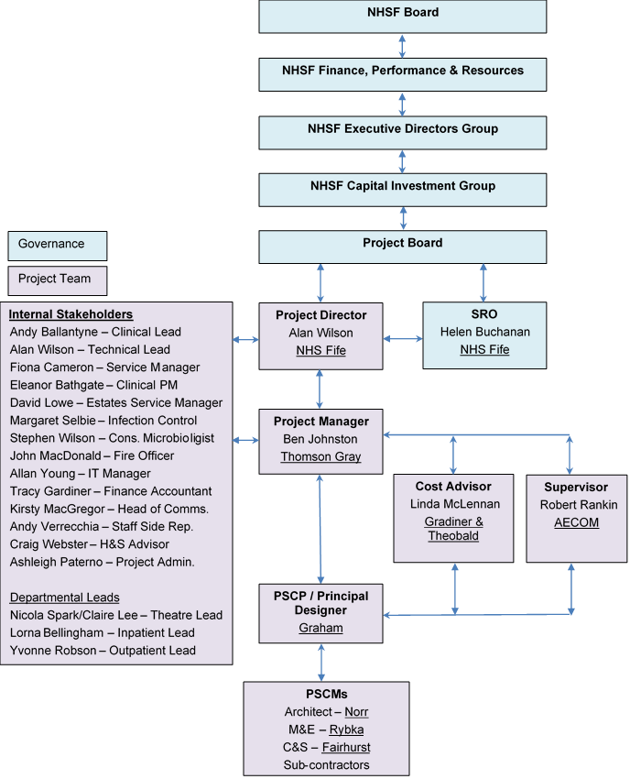

Figure 21 - Project structure

### Project Board

A Project Board has been established to oversee the project. The Project Board was set up at commencement of the OBC and Terms of Reference have been agreed. The Project Board meets monthly where they receive a regular project update report from the Project Director. Necessary matters are escalated by the Project Director as required whilst the Project Board offers direction to the Project Team.

Project Board membership and experience is outlined in the table below:

| **Named Person** | **Project Role and Responsibilities** | **Experience** |
| --- | --- | --- |
| Helen Buchanan (Director of Nursing) | Senior Responsible Officer – SRO with overall responsibility and accountability for the project. | Helen Buchanan took up her role as NHS Fife’s Executive Director of Nursing in July 2015.  Helen was previously the Associate Director of Nursing at NHS Forth Valley where she was the Board lead for the nursing and midwifery quality improvement agenda and was involved in a range of national programmes.  Helen has a broad portfolio of experience gathered across a range of strategic and clinical roles in both acute and primary care. |
| Alan Wilson (Capital Projects Director) | Project Director – Responsible for the delivery of the project from inception to completion. | Alan has worked within NHS Fife for 23 years within Estates Operations. He has over 10 years experience in the delivery of a wide range of Capital Projects within Healthcare environment. Alan is a Chartered Engineer and also an accredited NEC Project Manager. |
| Andy Ballantyne (Lead Consultant Orthopaedics) | Clinical Lead - Responsible for clinical governance. | Andy Ballantyne is a Consultant Orthopaedic Surgeon with NHS Fife since 2005.Andy has been the Clinical lead for Orthopaedics in NHS Fife since 2015. Andy was also a member of the core team involved in the development and submission of the IA for the Fife Elective Orthopaedic Centre delivered to CIG in Nov 2018. Andy has extensive experience in local DCAQ planning and delivery. Andy is an active member of the national Scottish Committee for Orthopaedic s and Trauma for 10 years, in roles of treasurer and more recently secretary and is also Co-Chair on the East Region Acute service review – orthopaedics work stream with specific involvement in DCAQ evaluation 2016-2018. |
| Margo McGurk (Director of Finance) | Project Board Member – Responsible for Financial Governance | Margo joined NHS Fife as Director of Finance in February 2020. She is a CCAB qualified accountant, with a broad range of experience across the public sector but particularly within the NHS in Scotland. She has significant experience of decision-making at strategic and operational levels and has a strong personal focus on developing strategy, supporting culture, delivering sound financial control and best value from the allocation of resources. Very experienced in delivering professional leadership to the finance function, she has held a number of senior roles across a number of NHS Boards. She is particularly interested in working in partnership across organisations and leading on the development and delivery of financial strategies to support delivery against agreed priorities. |
| Andrew Fairgrieve (Director of Estates, Facilities & Capital Services) | Project Board Member – Responsible for contributing towards general governance. | Andrew has vast Property and Asset management experience in the private sector and within the NHS. Andrew has a degree in IT/Electronics and a Masters Degree in building services design (mechanical and electrical). Andrew has also managed large new build and refurbishment projects. |
| Andy McKay (Deputy Chief Operating Officer) | Project Board Member – Responsible for contributing towards general governance | Andy has been with NHS Fife for just over a year and currently leads our Acute Services Division. Andy brings a range of experience to NHS Fife; he previously held senior operational leadership roles within Professional Services in the UK, and overseas, and has served as a Commissioned Officer with the British Army. |
| Fiona Cameron (Service Manager Planned Care) | Service Lead – Responsible for service governance. | Fiona is Service manager Orthopaedic, theatres & anaesthetics. Fiona has 15 years experiences of Orthopaedics as an extended scope physiotherapist, Orthopaedic service improvement lead and service manager. Fiona was a member of the core team involved in the development and submission of the IA for the Fife Elective Orthopaedic Centre. Fiona is also a Member of the Scottish Orthopaedic Service managers group and a member of East Region Orthopaedic service review group. Fiona has extensive experience of Orthopaedic and theatre redesign projects. |
| Dr Chris McKenna (Medical Director) | Project Board Member – Responsible for contributing towards clinical governance | Dr Chris McKenna started as Medical Director within NHS Fife on 1st March 2019.  Dr McKenna has previously served as Director of Emergency Care, where he has helped lead the redesign of services. |
| Kirsty MacGregor (Communications Manager) | Project Board Member – Responsible for communications governance. | Kirsty MacGregor brings more than 25 years of experience in public relations and marketing communications. Kirsty has a proven track record of providing expert and informed advice to senior management teams on all aspects of internal and external communications across a range of sectors including Higher Education, Local Government and the NHS.  A CIPR Accredited Practitioner, Kirsty also holds two Postgraduate Diplomas from the Chartered Institute of Public Relations, and the Chartered Institute of Marketing. |
| Murray Cross (General Manager Planned Care) | Project Board Member - Responsible for contributing towards general governance. | Murray has worked in NHS Fife for over 30 years, having started in Finance before moving into management in 1999. Murray has held a wide range of management positions across the Acute Division and has been in his current post of General Manager for Planned Care for the last 4 years. |
| Rona Laing (Non Executive Board Member) | Project Board Member – Responsible for contributing towards general governance. | Rona has been a Non-Executive Board member for 5 years she chaired the Audit and Risk Committee for several years and now chairs the Finance Performance and Resources Committee. Rona has contributed to the review and enhancement of the Board governance processes |
| Tracy Gardiner (Capital Accountant) | Capital Finance Lead – Responsible for financial governance. | Tracy has worked within NHS Fife for 25 years within the capital branch of the finance department. Tracy has a wide range of knowledge and experience in the delivery of capital projects within NHS Fife. |
| Wilma Brown (Employee Director) | Project Board Member – Responsible for staff governance. | Wilma has been the Employee Director for 10 years and will ensure we meet the required Staff Governance Standards through our Partnership processes. Wilma has been involved in a number of projects such as this and will ensure any aspects of the SG Standards are correctly identified and communicated between staff, staff side reps and the Project Board. |

Table 41 - Project Board experience

### Project Team

The project team sits below the Project Board and are responsible for delivering the project on a day to day basis. This includes, developing the design, managing risks, developing the costs, developing the business case, constructing the facility, commissioning the facility and successfully handing the facility over to NHS Fife at completion.

Within the Project Team, there are a range of roles with different responsibilities. The key roles and responsibilities are listed below:

**Project Director** – the Project Director is responsible for overseeing the delivery of the project on a day-to-day basis and for generally acting as the link between the Project Team and the Project Board. The Project Director will report to the Senior Responsible Officer and Project Board.

**Clinical Lead and Service Manager** – the Clinical Lead and Service Manager is responsible for clinical governance ensuring that sufficient engagement and participation is evidenced to allow the briefing and related design proposals to be robustly developed. They will also be responsible for accepting design proposals from a clinical perspective at key stages as part of the governance process and for resolving any conflict amongst Clinical Stakeholders.

**Clinical Project Manager** – the Clinical Project Manager role will involve providing support to the Clinical Lead and Service Manager. The role will also include leading on commissioning from a service perspective ensuring that the transfer to the new asset is managed smoothly.

**Technical Lead** – the Technical Lead will be responsible for ensuring that the briefing and related technical proposals align with the Board’s expectations and requirements. The Technical Lead will also be responsible for accepting design proposals from a technical perspective at key stages as part of the governance process.

**Technical Stakeholders** – the Technical Stakeholder group consists of representation form the following areas: estates, FM, fire, ICT and infection control. They will be responsible for providing local knowledge and advice in order to refine the briefing. They will also be required to review the PSCP’s proposals and attend agreed meetings so that the proposals can progressively be accepted in advance of the construction stage.

**Clinical Stakeholders** – the Clinical Stakeholder group are responsible for providing local knowledge and advice in order to refine the briefing. They will also be required to review the PSCP’s proposals and attend agreed meetings so that the proposals can progressively be accepted in advance of the construction stage.

**Project Manager** – the Project Manager will be the central hub within the project responsible for delivering the project within pre-agreed time, cost and quality parameters. All project communication should flow through the Project Manager as outlined within the organogram at Section 7.3.1. The Project Manager will report to the Project Director. The Project Manager will also be responsible for managing the project in accordance with the contract option selected.

**Joint Cost Advisor** – the Joint Cost Advisor will primarily work alongside the Project Manager assisting with setting the budget, creating cost plans, agreeing the target/price whilst contributing towards value management, value engineering and risk management. They will also assist the Project Manager with payment assessments and compensation events. The Joint Cost Advisor will act in a “joint” capacity assisting the PSCP with preparing pricing schedules / bills of quantities and other documentation required for tender purposes.

**Supervisor** – the Supervisor’s main duties relate to ensuring quality is provided during the construction stage. They do this through acting in accordance with the contract. The Supervisor may be appointed during the pre-construction phase to assist with developing the Works Information (testing requirements) and reviewing the PSCP’s proposals.

**PSCP** – the PSCP is responsible for designing and constructing the project within the agreed time, cost and quality constraints. They are also responsible for working in a safe manner whilst mitigating the risk of any operational disruption caused by the works. The PSCP’s full scope of duties are contained within the contract Works Information.

**Principal Designer** – the PSCP will be appointed as Principal Designer, in line with the CDM Regulations 2015. The role involves planning, management and coordination of health and safety in the pre-construction period, help and advice in bringing together the pre-construction information pack, working with the other designers to eliminate foreseeable health and safety risks, and ensuring the PSCP team are informed of risks requiring management in construction.

The Principal Designer is also responsible for coordinating and developing the Health and Safety File and for providing copies at the end of the project.

**PSCMs** – Principal Supply Chain members are designers and sub-contractors appointed directly by the PSCP to deliver and design the works.

### External Advisors

Independent consultants who have been appointed by the Board are set out in the table below:

| **Project role** | **Organisation** | **Lead person(s)** |
| --- | --- | --- |
| Project Manager | Thomson Gray | Ben Johnston |
| Cost Advisor | Gardiner & Theobald | Neil Cowan  Linda McLennan |
| Business Case Author | Thomson Gray | Ben Johnston |
| NEC Supervisor | AECOM | Robert Rankin |
| Clerk of Works | AECOM | Robert Rankin |

Table 42 - External Advisors

### Project Recruitment Needs

The Project Team has been developed robustly during the OBC and FBC Stages. All key roles are fulfilled and there are no immediate recruitment needs.

### Project Plan and Key Milestones

The project plan and key milestones are set out in the table below. A fully detailed draft construction programme has been developed and can be provided upon request.

| **Description / Activity** | **Date** |
| --- | --- |
| FBC |  |
| * Complete car park enabling works (to enable site to be cleared for construction) | Dec. 2020 |
| * Statutory consents | Dec. 2020 |
| * Fife Capital Investment Group (FCIG) | 1 Oct. 2020 |
| * Executive Director’s Group (EDG) | 8 Oct. 2020 |
| * Submit to Capital Investment Group (CIG), Scottish Government (SG) | 13 Oct. 2020 |
| * Clinical Governance | 4 Nov. 2020 |
| * Finance Performance and Resources Committee (FP&R), NHS Fife | 10 Nov. 2020 |
| * Capital Investment Group (CIG), Scottish Government (SG) Meeting | 11 Nov. 2020 |
| * Area Partnership Forum (APF) | 18 Nov. 2020 |
| * NHS Fife Board Meeting | 25 Nov. 2020 |
| Construction and handover (main works) |  |
| * Ground consolidation works | Jan. 2021 |
| * Start (main works) | Feb. 2021 |
| * Completion | Jul. 2022 |
| * NHSF commissioning / service migration | Aug. 2022 |
| * Operation / use | Sept. 2022 |

Table 43 - Project plan and key milestones

## Change Management Arrangements

### Operational and Service Change Plan

The Fife Elective Orthopaedic Centre will result in the following changes:

1. Increased surgical capacity by the provision of a third elective orthopaedic theatre with capacity to manage elective orthopaedic requirements for inpatient activity for the next 20 years based on ISD projections;
2. Increased ward capacity to provide a mixture of single room and day case facility to reflect the changing requirements for inpatient elective orthopaedic surgery;
3. Centralisation of NHS Fife MSK services to a single site, with resultant improved efficiency in OPD activity through developments consistent with the objectives of the Scottish Access Collaborative (SAC) in demand management within outpatients; and
4. Utilisation (where appropriate) of IT strategies building consistency with local and national strategy in the delivery of the aims of the SAC in demand management.

#### Theatres

Theatres plan to provide increased capacity by the provision of a third elective orthopaedic theatre. This will accommodate future demand for major joint surgery within NHS Fife over the next 20 years. These calculations are based on ISD projections for hip and knee arthroplasty (2017).

Short term theatre utilisation will be attained by relocating day case foot & ankle and arthroscopy lists to the Fife Elective Orthopaedic Centre. In addition, the expansion of the consultant workforce by 2 consultants will ensure the 3rd theatre is fully utilised and realise increased planned orthopaedic surgical capacity required to balance DCAQ. The movement of services will release day case capacity to be used by other services as part of wider planned care surgical service reorganisation.

Future demand will be accommodated by increasing theatre time utilisation and job plan redesign (weekend working, backfill and 3 session days).

The relocation of day case services will coincide with the opening of the Fife Elective Orthopaedic Centre. Subsequent adjustment to job plans will be recognised in future consultant appointments and a review of current job plans will be undertaken with a view to increasing flexibility. This will be a progressive process over the next 20 years reflecting the demands on service.

This will be led by Clinical Leads and Service Managers working in partnership with consultants to achieve theatre efficiency and delivery of the TTG.

#### Wards

In respect to the increased ward capacity, the workforce planning tool will be utilised to determine future nursing needs.

It is recognised that providing a mixture of day-case beds and single room inpatient beds offers patient capacity consistent to the changing requirements for inpatient bed space. An increasing number of patients, including lower limb arthroplasty, can be managed through a day-case facility. This has the benefit of maximising the efficient use of staff as it is recognised that a 100% single room wards have increased nursing requirements.

#### Centralisation of MSK services

Currently MSK service is delivered form a number of sites across NHS Fife. Often MSK practitioners are working in isolation with limited clinical or peer support. The centralisation of MSK services to a single purpose-built facility in Fife offers a number of benefits:

* MDT MSK delivery from single site;
* Opportunity to develop MDT support – clinical staff not working in isolation;
* Development of consistently applied pathways for MSK conditions;
* Efficiency opportunities in how aspects of service delivered (fracture clinics);
* Opportunities to develop AHP staff into more advance roles (fracture clinic nurses/ANP roles); and
* Opportunities to incorporate national and local IT strategies consistent with the Scottish Access Collaborative aims in demand management within outpatient services:
  1. Opt-In care
  2. Patient initiated review appointments
  3. Development of virtual clinics (NP and review)

This will be achieved by the service undertaking a review of current OPD activity and through a series of workshops looking at redesigning part of the service. Staff and patient engagement will be implemented within this transition. Service redesign will occur over the next three years to enable changes to be embedded prior to the transfer of services to the Fife Elective Orthopaedic Centre.

### Facilities Change Plan

The new facility will be serviced by NHS Fife’s in-house facilities team. The facility is a replacement for the current orthopaedic theatres and the associated ward currently located in Phase 2 tower block. The facility will be serviced under the existing facilities strategy through the link corridor provided in the new design that connects to the hospitals main FM corridor. Recognition has taken place that there will be a need for extra revenue costs for providing facilities services to the new building due to the increase in patient numbers projected over the next 25 years. These costs have been provided within the Financial Case (see Section 6).

### Stakeholder Engagement and Communications Plan

A Stakeholder Engagement and Communication Plan has been developed and endorsed by the Project Board. A copy of the plan can be located at Appendix O.

Stakeholder engagement has occurred at different levels to date. From a design perspective staff and service users have been actively involved in helping to develop the design of the facility. This has occurred through the following workshops:

* Development of the project’s Design Statement;
* 1:500 / 1:200 site and departmental adjacency workshops;
* 1:50 room adjacency workshops; and
* Achieving Excellence Design Evaluation Toolkit (AEDET) workshops.

Separately, several tools have been used to communicate the project to wider staff, service users and the general public. These tools have included:

* Dedicated website page on NHS Fife’s website;
* Statutory consultation meetings (2 no.); and
* Project displays / notice boards within the main hospital reception at VHK.

## Benefits Realisation

### Benefits Register

The rationale for an investment needs to be reflected in the realisation of demonstrable benefits, as this will provide the evidence base that the proposal is worthwhile and that a successful outcome is achievable. The benefits to be achieved are discussed in the Strategic Case and have resulted in the creation of a Benefits Register and Benefit Realisation Plan for the Project. The Benefits Register is located at Appendix K.

The benefits register includes a range of benefits to be realised by the development. Each benefit includes a target that will be used to indicate the measure of success during the Post Project Evaluation (PPE).

Benefits are either assessed in a quantitative or qualitative manner.

For the quantitative benefits, the register indicates the baseline (current position) at the start of the project including the source. This will be compared with the same data source when the PPE is completed.

For benefits that are qualitative in nature, questionnaires will be developed, and a mix of patient and staff surveys/interviews will be undertaken to outline the baseline for these benefits. The same survey tools will be used during the PPE to examine to what degree the improvements sought were achieved.

Additionally, a Red, Amber, Green (RAG) score highlighting the relative importance of each benefit is indicated using the scale outlined below in the table below.

|  |  |
| --- | --- |
| **Scale / RAG** | **Relative importance** |
| **1** | Fairly insignificant |
| **2** |  |
| **3** | Moderately important |
| **4** |  |
| **5** | Vital |

Table 44 - Benefits and relative importance

The baseline and target values for each benefit have been refined and updated during the FBC phase ensuring that relevant data is available for comparative purposes during the PPE.

Community Benefits

The Benefits Register also sets out wider sustainability opportunities associated with this Project. Notably there is potential to deliver community benefits through education, training and recruitment, whilst targeting work packages offered to Small or Medium Size Enterprises (SMEs).

Within the procurement process the requirement for community benefits was set out in the tender documentation. These requirements are referenced within the Benefits Register which the PSCP will be expected to meet and surpass.

### Benefits Realisation Plan

A Benefits Realisation Plan has been produced to support the achievement of the benefits outlined in the Benefits Register, and it is included as Appendix M.

The benefits realisation process is a planned and systematic process consisting of four defined stages outlined below. The implementation of this plan will be reviewed regularly by the Project Board.

Figure 22 - Benefits realisation process

The Benefits Realisation Plan outlines:

* Which Investment Objective the benefit addresses;
* Who will receive the benefit;
* Who is responsible for delivering the benefit;
* Any dependencies that could affect delivery of the benefit; and
* Any support needed from other agencies etc. to realise the benefit.

Benefits monitoring will be ongoing over the life of the Project through the planning, procurement and implementation phases. Progress will be reported to the Project Board at regular intervals and will culminate in the Project Evaluation Report to be produced in 2023.

## Risk Management

Risk management is a structured approach to identifying, assessing and controlling risks that emerge during the project lifecycle. It is a critical and continuous process throughout the planning, procurement and implementation journey of a project.

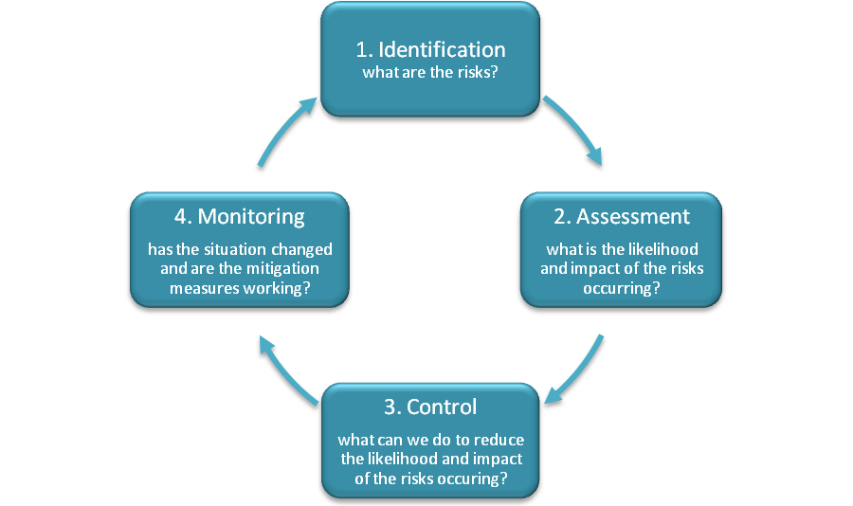

Figure 23 - Risk management process

### Updated Risk Register

The Project Team have continued to develop the Risk Register provided at OBC. The current FBC risk register can be located at Appendix M. The Risk Register is up to date and representative of the residual risks that may be encountered during the construction phase of the project. The headline items noted below, demonstrate how the risk register has been developed since IA.

* New risks have been identified and added to the register, whilst other risk have been closed;
* Probability, impact and risk ratings have been updated progressively at risk workshops;
* Mitigation measures have been agreed and updated;
* Each risk has been identified as quantifiable or unquantifiable – where the risk is identified as quantifiable it has been carried forward to allow contingency pricing;
* Risk owners and managers have been allocated. *A risk owner has overall responsibility for the risk, whilst a manager is responsible for helping to mitigate the risk.*

The commercial arrangements associated with the Risk Register are set out within the Commercial Case.

### Governance

The Project Director has overall responsibility for the project risk register. The Project Manager is however responsible for maintaining the risk register on a day to day basis and for organising regular risk workshops to review and manage the risks.

The risk register is updated and provided to the Project Board on a monthly basis as an Appendix to the Project Manager’s monthly progress report. Key risks are extracted from the risk register and highlighted within the Project Manager’s monthly report for ease of reference. The Project Board provide direction to the Project Director and Project Manager on risk matters as necessary.

## Commissioning

The importance of the commissioning process cannot be underestimated, as failure to adequately consider this process is likely to cause increases to project costs and failure to deliver agreed service benefits and project outcomes. The Project Board and Director are fully committed to implementing a robust commissioning process, ensuring that the facilities are safe to use and operate from the outset.

The commissioning process will be treated as a distinct workstreams, but fully integrated into the overall project to enable a smooth transition to the new working arrangements and realisation of the anticipated benefits. Workstreams will include Technical Commissioning and Operational Commissioning and these will be supported by BIM and Soft Landing processes.

Technical Commissioning concentrates on the readiness of the facility to support operational activity. As such the mechanical and electrical systems all need to be operating satisfactorily at handover of the facility and beyond. Operational Commissioning on the other hand is involved with getting the clinical services transferred into the facility with minimal disruption to business continuity. Given these separate requirements an Operational Commissioning Manager has been appointed directly by NHS Fife. The Technical Commissioning Manager role will be undertaken by the PSCP; however, the Project Director, Project Manager, NEC / Clerk of Works and Estates Service Manager will maintain active roles helping to facilitate a robust technical commissioning process.

The Commissioning Managers will report to the Project Manager on a day to day basis but will maintain lines of communication with the wider team to deliver against the plans.

A Commissioning Strategy and detailed commissioning programme has been developed to assist with the understanding and management of the commissioning process for the project – this is located at Appendix P.

## Post Project Evaluation

The arrangements for post implementation review and project evaluation reviews have been established in accordance with best practice. These reviews will determine whether the anticipated benefits identified at the outset have been delivered. The project will be evaluated in stages:

Stage 1 – Procurement Process Evaluation

An evaluation of the procurement process will be undertaken following the signing of the contract to assess the effectiveness of the procurement process in meeting the project objectives. This will identify any issues and lessons to be learned that will benefit future projects. This evaluation can take place shortly after commencement of the construction phase.

Stage 2 – Monitoring Construction

During the construction period progress will be monitored to ensure delivery of the project to time, cost, and quality to identify issues and actions arising. On completion of the construction phase the actual project outputs achieved will be reviewed and assessed against requirements, to ensure these match the project’s intended outputs and deliver its objectives.

Following completion, the Project Manager’s and Supervisor’s monthly reports will be reviewed and summarised to represent a holistic view of how the project performed during the construction period.

Stage 3 – Initial Project Evaluation of the Service Outcomes

This will be undertaken 6 to 12 months after the new facility has been commissioned. The objective is to determine the success of the commissioning phase and the transfer of services into the new facilities and what lessons may be learned from the process.

Stage 4 – Follow-up Project Evaluation

This will be undertaken 2 years into the operational phase by the Evaluation Team to assess the longer-term service outcomes and ensure that the project’s objectives continue to be delivered.

The following questions will be asked at each stage:

* Have relevant project objectives been achieved?
* Has the project progressed as planned?
* If the plan was not followed, why did this occur?
* If appropriate, how should plans for future projects be amended?

The process will be led by evaluators, independent of the delivery team, who will meet with representatives of the user groups and other key stakeholders. The Project Sponsor, on behalf of the Project Board, will receive reports at each stage of the evaluation process.

Appendix A – Strategic Assessment

Appendix B – Existing Plans

Appendix C – Projected Future Demand

Appendix D – Long and Short List of Options

Appendix E – Proposed Floor Layouts

Appendix F – AEDET

Appendix G – HAI SCRIBE

Appendix H – Design Statement

Appendix I – Derogation Schedule

Appendix J – Target Price and Project Budget Summary

Appendix K – Benefits Register

Appendix L – Benefits Realisation Plan

Appendix M – Risk Register

Appendix N – Communication Plan

Appendix O – Project Board Member’s Statement of Support

Appendix P – Commissioning Strategy