NHS Fife provides accessible communication in a variety of formats including for people who are speakers of community languages, who require Easy Read versions, who speak BSL, read Braille or use Audio formats.

NHS Fife SMS text service number 07805800005 is available for people who have a hearing or speech impairment.

To find out more about accessible formats contact:

Fife.equalityandhumanrights.nhs.scot

or phone 01592 729130

If you are a blood donor please take this leaflet with you next time you donate blood.

has had acupuncture treatment by

_____________________

Sterile, single use, disposable needles have been used for this treatment.

Further patient information leaflets are available online on our website [www.nhsfife.org/](http://www.nhsfife.org/)

Please do not hesitate to contact your nearest podiatry clinic should you have any queries.



Fife Council and NHS Fife

are supporting the people

of Fife together through

Fife’s Health and Social

Care Partnership.

**www.fifehealthandsocialcare.org**

|  |  |
| --- | --- |
| Issued | Jan 2002 |
| Revised | Sept 2020 |
| Next Review | Sept 2022 |
| Images | NHS Podiatry |



PODIATRY

DEPARTMENT

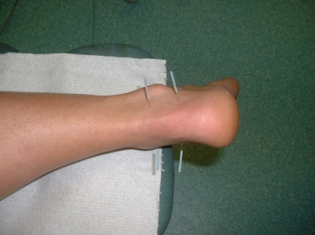

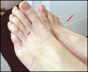  

ACUPUNCTURE

**WHAT IS ACUPUNCTURE?**

Acupuncture is a treatment where the patient is pricked with special needles. It was developed in China about 2000 years ago. Within NHS Fife Podiatry this is used as a complementary therapy.

**HOW DOES IT WORK?**

Acupuncture involves inserting fine needles into specific painful areas in the body.

1) Acupuncture is thought to interrupt the painful stimuli that the brain receives and thus reduce pain sensations.

2) Treatment with acupuncture has been shown to increase the production of the body’s own natural chemical painkillers called endorphins.

**WHAT CONDITIONS CAN BE HELPED?**

Acupuncture can be good for pain relief, especially in the muscles and joints, including some forms of arthritis.

**DOES IT HURT?**

Acupuncture is not usually completely pain free, although most people experience little more than a brief scratch sensation on insertion of the needle.

**ARE THERE SIDE EFFECTS?**

A small bruise may appear where the needle was inserted, this is not serious; it just means that a little vein was broken by the needle. Patients may find their pain or other symptoms become temporarily worse for a short time after acupuncture. Tell the podiatrist the next time you come.

Some people will get an ‘aggravation’ of this kind every time they have acupuncture. Often aggravation is followed by an improvement, particularly on the first occasion.

You may feel drowsy, this can occur sometime later after treatment therefore you should be CAUTIOUS about driving for the rest of the day and you should be aware that your reflexes may be slower than normal.

**CAN ACUPUNCTURE TRANSMIT INFECTION, AIDS OR HEPATITIS?**

NO, because all the needles are sterile

and disposed of after use.

**HOW SOON WILL I NOTICE AN IMPROVEMENT?**

Some patients notice some or even complete pain relief as soon as the needles are removed. Others find that improvement takes longer to appear — up to seven days.

**HOW MANY TREATMENTS WILL I REQUIRE?**

Most people require a course of roughly 3 to 6 treatments. At first you may be asked to come back after one or two weeks; as improvement occurs the time between treatments may be longer.

If no effect occurs after 2 or 3 treatments you are probably not going to respond to this form of treatment.

**WILL ACUPUNCTURE CURE ME COMPLETELY?**

It is unlikely you will be cured completely but it can depend on what you are being treated for.