Stress Incontinence

Service User Information Leaflet

Produced by: Pelvic Health Physiotherapy Service

Date of issue: Sep 2020 Review Date: Sep 2022

NHS Fife provides accessible communication in a variety of formats including for people who are speakers of community languages, who require Easy Read versions, who speak BSL, read Braille or use Audio formats.

NHS Fife SMS text service number 07805800005 is available for people who have a hearing or speech impairment.

To find out more about accessible formats phone 01592 729130 or contact: fife.equalityandhumanrights@nhs.scot.

What is Stress Incontinence?

This is when stress on the bladder causes you to leak urine. This can happen when you cough, sneeze, get up from a chair, run, lift something, laugh or during sexual intercourse. Stress incontinence is not linked to feeling stressed. Physical exercise or strain causes extra pressure on the abdomen. This puts pressure on the bladder. If the muscles which support and close off the bladder’s opening do not work properly, urine can leak out. The problem is more common in women, but some men do suffer from it too.

Why do the muscles not work properly?

The muscles that support and close off the bladder are called the pelvic floor muscles. Sometimes they can become weak.

The most common cause for this is pregnancy and childbirth. Being overweight, smoking, having a bad cough, constipation, lack of general fitness and menopausal changes can also weaken the muscles.

Side view of a woman’s pelvic floor muscles
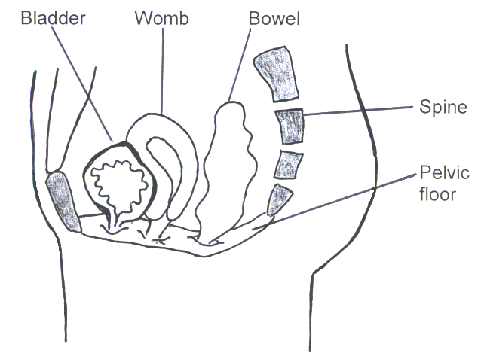

What can I do about it?

Working on pelvic floor exercises regularly is one of the most important things you can do. You should only practise pelvic floor exercises once you have been taught the correct technique. Your physiotherapist can check your technique.

Whenever there is an increase in pressure on your bladder, such as when you cough or lift something, you should pull up with your pelvic floor muscles. This is known as “The Knack”.

If you are a smoker, consider giving up or even cutting down. If you are overweight, losing a few pounds can help. If you have had a cough for a long time, or are constipated, you should get treatment from your doctor for these problems.

Pelvic Floor Exercises

The pelvic floor muscles are just inside your body, between your legs. They are attached between the bottom of your spine (coccyx) and the bone at the front (pubic bone). They help to support the pelvic organs such as the bladder, the womb and the bowel. These muscles work to help to keep the bladder and bowel openings closed to stop leakage and they relax when you pass urine and empty your bowels. Pelvic floor muscles should be worked to keep them healthy and strong like other muscles in your body. They can become damaged and weak like any other muscles in your body.

To work these muscles you should pull up around your anus (back passage) as if you are trying to stop passing wind. At the same time, try to pull up as if you were trying to stop passing urine mid-flow. You should be pulling upwards and forwards from your back passage towards your bladder.

You might find it easier to do them lying on your back or sitting. It is easy to use the wrong muscles instead of the pelvic floor, try not to squeeze your buttocks or tummy. Remember to keep breathing throughout.

If you get any pain, or your symptoms worsen after doing these exercises, stop and seek help from your specialist physiotherapist.

You should practise both fast and slow exercises at least 3 times a day. You can work the muscles in different positions. These include lying on your back with your knees bent up, sitting upright on a firm chair or standing. It takes about 3-6 months of daily exercise to increase your muscle strength.

Slow Holds

Gradually tighten the muscles and hold for up to 10 seconds. You may only be able to hold for 2 or 3 seconds to start with. Relax for 5 seconds before repeating. Repeat this exercise up to 10 times.

Fast Squeezes

Tighten as quickly and firmly as you can. Take time to fully relax the muscle before repeating the exercise. Repeat this up to 10 times.

Warning!

Although stopping your urine midstream does work your pelvic floor, this should not be done on a regular basis. It may interfere with normal bladder function.

Other ways to help

Squeezy App

“Squeezy” is the NHS App for pelvic floor muscle exercises and is available from the App Store and Google Play. This app has been designed by physiotherapists working in the NHS. It is discreet, informative and has helpful visual and audio prompts to support your exercise programme. It can give you reminders to exercise and records the number of exercises you have completed. There are also other pelvic floor exercise apps available.

Medication

There is medication available which may be prescribed by your doctor to help with stress incontinence. This is not seen as the best way to treat stress incontinence and isn’t always effective.

Vaginal Devices for Stress Incontinence

Your physiotherapist can advise you about products which can be used vaginally to support the opening of the bladder. These can be useful if you leak with specific activities such as at the gym, or running.

Surgery

Sometimes surgery is needed to improve stress incontinence. Your physiotherapist can refer you on to the hospital doctor if this needs to be considered.

Further information

www.nhs.uk/conditions/urinary-incontinence
www.bladderandbowel.org
www.bladdermatters.co.uk
https://pogp.csp.org.uk/publications/pelvic-floor-muscle-exercises-women

References

POGP Pelvic Floor Exercises for Women
BAUS Incontinence of Urine webpage
NICE Guideline: Urinary incontinence in women: Management

