*Cerys*

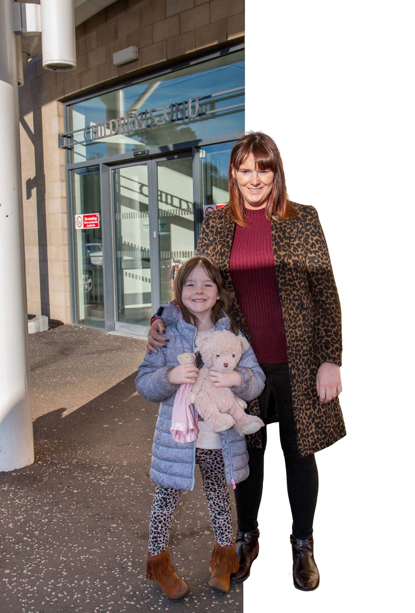

*goes to Theatre*

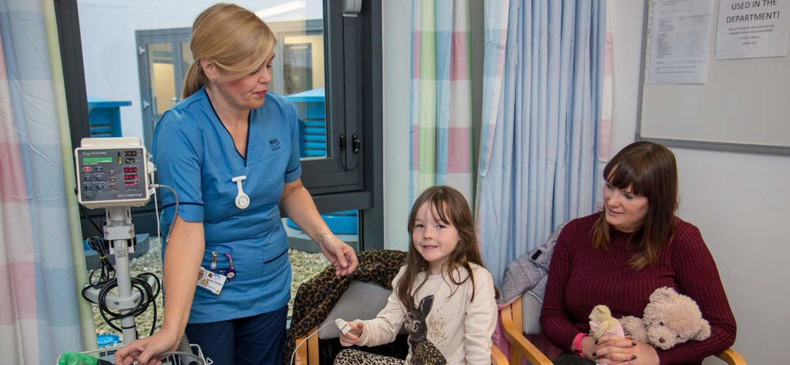

When Cerys arrived at the Children’s Unit she met the nurse who would be looking after her and was shown to her bed.

The nurse asked lots of questions to find out all about Cerys.

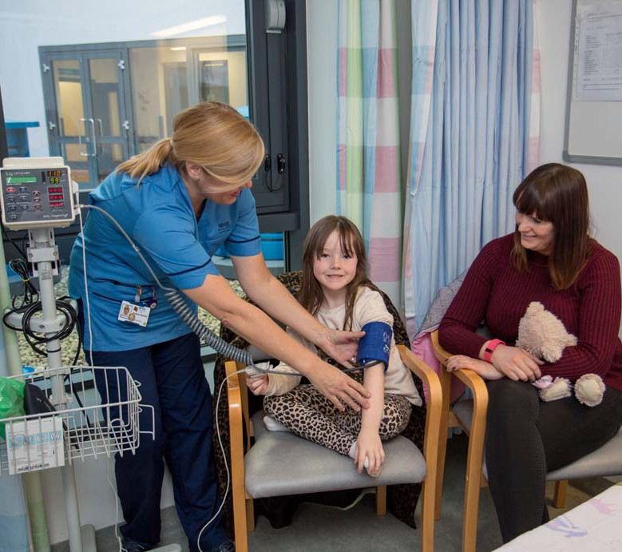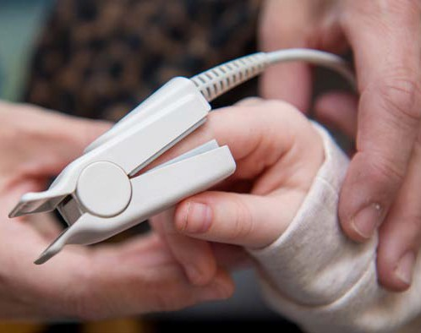

*The nurse placed a soft peg on her* finger and a cuff on *her arm,this made numbers appear on*

*the machine.*

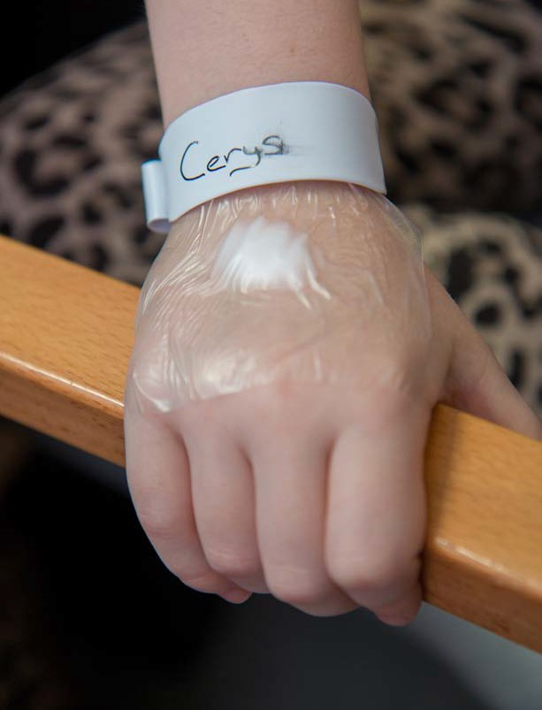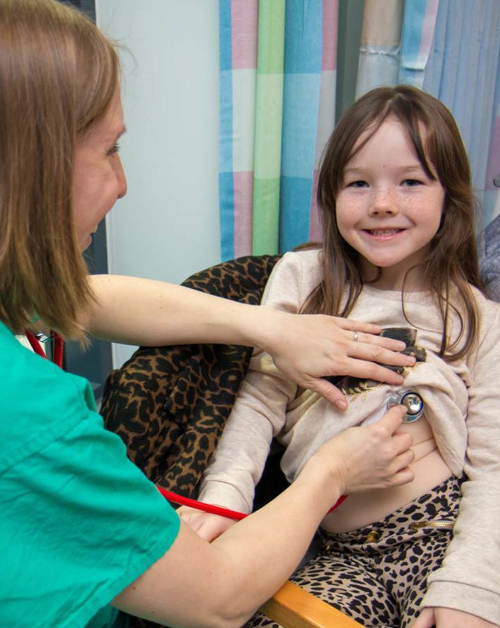

The nurse applied some special numbing cream to the back of both Cerys’ hands and put a clear plaster over the top to stop it from coming off. Cerys was also given a name band to wear.

To find out more about Cerys the doctor came to speak to Cerys and her Mum. The doctor used a stethoscope to listen to Cerys’ chest.

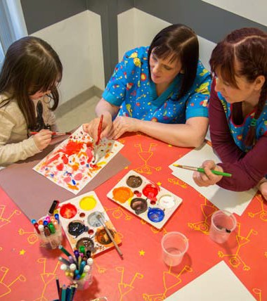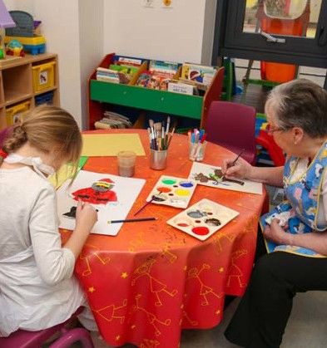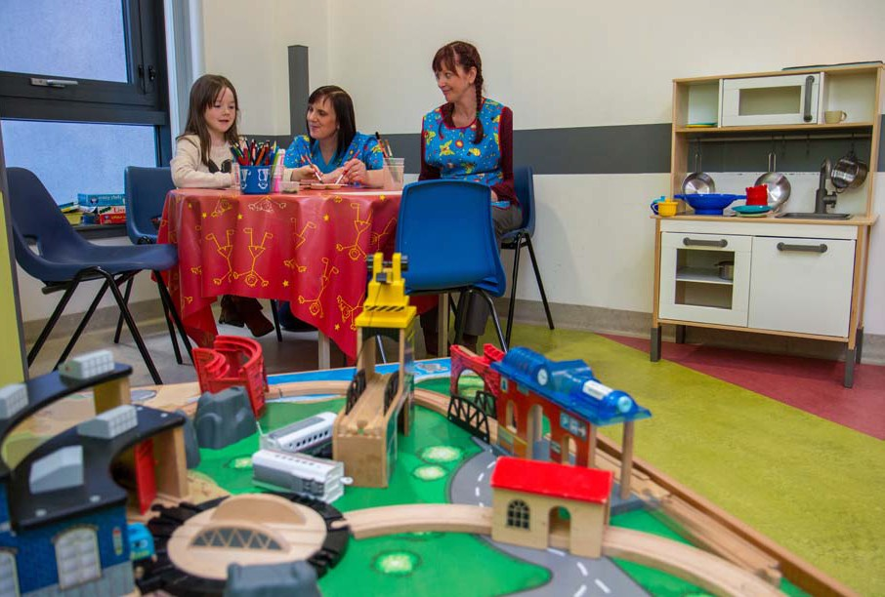

Cerys spent some time in the play area doing various activities with the play staff.

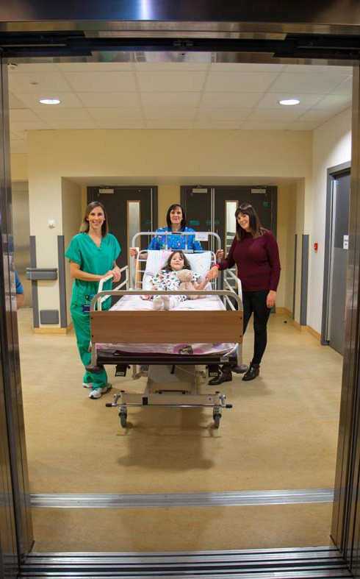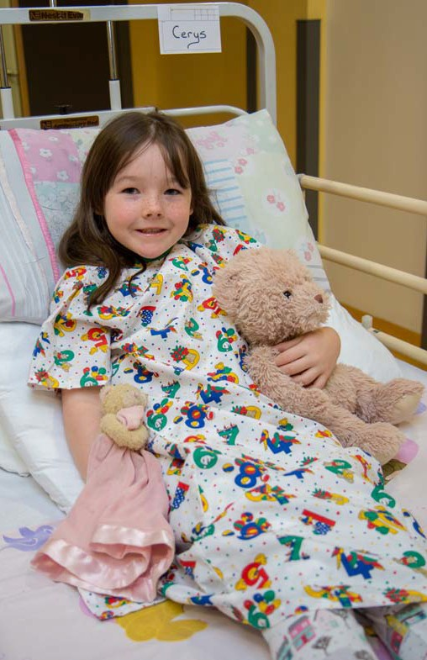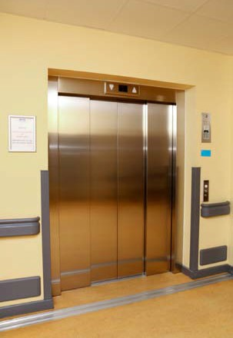

*When it was time for*

*Cerys to go to theatre*

*she was given a gown to wear.*

*Cerys and her Mum*

*went in the lift and* went up one floor.

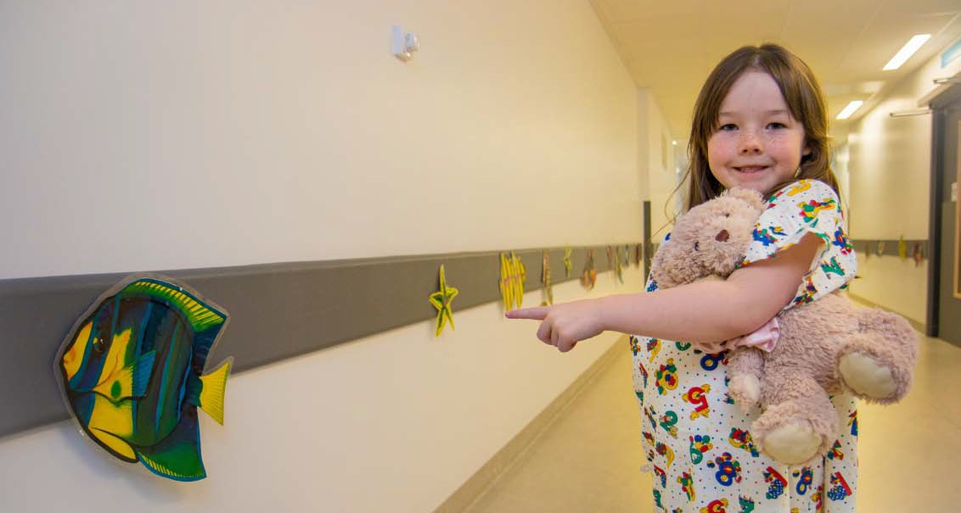

*When Cerys arrived at theatre reception she got off of her bed and followed the pictures of the sea animals to the anaesthetic room.*

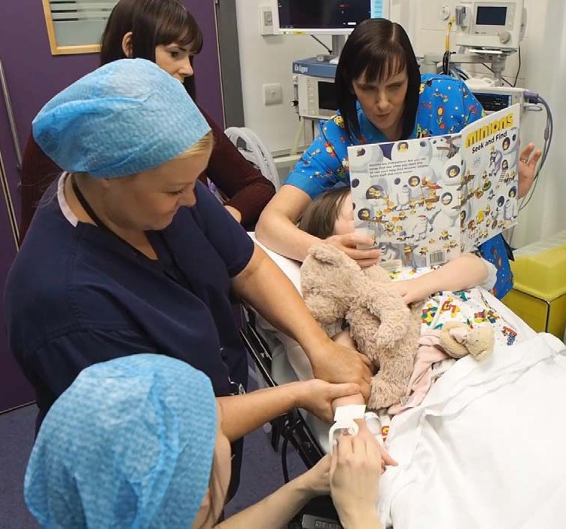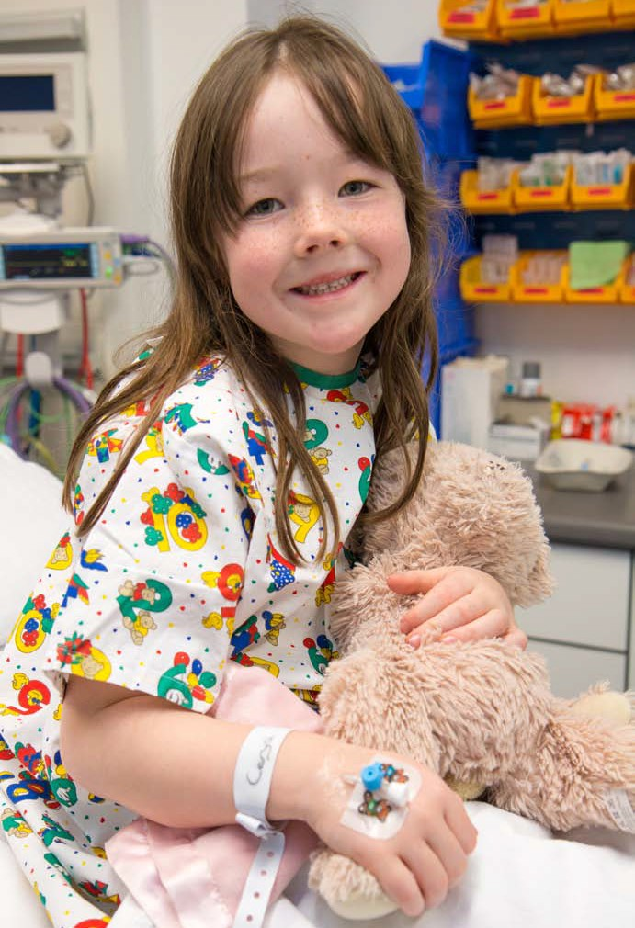

Cerys is looking at a book while the doctor is having a look at her hand where the cream

has been.

The doctor has given Cerys a little straw in her hand, this means she can be given the special sleepy medicine so she can have her operation.

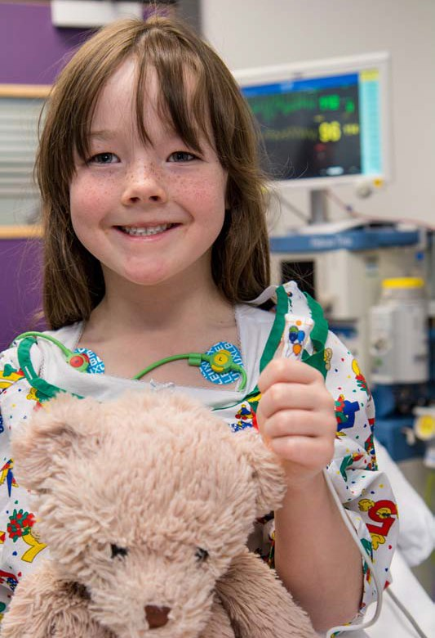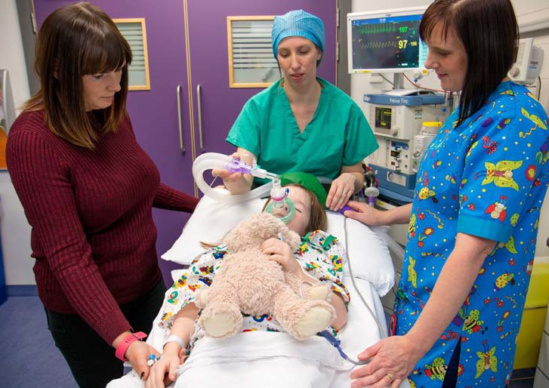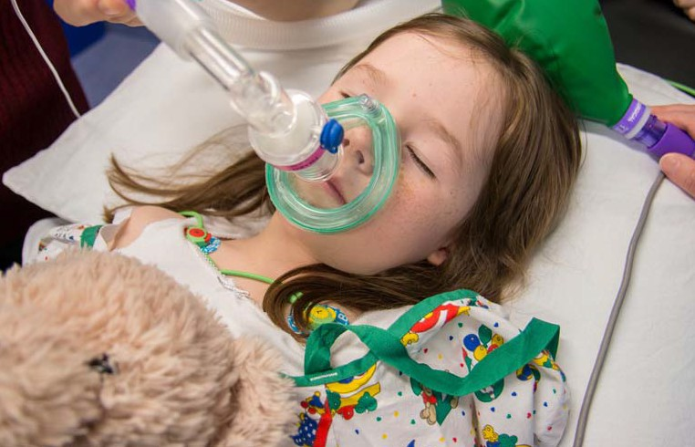

Before Cerys goes to sleep one of the nurses put three sticky dots on her with a wire attached to them.

This will make some wiggly lines on a computer screen. This is called a heart tracing and means that the doctors and nurses can monitor Cerys while she is having

her operation.

Cerys is breathing some oxygen through a mask before she

is given the special sleepy medicine through the straw in her hand.

Sometimes the mask is used to give the patient sleepy air.

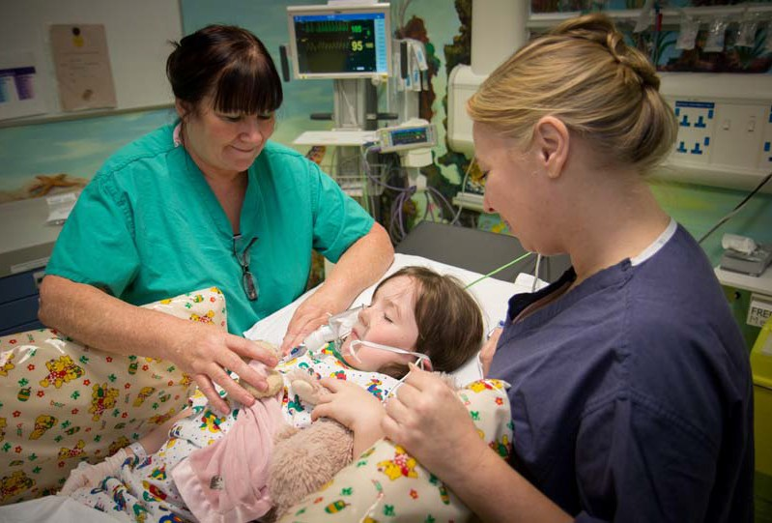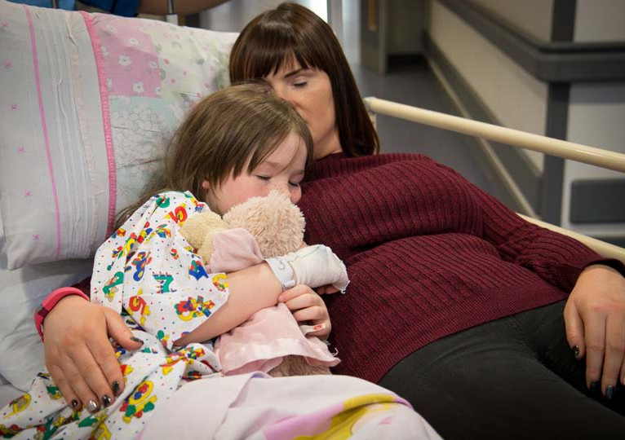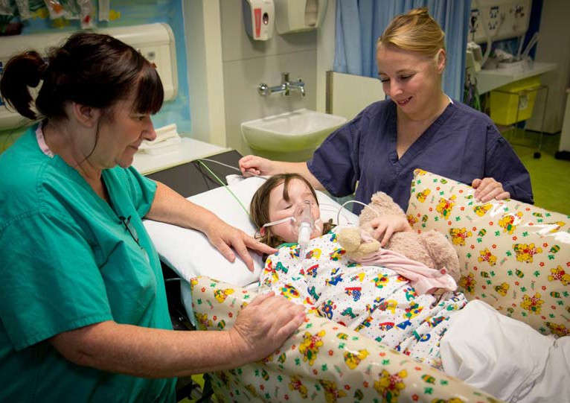

After Cerys had her operation she was taken to the recovery room.

She was still asleep and the nurses looked after her until her Mum arrived.

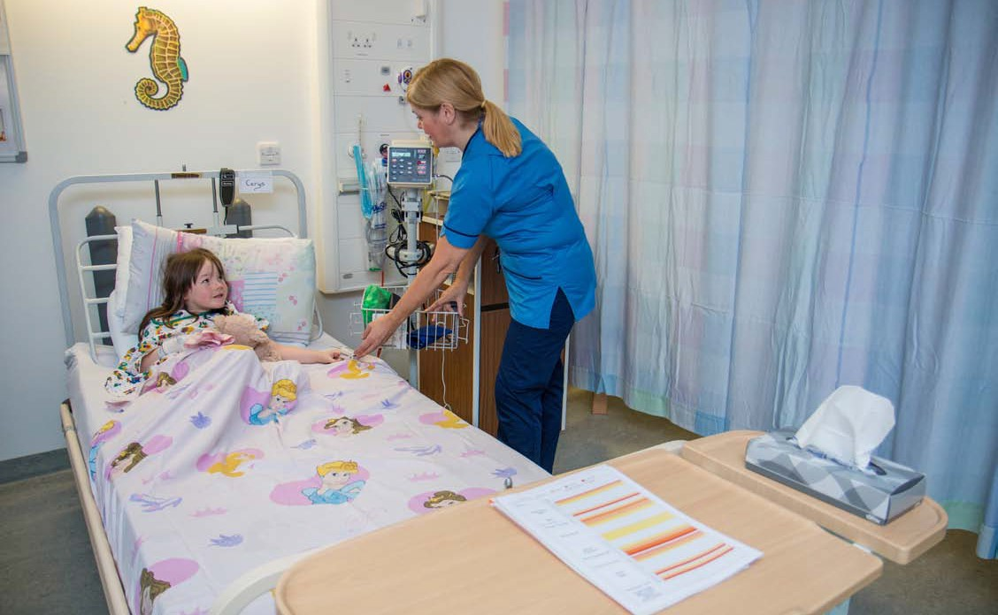

*When Cerys arrived back in the ward, the nurse put* the soft peg on her finger and the cuff on her arm *to check her numbers again.*

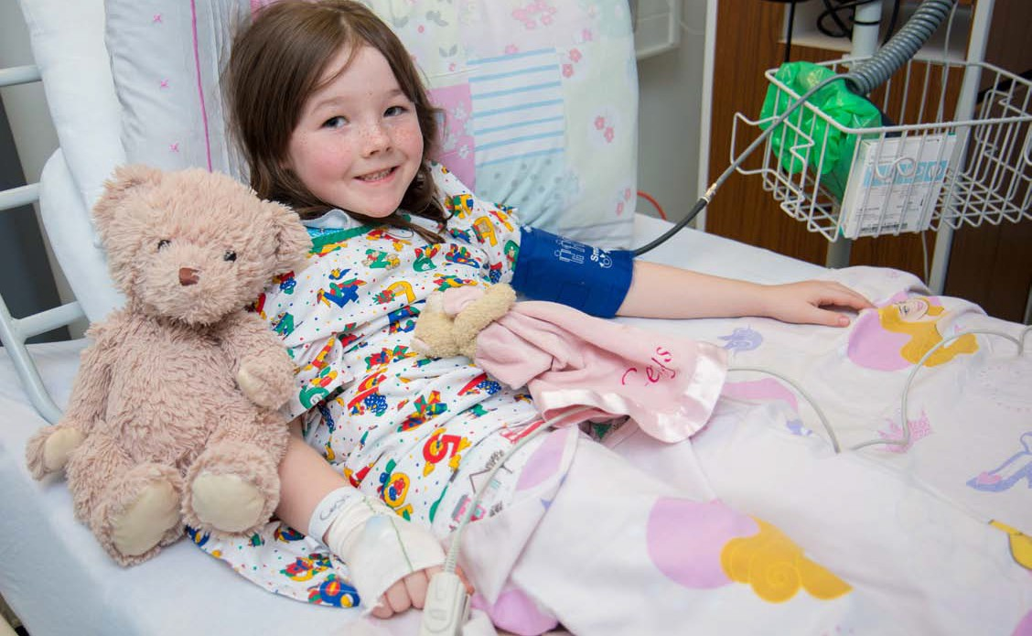

Cerys was given a drink of water.

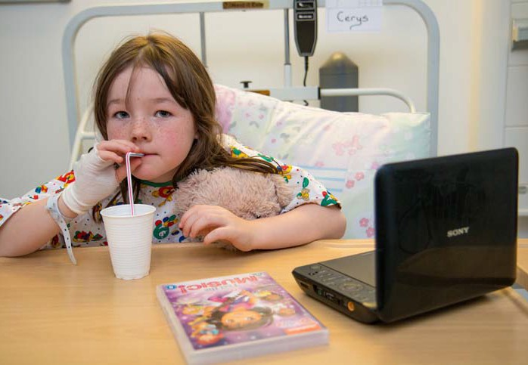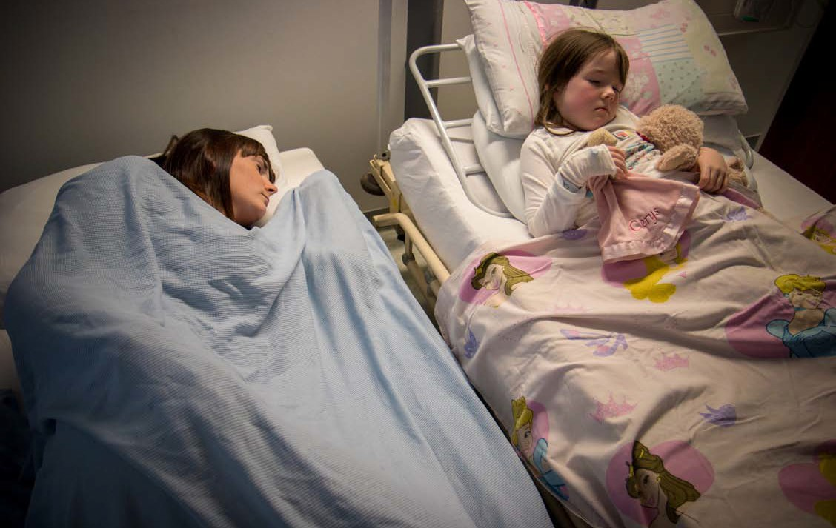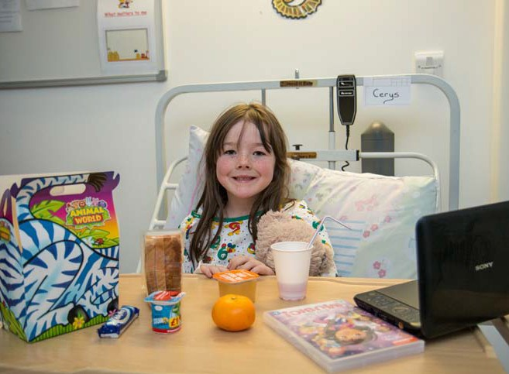

A short while later after having a drink Cerys got a snack box.

Cerys had to stay in hospital overnight so her Mum got to have a bed right beside her.

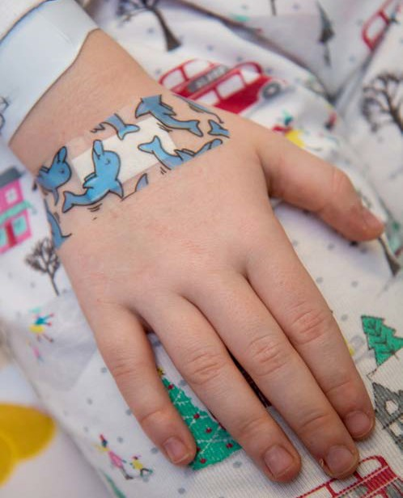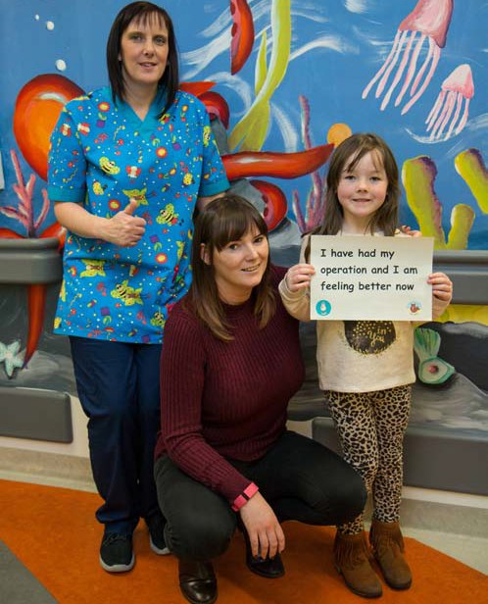

The next morning Cerys had some breakfast and then got the little straw out of her hand.

When the doctor said it was okay for Cerys to go, she went home with

her family.

