Plantar Heel Pain
(Pain beneath the heel)
The heel is a much specialised part of the body designed to absorb shock when walking / running. The force placed through the heel when walking is up to 3 times body weight. When running this increases to 6 times body weight. The heel is designed to withstand these repetitive forces via a strong heel bone (the Calcaneus or Calcaneum) and a tough fatty heel pad made up of columns of spiral shaped cells full of fat which act as a shock absorber. A number of muscles and ligaments insert into the heel bone. The strongest is called the plantar fascia, this is made up of several ligaments and a structure called the Plantar Aponeurosis which attaches into the heel bone and runs forwards into the arch of the foot and attaches near the ball of the foot. The Fascia helps maintain the arch of the foot and is placed under considerable stress during walking / exercise / prolonged standing.
What causes plantar heel pain?
There are a wide variety of causes
• Plantar fasciopathy – is probably the most common.
Other causes include –
• Arthritis in the ankle / heel (different forms of arthritis can lead to heel pain) • Irritation of nerves in and around the heel • Thinning / Weakness (Atrophy) of the heel pad • Injury of the heel pad or heel bones • Prolonged standing / working on hard surfaces • “Flat feet” or highly arched feet • Tight calf muscles • Bursitis • Bone infection

What is Plantar Fasciopathy?
This has historically been called plantar fasciitis, but it is now recognised to be less of an inflammatory condition and more as a result of degeneration of the tissues. The usual sites for heel pain are at the attachment of the plantar fascia to the heel bone and in the arch of the foot.
Usual sites of pain
Normal plantar fascia is a 4mm thick band of tissue that reaches from the heel to the toes. It stretches with every footstep to support the arch. Pain can occur when this is strained or compressed too much and can be present in one or both feet. There is usually a combination of factors that can lead to this developing including tight or weak leg muscles, foot shape, unsupportive footwear or changes to activity. The area may swell and tighten causing sharp, aching, throbbing or burning pain on the inside of the heel. This may be worse first thing in the morning, after inactivity or after walking long distances.
Why do I have it?
Plantar heel pain can affect almost anyone. One in 10 people will be affected during their lifetime with runners and people aged between 40 –60 years commonly being affected. You may have a higher risk of developing plantar heel pain if you are overweight, stand/walk for excessive periods, have tight or weak muscles around the foot and ankle or have changes to your activity levels.
What are the signs and symptoms?
Usually, there is a sharp, aching, throbbing or burning pain on the bottom of your heel which is worse when you get up after a period of rest especially with the first few steps in the morning. This pain can persist for some time, although generally it gets better as you move around. Sometimes the pain can be more constant and can come on during activity such as walking or standing. Plantar heel pain can take a long time to improve but symptoms can be reduced.

What treatments are available?
Remember the best placed person to start treatment is YOU!
Plantar heel pain can improve without treatment, but in many cases it is painful and can take up to a year or longer to progress. There is not one treatment alone that is recommended for plantar heel pain but a combination of the following treatments can be effective.
- Lifestyle changes: If you happen to be overweight, losing weight will help as it will reduce the amount of load going through the heel and fascia as you walk. If you think you need more help with weight loss, please discuss this with your podiatrist or GP.
- Exercise and physical activity: While the heels are painful, you should temporarily reduce weight-bearing activities such as running and strenuous walking. It is, however important that you remain physically active. Activities such as swimming, cycling and rowing can be useful to stay active until your heel pain improves
- Supportive Footwear - Shoes or trainers with a fastening and thicker soles stop the arch overstretching. Avoid flat soled, slip-on shoes, slippers or sandals when walking or standing, including indoors. If you are given insoles to rest the arch, wear them in the shoes advised.
- Massage roller - You can buy massage rollers or use a household item such as a golf /tennis ball or bottle of frozen water. Sit on a chair with your knee bent and foot flat on the ground. Press on the roller as hard as bearable and roll backward and forward under the arch.
- Plantar Fascia Stretch – in a seated position grasp big toe and pull in an upwards motion holding the stretch for a count of 30 seconds. (See attached leaflet & link 3)
- Plantar Fascia Massage: Massaging the fascia can be very useful. While seated, cross your leg over your knee and pull the toes back towards the shin until you feel a stretch in the arch of the foot. You can usually see the band of fascia become prominent...Use the thumb to massage as hard as you can, along the length of the fascia. Try to do this for two or three repetitions 1 or 2 times a day. (See attached diagram)
- Calf Stretches (see attached leaflet & Links 4, 5, 6 & 7) Seated: Before you get up in the morning, use a towel to stretch the calf muscles. Loop it around the ball of your foot and pull towards you for 30 seconds, and release. Repeat this two or three times. Standing: Face a wall and place your right leg behind you (feet facing forwards). Lean forward, bending the front leg, and push your right heel into the floor keeping the leg straight. Hold for 30 seconds and relax. Repeat three times. You should feel the stretch in the calf of your back leg. Repeat this stretch with the back knee bent, making sure the back heel stays on the ground.
- Intrinsic Foot Muscle Exercises – (see attached leaflet & link 1 & 2)
- Low dye strapping - Supportive strapping is useful in relieving heel pain. (see attached diagram)
- Insoles and foot orthotics - Cushioned heel pads and simple orthotics can be purchased from pharmacies and are often effective in relieving heel pain.
- Night Splint – you may wish to purchase a night splint to stretch the calf muscles and fascia as you sleep.
- Other treatments - Sometimes, particularly in severe or chronic (ongoing for several months) heel pain, a podiatrist may recommend other interventions.

It is important to remember that despite interventions you may be left with a degree of residual pain.

What is a heel spur?
Heel spurs are a shelf-like protrusion of bone arising from the underside of the calcaneus. They are often wrongly blamed as the cause of heel pain. Many people who have no symptoms have heel spurs. The spurs do form due to stress but are generally not the cause of the pain.

Links to online videos
- https://www.youtube.com/watch?v=r4_d-Ofm0Ac
- https://www.youtube.com/watch?v=5ixZj9vRF5k
- https://www.youtube.com/watch?v=l5zCe0AdQks
- https://www.youtube.com/watch?v=i62VbiuDU18
- https://www.youtube.com/watch?v=rlAjIXb-8BM
- https://www.youtube.com/watch?v=2_2GMXTc1BE
- https://www.youtube.com/watch?v=A_npfqG65vs

https://www.nhs.uk/conditions/foot-pain/heel-pain - NHS Inform Heel Pain Advice

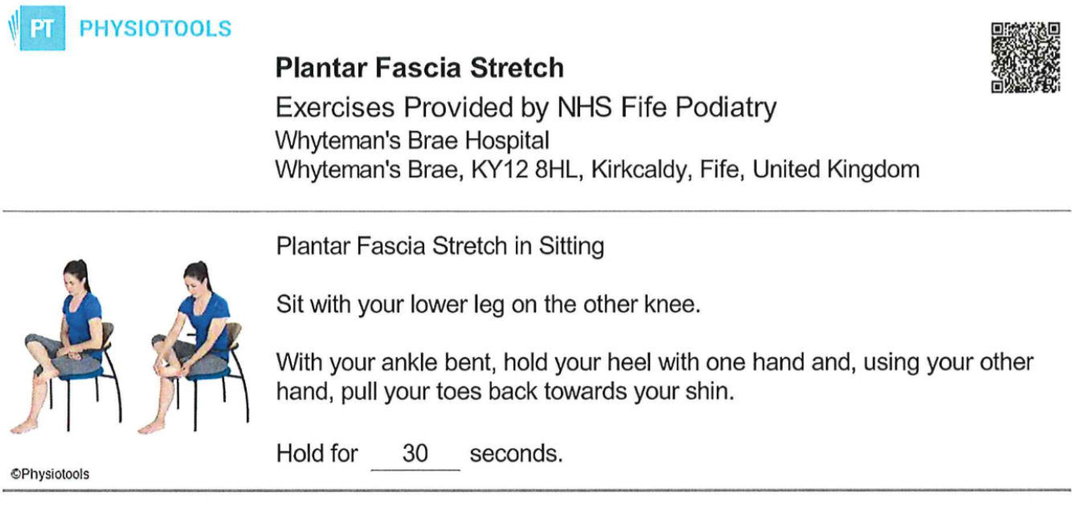

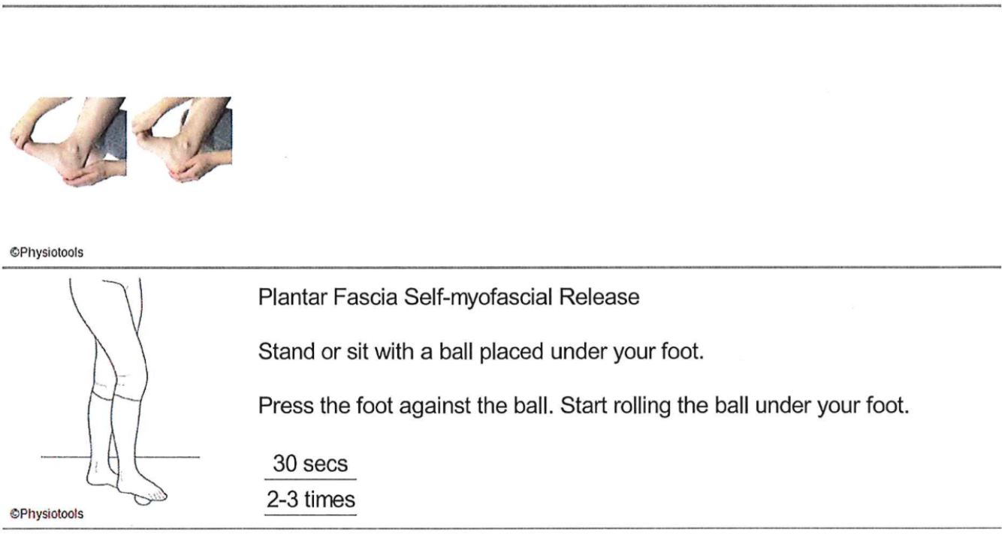

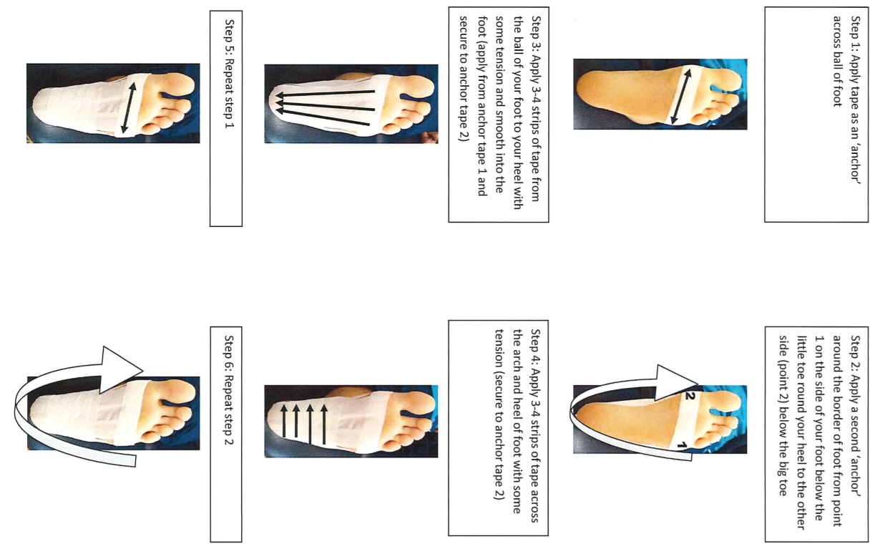
Step 6: Repeat step 2
Step 5: Repeat step 1
Step 4: Apply 3-4 strips of tape across the arch and heel of foot with some tension (secure to anchor tape 2)
Step 3: Apply 3-4 strips of tape from the ball of your foot to your heel with some tension and smooth into the foot (apply from anchor tape 1 and secure to anchor tape 2)
Step 2: Apply a second ‘anchor’ around the border of foot from point 1 on the side of your foot below the little toe around your heel to the other side (point 2) below the big toe
Step 1: Apply tape an ‘anchor’ across ball of foot

