**WHAT CONDITIONS CAN THE MSK PODIATRIST TREAT?**

The MSK clinic will accept referrals for the assessment of:

* Painful gait (walking).
* Recurrent lower limb and foot overuse injuries.
* Symptoms which could be the result of faulty foot function i.e. hip, knee and back pain.
* People who would benefit from an insole to relieve pressure.

NHS Fife provides accessible communication in a variety of formats including for people who are speakers of community languages, who require Easy Read versions, who speak BSL, read Braille or use Audio formats.

NHS Fife SMS text service number 07805800005 is available for people who have a hearing or speech impairment.

To find out more about accessible formats contact:

Fife.equalityand humanrights.nhs.scot or phone 01592 729130

Further patient information leaflets are available online on our website [www.nhsfife.org/](http://www.nhsfife.org/)



Fife Council and NHS Fife

are supporting the people

of Fife together through

Fife’s Health and Social

Care Partnership.

[**www.fifehealthandsocialcare.org**](http://www.fifehealthandsocialcare.org)

|  |  |
| --- | --- |
| Issued | January 2002 |
| Revised | Sept 2020 |
| Next Review | Sept 2022 |
| Images | Microsoft |



PODIATRY

DEPARTMENT

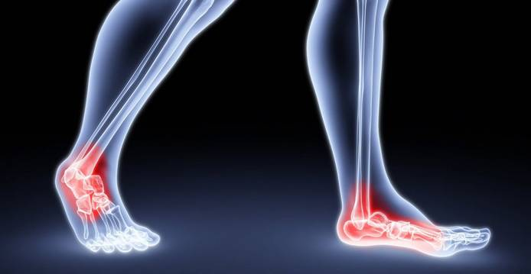

MUSCULOSKELETAL (MSK) PODIATRY

The MSK service is a specialised clinic within the podiatry department.

**HOW DOES THE REFERRAL SYSTEM WORK?**

Referrals can be made through your Physiotherapist, Podiatrist and also by self referral if you have attended previously.

Every referral received is assessed individually. If your referral is appropriate we will then contact you to let you know we have received your referral and ask you to contact us to make a suitable appointment. As we operate an ‘opting in’ appointment system it is up to you to arrange your appointment.

If we don’t hear from you within four weeks we will assume you no longer require an appointment and you will be discharged back to your original referrer.

**WHO IS ELIGIBLE FOR THE SERVICE?**

The service is open to all adults within the Fife area.

**WHAT WILL HAPPEN ON MY FIRST VISIT TO THE MSK PODIATY CLINIC?**

On the first visit the podiatrist will take a history of your lower limb problems and carry out your MSK assessment of your hips, legs and feet and assess your walking.

An MSK examination is an in depth assessment of your lower limb muscle action, joint position, lower limb function and walking. This is performed in order to identify various foot problems that can result in injuries, pain and dysfunction.

A management/care plan will then be developed with you at this time. This may involve referral onto another practitioner who will be able to take your management plan forward.

**WHAT WILL THE PODIATRIST NEED IN ORDER TO TREAT ME?**

The Podiatrist will require you to bring a pair of shorts and your new and used footwear. This will assist with the assessment

***About Orthotics...***

An orthotic is a full or ¾ length insole. They are worn inside the shoes to enhance foot and lower limb function, altering foot position and stabilising movement.

Orthotics operate in tandem with suitable footwear, and are ineffective in high heeled or narrow, pointed shoes.

**WHAT KINDS OF TREATMENT CAN THE MSK PODIATRIST USE?**

Advice on self management

Tailored stretching and strengthening exercise programmes

Specialised insoles,

Other therapies such as Low Level Light therapy, acupuncture and corticosteroid injection therapy may also be utilised as part of a management package.

Referral onto another discipline may be required to co manage your treatment.