**2025 Equal Pay Gap Analysis**

NHS Fife is committed to mainstreaming equality within the workplace. One of the ways of ensuring this is to carry out an Equal Pay Audit, the results of which are used to identify and analyse potential anomalies in remuneration.

This paper summarises the findings of the Equal Pay Audit carried out in 2025. It meets the requirements detailed within the Equality Act 2010, and our obligations under the Equality Act (Specific Duties) (Scotland) Regulations.

Workforce Categories

Under nationally agreed terms and conditions of employment, NHS employees are linked to broad organisational groupings or job categories. These job categories are:-

* Agenda for Change (e.g. Nursing and Midwifery, Support Services, Allied Health Professionals)
* Executive and Senior Managers, and
* Medical and Dental (e.g. Consultants, Specialty Doctors, Training Grade Doctors)

The level of remuneration within these job categories is determined by two factors:

1. Job evaluation processes determine the pay band and pay grades of jobs in the first two categories. This ensures employees receive equal pay for the same or broadly similar work, or work rated as equivalent and for work of equal value. There should therefore be no variation in the basic hourly earnings of employees, employed on the same pay band or grade, due to their Protected Characteristic status.
2. With the exception of the Executive and Senior Managers scales, the majority of employees move up scale points within each pay band or pay grade, based on annual increments. Each year of service on a pay band or pay grade equates to moving up one incremental scale point. Executive and Senior Manager progression includes an element of performance related pay progression.

Pay Data and Audit Methodology

In accordance with the Equality Act Regulations, Equal Pay Audits were undertaken on the Protected Characteristics of Disability, Gender and Race for employees who had provided a positive response within their Equal Opportunity questionnaire. Entries which were blank, or where employees opted not to provide these details, were discounted. The table below provides the percentage of workforce who recorded a positive response for each of the characteristics.

|  |  |  |  |
| --- | --- | --- | --- |
| **Characteristic** | Disability | Gender | Race |
| Response | 46.8% | 100.0% | 68.8% |
| % Change since 2023 | - 5.7% | - | + 7.8% |

The reduction in the number of employees providing a positive response for the Protected Characteristic of disability is explored further in the section below on Occupational Segregation and Closing the Pay Gap.

For the purposes of this audit, the monetary and percentage pay gap value identified is based on the average hourly pay, (excluding overtime), among our employees, between persons who identified as holding a particular Protected Characteristic and persons who did not hold the Protected Characteristic. The Audit utilises payroll records extracted in January 2025. NHS Fife processed a total of 10,045 payments during this pay period, involving 9,954 employees. This reflects a small number of employees holding multiple positions.

Collated information is presented to provide an overview for the relevant pay gap. Where results have indicated a headcount of less than 5 employees, the average hourly rate of pay has been redacted to ensure confidentiality of the employees involved.

Results of the 2025 Pay Audit

The results of the Equal Pay Audits are detailed in the tables below.

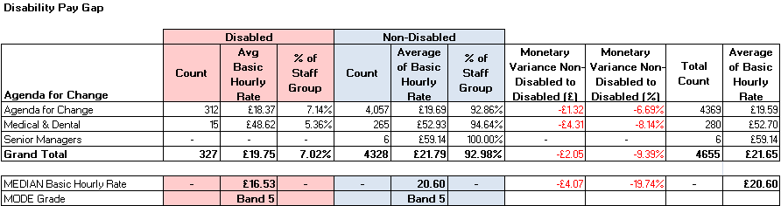

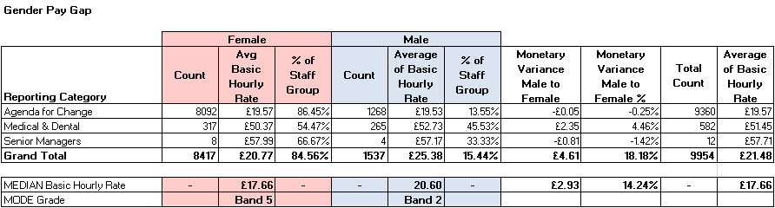

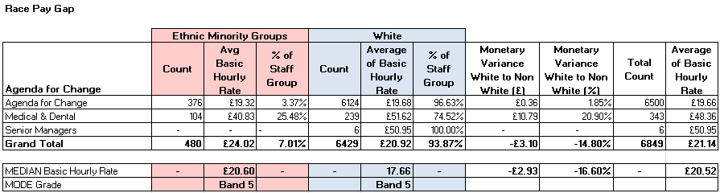

Occupational Segregation Indicators and Closing the Pay Gap

Disability

1. 7.0% of all those who provided a positive response to this Protected Characteristic identified themselves as disabled (4.7% in 2023), with the percentage of staff identifying themselves as disabled when measured against the wider NHS Fife workforce, increasing to 3.3% (2.5% in 2023). There are a variety of factors contributing to this increase, ranging from targeted recruitment campaigns, improved data capture and applicants being more confident in disclosing this information.
2. Despite improved data capture on those who identify themselves as disabled, the Pay Gap between those identifying themselves as disabled versus those who do not is -9.4%. This pay gap has steadily increasing since the requirement to measure the disability pay gap started in 2017 (0.8% in 2017).

|  |  |  |  |  |  |  |  |
| --- | --- | --- | --- | --- | --- | --- | --- |
|  | 2013 | 2015 | 2017 | 2019 | 2021 | 2023 | 2025 |
| Disability Pay Gap | - | - | -0.8% | -4.9% | -4.4% | -7.8% | -9.4% |
| Staff Identifying within PC |  |  | 80 | 127 | 131 | 240 | 327 |

1. The percentage of our workforce who have not provided a positive response to this Protected Characteristic has reduced by -5.7% in the previous 2 years. This decrease is believed to be associated with new applicants not recording instances where they do not identify themselves as disabled during the recruitment and on-boarding process. There is concern that these contrasting trends have resulted in distorting the average basic hourly rates used as part of the Equal Pay Audit calculations.
2. The Recruitment and on-boarding processes will be reviewed as part of a wider project focused on capturing and utilising information collated during the recruitment process more efficiently.
3. Focusing on those employees who have answered “Yes” and identified themselves as disabled, 71.4% of people who identify themselves as disabled work in job families associated with clinical activities versus 73.7% of people who did not. As shown in the chart below, there are small variations in the distribution of employees across individual job families when measured against an average of 7.0%.

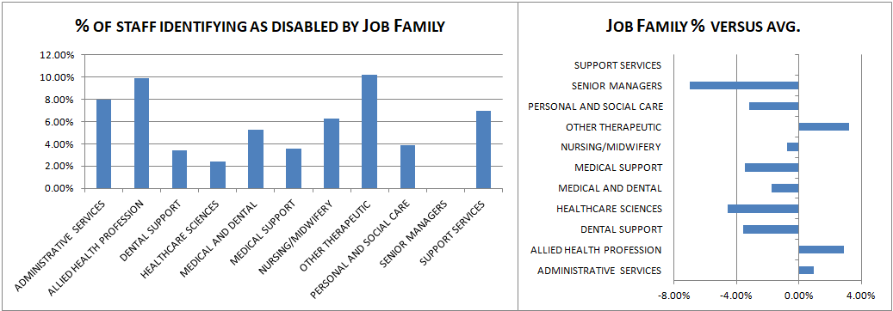

1. 60.2% of employees, who identified themselves as disabled, were engaged within professional roles remunerated on Agenda for Change Band 5 or above, compared to 59.1% of people who did not. As shown in the chart below, there were some variations in the distribution of staff across individual bandings when measured against an average of 7.0%.

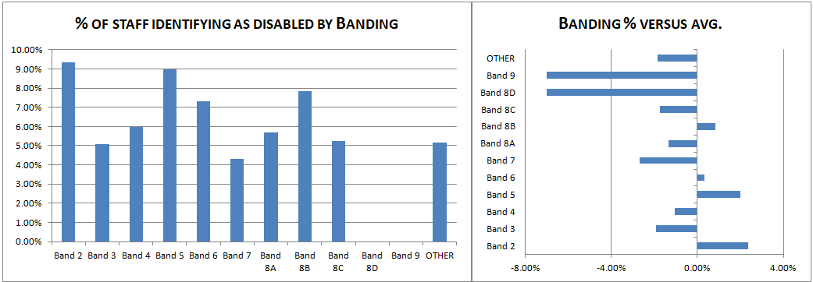

Gender

1. 84.6% of the NHS Fife workforce is female. The pay gap between female and male employees is 18.18%, with this figure reducing to 14.24% when based on the median (middle) value.
2. In relation to the nature of work performed by those individuals who identified themselves as female, 74.6% of people who identify themselves as female worked in job families associated with clinical activities versus 60.5% of people who did not. As shown in the chart below, there were variations in the distribution of employees across individual job families, although females were in the largest majority across all job families.

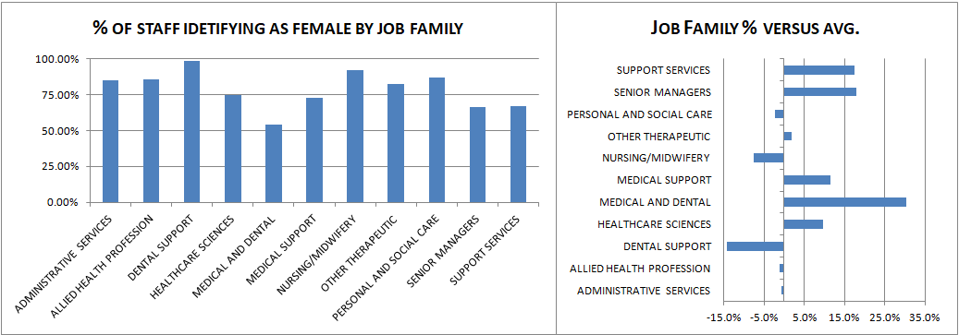

1. The gender pay gap is influenced by occupational segregation factors. Specifically, the proportion of the female and male employees engaged within the Medical and Dental plus Executive / Senior Manager Pay Grades. These grades are typically remunerated at higher hourly rates when compared to the Agenda for Change job families. Although there are a greater proportion of females engaged in both job categories, overall the distribution of the female workforce engaged in non Agenda for Change job families was 3.9% versus 17.6% for males. This higher proportion of males engaged in non Agenda for Change pay grades had a greater impact in increasing the average basic hourly rate for males.

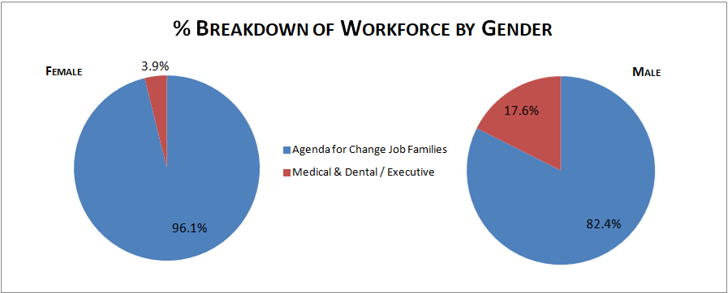

1. The results of the 2025 Gender Pay Audit are provided at the end of this report.

Race

1. 7.0% of all those who provided a positive response to this Protected Characteristic identified themselves as belonging to a non-white racial group (4.8% in 2023). This group of employees are described as a minority racial group for the purposes of determining Occupational Segregation. The percentage of employees identifying themselves as belonging to a minority racial group as measured against the wider NHS Fife workforce has risen to 4.8% (2.8% in 2023). Similar to increases in the data capture for those identifying as disabled, there are a variety of factors contributing to this increase, ranging from international recruitment campaigns, improved data capture and applicants and staff being more confident in disclosing this information.
2. Those who identify themselves as belonging to a minority racial group have been remunerated, on average, at a higher basic hourly rate compared to those who do not. The Pay Gap sits at 14.8%. There has been more fluctuation in this pay gap since 2017, in part due to the move to the Regional employer model for Doctors and Dentists in Training introduced in August 2018 (resulting in a reduction in the number of staff identifying as a minority racial group between 2017 and 2019, and a targeted international recruitment campaign between 2023 and 2024.

|  |  |  |  |  |  |  |  |
| --- | --- | --- | --- | --- | --- | --- | --- |
|  | 2013 | 2015 | 2017 | 2019 | 2021 | 2023 | 2025 |
| Race Pay Gap | - | - | 1.2% | 5.5% | 28.3% | 22.4% | 14.8% |
| Staff Identifying within PC |  |  | 142 | 98 | 160 | 272 | 480 |

1. There is a greater concentration of persons from a minority group engaged within clinical job families. 90.4% of persons from a minority group are engaged within job families associated with clinical work compared to 70.5% of persons who are not. As shown in the chart below, the greatest concentration of employees from this Protected Characteristic are engaged within the Medical and Dental job family, with the lowest concentration engaged within the Administrative Services job family.

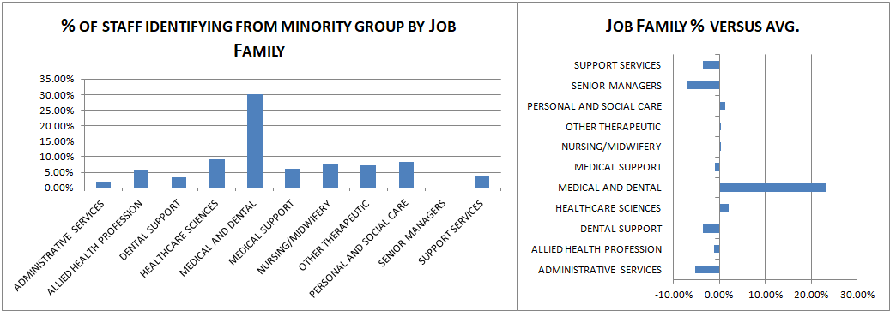

1. 78.2% of individuals who identified themselves from a minority group were engaged within professional roles remunerated on Agenda for Change Band 5 or above, compared to 57.1% of people who did not. As shown in the chart below, the largest concentration of employees were remunerated on Agenda for Change Band 5 and the Medical & Dental pay grades.

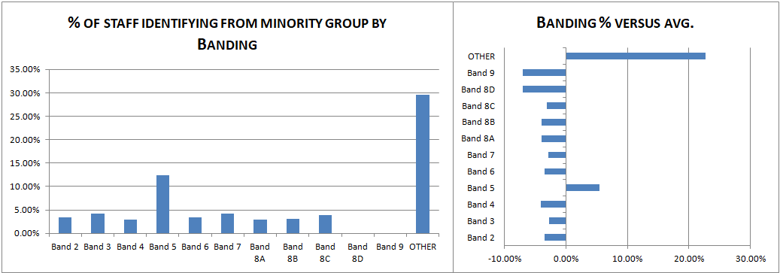

Conclusion

Workforce Policies and Procedures are agreed nationally and in partnership with Trade Unions and Professional Organisations. Their implementation ensures that any pay gaps highlighted in this report are not linked to an employee’s Protected Characteristic status, rather they are explained by other factors such as improvement in the capture of Protected Characteristic information within the recruitment process or by occupational (gender) segregation, particularly how the higher prevalence of male employees within non Agenda for Change pay rates has had the impact of increase the average hourly rate of pay for male employees.

To ensure continued compliance with the Equality Act, Workforce Policies and Procedures will continue to be subject to equality impact assessments, and the recruitment and on-boarding processes relating to capturing information on a person’s disability will continue to be reviewed. NHS Fife will also monitor its published Equal Pay Gap information against other NHS Scotland organisations to ensure there is no apparent deviation from NHS Scotland averages.

|  |
| --- |
| Reporting Category: Agenda for Change |
| **Gender Equal Pay Audit** |

|  |  |  |  |  |  |  |  |  |  |  |  |
| --- | --- | --- | --- | --- | --- | --- | --- | --- | --- | --- | --- |
|  |  | Female | | | Male | | |  |  |  |  |
| **Job Family** | **AFC Band** | **Count** | **Avg Basic Hourly Rate** | **% of Staff Group** | **Count** | **Average of Basic Hourly Rate** | **% of Staff Group** | **Monetary Variance Male to Female** | **Monetary Variance Male to Female %** | **Total Count** | **Average of Basic Hourly Rate** |
| ADMINISTRATIVE SERVICES | Band 2 | 310 | 13.63 | 87.08% | 46 | 13.61 | 12.92% | -£ 0.02 | -0.18% | 356 | 13.63 |
|  | Band 3 | 362 | 14.85 | 92.35% | 30 | 14.75 | 7.65% | -£ 0.11 | -0.71% | 392 | 14.85 |
|  | Band 4 | 401 | 16.08 | 93.69% | 27 | 15.78 | 6.31% | -£ 0.30 | -1.88% | 428 | 16.06 |
|  | Band 5 | 128 | 18.85 | 74.42% | 44 | 18.49 | 25.58% | -£ 0.36 | -1.96% | 172 | 18.76 |
|  | Band 6 | 75 | 23.02 | 66.96% | 37 | 23.33 | 33.04% | £ 0.31 | 1.34% | 112 | 23.12 |
|  | Band 7 | 63 | 26.83 | 67.74% | 30 | 26.69 | 32.26% | -£ 0.14 | -0.53% | 93 | 26.79 |
|  | Band 8A | 23 | 32.13 | 60.53% | 15 | 31.99 | 39.47% | -£ 0.14 | -0.45% | 38 | 32.08 |
|  | Band 8B | 18 | 37.65 | 69.23% | 8 | 37.44 | 30.77% | -£ 0.21 | -0.57% | 26 | 37.58 |
|  | Band 8C | 9 | 44.50 | 81.82% | 2 | * | 18.18% | - | - | 11 | 44.88 |
|  | Band 8D | 6 | 51.96 | 75.00% | 2 | * | 25.00% | - | - | 8 | 51.87 |
| **ADMINISTRATIVE SERVICES (TOTAL)** |  | **1382** | **17.20** | **85.20%** | **240** | **20.53** | **14.80%** | **£ 3.33** | **16.22%** | **1622** | **17.69** |
| ALLIED HEALTH PROFESSION | Band 2 | 12 | 13.51 | 85.71% | 2 | 13.87 | 14.29% | £ 0.37 | 2.64% | 14 | 13.56 |
|  | Band 3 | 118 | 14.91 | 89.39% | 14 | 14.95 | 10.61% | £ 0.04 | 0.29% | 132 | 14.91 |
|  | Band 4 | 57 | 15.93 | 91.94% | 5 | 15.62 | 8.06% | -£ 0.31 | -1.96% | 62 | 15.90 |
|  | Band 5 | 71 | 17.21 | 76.34% | 22 | 17.39 | 23.66% | £ 0.19 | 1.08% | 93 | 17.25 |
|  | Band 6 | 229 | 23.86 | 83.88% | 44 | 22.99 | 16.12% | -£ 0.87 | -3.79% | 273 | 23.72 |
|  | Band 7 | 206 | 28.20 | 89.18% | 25 | 27.74 | 10.82% | -£ 0.46 | -1.65% | 231 | 28.15 |
|  | Band 8A | 46 | 32.83 | 85.19% | 8 | 32.09 | 14.81% | -£ 0.74 | -2.31% | 54 | 32.72 |
|  | Band 8B | 6 | 37.65 | 66.67% | 3 | * | 33.33% | - | - | 9 | 37.65 |
|  | Band 8C | 1 | * | 50.00% | 1 | * | 50.00% | - | - | 2 | 43.45 |
|  | Band 9 | 1 | * | 100.00% |  |  | - | - | - | 1 | 63.67 |
| **ALLIED HEALTH PROFESSION (TOTAL)** |  | **742** | **22.99** | **85.88%** | **122** | **22.71** | **14.12%** | **-£ 0.28** | **-1.23%** | **864** | **22.95** |
| DENTAL SUPPORT | Band 2 | 2 | * | 100.00% |  |  | - | - | - | 2 | * |
|  | Band 3 | 10 | 14.92 | 100.00% |  |  | - | - | - | 10 | 14.92 |
|  | Band 4 | 36 | 15.97 | 97.30% | 1 | * | 2.70% | - | - | 37 | 15.99 |
|  | Band 5 | 16 | 19.61 | 100.00% |  |  | - | - | - | 16 | 19.61 |
|  | Band 6 | 11 | 23.90 | 100.00% |  |  | - | - | - | 11 | 23.90 |
|  | Band 7 | 3 | * | 100.00% |  |  | - | - | - | 3 | * |
| **DENTAL SUPPORT (TOTAL)** |  | **78** | **18.08** | **98.73%** | **1** | * | **1.27%** | **-** | **-** | **79** | **18.06** |
| HEALTHCARE SCIENCES | Band 2 | 1 | * | 100.00% |  |  | - | - | - | 1 | * |
|  | Band 3 | 34 | 14.93 | 70.83% | 14 | 15.03 | 29.17% | £ 0.10 | 0.65% | 48 | 14.96 |
|  | Band 4 | 10 | 16.28 | 90.91% | 1 | * | 9.09% | - | - | 11 | 16.17 |
|  | Band 5 | 15 | 19.27 | 68.18% | 7 | 17.85 | 31.82% | -£ 1.42 | -7.94% | 22 | 18.82 |
|  | Band 6 | 41 | 24.75 | 77.36% | 12 | 25.21 | 22.64% | £ 0.46 | 1.83% | 53 | 24.85 |
|  | Band 7 | 19 | 28.26 | 76.00% | 6 | 28.89 | 24.00% | £ 0.62 | 2.16% | 25 | 28.41 |
|  | Band 8A | 10 | 32.65 | 83.33% | 2 | * | 16.67% | - | - | 12 | 32.61 |
|  | Band 8B | 3 | * | 50.00% | 3 | * | 50.00% | - | - | 6 | 38.50 |
|  | Band 8C | 1 | * | 100.00% |  |  | - | - | - | 1 | * |
|  | Band 8D | 1 | * | 100.00% |  |  | - | - | - | 1 | * |
| **HEALTHCARE SCIENCES (TOTAL)** |  | **135** | **22.69** | **75.00%** | **45** | **22.37** | **25.00%** | **-£ 0.32** | **-1.44%** | **180** | **22.61** |
| MEDICAL SUPPORT | Band 2 | 1 | * | 100.00% |  |  | - | - | - | 1 | * |
|  | Band 3 | 1 | * | 50.00% | 1 | * | 50.00% | - | - | 2 | * |
|  | Band 4 | 2 | * | 100.00% |  |  | - | - | - | 2 | * |
|  | Band 5 | 34 | 18.34 | 80.95% | 8 | 19.07 | 19.05% | £ 0.73 | 3.82% | 42 | 18.48 |
|  | Band 6 | 2 | * | 22.22% | 7 | 24.69 | 77.78% | - | - | 9 | 24.81 |
|  | Band 7 | 5 | 27.96 | 83.33% | 1 | * | 16.67% | - | - | 6 | 28.20 |
|  | Band 8B | 1 | * | 100.00% |  |  | - | - | - | 1 | * |
| **MEDICAL SUPPORT (TOTAL)** |  | **46** | **19.78** | **73.02%** | **17** | **21.76** | **26.98%** | **£ 1.98** | **9.08%** | **63** | **20.31** |
| NURSING/MIDWIFERY | Band 2 | 320 | 13.62 | 91.69% | 29 | 13.49 | 8.31% | -£ 0.13 | -0.93% | 349 | 13.61 |
|  | Band 3 | 856 | 14.85 | 89.45% | 101 | 14.88 | 10.55% | £ 0.02 | 0.16% | 957 | 14.86 |
|  | Band 4 | 166 | 15.69 | 92.22% | 14 | 15.56 | 7.78% | -£ 0.12 | -0.80% | 180 | 15.68 |
|  | Band 5 | 1712 | 19.44 | 92.94% | 130 | 19.50 | 7.06% | £ 0.06 | 0.29% | 1842 | 19.45 |
|  | Band 6 | 829 | 23.13 | 92.73% | 65 | 23.51 | 7.27% | £ 0.38 | 1.63% | 894 | 23.16 |
|  | Band 7 | 543 | 27.31 | 94.60% | 31 | 27.46 | 5.40% | £ 0.15 | 0.55% | 574 | 27.32 |
|  | Band 8A | 65 | 31.89 | 90.28% | 7 | 32.93 | 9.72% | £ 1.05 | 3.17% | 72 | 31.99 |
|  | Band 8B | 26 | 37.20 | 83.87% | 5 | 36.79 | 16.13% | -£ 0.41 | -1.11% | 31 | 37.14 |
|  | Band 8C | 2 | * | 66.67% | * | 43.45 | - | - | - | 3 | * |
|  | Band 8D | 4 | * | 100.00% |  |  | - | - | - | 4 | * |
| **NURSING/MIDWIFERY (TOTAL)** |  | **4505** | **19.96** | **92.18%** | **382** | **19.55** | **7.82%** | **-£ 0.41** | **-2.10%** | **4887** | **19.93** |
| OTHER THERAPEUTIC | Band 2 | 26 | 13.58 | 76.47% | 8 | 13.73 | 23.53% | £ 0.16 | 1.15% | 34 | 13.61 |
|  | Band 3 | 35 | 14.56 | 85.37% | 6 | 14.48 | 14.63% | -£ 0.08 | -0.54% | 41 | 14.55 |
|  | Band 4 | 47 | 15.50 | 82.46% | 10 | 15.21 | 17.54% | -£ 0.29 | -1.90% | 57 | 15.45 |
|  | Band 5 | 44 | 18.56 | 83.02% | 9 | 18.01 | 16.98% | -£ 0.55 | -3.04% | 53 | 18.47 |
|  | Band 6 | 43 | 21.55 | 84.31% | 8 | 22.72 | 15.69% | £ 1.17 | 5.16% | 51 | 21.74 |
|  | Band 7 | 79 | 27.33 | 86.81% | 12 | 27.33 | 13.19% | £ 0.00 | 0.01% | 91 | 27.33 |
|  | Band 8A | 86 | 32.32 | 82.69% | 18 | 32.21 | 17.31% | -£ 0.11 | -0.34% | 104 | 32.30 |
|  | Band 8B | 45 | 37.91 | 78.95% | 12 | 37.65 | 21.05% | -£ 0.26 | -0.69% | 57 | 37.86 |
|  | Band 8C | 18 | 45.02 | 81.82% | 4 | * | 18.18% | - | - | 22 | 44.88 |
|  | Band 8D | 3 | * | 60.00% | 2 | * | 40.00% | - | - | 5 | 52.92 |
|  | Band 9 | 2 | * | 100.00% |  |  | - | - | - | 2 | * |
| **OTHER THERAPEUTIC (TOTAL)** |  | **420** | **25.90** | **82.68%** | **88** | **26.30** | **17.32%** | **£ 0.40** | **1.52%** | **508** | **25.97** |
| PERSONAL AND SOCIAL CARE | Band 3 | 8 | 15.03 | 100.00% |  |  | - | - | - | 8 | 15.03 |
|  | Band 4 | 3 | * | 100.00% |  |  | - | - | - | 3 | * |
|  | Band 5 | 14 | 18.68 | 93.33% | 1 | * | 6.67% | - | - | 15 | 18.81 |
|  | Band 6 | 13 | 23.12 | 86.67% | 2 | * | 13.33% | - | - | 15 | 23.16 |
|  | Band 7 | 9 | 27.90 | 90.00% | 1 | * | 10.00% | - | - | 10 | 27.74 |
|  | Band 8A | 3 | * | 60.00% | 2 | * | 40.00% | - | - | 5 | 33.15 |
|  | Band 8B | 1 | * | 100.00% |  |  | - | - | - | 1 | * |
|  | Band 8D | 2 | * | 50.00% | 2 | * | 50.00% | - | - | 4 | * |
| **PERSONAL AND SOCIAL CARE (TOTAL)** |  | **53** | **23.17** | **86.89%** | **8** | **33.26** | **13.11%** | **£ 10.09** | **30.34%** | **61** | **24.49** |
| SUPPORT SERVICES | Band 2 | 664 | 13.67 | 73.21% | 243 | 13.67 | 26.79% | £ 0.00 | 0.03% | 907 | 13.67 |
|  | Band 3 | 56 | 14.79 | 56.00% | 44 | 14.80 | 44.00% | £ 0.01 | 0.07% | 100 | 14.80 |
|  | Band 4 | 6 | 16.19 | 13.04% | 40 | 16.32 | 86.96% | £ 0.12 | 0.74% | 46 | 16.30 |
|  | Band 5 |  |  | 0.00% | 7 | 19.60 | 100.00% | - | - | 7 | 19.60 |
|  | Band 6 | 7 | 21.72 | 29.17% | 17 | 23.83 | 70.83% | £ 2.10 | 8.83% | 24 | 23.21 |
|  | Band 7 | 2 | * | 18.18% | 9 | 27.23 | 81.82% | - | - | 11 | 27.63 |
|  | Band 8A | 3 | * | 75.00% | 1 | * | 25.00% | - | - | 4 | 31.16 |
|  | Band 8B |  |  | - | 2 | * | 100.00% | - | - | 2 | 36.79 |
|  | Band 8C |  |  | - | 1 | * | 100.00% | - | - | 1 | 46.58 |
|  | Band 8D |  |  | - | 1 | * | 100.00% | - | - | 1 | 51.59 |
| **SUPPORT SERVICES (TOTAL)** |  | **737** | **13.96** | **66.88%** | **365** | **15.37** | **33.12%** | **£ 1.41** | **9.20%** | **1102** | **14.43** |
| **GRAND TOTAL** |  | **8092** | **19.57** | **86.45%** | **1268** | **19.53** | **13.55%** | **-£ 0.05** | **-0.25%** | **9360** | **19.57** |

|  |
| --- |
| Reporting Category: Medical & Dental |
| **Gender Equal Pay Audit** |

|  |  |  |  |  |  |  |  |  |  |  |  |
| --- | --- | --- | --- | --- | --- | --- | --- | --- | --- | --- | --- |
|  |  | Female | | | Male | | |  |  |  |  |
| **Job Family** | **AFC Band** | **Count** | **Avg Basic Hourly Rate** | **% of Staff Group** | **Count** | **Average of Basic Hourly Rate** | **% of Staff Group** | **Monetary Variance Male to Female** | **Monetary Variance Male to Female %** | **Total Count** | **Average of Basic Hourly Rate** |
| MEDICAL & DENTAL | Associate Specialist | 3 | * | 75.00% | 1 | * | 25.00% | - | - | 4 | * |
|  | Clinical Director | 1 | * | 100.00% |  |  | - | - | - | 1 | * |
|  | Clinical Fellow | 27 | £ 23.29 | 55.10% | 22 | £ 23.14 | 44.90% | -£ 0.15 | -0.65% | 49 | £ 23.22 |
|  | Consultant | 161 | £ 60.19 | 48.64% | 170 | £ 60.68 | 51.36% | £ 0.49 | 0.81% | 331 | £ 60.44 |
|  | Dental Officer | 18 | £ 40.14 | 85.71% | 3 | * | 14.29% | - | - | 21 | £ 40.68 |
|  | Director of Public Health | 1 | * | 100.00% |  |  | - | - | - | 1 | * |
|  | Foundation House Officer Year 1 | 3 | * | 33.33% | 6 | £ 16.54 | 66.67% | - | - | 9 | £ 16.54 |
|  | Foundation House Officer Year 2 | 8 | £ 20.69 | 66.67% | 4 | * | 33.33% | - | - | 12 | £ 20.85 |
|  | Medical Director |  |  | - | 1 | * | 100.00% | - | - | 1 | * |
|  | Other | 5 | £ 61.19 | 83.33% | 1 | * | 16.67% | - | - | 6 | £ 61.27 |
|  | Salaried GP | 41 | £ 53.15 | 56.94% | 31 | £ 53.53 | 43.06% | £ 0.38 | 0.71% | 72 | £ 53.32 |
|  | Senior Dental Officer | 7 | £ 47.10 | 100.00% |  |  | - | - | - | 7 | £ 47.10 |
|  | Specialist Doctor |  |  | - | 1 | * | 100.00% | - | - | 1 | * |
|  | Specialty Doctor | 41 | £ 38.64 | 64.06% | 23 | £ 38.94 | 35.94% | £ 0.30 | 0.77% | 64 | £ 38.74 |
|  | Specialty Registrar | 1 | * | 25.00% | 3 | * | 75.00% | - | - | 4 | * |
| **MEDICAL & DENTAL (TOTAL)** |  | **317** | **£ 50.37** | **54.47%** | **265** | **£ 52.73** | **45.53%** | **£ 2.35** | **4.46%** | **582** | **£ 51.45** |

|  |
| --- |
| Reporting Category: Executive / Senior Managers |
| **Gender Equal Pay Audit** |

|  |  |  |  |  |  |  |  |  |  |  |  |
| --- | --- | --- | --- | --- | --- | --- | --- | --- | --- | --- | --- |
|  |  | Female | | | Male | | |  |  |  |  |
| **Job Family** | **AFC Band** | **Count** | **Avg Basic Hourly Rate** | **% of Staff Group** | **Count** | **Average of Basic Hourly Rate** | **% of Staff Group** | **Monetary Variance Male to Female** | **Monetary Variance Male to Female %** | **Total Count** | **Average of Basic Hourly Rate** |
| EXECUTIVE / SENIOR MANAGERS | EXECUTIVE MANAGER COHORT - GRADE A |  |  | 0.00% | 1 | * | 100.00% | - | - | 1 | * |
| EXECUTIVE MANAGER COHORT - GRADE C | 2 | * | 100.00% |  |  | 0.00% | - | - | 2 | * |
| EXECUTIVE MANAGER COHORT - GRADE E | 3 | * | 50.00% | 3 | * | 50.00% | - | - | 6 | £ 60.69 |
| EXECUTIVE MANAGER COHORT - GRADE F | 1 | * | 100.00% |  |  | 0.00% | - | - | 1 | * |
| EXECUTIVE MANAGER COHORT - GRADE H | 1 | * | 100.00% |  |  | 0.00% | - | - | 1 | * |
| EXECUTIVE MANAGER COHORT - TRANSITIONAL GRADE C | 1 | * | 100.00% |  |  | 0.00% | - | - | 1 | * |
| **EXECUTIVE / SENIOR MANAGERS (TOTAL)** |  | 8 | £ 57.99 | 66.67% | 4 | £ 57.17 | 33.33% | -£ 0.81 | -1.42% | 12 | £ 57.71 |