Fife’s Children and Young People's Occupational Therapy
Graded Approach to Messy Play

For children, the feel of materials and textures that they have not experienced before can be challenging, and for those who are sensitive to tactile (touch) information this can feel distressing and/or distracting. The wide range of materials and textures that we come across can be grouped loosely into those materials which are less challenging and easier to tolerate to those which are more challenging and more difficult to tolerate. When working with a child who is sensitive to touch, it is helpful to build upon their experiences with a graded approach. Work on encouraging them to be confident and happy exploring materials from level 1 before moving on to the materials in level 2 and so on.
Points to Remember
- Remember unexpected sensory experiences of any kind can cause a child to feel threatened e.g. touching someone from behind or a tickly spider landing on ones arm. This definitely applies to exposure to new materials therefore it is very important that you allow your child to explore at their own pace and under their own control.
- Exposure to a wide range of textures including edible and non-food items from an early age will support your child to develop their knowledge and experience of tactile information and therefore their tactile sense.
- Do not force your child’s hand into the sensory substances and spend as much time as needed becoming comfortable with level 1 materials before moving on.
- Textures are graded from those which are less challenging (level 1) to those that are very challenging (level 4).
- When your child is accepting of the dry textures gradually increase to soft, then wet. Only begin to introduce your child to more challenging textures when your child is ready.
- It is important for the child to develop an interest in the activity first so try to make the activity relevant to their particular interests.
- When introducing more challenging textures to a child, grade the amount of direct contact with the texture. For example, start with using a tool to explore sensory play i.e. rolling pin for play dough and cooking, cutters, stamps, paintbrushes and sponges. Use a spoon/tongs to find objects hidden in foam/sand.
- You can try hiding toys and characters in the sensory media i.e. dinosaurs in jelly or a big tub of rice.
- Gradually increase direct skin contact – enable child to get a little of the texture on their skin whilst using the tool. Then progress to using finger tips (one hand then both hands), then fingers, then whole hand, then progress to both hands.
- Make race tracks for toy cars in custard with fruit obstacles i.e. grapes, apples or involve your child in a painting or craft activity using food and non-food items.
- Consider varying the temperature of media e.g. ice cube in warm water or warmed chocolate sauce on ice cream.
- Complete a range of muscle work activities prior to messy play. Remember to consider your child’s other senses – it may be that they dislike the smell of something rather than the feel of it or perhaps the environment is too noisy for them and they need a quieter and calmer place to go in order to feel able to explore a new tactile activity.
- Progress to exploring with feet when your child is comfortable with their hands
- Progress onto identifying items without using vision (feely bags)

Grading Messy play
Level 1 - Dry/Hard textures e.g. rice, pasta, sand, oats, brushes, wood, sponges and metal objects commonly found around the house that have different textures
Level 2 - Soft Textures e.g. play dough, dry finger paints, cotton wool
Level 3 - Wet Textures e.g. wet sand, paint, custard
Level 4 – Slimy/Lumpy textures e.g. jelly, cornflower and water mix, tapioca, baked beans, shaving foam, wet oats, banana

Play Suggestions which can be adapted to your child’s level of need
Bath Time: Encourage your child to experiment with a variety of textures against his skin when washing. Offer different kinds of soap (oatmeal soap, shaving cream, lotion soap) and differently textured sponges or wash cloths (loofa sponge, thick flannels, mesh shower puff, natural sponge)
Water Play: Fill a sink with soapy water and a variety of unbreakable bottles, sponges, egg whisk and toy water pumps. Alternatively fill a bath or paddling pool outside. Pouring and measuring are excellent for developing the tactile system.
Sand Play: Using a sand box add small toys (cars, trucks, people, and dinosaurs) which the child can arrange and rearrange bury and rediscover. Alternatives to sand are dried beans, rice, pasta, cornmeal, popcorn and mud.
Feely Box: Cut a hole in the top/side of a shoebox. Place different objects in the box, such as spools, marbles, plastic animals and little aeroplanes. The game is for the child to insert a hand through the hole and guess what toy he is touching – without looking. This activity improves the child’s ability to discriminate the form of an object without the use of vision.
Hands-on Cooking: Experiment with making biscuit dough, bread dough, pizza dough, pastry or crumble mixture.
Building Hand Towers: Child lays his hand down, cover with your hand, then child’s other hand, and then show child how to pull out the bottom hand quickly.

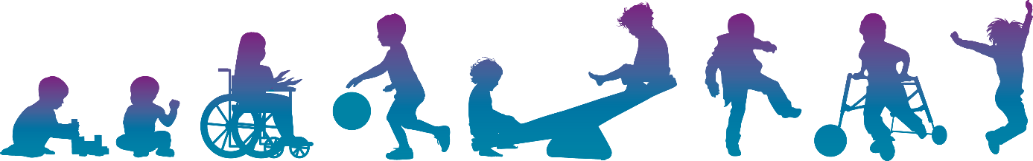
Adapted from “WYE Valley NHS” [Online] Available at wvt-graded-approach-to-messy-play.pdf (wyevalley.nhs.uk) (Accessed 15.02.23)

