


Constipation

Service User Information Leaflet

Produced by: Pelvic Health Physiotherapy Service

Date of issue: Sep 2020 Review Date: Sep 2022

NHS Fife provides accessible communication in a variety of formats including for people who are speakers of community languages, who require Easy Read versions, who speak BSL, read Braille or use Audio formats.

NHS Fife SMS text service number 07805800005 is available for people who have a hearing or speech impairment.

To find out more about accessible formats phone 01592 729130 or contact: fife.equalityandhumanrights@nhs.scot.

Aim of this leaflet

To give you information about the causes and treatment of constipation.

What is Constipation?

- When your bowels open fewer than three times a week.
- Pain or straining on passing a stool.
- Stools which are hard and dry. Stools may be a larger clump or small pellets.

Symptoms of Constipation

- Feeling uncomfortable or bloated in the abdomen.
- Having to strain to empty your bowels. This can cause piles which may appear at the back passage and bleed.
- Women may find intercourse uncomfortable if the bowel is very full.

Causes of Constipation

- Irregular meals and too much processed food.
- Not enough fibre in the diet.
- Not drinking enough (less than 1.5 litres per day).
- Not allowing time to open your bowels each morning.
- Ignoring the urge to empty your bowels.
- Inactivity.
- Uncoordinated straining. Some people do not strain effectively and may also fail to relax the muscles around the back passage when they strain.
- Shift work.
- Stress and anxiety.

Conditions that may make constipation worse

- Pregnancy and childbirth.
- Painful anal condition such as piles.
- Emotional upset, anxiety or depression.
- Underactive thyroid gland.
- Obstruction to the bowels by scarring, inflammation or tumours.
- Surgery.
- Weak pelvic floor.
- Poor toilet facilities.

What can I do about it?

- Eat enough fibre.
- Make sure you drink enough (1.5 to 2 litres a day or 6 to 8 mugs).
- Eat breakfast and have a hot drink to stimulate the gut.
- Eat regularly.
- When you get the urge to empty your bowel, go to the toilet immediately.
- Allow yourself plenty of time for toileting in your morning routine.
- Take regular exercise. Keep active!
- Find out how to strengthen your pelvic floor.

Fibre in the diet

Fibre acts like a sponge. It soaks up water as it passes through the gut. This makes stools both solid yet soft enough to pass.

How to eat more fibre

- Make changes to your diet slowly over several weeks.
- Eat wholemeal or wholegrain bread rather than white.
- Use brown pasta and rice instead of white.
- Eat high fibre breakfast cereals like Weetabix, Shredded wheat, Shreddies or real porridge (not instant porridge).
- Fresh fruit makes a good snack. Aim for 2 portions daily.
- Try to have at least 2 servings of vegetables daily.
- Pulses and lentils are a good source of fibre. They can be added to stews, soup and salads.

Supplementing fibre intake

Your physiotherapist or pharmacist can give you advice on products such as Golden Linseed or Lepicol. These offer supplementary fibre if dietary changes are not enough.

Positioning on the toilet

If you can get into a good position on the toilet it will make emptying your bowel much easier. Try to recreate the squatting position that our bowels are designed for.
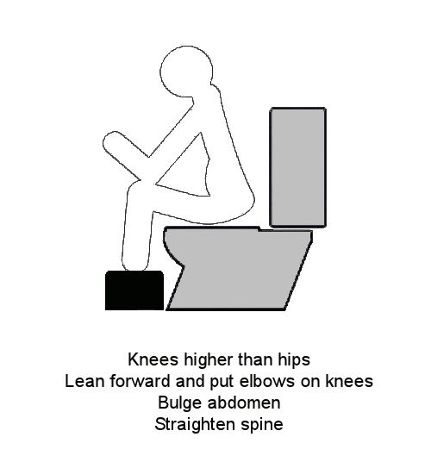
- Get your knees higher than your hips.
- A foot rest can be useful.
- Lean forwards and put your elbows on your knees.
- Bulge your tummy forward.
- Straighten your spine.

Laxatives

A few people will need to take a regular laxative. This should only be done if advised by your doctor.

Bulk forming laxatives work by increasing the bulk of the stool to stimulate the gut. It is important to drink plenty of fluid when taking this medication. Examples are Fybogel and Regulan.

Osmotic laxatives help to keep fluid in the stool and increase its bulk. It is important to drink plenty of fluid when taking this medication. Common examples are Laxido and Lactulose.

Stimulant Laxatives help to get the gut to work faster. An example is Bisacodyl. This type should be used short term only.

Are laxatives harmful?

- Constipation is usually improved by a good diet and drugs are not needed however, occasional use of a suitable laxative is harmless.
- Regular use should be avoided unless directed by a health care professional.
- Laxatives can cause abdominal pains and a feeling of needing to empty the bowel urgently if used in large doses.

When should you see the doctor?

- If constipation does not get better with simple treatments and is causing you trouble.
- Changes in bowel habit occurring for no obvious reason in people aged over 40 years.
- If there is also rectal bleeding.
- If there are also new abdominal symptoms such as pain or bloating.

Further tests and investigations

If your constipation isn’t improved by some of these measures, you may be referred to see a specialist doctor who deals with constipation. They may decide to do some tests to find out why you have constipation. These may include:

- Colonic transit studies (to see how long food takes to pass through your gut)
- Anorectal physiology/proctography (to assess how your bowel functions when you open your bowels)
- Flexible sigmoidoscopy/colonoscopy (to look inside the bowel)
- MRI (to look for any prolapse of the bowel when it empties)

All of these would be discussed with you by the doctor.

