

**PREVENTION**

Changing your footwear is the best way to help prevent symptoms of a Morton’s Neuroma.

Make sure shoes are well fitted, supportive, low heeled and wide at the toes and forefoot.

NHS Fife provides accessible communication in a variety of formats including for people who are speakers of community languages, who require Easy Read versions, who speak BSL, read Braille or use Audio formats.

NHS Fife SMS text service number 07805800005 is available for people who have a hearing or speech impairment.

To find out more about accessible formats contact:

Fife.equalityandhumanrights.nhs.scot or phone 01592 729130

Further patient information leaflets are available online on our website [www.nhsfife.org/](http://www.nhsfife.org/)

Fife Council and NHS Fife

are supporting the people

of Fife together through

Fife’s Health and Social

Care Partnership.

**www.fifehealthandsocialcare.org**



|  |  |
| --- | --- |
| Issued | Oct 2012 |
| Revised | Sept 2020 |
| Next Review | Sept 2022 |
| Images | NHS Fife Illustrations |

PODIATRY

DEPARTMENT

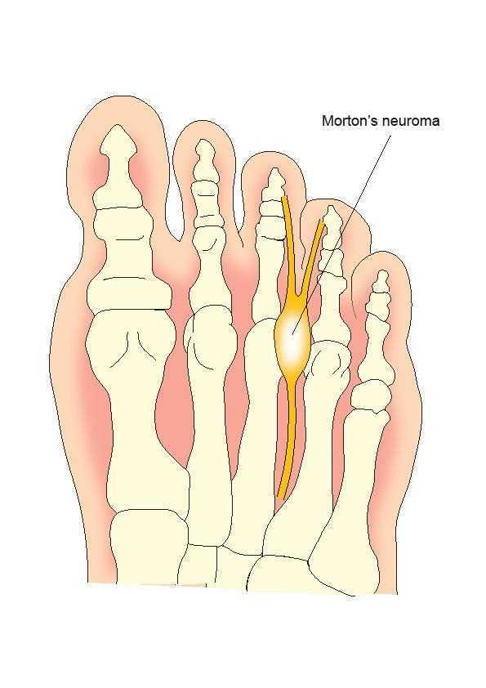

## **MORTON’S NEUROMA**

## **MORTON’S NEUROMA**

Also known as:

* Morton’s Metatarsalgia;
* Morton’s Neuralgia;
* Inter-metatarsal Neuroma.
* Plantar Digital Neuritis

## **WHAT IS A MORTON’S NEUROMA?**

Morton’s Neuroma is a problem where a thickening of tissue surrounds the nerve between the bones of the forefoot (metatarsals). This can result in pain.

The neuroma is not dangerous, and will not cause problems other than in the foot.

## **WHAT CAUSES A MORTON’S NEUROMA?**

It is not really known why people get Morton’s Neuroma. Theories include: Tight fitting footwear People with flatter or highly arched feet or altered toe position may also be more likely to suffer with Morton’s Neuroma. Repetitive high forces such as running, dancing and athletics may contribute too.

**SYMPTOMS**

Patients may suffer from all or some of the following:

* Pain when walking or increased activities
* Numbness in the foot and toes
* Pins and needles in toes
* Sharp shooting pains
* Relief when shoes are removed
* Feels like walking on a pebble

**TREATMENT**

* The first stage of treatment is footwear advice and changes. A properly fitted and supportive shoe can help with the pain.
* You may be given calf muscle stretches if needed to reduce the weight on your forefoot.
* Your Podiatrist or GP may advise tablets that reduce inflammation e.g. Ibuprofen (see GP or Pharmacist for further advice).
* The Podiatrist might make an insole for your shoes to help relieve the pain.
* For more severe/persistent cases, a steroid injection may be considered
* Surgery may be considered if all other interventions fail to improve your symptoms.