Communications Hayfield House  Kirkcaldy  Fife KY2 5AH  www.nhsfife.org  Date: 15 December 2020  01592 647971  fife.communications@nhs.scot | 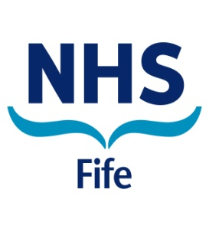
Press Release
60-64 Year Olds Encouraged to Take Up Flu Vaccination
People aged 60-64 are being encouraged to take up the offer of a flu vaccination in the next phase of this year’s immunisation programme.
A number of vaccination clinics are being hosted across Fife.
NHS Fife Deputy Director of Public Health, Dr Esther Curnock, said: “Eligibility for the flu vaccination this year has been extended to people aged 60-64 and we are keen to see as many people within this group take up the offer.
“As a result we will be holding clinics across Fife. If you are unable to attend a clinic you can also make an appointment at a participating pharmacy, details of which are available on the NHS Inform website.
“Flu can be serious and it is more important than ever that if you are in an eligible groups you are vaccinated.
“The flu jab remains the safest and most effective way to help protect against flu and its complications and getting vaccinated takes only a few minutes.”
People in the 60 to 64 year old age range should visit www.nhsinform.scot/flu or call 0800 22 44 88 to find out more about how to arrange their flu vaccine in Fife.
Changes have been made to the delivery of flu vaccination this year. Rather than attend their local GP practice to get the flu jab, those eligible have received their vaccinations in community venues and through a network of more than 50 participating community pharmacies across Fife.
Phase one of the flu vaccination programme has already included those aged 65 or over; those over six months of age with a medical condition which puts them in an ‘at risk’ group (such as diabetes, cystic fibrosis, multiple sclerosis, heart and lung diseases, autoimmune disorders or sickle cell disease); people living in the same house as those previously shielding from COVID-19; pregnant women; children in primary school; 2-5 year olds not yet in school; health and social care workers and young and unpaid carers.

ENDS/-
Issued: 15th December 2020
Notes to Editors:
Information on how to access flu vaccine for eligible groups can be found at www.nhsinform.scot/flu

