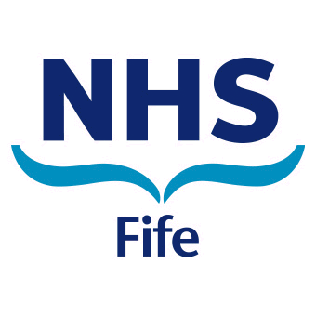
Signs your premature baby is ready for food
If your baby is achieving 3 or more of the below signs then they are ready for food.
- Your baby should be able to sit straight with support in their baby chair.
- Your baby should be able to hold their head up without support.
- Your baby should be interested in watching you eat.
- Your baby should be able to open their mouth for the spoon.
- Your baby should be able to hold a toy and bring it up to their mouth.
Recommended first foods.
We would encourage preparing your own home cooked foods as much as possible, as your preterm baby needs the vitamins and goodness that gets lost in processed baby jar food that you can buy in the shops.
Your baby is still learning to eat, so foods should be pureed until able to chew and then you can change the texture of foods to a thicker consistency.
- Ideal first foods would be for example:
- Pureed vegetables and fruit
- Natural yoghurt
- Baby cereal age 4 months from the shop
Once your baby is taking the above foods well, start to introduce meats as it is important your baby receives iron and protein to help with your baby’s growth.
The only foods that should be avoided are:
- Honey and whole nuts.
Formula milk should be used until 1 year and drinks from a lidded cup when ready.

