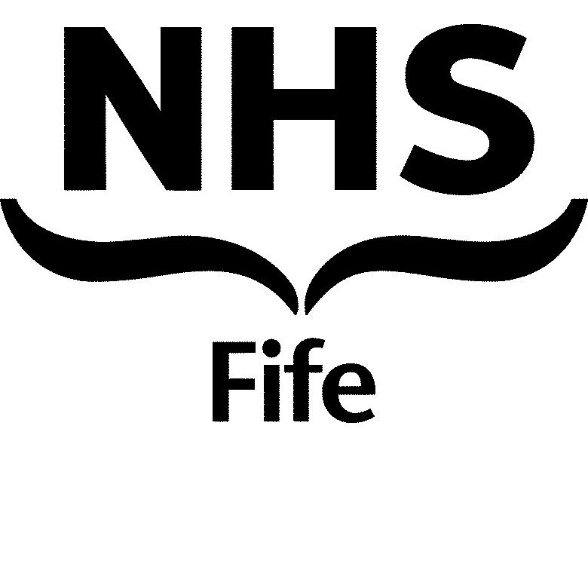
MEDICAL & DENTAL STAFF ANNUAL LEAVE ENTITLEMENTS
Appendix 4
FOR OTHER MEDICAL AND DENTAL STAFF

Medical & Dental staff have individual leave years therefore, this guidance is designed to assist Medical & Dental staff and their Managers to ensure they receive the appropriate annual leave and public holidays. The NHS Fife Public Holiday dates are agreed by the Area Partnership Forum.

Please note that pro-rata entitlements for part-time staff will be determined by the number of days / part weeks worked.

GRADE | ANNUAL LEAVE / PUBLIC HOLIDAY ENTITLEMENT
PUBLIC DENTAL SERVICE DENTISTS  (PDS Terms and Conditions Section 7) | On appointment 27 days per annum  After 5 years’ service 29 days per annum  After 10 years’ service 33 days per annum  8 Public Holidays
SENIOR CLINICAL FELLOWS  (Aligned to SAS Terms and Conditions) | 33 days / 6.6 weeks annual leave after completion of a minimum of 2 years’ service in the Specialty Doctor grade and/or in equivalent grades or who had an entitlement to 33 days / 6.6 weeks annual leave per year or more in their immediately previous appointments.  28 days / 5.6 weeks per annum, if not included in above.  8 Public Holidays
JUNIOR CLINICAL FELLOWS  (Aligned to Fixed Term Specialty Registrar Terms and Conditions) | 33 days per annum if on the third or higher incremental points of the salary scale.  28 days per annum if on the minimum, 1st or 2nd incremental points of the salary scale.  8 Public Holidays
LOCUM APPOINTMENT FOR SERVICE  (Aligned to Specialty Registrar Point 3 of salary scale) | 33 days / 6.6 weeks per annum  8 Public Holidays

